Research paper

ANALYTICAL TOOL ASSISTING THE DESIGNER
OF PIN-LUG CONNECTIONS

A. Strozzi¹, E. Radi²

¹ Dipartimento di Ingegneria “Enzo Ferrari”, Università di Modena e Reggio Emilia,
Via Vivarelli, 10, I-41125 Modena, Italy. Email: antonio.strozzi@unimore.it
²Dipartimento di Scienze e Metodi dell'Ingegneria, Università di Modena e Reggio Emilia,
Via G. Amendola 2, I-42122 Reggio Emilia, Italy. Email: enrico.radi@unimore.it

Corresponding author: Strozzi Antonio:
Email: antonio.strozzi@unimore.it
Address: Via Vivarelli, 10, I-41125 Modena, Italy.

Abstract
A theoretical model of a pin-lug fitting in the presence of a pin-lug gap is developed that accounts for the nonlinear link between the load and the pin-lug angular width in this progressive contact, which is assumed frictionless. This model adopts a simplified lug geometry, described by a purely flexural partial ring whose extremities are fixed to a base, solved with the virtual work principle. Based on an already available load factor regrouping the effect on the contact angular extent of the applied load, of the Young’s modulus, and of the gap, but not of the lug geometry, an enhanced load factor is developed that includes, although approximately, the influence of the lug geometry on the contact angle. This approach is useful in selecting a suitable clearance between the lug and the pin, which keeps the contact pressure to a minimum for an imposed load.

Keywords

Pin-lug connection; clearance; nonlinear progressive contact; analytical model; load factor; Finite Elements,

Highlights
• In a pin-lug contact the connection between the contact width and the load is nonlinear.

• A factor exists linking the contact width to load and clearance, but not to lug geometry.

• This factor is expanded to comprise the lug geometry effect on the contact extent.

• This enhanced factor assists the designer in selecting a suitable initial clearance

Nomenclature

p pressure profile
k coefficient
E Young’s modulus
F radial force
I moment of inertia of lug cross section for a unit out of plane thickness of lug
M bending moment
M₀ bending moment at the lug centre
N axial force
N₀ axial force at the lug centre
Q₀ shear force at the lug centre
P load
r_{g} radius of the centre of mass
r_{i} lug inner radius
r_{o} lug outer radius
x coordinate
y coordinate

α half contact angular extent
β angle defining the clamp angular position
δ=r_{i}/r_{o} aspect ratio
θ angular coordinate
Δ diametral clearance
Φ=P/(EΔ) load factor
Ψ=Pr_{g}³/(EIΔ) enhanced load factor

1. Introduction
r_{i}
α
r_{o}
Δ
P
P

α
p

α
F
β
M₀
N₀
r_{g}

(a) (b)

Figure 1. (a) Pin-lug connection, (b) the lug is simplified as a partial ring of constant section.

Pinned connections are employed in industrial machines to transmit loads while allowing for relative rotation of machine components. They are encountered in lifting lug arrangements and anchorage systems employed in the pressure vessel realm, see e.g. [1], [2]. The recent thesis [3] collects both theoretical and industrial aspects related to the design and application of pin jointed connections.
Although Finite Elements (FE) provide the most realistic and comprehensive insight into the mechanical response of pinned connections, mathematically oriented researchers are still attracted by this topic, e.g. [4] and [5]. An appealing feature is the progressive contact problem, since the pin-lug contact extent augments with load until the contact angular width approaches to its plafond of π, see [6]. The nonlinear response with load of this kind of structures constitutes a challenging source of mathematical difficulties, see [7] for an extended, updated, literature review.
Another problematic aspect is the modification of the pressure distribution with the pin-lug contact angle, see [8]. In fact, for limited contact arcs the contact profile is reminiscent of a Hertzian profile, whereas for higher contact widths the pressure remains essentially constant along the contacting arc, see [5] and Figure 4 (b) of [8]. It is correctly concluded in [8] that, for a general contact extent, the pressure distribution cannot be thoroughly represented by any available assumption.
To model analytically the pin-lug contact, the Hertzian theory has been invoked in [3], [5], and [9]. In [10] the effect of the initial gap has been accounted for with a Winkler foundation. In this paper, following [11], a different approach is used: the whole lug is modelled as a curved beam, partially wrapping around the pin, and partially detaching from it.
The lug models of a pinned connection may be classified into two main groups, the first of which relies on the 2D theory of elasticity, whereas the second class adopts a curved beam model, see [7]. A curved beam model has here been preferred for simplicity.
The literature review concerning pin-lug fittings exhibiting an initial gap is briefly reviewed hereinafter.
In the pioneering study of [12], a pinned connection is mimicked as a curved beam wrapping around a rigid pin, whose extremities are fixed to a rigid base.
A relevant 2D elastic result valid for a pin inserted with a gap Δ into the bore of an infinite plate mimicking the lug, and loaded by a force P, (this nonlinear problem is usually referred to as “pin in plate problem”), has been achieved in [13], [14], [15]. The effect of gap, angular contact width, and geometrical parameters, is examined separately in [16]; however, various effects may be condensed into a single expression, albeit approximately. In particular, in [13] a load factor Φ=P/(EΔ) is identified, that summarizes the nonlinear effect on the contact angular extent of three independent variables, namely the total load P, the pin-bore initial diametral gap Δ, and the Young’s modulus E. While Φ includes the effect of the lug microgeometry expressed by Δ, it ignores the lug macrogeometry, defined by the aspect ratio δ=r_{i}/r_{o}, where r_{i} and r_{o} denote the lug inner and outer radii, see Figure 1 (a). In fact, the load factor Φ has been derived in [13] for lugs described as infinite, bored plates.
The extension of the above load factor Φ to lugs of finite dimension has been considered in [17], where it has been demonstrated that, for a lug with rounded extremity and for a prescribed δ=r_{i}/r_{o}, the contact angular extent exclusively depends on Φ. Consequently, it is possible to compile design diagrams describing along the x-axis the load factor Φ, along the y-axis the contact angular extent, and including a family of curves, each valid for a particular lug aspect ratio δ, see [18].
In [8] several pin lug geometries are examined with FE, and it is observed that the stress transfer remains approximately the same provided that the contact angle is the same. In other words, in [8] the load factor Φ=P/(EΔ) is numerically deduced. The approximations noted in [8] in the employment of Φ are confidently ascribable to the circumstance that Φ ignores for the lug aspect ratio δ.
The next step in the understanding of this progressive contact is the determination of a design parameter, enhanced with respect to Φ, here denoted by Ψ, summarizing not only the consequence on the pin-lug contact arc of the pin-bore gap, but also that of the lug geometry. So, this parameter Ψ is expected to express the pin-lug contact angular extent as a function of the total load P, the initial gap Δ, the Young’s modulus E, and the lug geometry. This regrouping entrusted to Ψ is considered in this paper, based upon preliminary results presented in [7].
Since Ψ allows the contact angular extent to be forecast in terms of the simultaneous combination of the load, the clearance, the elastic constant, and the lug aspect ratio, it may also predict whether, for an imposed load, the full contact angle is sufficiently close to its plafond value π, see Figure 1. Thus, Ψ assists the designer in dimensioning pin-lug connections whose contact width is maximum.
The derivation of the enhanced load factor Ψ is approximate for two main reasons. First, for simplicity the beam model here adopted is purely flexural, so that the shear effect is disregarded. Second, as it emerges from Figure 1 (b), the lug portion far from the contact zone has been idealized in a simplified, approximate fashion, adopting a partial ring exhibiting a constant radial thickness.
This paper is structured in the following way. An analytical model of the lug is formulated as a purely flexural, curved, incomplete beam. Then, the lug wrapping and bending moment within the pin-lug contact arc are expressed as functions of the initial gap, the Young’s modulus, and the lug geometry. The model is then solved with the virtual work principle, and the enhanced load factor Ψ is derived, that condenses not only the effect of P, E, Δ, in the form Φ=P/(EΔ), see [13], but also the effect of the lug geometry, expressed by r_{g}³/I, where I is the moment of inertia and r_{g} is the centre of mass radius, thus obtaining the enhanced load factor Ψ=Pr_{g}³/(EIΔ) (the variables P and I are expressed for unit thickness of the lug, so that Ψ is adimensional).
The interest of the authors focuses on precision mechanical applications with tolerances H7/g6. In normal production tolerances, the ratio between the pin diameter and the initial diametral clearance is of the order of 0.002. A numerical example evidencing the usefulness of Ψ in selecting a suitable initial clearance ends the paper.

2. Lug wrapping around the pin
The formulae describing the lug wrapping around the pin are extracted from [11]. The pin is assumed as rigid. The angular semiwidth of the contact between the pin and the lug is denoted by α; θ is the angular coordinate; r_{g} is the radius of the centre of mass; Δ is the diametral initial clearance. The lug curvature variation along the contact arc is
. (1)
Therefore, the lug bending moment along the contact interval 0 ≤ θ ≤ α, see Fig. 1 (b), remains constant and equal to
(2)
Formula (2) shows that the lug bending moment within the pin-lug fitting is expressed as a function of Δ, E, and of the lug geometry described by I/r_{g}², where I=(r_{o}−r_{i})³/12 is the moment of inertia of the cross section of the lug, for a unit out of plane thickness of the lug. Since M₀ is independent of the total load P, an increase of P yields an increment of the contact arc and of the normal force, but not of the lug curvature and bending moment.

3. Lug beam-like model
As shown in Figure 1 (b), the lug is approximated as a purely flexural, incomplete ring of constant radial thickness, whose extremities are clamped to a rigid base, see [12]. In Fig. 1 the angle θ defines the polar coordinate, whose origin lies on the pin-lug contact arc centre; α denotes the contact extremity; β indicates the lug clamped extremity. The lug is virtually segmented into two regions, respectively referred to as pressurized bored region, and unpressurized bored region. The angular interval of the first region is 0≤θ≤α; the second interval is α≤θ≤β. In addition, P indicates the total applied load, Δ the initial diametral clearance, r_{i} the radius of the lug bore, r_{o} the radius of the lug circular extremity, and r_{g} the radius of the centre of mass. The aspect ratio r_{i}/r_{o} is δ, and the contact pressure is p.
Following [6] and [11], in this purely flexural model the contact reaction includes, in addition to the distributed contact pressure p, a point load F at the contact extremity, radially oriented outwards on the lug, see Figure 1 (b), This load F prevents from an unphysical compenetration between the pin and the lug. This lateral concentrated force F occurs in a purely flexural model, whereas it becomes a finite pressure bump in the plane theory of elasticity, as well as in experimental and FE models, see [19], [20], [21].
Fig. 1 (b) displays the unknown internal moment M₀ and force N₀ acting at the lug central section, where the central shear force Q₀ vanishes due to symmetry. Following [11], the contact pressure p is assumed to remain constant along the contact arc 0≤θ≤α.
The expressions of the bending moment M(θ) along the pin-lug contact arc, assumed as positive if it straightens the lug, are reported below for the two above defined regions, see Fig. 1 (b)
,
.
(3)
In view of eqns (3), the condition that the bending moment remain constant along the lug portion in contact with the pin demands
(4)
The introduction of condition (4) into the two formulae (3) of M(θ) valid for the two regions of the lug sketched in Fig. 1 (b), simplifies their expression as follows

. (5)

The lug model of Fig. 1 (b) in terms of an incomplete ring is a twice statically indeterminate problem; this structure is here solved with the principle of virtual work which, with respect to Castigliano, see [7], reduces the weight of the computations. Two compatibility equations are formulated, requiring the vanishing at the lug central cross section of both the rotation and the normal displacement. Two exploratory unit loads must be applied to the lug central section defined by θ=0 and, since a purely flexural model is adopted, only the bending moment produced by the two exploratory loads is considered in the distinct computation of the virtual work for the two above defined lug regions.
The bending moment produced by the exploratory moment M₀ = −1 along the whole lug is
, (6)
whereas the exploratory moment produced by the exploratory load N₀ = −1 along the whole lug is
. (7)
The exploratory loadings of expressions (6) and (7) may be combined linearly, thus achieving some simplifications, which reduce the two compatibility conditions to the two equations
(8)
Even without explicitly performing the analytical passages, an attentive exam of equations (5) indicates that equations (8) express a link between a function exclusively depending on the angles α and β, on M₀/r_{g}, on N₀, and on F. Consequently, the solution of equations (8) delivers expressions of the two unknowns F and N₀ in terms of M₀/r_{g} and of a function of α and β. With the aid of expression (4), the balance condition for the forces acting on the lug along the direction of the load P demands
(9)
By introducing in the equilibrium equation (9) the expressions of F and N₀ computed from equations (8) in terms of M₀/r_{g} and of a function of α and β, it is argued that a connection must exist between M₀/(Pr_{g}) and a function depending on α and β. By introducing in the above connection the expression (2) of M₀, it may be concluded that a link exists between the angles α and β, and the ratio EIΔ/(Pr_{g}³). Consequently, the load factor Ψ=Pr_{g}³/(EIΔ) must account for the simultaneous effect of P, E, Δ, I/r_{g}³ on the pin-lug contact angular extent, for a beam-type model. The above factor Ψ is here named enhanced load factor, since it is an extension of the load factor Φ=P/(EΔ) of [13].
The parameter I/r_{g}³ expressed as a function of the aspect ratio δ is

(10)

If the lug geometry is assumed as fixed, and β is imposed, then the angle α depends on the ratio F=P/(EΔ). This result has here been obtained with the beam-like model of the lug, and it coincides with the result derived in [13] with the 2D theory of elasticity. It may be concluded that the beam-like model of the lug favoured in this study produces an exact load factor F=P/(EΔ) valid for describing the half contact angle α as a function of the load P and of the gap Δ but, as discussed below after formulae (14), it is unable to account for the lug geometry.
Moving to explicit calculations, after some algebraic manipulations the following non-linear implicit relation for the angle α is obtained
(11)
where
. (12)
The corresponding unknown N₀ is given by
(13)
Finally, the point load F becomes
(14)
An alternative lug analytical model has also been developed according to [22] and [23], but this more complex modelling did not appreciably improve its accuracy.
A discussion on the physical relevance of the enhanced load factor Ψ is presented in the following. For an imposed value of the clamp angle β, if two pinned connections were described by the same value of Ψ, then the beam model developed in Section 3 in terms of an incomplete ring would deliver the same value of the half contact angle α, as previously commented in relation to equations (8) and (9). Consistently, in Figure 2 the family of solid curves describing, for an analytical lug model expressed in terms of an incomplete ring, the connection between Ψ and α, each family referring to a selection of aspect ratios δ=r_{i}/r_{o}, see [14], and to three clamp angles β, are superimposed for an imposed β, that is, such curves represent a single curve. It is concluded that, with reference to the analytical curved beam model described by a partial ring, in the evaluation of the half contact angle α, Ψ correctly considers the load P, the initial clearance Δ, the Young’s modulus E, the aspect ratio δ, and the moment of inertia I.

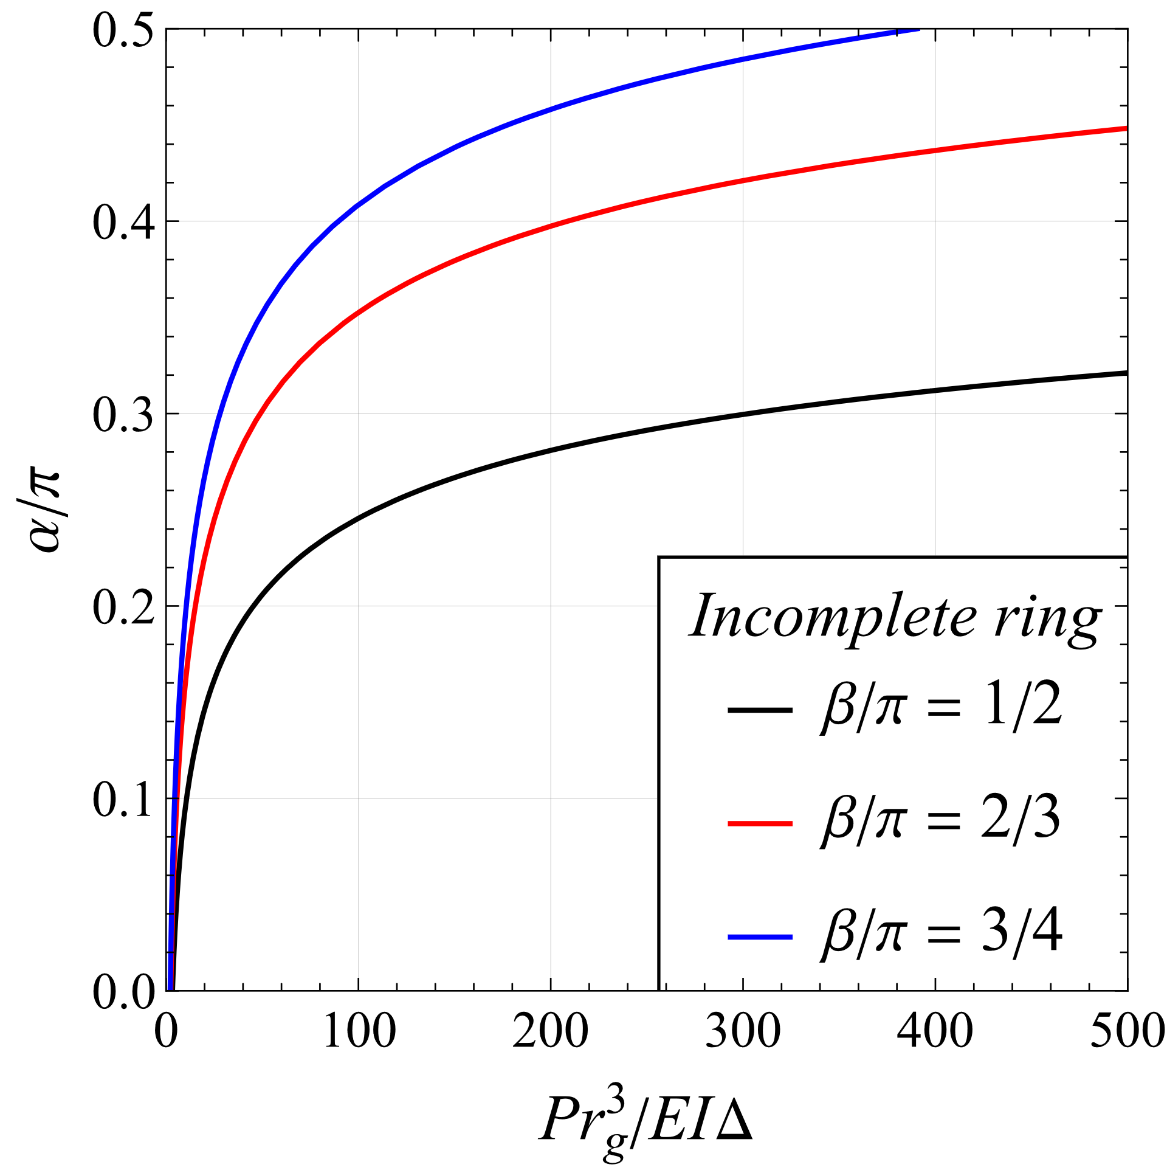
Figure 2. Half contact angular extent α/π versus the enhanced load factor Ψ for the analytical lug model expressed in terms of an incomplete ring.

The enhanced load factor Ψ does not account for the clamp angle β, that is, the contact angle depends on β, which may be selected to optimize the analytical results of Figure 2 versus the FE forecasts of Figure 4. For the time being, a suitable β value for the high gradient region appears to be β/π=3/4.
Figure 3 reports the normalized half contact angular extent α/π versus the load factor Φ (and not Ψ) for the lug analytical beam model expressed in terms of a partial ring. A selection of aspect ratios has been considered together with a single normalized clamp angle β/π, evidencing that the corresponding curves are markedly not superimposed. This result indicates that the load factor Φ is unsuitable for carefully describing the effect of the lug aspect ratio on the evaluation of the half contact angle α.
Moving to the kindred diagram 4 of Section 4, compiled on the basis of FE forecasts, it appears that such curves connecting Ψ to α, do not overlap, although they are sufficiently close to each other. This result indicates that in a FE analysis the enhanced load factor Ψ only approximately accounts for the above effects of P, D, E, r_{i}/r_{o}, I, on the evaluation of α. In summary, Ψ is an exact regrouping factor for the simplified analytical beam-like lug model of Figure 1 (b), but for the FE forecasts it becomes approximate. Despite such limits, Ψ is useful in forecasting which combination of load P, initial clearance D, Young’s modulus E, aspect ratio δ, moment of inertia I, produces a half contact angle α close to π/2, see Section 5. This information is relevant, since a further increase of the load P would produce a negligible increase of the contact angle. The contact problem would thus become essentially stationary in terms of contact angle extent, and no longer progressive, and the analysis of the stresses would become greatly simplified by the linear behaviour of the lug in terms of stresses.

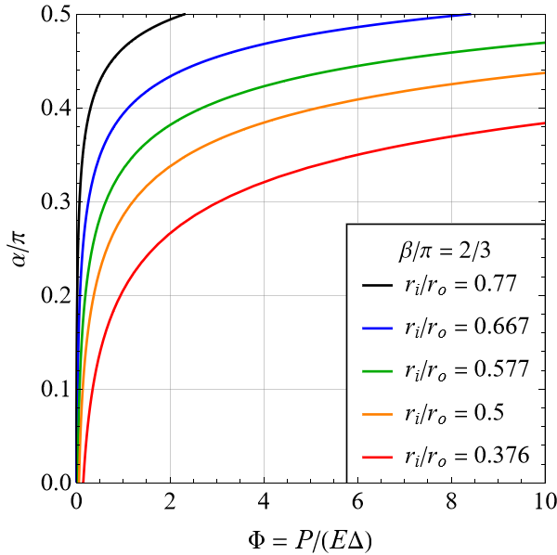

Figure 3. Half contact angular extent α/π versus the load factor Φ for the analytical lug model expressed in terms of a partial ring.

4. Comparison between analytical beam-like predictions and FE forecasts
The 2D FE mesh adopted in this study is essentially that developed in [7] and [18]. The FE package MSC Marc 2017r1 has been used. The number of nodes reaches 100000, and three elements have normally been used for each angular degree of the lug arc in contact. In [18], mesh convergence tests have been carried out versus series solutions. Further details are omitted for brevity.
Figure 4 is based upon plane FE forecasts, and it reports along the x-axis the enhanced load factor Ψ and along the y-axis the normalized half contact angle α/π, for several of δ=r_{i}/r_{o} aspect ratios. The various curves are not monotonically connected to δ. For instance, the black and the green curves, referring to δ=0.77 and 0.577, respectively, are (essentially) superposed, whereas the blue curve, referring to δ=0.667, is external to them.

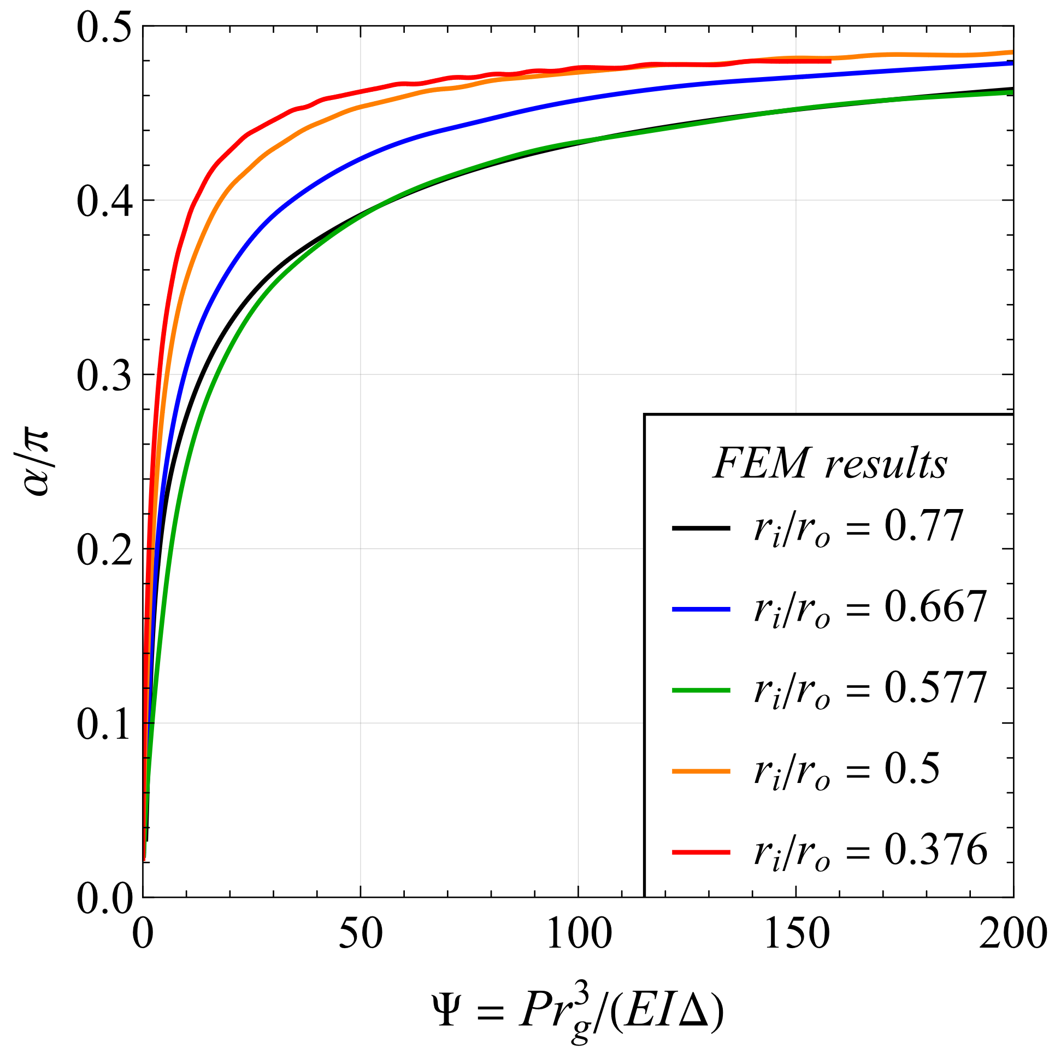
Figure 4. The FE predictions of the half contact angle α/π versus the enhanced load factor Ψ, for a selection of aspect ratios δ.

As already discussed in Section 3 and illustrated in Fig. 2, the half contact angle α predicted by the purely flexural incomplete ring model for a fixed value of the angular extent β uniquely depends on the parameter Ψ, which exactly describes the simultaneous effect of P, E, Δ, and δ. However, the FE forecasts in Fig. 4 provide slightly different values of the half contact angle α for the same value of the parameter Ψ, but for different selections of the aspect ratio r_{i}/r_{o}. This discrepancy is clearly due to the limitation of the one-dimensional (1D) beam model with respect to the two-dimensional (2D) approach of the FE analysis. Indeed, the actual lug geometry is more complex than an incomplete ring of uniform radial width, due to the contribution of the lug shank. Moreover, the 2D FE model incorporates the effect of shear and transversal beam deformability, which are neglected in the purely flexural incomplete ring model adopted. Therefore, the FE curves in Fig. 4 forecasting the half contact angle versus Ψ and referring to a selection of aspect ratios cannot exactly overlap, as it occurs for the 1D beam model. An attempt to analytically model the pin-lug connection by using the two-dimensional theory of elasticity is made in [24], where the lag is modelled by an incomplete ring of uniform thickness and the contact angle is found to depend on the parameter Ψ as well as on the aspect ratio δ.
If the parameter Φ is chosen for the description of the half contact angular extent α instead of the parameter Ψ, then the corresponding relation for a specific angular extent β is not defined uniquely. Indeed, for fixed values of the parameters Φ and β, the incomplete ring beam model provides different values of the half contact angle α for different values of the aspect ratio δ=r_{i}/r_{o}. A similar trend also occurs for the FE predictions on the half contact angle α reported in Fig. 5 in terms of the parameter Φ and for a selection of aspect ratios δ. Therefore, the adoption of the parameter Ψ is preferable, since it allows the 1D beam model to take into consideration the simultaneous effect of P, E, Δ, and δ on the half contact angle α.
For Ψ=50, the maximum divergence among the curves of Figure 4 with respect to their mean value is about 15 %. Despite this occurrence, the diagram of Figure 4 provides the following useful indication for the design of pinned connections: the progressive pin lug contact becomes essentially stationary, that is, the angular extent reaches its plafond, for Ψ ~ 200.

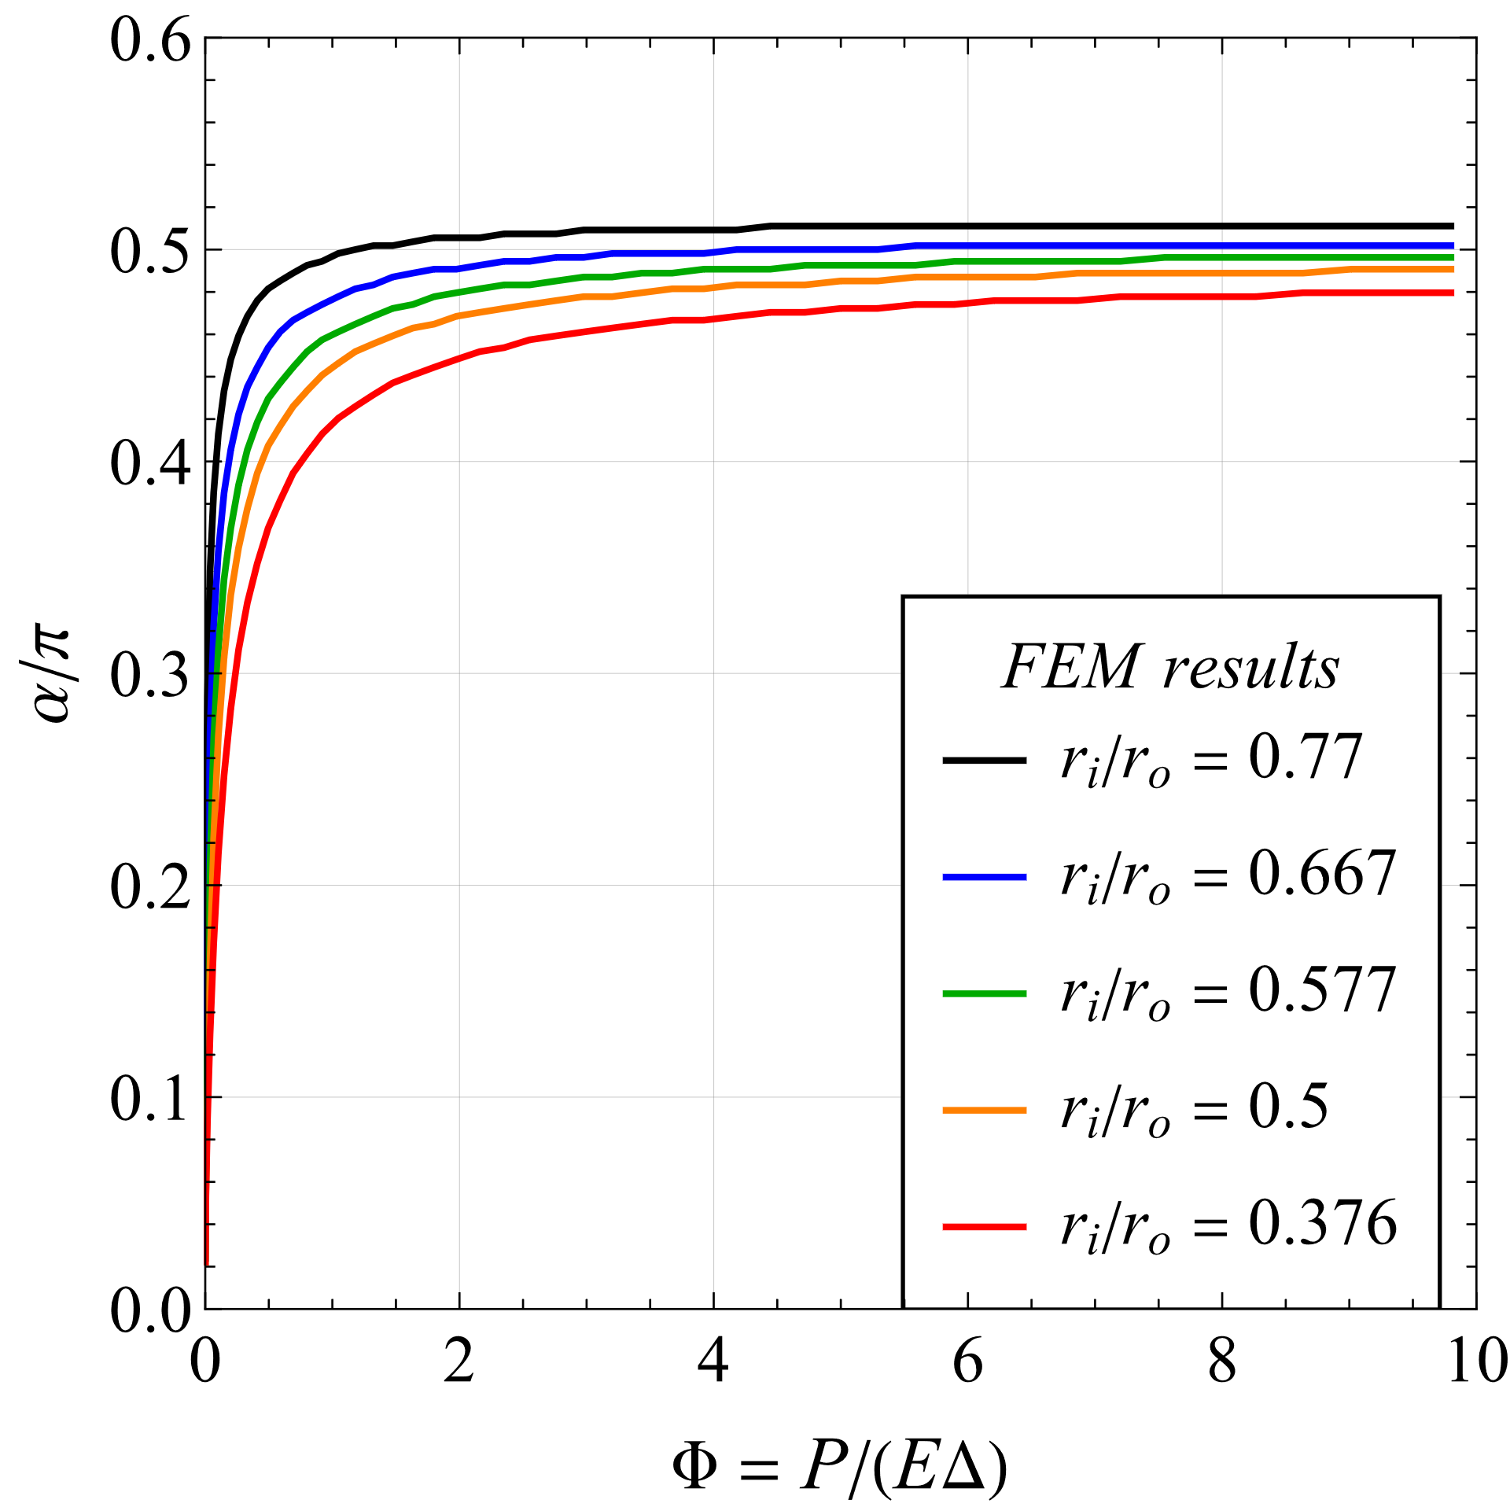
Figure 5. The FE prediction on the half contact angle α/π, versus the load factor Φ, for a selection of δ=r_{i}/r_{o} aspect ratios.
Figure 5 too is based upon FE forecasts, but it reports along the x-axis the load factor Φ (and not Ψ), and along the y-axis the normalized half contact angle α/π, for several δ=r_{i}/r_{o} aspect ratios. It appears that the curves of Figure 5 are less mutually close than those of Figure 4, thus evidencing the merit of Ψ versus Φ in describing the effect of the lug geometry.
The form of a suitable interpolating function mediating the various curves of Figure 4 has been suggested by the analytical modelling of the contact between a rectilinear flexible beam and a rigid pin, in which the beam wraps around the pin, examined in [24]. Such form is
, (15)
where the exponents at the denominator have been derived by minimizing the error with respect to the FEM results. A comparison between the half contact angular extent α forecast by the FEM analysis (solid lines) and the approximated values obtained from eqn (15) (dashed lines) is provided in Figure 6, for four values of δ=r_{i}/r_{o}. This diagram may be employed to estimate the contact angle for an imposed value of the enhanced load factor.

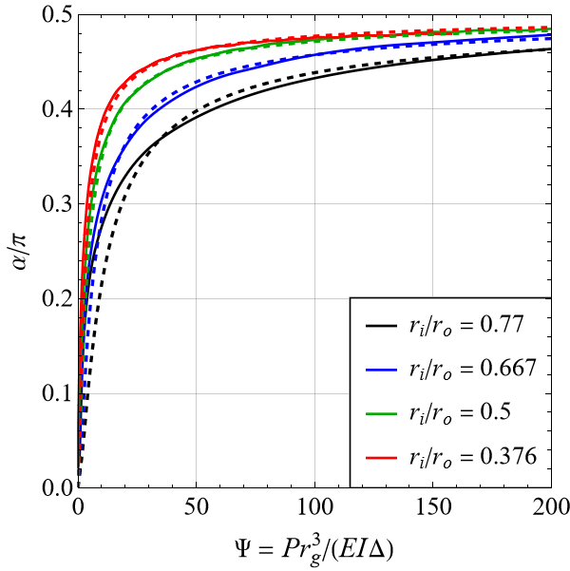
Figure 6. Comparison between the half contact angular extent α forecast by the FEM analysis (solid lines) and the approximated values obtained from eqn (15) (dashed lines) for four values of δ=r_{i}/r_{o}.

5. Application of the above analytical results to the design of pin-lug fittings
The formulae obtained in this paper assist the engineer in designing a suitable pinned connection. In particular, if the applied load, the Young’s modulus, and the lug geometry are known, it is possible to forecast the initial diametral gap that produces a full angular contact extent close to its plafond π. In fact, for a higher loading the contact arc becomes stationary while the stresses behave linearly with the load, see [17], thus simplifying the stress calculations. In fact, when the pin-lug contact problem becomes linear, the determination of the lug stresses may be derived from a single FE analysis.
As an example of the usefulness of Ψ, let us consider a pin-lug connection defined by P=10000 N/mm (for a unit out of plane thickness of the lug), r_{i} = 20 mm, r_{o} = 40 mm, E=210000 MPa, then r_{g}=(r_{i}+r_{o})/2=30 mm, I=(r_{o}−r_{i})³/12=666.67 mm³. (The variables P and I are expressed for lug unit thickness, so that Ψ is adimensional.) Moreover, Ψ = Pr_{g}³/(EIΔ) = 10000×30³/(210000×666.67×Δ) = 200, where the value 200 has been assumed in Section 4 as the transition of Ψ from the lug nonlinear response to its linear counterpart, see Figure 4. The previous computations provide Δ=0.0096 mm. If the equally acceptable value Ψ=150 were employed, then the reasonably similar value Δ=0.0129 mm would be obtained. Thus, these computations provide an order of magnitude for Δ.
The selection of the suitable intitial clearance is rarely discussed in the scientific literature. A review of the influence on the clearance of the load capacity according to various standards is presented in [3].

6. Future work
It has been noted in Section 3 that, for a purely flexural lug model, the pin-lug contact reaction includes concentrated forces F radially oriented outwards, see Figure 1 (b) and [25], whose presence precludes the possibility to compute realistic lug stresses. It has however been shown in [26], [27] that the point load may be substituted by a suitably distributed, Hertzian type, pressure profile, amenable to an estimation of the lug stresses. The suitability of this substitution in the title problem will be the subject of future research. Another aspect is the optimization of the β angle defining the clamp angular position, see the related comments in Section 3.

7. Conclusions
An analytical, purely flexural model of a pin-lug fitting in the presence of a pin-lug gap has been expressed in terms of a partial ring with constant radial thickness, and solved with the principle of virtual work. From this investigation, the following conclusions can be drawn.
• The mechanical response of pinned connections has been virtually split into two regions. For lower loads, the contact is progressive, and both the contact angular extent and the contact pressure increase nonlinearly with the load. With this modelling, a load threshold may be estimated, beyond which the pin-lug contact problem becomes essentially linear in terms of stresses, and stationary in terms of contact extent.
• An enhanced load factor Ψ, improving the classical load factor Φ, has been derived, that accounts for the effect on the contact angular extent of the load, of the elastic constant, of the initial gap and, although approximately, of the lug aspect ratio, according to the expression Ψ=Pr_{g}³/(EIΔ). By using a beam-like model for the lug, analytical curves have been achieved that describe the nonlinear progressive contact extent versus the normalized load and the lug geometry. These forecasts have been reasonably positively compared to their FE counterparts for an ample selection of lug geometries.
• A numerical example has been presented that evidences the employment of the enhanced load factor in providing indications useful for the design of pinned connections. In fact, for an imposed load it is possible to estimate the initial clearance for which the full contact angle essentially reaches its plafond of π. Beyond this load virtual transitional value, the pin-lug contact problem becomes essentially linear in terms of stresses, and stationary in terms of contact angular extent, so that the determination of the lug stresses may be confined to a single FE analysis.

REFERENCES
1 Antalffy LP, Miller III GA, Kirkpatrick KD, Rajguru A, Zhu Y. The design of lifting attachments for the erection of large diameter and heavy wall pressure vessels. Int J Press Vessels Pip 2016; 139: 12-21.
2. Pechatsko B, Stambolia J, Shields EB, Davenport JB, Orning AD. Stress analysis of a pin and clevis assembly. In ASME Pressure Vessels and Piping Conference, New York, USA, 2003, vol. 16990, pp. 83-89.
3. Harms I. Pinned connections. Doctoral dissertation. Delft University of Technology, 2015.

4. Wenliu X, Wang L. Simplified model for static stress analysis of straight eccentric lug subjected to cosine distribution pressure. Struct 2021; 34: 2077-2086.
5. Li Y, Huang R, Zhao S, Wang J. Contact pressure analysis of pin-loaded lug with clearance. Adv Mech Eng 2022; 14(6): 16878132221107475.
6. Barber JR. Contact mechanics. Berlin: Springer International Publishing, 2018.
7. Strozzi A, Giacopini M, Bertocchi E, Mantovani S, Baldini A. Towards an analytical model of a pin-lug connection. Int J Solids Struct 2022; 253: 111446.
8. Wang G S. Stress analysis for a lug under various conditions. J Strain Anal Eng Des 1994; 29(1): 7-16.
9. Pedersen NL. Stress concentration and optimal design of pinned connections, The J Strain Anal Eng Des 2019; 54(2): 95-104.
10. Antoni N. A study of contact non-linearities in pin-loaded lugs: Separation, clearance and frictional slipping effects. Int J Nonlin Mech 2014; 58: 258-282.
11. Feodosiev VI. Advanced stress and stability analysis: worked examples. Berlin: Springer Science & Business Media, 2005.
12. Cox HL, Brown AFC. Stresses round pins in holes. Aeronaut Quart 1964; 16: 357-372.
13. Persson A. On the stress distribution of cylindrical elastic bodies in contact, Ph.D. dissertation, Chalmers, Tekniska, Goteborg, Sweden 1964.

14. Ciavarella M, Decuzzi P. The state of stress induced by the plane frictionless cylindrical contact. I. The case of elastic similarity. Int J Solids Struct 2001; 38(26-27): 4507-4523.

15. Ciavarella M, Decuzzi P. The state of stress induced by the plane frictionless cylindrical contact. II. The general case (elastic dissimilarity). Int J Solids Struct 2001; 38(26-27): 4525-4533.
16. Aslam A, Sekhon GS, Kumar R. Elastic analysis of a pin loaded lug. J Aircraft 2004; 41(2): 365-371.
17. Ciavarella M, Baldini A, Barber JR, Strozzi A. Reduced dependence on loading parameters in almost conforming contacts. Int J Mech Sci 2006; 48(9): 917-925.
18. Strozzi A, Baldini A, Giacopini M, Bertocchi E, Bertocchi L. Maximum equivalent stress in a pin-loaded lug in the presence of initial clearance. J Strain Anal Eng Des 2011; 46(8): 760-771.
19. Strozzi A, Baldini A, Giacopini M, Rosi R, Bertocchi E. Contact stresses within a split ring inserted into a circular housing. J Strain Anal Eng Des 2009; 44(8): 671-688.
20. De Bona F, Strozzi A, Vaccari P. On the pressure distribution at the contact between small end of a conrod and gudgeon pin. In AMST’99 (ed Kuljanic E) International Centre for Mechanical Science 1999, vol 406, pp. 745-752. Springer, Vienna.
21. Dragoni E, Strozzi A. Analysis of a split ring inserted into a circular housing. J Strain Anal Eng Des 1986; 21(2): 59-70.
22. Koiter WT. An elementary solution of two stress concentration problems in the neighborhood of a hole. Quart Appl Math 1957; 15(3): 303-308.
23. Oden JT, Ripperger EA, Saunders H. Mechanics of elastic structures (2nd ed). New York: McGraw-Hill, 1982.
24. Radi E, Strozzi A. Advancing contact of a 2D elastic curved beam indented by a rigid pin with clearance. Int J Nonlin Mech 2023; 149: 104323.
25. King WW. Interference of a uniform open ring with a rigid cylinder. J Appl Mech 1989; 56: 717-719.
26. Barber JR. Contact mechanics. Berlin: Springer International Publishing, 2018.
27. Kim JH, Ahn YJ, Jang YH, Barber JR. Contact problems involving beams. Int J Solids Struct 2014; 51(25-26): 4435-4439.

