
Study on the link between the levels of basic competences and formal educational attainment in a cross-country and within-country perspective

Educational attainment and basic competences of young adults in Europe



Authors

Anja Meierkord
Vicki Donlevy
Andy Green
Nicola Pensiero
Facundo Herrera

EUROPEAN COMMISSION
Directorate-General for Education and Culture
Unit A.4 –Studies, Impact Assessments, Analysis and Statistics
European Commission
B-1049 Brussels

EUROPEAN COMMISSION

Educational attainment and basic competences of young adults in Europe
Study on the link between the levels of basic competences and formal educational attainment in a cross-country and within-country perspective

Directorate-General for Education and Culture

Disclaimer

This document has been prepared for the European Commission; however, it reflects the views only of the authors, and the Commission cannot be held responsible for any use which may be made of the information contained therein.

Ce document a été préparé pour la Commission européenne; néanmoins, il reflète uniquement l’avis des auteurs et la Commission ne saurait être tenue responsable de toute utilisation qui serait faite des informations qu’il contient.

Dieses Dokument wurde für die Europäische Kommission erstellt. Es gibt jedoch lediglich die Meinung der Autoren wieder, und die Kommission kann nicht für die Verwendung der darin enthaltenen Informationen verantwortlich gemacht werden.

Europe Direct is a service to help you find answers
to your questions about the European Union.

Freephone number (*):
00 800 6 7 8 9 10 11
(*) The information given is free, as are most calls (though some operators, phone boxes or hotels may charge you).

More information on the European Union is available on the internet (http://europa.eu).

Luxembourg: Publications Office of the European Union, 2015
ISBN 978-92-79-50996-4
doi: 10.2766/598317

© European Union, 2015
Reproduction is authorised provided the source is acknowledged.

Table of Contents
1. Introduction 1
1.1 Aims and objective of this study 1
1.2 Defining skills and competences 2
1.3 Methodology for this study 2
1.4 Structure of this report 2

2. PIAAC - Assessing adult competences and educational attainment 4
2.1 How PIAAC assesses competences 5
2.2 How PIAAC captures educational attainment 7

3. Competences of young adults in Europe 10
3.1 Focus on young people – definition of the sample 11
3.2 Distribution of proficiency levels across and within Member States 12
3.3 Average competences and their distribution across Member States 16
3.4 Patterns and groups of countries 23

4. Trends in educational attainment in Europe 27
4.1 Educational expansion at EU-28 level 28
4.2 Educational expansion at Member State level 30
4.3 Expanding competences alongside educational attainment? 34

5. Linking educational attainment and basic competences 41
5.1 Brief overview of the literature 43
5.2 Average numeracy and literacy competence by educational attainment 45
5.3 Competence differences between qualification levels across the EU-28 49
5.4 Cross-country variation of the competence differences 59

6. Effects of different education systems and features on competences 69
6.1 Methodology 70
6.2 Brief overview of the literature 75
6.3 Analysis and results 81

7. Concluding discussion and recommendations 96

Annexes:

Annex I – Bibliography A1
Annex II – Study methodology A12
Annex III – Features of the PIAAC sample A22
Annex IV – Additional Graphs Chapter Four A23
Annex V – Variables considered for the empirical model A37
Annex VI – Additional tables Chapter Five A38
Annex VII – Additional tables and information Chapter Six A40

List of abbreviations
- ALL: Adult Literacy and Lifeskills Survey
- BTEC: Business and Technology Education Council
- CEDEFOP: European Centre for the Development of Vocational Training
- DID: Difference-in-difference
- EC: European Commission
- EU: European Union
- EULFS: European Labour Force Survey
- FIMS: First International Maths Study
- FISS: First International Science Study
- GCSE: General Certificate of Secondary Education
- GNVQ: General National Vocational Qualification
- IALS: International Adult Literacy Survey
- ICT: Information and Communication Technologies
- ISCED: International Standard Classification of Education
- MENESR: Ministère de l'Education nationale, de l'Enseignement supérieur
- NVQ: National Vocational Qualification
- OECD: Organisation for Economic Cooperation and Development
- PIAAC: Programme for the International Assessment of Adult Competencies
- PIRLS: Progress in International Reading Literacy Study
- PISA: Programme for International Student Assessment
- PUF: Public Use Files
- SAS: Survey of Adult Skills
- SIMS: Second International Maths Study
- SISS: Second International Science Study
- TIMMS: Trends in International Mathematics and Science Study
- UNESCO: United Nations Organisation for Education, Science and Culture
- VET: Vocational education and training

Country abbreviations
- AT: Austria
- BE: Belgium
- BE (FL): Belgium (Flanders)
- BG: Bulgaria
- CA: Canada
- CY: Cyprus
- CZ: Czech Republic
- DE: Germany
- DK: Denmark
- EL: Greece
- EE: Estonia
- ES: Spain
- FI: Finland
- FR: France
- HR: Croatia
- HU: Hungary
- IE: Ireland
- IT: Italy
- JP: Japan
- KR: Korea
- LT: Lithuania
- LU: Luxembourg
- LV: Latvia
- MT: Malta
- NL: Netherlands
- NO: Norway
- PL: Poland
- PT: Portugal
- RO: Romania
- SE: Sweden
- SI: Slovenia
- SK: Slovak Republic
- UK: United Kingdom
- UK (EN): United Kingdom (England)
- UK (NI): United Kingdom (Northern Ireland)
- US/USA: United States of America

1. Introduction
Qualifications have long been considered the core outcome of formal education. Policy-makers have worked under the assumption that completing a specific stage or spending a specific time in formal education equips young people with the skills and competences needed for economic and social participation. Academics typically use qualifications as proxies for skills in the absence of a direct measurement. More recently, results from international large scale skills assessment surveys have provided a comparative assessment of skills proficiency across a large number of countries and suggested that the qualifications and skills of an individual do not relate as closely to each other as assumed to date.
Data from the Organisation for Economic Cooperation and Development (OECD) Programme for International Student Assessment (PISA) for example shows that there are significant differences in skills proficiency at similar levels of educational attainment both within and between countries. Cross-country differences may imply that certain education systems are more effective in equipping young people with skills than others (see e.g. OECD 2014). This is of interest for policy-making, as research increasingly suggests that skills, not merely formal educational attainment, are predictors of individual life-chances, such as life-time earnings (Woessmann 2014, Hanushek et al 2015) and social outcomes such as political trust or volunteering (Da Costa et al 2014).
To date, this research has focused on the skills and competences of school children up to lower secondary level, but little is known about the relationship between educational attainment and skills for subsequent stages of formal education, i.e. at upper secondary and tertiary level. New data from the OECD’s Survey of Adult Skills (SAS), produced within the context of the OECD Programme for the International Assessment of Adult Competencies (PIAAC), now facilitates such analysis by providing an assessment of the proficiency of 160,000 adults (age 16-65) across 24 countries in a number of information processing contexts – namely literacy, numeracy and problem-solving in technology-rich environments (OECD 2013a). 17 European Member States took part in PIAAC.

1.1 Aims and objective of this study
This study aims to close this research gap by investigating the link between educational attainment at upper secondary and tertiary level and basic competences from a cross-country and within-country perspective. It further explores the potential reasons underlying the observed patterns. Using PIAAC data, this study makes four contributions to the policy debate. First, it provides an overview of young people’s literacy and numeracy proficiency in Europe and highlights groups of countries with similar results. Second, it shows that, while educational attainment across Europe has clearly increased in the last decades, this expansion has not always been accompanied by a similar increase in basic competences of young people. Third, it estimates the partial effect of different levels of educational attainment on competence levels and shows that those with higher educational attainment also achieve higher numeracy and literacy proficiency. Fourth, it shows that there is significant variation in the relationship between educational attainment and basic competences across countries, and explores which education systems and education system features are successful in supporting young people to gain and maintain competences at upper secondary and tertiary level.

1.2 Defining skills and competences
In line with the OECD PIAAC definition (2013c: 94) competences in the context of this study are understood “as the application and use of knowledge and skills in common life situations as opposed to the mastery of a body of knowledge or a repertoire of techniques”. Compared to skills, competences are understood to encompass a broader concept, which includes the application of knowledge, skills and attitudes in real life contexts. However, it should be noted that in many cases – in particular in the EU policy literature – skills and competences are used interchangeably. For the purpose of this study, we define basic competences operationally, i.e. the numeracy and literacy competence as assessed through PIAAC. In this context, skills and competences are used interchangeably throughout the report.

1.3 Methodology for this study
The results of this study were produced using a range of quantitative data sources and methodologies, a multi-level/panel data analysis using PIAAC micro-data and a difference-in-difference analysis using PIAAC data aggregated at country level. The detailed methodology and data sources used are described in each subchapter. Additionally, three qualitative country case studies on Denmark, France and Spain were conducted and included a review of the relevant literature and key informant interviews. Evidence from the case studies is presented throughout the report to contextualise the quantitative findings. The study was carried out with the support of a Scientific Committee composed of Prof. Richard Desjardins, Prof. Beatrice Rammstedt, Dr. Silke Schneider and Prof. Patrick Werquin. A full description of the methodology for this study can be consulted in Annex II.

1.4 Structure of this report
This report is structured as follows:
The current Chapter One provides an introduction to the report, including the main aims of the study and methodology used;
Chapter Two provides an introduction to the key data source for this study – the OECD’s Survey of Adult Skills;
Chapter Three sets out an overview of the competences of young adults in Europe, making reference to both average competence levels and their distribution, and presents a typology of countries with similar results across the two dimensions of average proficiency and dispersion;
Chapter Four discusses the evidence for educational expansion in Europe using Eurostat data and investigates, using PIAAC and IALS data, if this expansion has been accompanied by an equal expansion of competences of young people;
Chapter Five investigates the link between educational attainment and competences. It gives a brief review of the literature before analysing the link between competences and educational attainment and its variation across countries;
Chapter Six explores which types of education systems or specific features of education systems enable young people to gain and maintain competences at upper secondary and tertiary level;
Chapter Seven provides a concluding discussion of the key findings and sets out policy recommendations in three areas: 1) improvement of the quality and effectiveness of formal education; 2) improving or adjusting the comparability of formal educational qualification and their classification; and, 3) improving and further developing international assessment of competences.

2. PIAAC - Assessing adult competences and educational attainment
The focus of policy-making has traditionally been on enhancing educational attainment levels, however research increasingly suggests that skills and competences, rather than merely formal educational attainment, are better predictors of individual life-chances, such as life-time earnings (Woessmann 2014, Hanushek et al 2015) and social outcomes such as political trust or volunteering (Da Costa et al 2014). Accordingly, policy-makers are increasingly interested in understanding and developing their populations’ competences and skills, rather than only their educational attainment.
However, conceptualising and assessing competences is a challenging task, in particular from a comparative cross-country perspective. Since 2013, new data from the OECD’s Survey of Adult Skills (SAS), produced within the context of the OECD Programme for the International Assessment of Adult Competencies (PIAAC), provides empirical evidence on the competences of 160,000 adults (age 16-65) across 24 countries in a number of information processing contexts – namely literacy, numeracy and problem solving in technology-rich environments (OECD 2013a). 17 European Member States took part in PIAAC. Using PIAAC data, this report defines competences operationally, i.e. numeracy and literacy competences as measured in PIAAC which young people possess.
Key findings
- PIAAC assesses three domains of cognitive skills: literacy, numeracy and problem solving in technology-rich environments (ICT).
- It assesses basic and general skills, rather than advanced and specific skills.
- Results are measured on a 500 point scale. The scale has been divided into 6 proficiency levels.
- Data was collected using a computer-based assessment at the home of the respondents. An extensive background questionnaire was also completed.
- In PIAAC, educational attainment is captured using the International Standard Classification of Education (ISCED 1997).
- It is important to understand the limitations of both the assessment of competences using PIAAC, in particular what it does and does not measure, and the ISCED classification, in particular difficulties arising from the comparability of qualifications.

2.1 How PIAAC assesses competences
PIAAC is designed to increase the evidence base on the stock of competences in the population by providing a direct measurement of key cognitive skills and internationally comparable (OECD 2013b). It is the third of a series of international adult skills surveys which have been implemented since the mid-1990s by OECD countries and was preceded by the International Adult Literacy Survey (IALS) (1994-98) and the Adult Literacy and Lifeskills Survey (ALL) (2003-06). PIAAC has been designed so that data can be linked to IALS and ALL in the domain of literacy and ALL in numeracy (OECD 2013a).
PIAAC assesses three ‘domains’ of cognitive skills which, according to the OECD, represent “cross-cutting cognitive skills that provide a foundation for effective and successful participation in the social and economic life of advanced economies” (OECD 2012: p. 9). A comprehensive conceptualisation can be found in OECD (2012), but domains are in sum defined as:
- Literacy: “understanding, evaluating, using and engaging with written texts to participate in society, to achieve one’s goals, and to develop one’s knowledge and potential.”
- Numeracy: “the ability to access, use, interpret and communicate mathematical information and ideas, in order to engage in and manage the mathematical demands of a range of situations in adult life.”
- Problem solving in technology-rich environments: “using digital technology, communication tools and networks to acquire and evaluate information, communicate with others and perform practical tasks.”
In each of the three domains, proficiency is conceptualised as a continuum of ability involving the mastery of information-processing tasks of increasing complexity. The results are measured on a 500-point scale and scales have been divided into ‘proficiency levels’ (see also Chapter Three below).
Question items are designed to relate to real world problems of the survey population, such as interpreting graphs (numeracy skills) or extracting information from a short pieces of text, such as a set of instructions (literacy skills). It should be noted that PIAAC assesses basic and general skills, rather than skills that are advanced and specific (Heising/Solga 2014: p. 3). More advanced competences were not tested in PIAAC. For example, in the numeracy domain, the focus was on everyday tasks involving numerical operations such as correctly interpreting bar charts that might appear in newspaper articles or government brochures. It was not on solving problems that require for example knowledge of inferential statistics or calculus. This may limit the ability to ascertain competence differentials in the upper part of the educational distribution (Heisig/Solga 2015).
PIAAC was implemented as a computer-based assessment at the homes of the respondents. This presented the opportunity to include: technology-based texts and environments, reflecting the range of materials that many adults encounter in their everyday lives; more reliable computer-based scoring; and, the use of adaptive algorithms to optimise the delivery of test items within a domain to estimate proficiency levels of individuals, thereby allowing PIAAC to provide more reliable information about skills in a relatively short period of time (OECD 2013a). In addition to the skills assessments, survey participants completed an extensive background questionnaire, including the provision of some information on educational background, current and past work experience, social and linguistic background, literacy and numeracy practices, as well as skill use at work and home.

2.1.1 Limitations
The design and implementation of PIAAC was guided by expert-developed technical standards and guidelines to ensure that the survey yielded high-quality and internationally comparable data. Compliance with the technical standards was mandatory and monitored throughout the process (OECD 2013a). This included for example the requirement for extensive analysis of non-responses in countries, where the response rate was below 70% (Rammstedt/Mahler 2014) and measurement equivalence across cultural and linguistic contexts, which is crucial for the comparability of results. Thorn (2009) argues that International Adult Literacy and Basic Skills Surveys in the OECD region were explicitly developed as international or cross-national assessments designed to provide valid and reliable measures of proficiency across different countries, languages and cultures. He described the efforts made in ensuring that the assessments are, as far as is possible, culturally and linguistically unbiased. Stimulus materials and ideas for tasks were solicited from a wide a range of contributors. Standards were established regarding the translation and adaptation of items. Translations and adaptations were centrally verified and item performance was rigorously tested.
However, others have questioned the measurement equivalence across countries, in particular how well the definitions of competences fit adults’ lives in any particular country (Evans 2014) and the ability of the PISA and PIAAC surveys to measure people’s capacity to use skills and knowledge in real everyday challenges given the differences in culture, social activities and work methods between and within countries (Serentill and Palma 2014). Additionally, some have criticised errors found in questions and answers. Serentill and Palma (2014) found errors in the answers to calculation and reading understanding questions.
As previously for PISA, PIAAC has also been criticised with regards to what it does and does not measure:
- The survey has been criticised for being limited in that it directly measures only part of the cognitive skills and not other abilities required for adults such as interpersonal skills and creativity (Palmen 2014). Indeed, Andreas Schleicher, Director for Education and Skills at the OECD, has confirmed that work is underway to expand the framework of competences (Hackl 2014).
- PIAAC measures skills which are reflective of the content of general education programmes, rather than VET-specific skills. This may be one of the reasons behind the fact that adults with upper-secondary VET qualifications generally have lower levels of literacy and numeracy proficiency than people with general upper-secondary education, as has been found in previous research (see Cedefop 2014).
- The focus of PIAAC is only on specific aspects of literacy and numeracy. Regarding literacy for example, the focus lies on the understanding and use of texts, while writing skills and the ability to produce or format documents is not assessed (St Clair 2012). According to Thorn (2009), international adult skills surveys do not assess writing because of practical difficulties, not because these skills are not considered as important aspects of literacy (Thorn 2009).
- Others have criticised the narrow definition of literacy measured by PIAAC and other similar surveys, and how well these surveys represent the literacy abilities and practices of adults (Hamilton 2001, Sticht 2013). For example, Sticht (2013) compared the results of international assessments such as IALS with self-assessments of literacy, and found that most adults who are found to have inadequate literacy in these tests do not think they have a ‘literacy problem’.
Nonetheless, the PIAAC survey constitutes an improvement from earlier comparative assessments of adult competences. Heisig and Solga (2015) assert that the PIAAC data is of much higher quality than IALS data. They state that the quality of competence measurements has advanced considerably since the mid-1990s, partly due to the advances spawned by the Programme for International Student Assessment (PISA).

2.2 How PIAAC captures educational attainment
In PIAAC, educational attainment, defined as formal qualification levels, was captured using the International Standard Classification of Education (ISCED 1997) and assigned to 13 groups designed to be internationally comparable (Allen et al 2013: p.33). To be easily understood by PIAAC respondents, all questions pertaining to level of education were framed in terms of the qualifications currently or formerly available in the country concerned.

The International Standard Classification of Education (ISCED) was developed by UNESCO to facilitate comparisons of education indicators and statistics across countries on the basis of uniform and internationally-agreed definitions. ISCED maps country-level qualifications onto ISCED levels based on information such as entry requirements, entry age and duration of the course in consultation with experts. For PIAAC, countries were required to develop an individual list of qualifications that could be directly matched to the ISCED categories and to supply a full conversion scheme from their national levels to the international ISCED levels, including a specification of nominal years of schooling corresponding to each level and orientation and, where relevant, the vocational or academic nature of the programme (OECD 2013a).

2.2.1 Limitations
While ISCED is the only classification system that supplies regular, worldwide and publicly available data on education systems of such breadth, detail and acceptance (Bohlinger 2013), there are a number of important caveats to be kept in mind throughout this report relating to the use of ISCED as a framework for categorising educational attainment:
Education systems are constantly evolving: the framework needs to be updated periodically to ensure that it reflects current structures. The classification was first developed by UNESCO in 1976 and was then revised in 1997. In 2011, a revision to ISCED was formally adopted by UNESCO Member States (UNESCO 2012). PIAAC uses ISCED 1997.
The mapping of qualifications to ISCED levels is political: the central criterion for the mapping of a qualification to an ISCED level is the complexity of its content. However, it is a challenge to directly assess and compare the content of programmes across education systems in a consistent way. Therefore ISCED 97 uses a number of auxiliary criteria as proxies. These criteria include: the typical starting age of participants, the theoretical and typical duration of a programme, the typical and minimum entrance requirements, and the type of certificate or diploma awarded upon successful completion of the programme (Schneider/Kogan 2008). Using these proxies, the responsibility of defining the complexity of content is handed over to the individual countries. The mapping is implemented following a process of negotiation, and is carried out by the involved actors from policy, practice and academic research. Integral to this process is a certain conception of the value of learning processes and qualifications (Bohlinger 2013).
Schneider (2009) finds that, in some cases, assignments of educational qualifications to ISCED categories seem to deviate from the ISCED 97 definitions, possibly for political reasons. Along the same lines, Steedman and McIntosh (2001) describe how political considerations influence the allocation of different education and training outcomes to the categories of the ISCED scale. Even its application, i.e. when ISCED levels have already been defined, inconsistencies remain: Ortmanns and Schneider (2014) and Schneider (2009) find that ISCED is not applied consistently across different surveys, with important implications for inconsistencies of what is measured when assessing educational attainment.

ISCED does not capture certain information: As any standardised classification, ISCED only approximates educational attainment. There are a number of important aspects of educational attainment which ISCED cannot capture:
- Educational attainment encompasses not only formal learning but also non-formal and informal learning, provided that this is recognised for the purposes of a formal qualification. ISCED however makes no provision for learning that does not lead to a recognised qualification, or for non-accredited qualifications (Bohliner 2013).
- ISCED does not allow any distinction between elitist, highly selective and prestigious types of higher education (e.g. Russell Group universities in the UK) and mainstream universities (Schneider/Kogan 2008).
- ISCED does not capture changes in standards of specific educational qualifications over time. Unless changing standards are accompanied by corresponding changes in the ISCED criteria (typical entry age, entry requirements etc.), there is no change in the classification of such qualifications over time, and the change remains hidden. This is due to the use of auxiliary criteria as proxies for educational content, which are necessarily imperfect. For example, it is widely recognised by sociologists in the UK that standards for educational certificates typically awarded around age 16 and giving access to upper secondary general education have decreased over the last century whenever the respective examinations were reformed (Schneider/Kogan 2008).
Consequently, when using the ISCED framework, an accurate understanding of data requires knowledge of national mappings and the national context (Bohlinger 2013).

3. Competences of young adults in Europe
Proficiency in basic competences such as numeracy, literacy and ICT are key to a young person’s individual life-chances, but also for the economic competitiveness and innovativeness of European economies more widely (EC 2014: 46). Hence, it is one important aim of education systems to equip their population with these competences.
Research to date focused on cross-country differences of competence levels of the entire adult population. More recently, further analysis has been conducted on young people (see e.g. OECD 2015), which shows that there are considerable cross-country differences in average levels of basic competences and their distribution. These cross-country differences may imply that certain education systems are more effective in equipping young people with skills than others (see e.g. OECD 2014).
This chapter provides an overview of numeracy and literacy competences of young adults aged 20-34 in Europe. It first highlights the shares achieving at different proficiency levels of numeracy and literacy by country. It then presents estimates of average numeracy and literacy proficiency of young people and shows which Member States are performing significantly different from each other. Further, it examines the distribution of competences. It closes with a presentation of a typology of countries.
Key findings
- Across the EU, just over one in two (55.6%) young people have more complex numeracy skills and understanding (scoring at proficiency level 3 or above). This share is slightly higher for literacy (60%).
- 14.3% of young people in the EU are lowest performers in numeracy (scoring at proficiency level 1 or below), and 11.5% in literacy. This means they are at most able to perform very simple tasks in familiar contexts.
- In both numeracy and literacy, BE (FL), FI and NL achieve the highest average proficiency scores in the EU. These Member States also achieve the largest shares of young people (at least two in three) with more complex skills and understanding.
- In contrast, ES and IT achieve the lowest average numeracy and literacy proficiency scores in the EU and also the smallest shares (two in five young people) of those achieving at proficiency levels 3 or above.
- In some countries competences are more equally distributed than in others. Differences between highest and lowest performers are largest in SE and the UK (EN/NI) and smallest in CZ in both literacy and numeracy.
- Average differences between countries are not always statistically significant.

3.1 Focus on young people – definition of the sample
This report uses cross-sectional survey data collected between August 2011 and March 2012 through the OECD Programme for the International Assessment of Adult Competences (PIAAC). Data was collected in 24 countries, including 17 European Member States. The total sample size is approximately 160,000, with a minimum of 5,000 respondents surveyed in each country. Samples for each country are representative probability samples of the population of 16-65 year olds, although sampling schemes varied. Post-sampling weights are applied throughout this report.
Throughout this report, we use the revised Public Use Files (PUF) of PIAAC, which were released on 10 March 2015, for 16 European countries (or sub regions, i.e. Flanders in the case of Belgium and England and Northern Ireland in the case of the United Kingdom). This excludes Cyprus, for which public use files are not available and data quality is questionable (see e.g. Heisig/Solga 2015). Further, the PIAAC sample in this report is restricted to young adults aged 20-34 years old. This is based on the assumption that the relationship between qualification levels and skill proficiency is more direct for this age group, while it weakens for older age groups due to non-formal learning (with a positive effect) and skill deterioration (with a negative effect) (see Desjardins/Warnke 2012). To account for varying patterns of graduation age from tertiary education in some countries, the upper age limit was chosen to be 34. The likely longer work experience of this age group which may impact on skills proficiency is controlled for in the analysis in Chapter Five.
Throughout the report, we exclude those young people from the analysis who did not answered the survey due to language difficulties or learning disabilities. This is referred to as literacy-related non-response. It should be noted that in countries with high shares of literacy-related non-response, this exclusion may lead to an overestimation of average competences, as those with language difficulties or learning disabilities are likely to display lower competence scores than the average population. In the sample of young people used for this report the share of literacy-related non-response is negligible with 1% overall and below 2% in all countries except for Belgium (FL). Belgium (FL) displays (at 9%) a high rate of literacy-related non-response in the age group of 20-34 year olds. This may primarily be due to the fact that the test was administered in Dutch, while part of the population may be native French (or German) speakers. However, it is difficult to quantify the effect of this high share of non-responses on the estimations in the subsequent analysis. Hence, this caveat should be kept in mind in the interpretation of the subsequent analysis for Belgium (FL). A full overview of literacy-related non-response in the sample can be found in Annex III.
Moreover, in order to provide a comprehensive picture of the competences of all young people across Europe as well as in particular Member States, our analysis includes the competences of all young people aged 20-34 in the country independently of where the young person acquired his or her highest level of qualification. For the purposes of interpretation of the data, it should be noted that while only 1% of young people in our sample have acquired their highest level of formal qualification outside of the education system of the country in which they took the PIAAC test, this share is higher in some countries. In Denmark 3% of young people did not acquire their highest degree within the Danish education system, while in Austria 9% of young people did not acquire their highest degree within the Austrian education system. Again, this is likely to influence the interpretation of the data, yet we cannot determine the direction of the impact.

3.2 Distribution of proficiency levels across and within Member States
To gain a first impression of the distribution of young people’s literacy and numeracy competences across Europe, this section presents data on the performance of young people at different proficiency levels across Member States. Proficiency in the numeracy and literacy dimension has been grouped at 6 levels by the OECD (2013b):
- Below level 1 (below 176 points): adults can perform very simple tasks in familiar contexts with simple processes such as reading a text or answering a simple question for literacy, and basic arithmetic for numeracy.
- Level 1 (from 176 to 225 points): adults at this level are expected to recognise basic vocabulary and determine meaning in paragraphs for literacy; for numeracy, they are expected to complete tasks which demand a one-step process such as understanding percentages or other basic arithmetic operations.
- Level 2 (from 226 to 275 points): for literacy, adults can accomplish two or more step processes and interpret relatively simple information through for example paraphrasing or using some inference; for numeracy, they can complete tasks which demand some textual interpretation of graphs with explicit mathematical content.
- Level 3 (from 276 to 325): for literacy, they can successfully perform tasks in an unfamiliar context where texts are more dense and carry out demanding interpretation or evaluation for the construction of meaning; for numeracy, they can perform tasks which demand dealing with patterns, mathematical relationships and basic statistical interpretation.
- Level 4 (from 326 to 375): for literacy, adults at this level are expected to synthesise multiple types of texts using background knowledge and dealing with competing information; for numeracy, they are expected to be able to complete tasks demanding complex reasoning and analysis of abstract and unfamiliar data.
- Level 5 (from 376 to 500): for literacy, adults at this level are expected to deal with dense texts, search for and interpret information and evaluate arguments based on the evidence; for numeracy, respondents must be able to evaluate complex representations integrating multiple types of mathematical information and developing mathematical arguments.
As has been noted by the OECD, level 3 does not constitute a benchmark as such (OECD 2013: 99). However, it may be seen as the step where respondents move from relatively basic competences to more complex skills and understanding.
The following highlights the overall distribution of competences, as well as country’s shares of highest and lowest performers.

3.2.1 Distribution of proficiency levels - numeracy
Figure 3.1 below displays the share of young people aged 20-34 scoring at each of the six proficiency levels (from below level 1 to level 5) on the numeracy scale. Countries are ranked in decreasing order of the share of young people achieving level 3 and above.
Figure 3.1 Percentage of young adults (20-34) scoring at each proficiency level in numeracy
Notes: Own calculations, presentation adapted from OECD (2013) Survey of Adult Skills, mean scores are shown with a .95 confidence interval. Literacy-related non-response (missing) is excluded from the calculation of mean scores.
Across the EU-16, more than one in two young people display numeracy competences at level 3 or above (55.6%), with the majority of countries scoring higher than this average. Only in France, Italy, Ireland, Poland, Spain and the UK (EN/NI) are there more young people scoring below level 3 than above, implying that the majority of young people in these Member States possess only basic mathematical skills. The smallest share of young people with relatively more complex numerical skills and understanding can be observed in Spain, where only 36.5% achieve at least level 3. At the other end of the spectrum are Belgium (FL), Finland and the Netherlands, where at least two in three young people achieve level 3 or above. In Finland, the best performer in this sample, 72.4% of young people display competences at this level.
In the EU-16, 16.5% of young adults achieve level 4 or 5, i.e. they possess high numerical competence such as the ability to understand complex data, abstract mathematical concepts and statistical data, and are able to draw inferences and evaluate choices. Again, the share of those high achievers varies significantly between Member States: large shares of young people achieve level 4 or 5 in Finland (29.2%), Sweden (24.0%) and Belgium (23.9%). Significantly smaller shares achieve these levels in the lowest performing countries Spain (5.5%), Italy (6.9%) and Ireland (9.1%).
At the opposite end of the spectrum, 14.3% of young people in the EU-16 achieve only at level 1 or below on the numeracy scale, i.e. they are solely able to cope with simple or very simple tasks in familiar contexts. The largest shares of the lowest performers can be found in Italy (25.2%), the United Kingdom (EN/NI) (22.8%) and Spain (21.9%). These shares are small in the highest performing countries: Finland (6.8%), Belgium (FL) (8%) and the Netherlands (8.9%). In general, those countries with larger shares of young people at higher proficiency levels feature small shares of young people achieving below level 1. It should be noted though that the share of lowest achievers is relatively large in Sweden (4.3%) and Denmark (4.0%), despite the overall high achievement of young people in these Member States.

3.2.2 Distribution of proficiency levels - literacy
Similar patterns can be observed for literacy proficiency (see Figure 3.2). As above, countries are ranked in decreasing order of the share of young people achieving level 3 and above. The order of countries at the top and bottom of the distribution is almost identical to the patterns observed in the numeracy domain. Overall, larger shares of young people across Europe achieve higher levels of proficiency in literacy than they do in numeracy: 60% of young people across the EU-16 achieve at least proficiency level 3 (OECD 2013b).
Figure 3.2 Percentage of young adults (20-34) scoring at each proficiency level in literacy

Notes: Own calculations, presentation adapted from OECD (2013) Survey of Adult Skills, mean scores are shown with a .95 confidence interval. Literacy-related non-response (missing) is excluded from the calculation of mean scores.
Again we can observe vast differences between countries, with at least two in three young people achieving level 3 or above in Finland (80.0%), the Netherlands (73.0%), Sweden (69.0%) and Belgium (FL) (69.0%), but only two in five achieving those levels in Italy (38.8%) or Spain (42.0%).
Looking at the highest and lowest performers, it can be seen that large proportions of young people in Finland (35%), the Netherlands (27.6%) and Sweden (22.7%) achieve levels 4 and 5, while only small shares display these high levels of competence in Italy (5.4%), Spain (6.6%) and the Slovak Republic (10.1%). At the other end of the spectrum, 11.5% of young people score at Level 1 or below. The highest share of these lowest achievers can be found in Italy (22.8%),Spain (18.9%) and the United Kingdom (EN/NI) (15.1%); the smallest share of lowest achievers is found in Finland (4.6%) and the Netherlands (6.9%).

3.3 Average competences and their distribution across Member States
Analysing the distribution of different proficiency levels by Member State has provided a first impression of how numeracy and literacy levels of young people vary across Europe. The following now discusses average competences by country and where they are significantly different between countries. It also discusses the distribution of competences within countries, namely the size of the gap between the highest and lowest achievers.

3.3.1 Average competences and their distribution - numeracy
Figure 3.3 displays the average (or mean) numeracy scores and percentiles by country. Countries are ordered according to average numeracy proficiency.
Figure 3.3 Mean numeracy scores of young adults (20-34) and percentiles

Notes: Own calculations, presentation adapted from OECD (2013) Survey of Adult Skills, mean scores are shown with a .95 confidence interval. Literacy-related non-response (missing) is excluded from the calculation of mean scores
In the EU-16, the average numeracy score is 278 points. The top five average numeracy scores are achieved by Finland (299), Belgium (FL) (293), the Netherlands (292), Sweden (288) and the Czech Republic (288). At the bottom of the distribution are Spain (258), Italy (258), Ireland (265), the UK (EN/NI) (265) and France (269).

Confidence intervals and significant differences
The dark blue depicts the 95% confidence interval around the mean; this describes the level of uncertainty – the margin of error – that exists around the estimated average score. It helps us understand how precise the estimate is – the smaller the margin of error and the confidence interval, the more confident we can be about the estimate of the mean. Where confidence intervals overlap, we cannot conclude that average scores are significantly different from each other, as there is a probability that they are in fact the same.
Following the discussion about confidence intervals and statistical significance above, table 3.1 below highlights two key issues:
- In many cases, differences of average competences between countries are not significant. Young people in Finland for example do not achieve significantly higher numeracy proficiency scores than young people in Belgium (FL). This is due to the fact that there is a certain degree of uncertainty around our estimate of average numeracy competence in Finland (299) and Belgium (293), which implies that we can not conclude that their average scores are in fact different from each other.
- It also highlights that some countries score significantly above (highlighted in light blue) or below (highlighted in light orange) the EU-16 average. This means that on average young people in these countries display in fact higher (or lower) average numeracy competence than young people in the EU-16 as a whole.

Table 3.1 Are average differences in numeracy significant?
 | Significantly above the EU-16 average
 | Not significantly different from the EU-16 average
 | Significantly below the EU-16 average
Country of reference | Mean score | Countries whose mean is NOT significantly different from the reference
Finland | 299 | Belgium (FL)
Belgium (FL) | 293 | Finland, Netherlands, Sweden
Netherlands | 292 | Belgium (FL), Czech Republic, Sweden
Sweden | 288 | Austria, Belgium (FL), Czech Republic, Denmark, Estonia, Netherlands
Czech Republic | 288 | Austria, Denmark, Estonia, Netherlands, Sweden
Denmark | 285 | Austria, Czech Republic, Estonia, Germany, Sweden
Estonia | 283 | Austria, Czech Republic, Denmark, Germany, Sweden, Slovak Republic
Austria | 283 | Czech Republic, Denmark, Estonia, Germany, Slovak Republic, Sweden
Germany | 281 | Austria, Denmark, Estonia, Slovak Republic
Slovak Republic | 279 | Austria, Estonia, Germany
EU-16 | 278 | Germany, Slovak Republic
Poland | 271 | France, United Kingdom (EN/NI)
France | 269 | Ireland, Poland, United Kingdom (EN/NI)
UK (EN/NI) | 265 | Italy, Ireland, France, Poland
Ireland | 265 | France, Italy, United Kingdom (EN/NI)
Italy | 258 | Ireland, Spain, United Kingdom (EN/NI)
Spain | 258 | Italy
Notes: own elaboration based on PIAAC data, significance at 0.05 level

Percentiles, dispersion and equity
In addition to the average scores and their significance, Figure 3.3 also displays the 5th, 25th, 75th and 95th percentiles for each country. Here, percentiles refer to the competence proficiency of the 5% and 25% lowest performers (5th and 25th percentile) and the 5% and 25% best performers (95th and 75th percentile) in a specific country. This can help us to understand the dispersion of numeracy proficiency, as the distance between those extremes provides a measure of dispersion of competences within a country: the smaller the gap between the 5th and 95th percentile, the greater the equity of competences within a country.
Across the EU-16, the score at the 5th percentile is 190, (i.e. 5% of the EU-16 population of young people score lower than this value), while that at the 95th percentile is 352 points. The difference between the two extremes is 162 points for the EU-16. In some EU Member States, differences between highest and lowest performers are larger than that, i.e. there is a 181 point difference between the 5th and 95th percentile in the United Kingdom (EN/NI) and Sweden. In the case of Sweden, it shows that, even though young people display the fourth highest numeracy proficiency score in the EU-16 on average, the achievement of the lowest performers (5th percentile) is substantially below that of a large number of Member States which show much lower average achievement rates. The smallest differences between lowest and highest performers are observed in the Czech Republic (141) and Estonia (148).

3.3.2 Average competences and their distribution - literacy
Similar patterns of within and across country differences can be observed for literacy (see Figure 3.4 below). In general, average proficiency scores in literacy are higher than average numeracy scores. Across the EU-16, the average literacy score is 282 (compared to 278 for numeracy). However, the order of Member State performance remains largely the same, but with Estonia now featuring in the top five best performing Member States. The top five average literacy scores are achieved by Finland (307), the Netherlands (299), Belgium (FL) (291), Sweden (291) and Estonia (287). The five Member States with the lowest average literacy scores are Italy (259), Spain (264), Ireland (275), the United Kingdom (EN/NI) (277) and the Slovak Republic (278).
Figure 3.4 Mean literacy scores of young adults (20-34) and percentiles

Notes: Own calculations, presentation adapted from OECD (2013) Survey of Adult Skills, mean scores are shown with a .95 confidence interval. Literacy-related non-response (missing) is excluded from the calculation of mean scores.
Table 3.2 highlights in how far the observed differences are significant between countries. It shows that the top-performers, Finland and the Netherlands, indeed perform significantly better then other EU Member States.

Table 3.2 Are average differences in literacy significant?
 | Significantly above the EU-16 average
 | Not significantly different from the EU-16 average
 | Significantly below the EU-16 average
Country of reference | Mean score | Countries whose mean is NOT significantly different from the reference
Finland | 307
Netherlands | 299
Belgium (FL) | 291 | Czech Republic, Estonia, Sweden
Sweden | 291 | Belgium (FL), Czech Republic, Estonia
Estonia | 287 | Belgium (FL), Czech Republic, Sweden
Czech Republic | 286 | Austria, Belgium (FL), Denmark, Estonia, Germany, Sweden
EU-16 | 282 | Austria, Czech Republic, Denmark, Germany
Germany | 282 | Austria, Czech Republic, Denmark, France, Poland, Slovak Republic, United Kingdom (EN/NI)
Denmark | 282 | Austria, Czech Republic, Germany, France, Poland, Slovak Republic, United Kingdom (EN/NI)
Austria | 281 | Czech Republic, Denmark, France, Germany, Poland, Slovak Republic, United Kingdom (EN/NI)
Poland | 279 | Austria, Denmark, France, Germany, Ireland, Slovak Republic, United Kingdom (EN/NI)
France | 278 | Austria, Denmark, Germany, Ireland, Poland, Slovak Republic,  United Kingdom (EN/NI)
Slovak Republic | 278 | Austria, Denmark, France, Germany, Ireland, Poland, United Kingdom (EN/NI)
UK (EN/NI) | 277 | Austria, Denmark, France, Germany, Ireland, Poland, Slovak Republic
Ireland | 275 | France, Poland, Slovak Republic, United Kingdom (EN/NI)
Spain | 264 | Italy
Italy | 259 | Spain
Notes: own elaboration based on PIAAC data, significance at 0.05 level
In terms of the dispersion of competency scores within countries, as measured by the difference between the 95th and the 5th percentile, the same patterns hold as for numeracy. The largest gaps between the highest and lowest performers within countries can be observed in Sweden (163) and the United Kingdom (EN/NI) (162), while the smallest gaps can be observed in the Czech Republic (129) and the Slovak Republic (136).

3.4. Patterns and groups of countries
The above analysis illustrates that there are vast differences between European Member States both with regards to average numeracy and literacy competences amongst young adults and with regards to the performance gap between highest and lowest performers (equity) within this group. Yet there are groups of countries displaying similar patterns with respect to both. For the numeracy dimension, we can distinguish between four groups of countries:
- Countries with above average mean scores and above average equity. This group includes Belgium (FL) the Czech Republic, Estonia, Finland and the Netherlands.
- Countries with above average mean scores, but also below average equity. This group includes Denmark and Sweden.
- Countries with below average mean scores and above average equity. This includes Italy and Spain.
- Countries with below average mean scores and below average equity. This group includes France and the United Kingdom (EN/NI).
Other countries which cannot be clearly attributed to any of the groups include Austria, Germany, Ireland, Poland and the Slovak Republic.
Figure 3.5 Mean and dispersion (equity) of numeracy scores, patterns across countries

Notes: Own calculations, countries marked in red do not display mean scores which are significantly different from the average at the 0.05 level. Literacy-related non-response (missing) is excluded from the calculation of mean scores.

Case study 1 below illustrates the observed patterns using the case study of France.
Case study example 1: the relationship between low average performance and educational inequalities in France
The major systemic (as opposed to socio-demographic) reason advanced - in both the literature and in interviews - for the French PIAAC results, and in particular for the large proportion of low performers which drags the average down, was the inequalities in the French education system. As stated by the European Commission, “the French education system […] is still unable to reduce educational inequalities. Disparities have been widening during the last decade due to a sharp increase in the number of low achievers. The performance gap in basic skills related to socioeconomic and cultural background is among the highest in OECD countries” (EC 2014).
17% (119,000) of young people who left initial education in 2010 had achieved no formal qualification at all, a proportion which has remained stable since 2007. Of these, 65% were boys, 13% lived in disadvantaged urban areas (ZUS – zones urbaines sensibles), only 7% had a father who had worked an executive/managerial role (compared for example to 57% of those who had achieved a doctorate) and only 4% had a mother with a tertiary level diploma (compared to 19% of those who had achieved a general baccalaureate) (CEREQ 2014). Pupils from the most disadvantaged socioeconomic backgrounds - including those of migrant background, those whose parents have a low level of education, those who live in isolated rural areas or suburbs of large cities, and those who live in poorer households – have a very low average level of performance compared to the French average. The French education system is not managing to overcome these socioeconomic differences. The carte scolaire system (which allocates children to attend their local school) has often concentrated under-achievement and deprivation in poorly performing schools which struggle to cope with diverse and challenged populations in disadvantaged areas, leading to what has been described by certain observers as a form of ‘segregation’. The limited tracking within the system of college unique (comprehensive schools for all levels of ability, implemented in 1975 and heralded as a sign of democratisation of education for all) means that talented pupils often remain in the same classes as those with greater difficulties. Measures have not yet been successfully implemented to sustainably bridge these inequalities.

Notes: qualitative case study based on key informant interviews; the list of interviewees can be consulted in Annex II.

Similar patterns can be observed for literacy, even though Member States’ performance in the dimension of mean competence and equity are much closer together than for numeracy, so that groups are less distinct. Again, we can distinguish between four groups of countries:
- Countries with above average mean scores and above average equity. This group includes Belgium (FL), Estonia and Finland.
- Countries with above average mean scores, but also below average equity. This group includes the Netherlands and Sweden.
- Countries with below average mean scores and above average equity. This includes Ireland, Italy, the Slovak Republic and Spain.
- Countries with below average mean scores and below average equity. This group includes the United Kingdom (EN/NI) and Poland.
A number of countries cannot be clearly attributed to either group, including Austria, Germany, the Czech Republic, Denmark and France.
Figure 3.1 Mean and dispersion of literacy scores, patterns across countries

Notes: Own calculations, countries marked in red do not display mean scores which are significantly different from the average at the 0.05 level. Literacy-related non-response (missing) is excluded from the calculation of mean scores.
While some countries change groups depending on the dimensions under observation, patterns are stable for a certain number of Member States. In both dimensions, Belgium (FL), Estonia and Finland display above average mean scores and above average equity; the United Kingdom (EN/NI) features below average mean scores and below average equity; Italy and Spain display below average mean scores and above average equity; and Sweden displays above average mean scores and below average equity. This indicates that high average levels of competences and equity of competences do not need to be trade-off, as some Member States manage to successfully combine both. Future research could investigate potential determinants for this positive country performance. Case study example 2 explores some explanations fore the weak performance of Spain.
Case study example 2: Weak performance of Spain
According to interviewees, there are a number of explanations for the low performance of the Spanish education system in equipping young people with basic competences:
Technical explanations included the non-response due to the emigration of high-skilled young adults and the fact that many young people were not present at their registered place of residence at the time of the tests, due to the fact that they live in university accommodation (but are registered at their parental home). In spite of the use of weights to correct for this non-response issue, the sample is considered to be slightly downward-biased.
Other explanations named were:
- The strong focus of the Spanish education system on contents rather than competences. Policy-makers have introduced changes and new cohorts are benefiting from a different pedagogical framework since the introduction of the Bologna process. However, certain interviewees believe it is too soon to observe the effects of the latest reform in higher education;
- The difficulty for young people in Spain to maintain competences acquired in school when their labour market attachment is often weak, implying a fast deterioration of numeracy and literacy skills during spells of unemployment and inactivity (see Villar 2013, Jimeno, Lacuesta and Villanueva 2013). Even when employed, young people often experience low levels of investment in their human capital due to their often only temporary employment contracts (Cabrales, Dolado y Mora 2013);
- The prevalence of early school leaving (Felguroso 2013).

Notes: qualitative case study based on key informant interviews; the list of interviewees can be consulted in Annex II.

4. Trends in educational attainment in Europe
Increasing educational attainment has traditionally been a key goal of EU education policy, as reflected in the Europe2020 strategy goals of reducing early school leaving to below 10% and ensuring that at least 40% of all 30-34 year olds attain a tertiary level qualification. This is based on the assumption that educational attainment is not only a key determinant of individual labour market participation and employment, but also a determinant of an economy’s ability to satisfy the labour demand of increasingly knowledge-intensive economies and to effectively compete in the global market.
Educational expansion policies in Europe and the greater demand for qualifications have enabled more people to achieve higher qualifications over the last decades. According to Eurostat data, the share of adults aged 30-34 having completed tertiary education has increased from 23.6% in 2002 to 36.9% in 2013 in the EU. However, the degree to which this educational expansion is accompanied by a similar increase in competences within the population has been questioned. This chapter offers an overview of educational expansion across Europe over the past decades and analyses whether this expansion has been accompanied by a similar increase in competences.
Key findings

- According to European Labour Force data, there has been a strong expansion of educational attainment in the EU-28 in the past 40 years. The share of people aged 25-34 with tertiary attainment is 15.8 percentage points higher than amongst the 55-64 age cohort. At the same time, the share of those with only lower secondary attainment is 16 percentage points lower in the youngest age group.
- However, there are large differences between Member States. While the share of young people aged 25-34 with tertiary degrees is nearly 30 percentage points higher in Poland than in the 55-64, it is only 3 percentage points higher in Germany. This shows that countries have experienced varying levels of educational expansion in the last 40 years.
- There is no evidence that educational expansion is accompanied by a similar increase in competences. Comparing literacy competences of young adults in the mid-1990s with those of young people 15 years later using International Adult Literacy Survey (IALS) and PIAAC data, we show that most countries do not display a significant change of average literacy competence in this time period. In three countries - Belgium, Denmark and Sweden - average competences even significantly deteriorate in this time period. Only in Poland, where substantial educational expansion took place, can we observe significantly improved literacy competences of the 20-34 age cohorts.

4.1 Educational expansion at EU-28 level
To illustrate the extent of educational expansion in Europe over the last decades, this analysis uses European Labour Force Survey (EULFS) data. It compares levels of educational attainment of different age cohorts across and between countries. Educational attainment refers to the highest level of education successfully completed by an individual and validated through a recognised qualification/credential. Using Eurostat data, the highest level of education follows the ISCED 2011 classification and has been recoded into three broad categories:
- Lower secondary education attainment includes ISCED levels 0, 1 and 2, i.e. those who have attained at most lower secondary education, including those with highest educational attainment of less than primary and primary education.
- Upper secondary and post-secondary/non-tertiary education attainment includes ISCED levels 3 and 4, i.e. any educational programmes at upper secondary and post-secondary non-tertiary education.
- Tertiary education attainment includes ISCED levels 5, 6, 7 and 8, i.e. short-cycle tertiary, bachelor, master and doctoral degrees or equivalent.
In the last 40 years, each age cohort across Europe displayed increasing rates of tertiary attainment and decreasing rates of lower secondary attainment, indicating a general trend towards higher educational attainment (see Figure 4.1 below).
Figure 4.1 Highest educational attainment by age cohort for all EU-28 countries in 2014 (%)

Notes: European Labour Force Survey, own illustration based on Eurostat data, edat_lfse_05, edat_lfse_06, edat_lfse_07, accessed 21.05.2015
In 2014, while only 21.3% of 55-64 year olds and 25.3% of 45-54 years olds hold a tertiary degree, 33.4% of adults aged 35-44 and 37.2% of adults aged 25-34 have achieved this level of attainment.
Conversely, the share of people with only lower secondary attainment has decreased over the last decades, with 16.9% of the 25-34 age cohort achieving at most lower secondary qualifications compared to 33.0% amongst the 55-64 age cohort.
The percentage of people with at most upper secondary and post-secondary/non-tertiary education remains relatively stable across the four age cohorts. This may be due to the fact that two simultaneous developments influence the share of those holding at most upper secondary qualifications/post-secondary non-tertiary. On the one hand, people who would have previously obtained upper secondary qualifications move up to achieve tertiary qualifications and hence lower the share of upper secondary and post-secondary non-tertiary graduates. On the other hand, people who would have previously obtained only lower secondary education are achieving upper secondary and post-secondary non-tertiary qualifications. As these changes are of similar magnitude, the overall share of people with educational attainment at upper secondary and post-secondary non-tertiary level seems to remain stable.
It should be noted that comparing cohorts may underestimate the level of educational expansion occurring at the level of initial education, as older cohorts have had more time to acquire formal qualifications, for example in the context of adult learning.

4.2 Educational expansion at Member State level

4.2.1 Increasing tertiary attainment
Looking further into more detailed developments by qualification level, Figure 4.2 shows the share of people with tertiary degrees by Member State and age group, ranked in descending order by the share of 25-34 year olds with tertiary educational attainment.
Figure 4.2 Share of population with tertiary educational attainment, by age cohort, 2014 (%)

Notes: European Labour Force Survey, own illustration based on Eurostat data, edat_lfse_07, accessed 21.05.2015, countries are ranked according to attainment in the 25-34 age-group
The data indicates a general expansion of tertiary education, with the vast majority of countries displaying the highest share of people achieving tertiary education in the youngest age cohort and the smallest share of people achieving tertiary education levels in the oldest cohort. However there are large differences in the rate and extent of expansion in tertiary education across the different countries. The mean percentage point difference between the youngest (25-34) and oldest (55-64) cohorts for tertiary attainment is 15.8. Yet, in the majority of countries (19 out of 28), the difference between these two groups is above average, suggesting that in many Member States the increase in tertiary attainment has been considerable over the past 40 years (see Figure 4.3).

Figure 4.3 Percentage point change of tertiary attainment between those aged 25-34 and 55-64
Notes: European Labour Force Survey, own illustration based on Eurostat data, edat_lfse_07, accessed 21.05.2015, countries are ranked according to percentage point change between 25-34 and 55-64 age groups.

Countries which have shown the greatest increase in tertiary attainment levels in the past 40 years, and hence substantial educational expansion, are Poland (29.0 percentage points increase), Cyprus (28.4), Ireland (26.5), Lithuania (25.0) and France (23.0). The smallest changes can be observed in Germany (2.9), Finland (6.1), Bulgaria (8.4) and Estonia (8.6).
Case study example 3 below illustrates the process of and drivers for educational expansion using the example of France – one of the countries, which has experienced one of the largest tertiary educational expansions in the European Union in the last 40 years.
Case study example 3: Educational expansion in France
France has seen a high degree of educational expansion at both upper secondary and tertiary levels, with one of the highest increases in tertiary attainment between those aged 25-34 years and those aged 55-64 years in the EU.
Both the literature (e.g. OECD 2014b) and interviewees however stressed that this expansion has been the result of France, similar to other Southern European Member States, catching up with other EU/OECD countries. After the Second World War, only about 10% of French learners went on to complete upper secondary education, whereas this proportion was already around 80% in the USA. Despite the goal of the French revolution to educate the masses, higher levels of education remained reserved for a restricted number until the late 1960s. 2.3 million students were enrolled in higher education in 2010 compared to 310,000 in 1960, representing an increase of over 700% over fifty years (MENESR 2013:29).
A key factor in increasing completion of upper secondary education has been the creation of higher vocational diplomas, such as the technological baccalaureate in 1965 or the vocational baccalaureate in 1987 (Bonnal and Favard 2007). The 1989 Law on the Orientation of Education also set down an aim that at least 80% of any cohort should successfully achieve baccalaureate level (awarded at the end of upper secondary education). Although this was not achieved within the 10-year timeframe stipulated, it is now a reality.
Expansion at tertiary level was of course partially driven by the greater access facilitated by the higher levels of achievement at upper secondary level. Other factors included the creation of IUTs (‘university institutes of technology’) in 1966 and the development of university-level curricular pathways and Grandes Ecoles (OECD 2014). Interviewees highlighted that a large part of the increase can also be explained by the huge influx of women into higher education since the late 1960s.

Notes: qualitative case study based on key informant interviews; the list of interviewees can be consulted in Annex II.

4.2.2 Decreasing shares of ‘Early School Leavers’
The other side of the education expansion is a reduced number of ‘early school leavers’, people who leave school with a low level of formal educational attainment. In line with the Europe 2020 targets, the aim is to lower this share to a maximum of 10% in the 18-24 age group. Figure 4.4 shows the shares of those who can be considered as early leavers (albeit for different age cohorts than the EU2020 target) for each of the EU-28 countries ranked by the attainment in the 25-34 age cohorts. Nine countries display an early school leaving rate of 10% or less in the youngest age cohort: Croatia, Czech Republic, Poland, Slovenia, Slovakia, Lithuania, Finland, Ireland and Austria.
Figure 4.4 Share of population with only lower secondary educational attainment, by age cohort, 2014
Notes: European Labour Force Survey, own illustration based on Eurostat data, edat_lfse_05, edat_lfse_06, edat_lfse_07, accessed 21.05.2015, countries are ranked according to attainment in the 25-34 age-group

On average the percentage difference between the oldest and youngest cohort is -16 percentage points. This supports the earlier finding that educational expansion is an observable effect at lower secondary and tertiary level, as the population moves into higher levels of education, while the middle level may appear relatively stable. The countries with the largest differences between age groups are Portugal (-42 percentage points), Malta (-35) and Greece (-31). However some countries have seen an increase in low education attainment over time: Lithuania (4 percentage points), Estonia (3) and Latvia (3).
Some countries identified earlier as having experienced substantial tertiary expansion, such as Cyprus and Ireland, also have a comparably high decrease in early school leavers (31 and 28 percentage points respectively); some countries with a small to medium-sized change in tertiary attainment (e.g. Germany, Bulgaria, UK and Denmark) also have a similar decrease in early leavers. Conversely however Poland and Lithuania are countries with substantial tertiary expansion but no similar decrease in early school leavers; in both countries levels of lower secondary attainment are below 10% and have been for several decades.
Additional graphs using time series data to illustrate educational expansion for each Member State can be found in Annex IV.

4.3 Expanding competences alongside educational attainment?
While the above findings show a clear trend of increasing educational attainment across Europe, it has been questioned whether this rise is accompanied by a similar increase in competences of young people aged 20-34, or if educational expansion primarily leads to ‘credential inflation’ without impacting on competence levels. The below analysis uses data on adult competences collected through the International Adult Literacy Survey (IALS) in the mid-1990s and compares this to the PIAAC data. This allows for assessing the changes in average (literacy) proficiency levels of young people, as well as their distribution, over time.

The International Adult Literacy Survey (IALS)

The International Adult Literacy Survey (IALS) aimed to understand the magnitude and nature of literacy proficiency across 20 countries and was a collaborative effort of national governments and international organisations. Data was collected on nationally representative samples of the adult population aged 16 to 65 between 1994 and 1998 (OECD 2000).
It assessed three domains of literacy: prose literacy, document literacy and quantitative literacy. Each domain was scored from 0 to 500 and proficiency was divided into 5 different levels:
- Level 1 corresponds to poor literacy skills;
- Level 2 corresponds to the ability to deal with elementary material, but not with not complex tasks;
- Level 3 is the minimum level of literacy required to deal with the demands of private and working life, and corresponds to a level expected to be achieved by the successful completion of high-school;
- Level 4 and 5 imply a high command of information processing skills.
11 countries are included both in IALS and PIAAC: BE (FL), CZ, DE, DK, FI, IE, IT, NL, PL, SE and UK (EN and NI).The OECD has recalibrated the IALS data on literacy skills to make it comparable with the PIAAC data on literacy skills. Hence, the files have been updated with the addition of plausible value variables following the same methodology as in PIAAC and literacy levels and scores for both surveys are equivalent with regards to what each level implies (Statistics Canada 2015). As defined earlier, both the PIAAC and IALS sample is restricted to the group of young adults aged 20-34.

4.3.1 Changes in average literacy proficiency over time

When comparing the average literacy proficiency of young adults in the mid-1990s with that of young adults around 15 years later, we find that proficiency in the sample has slightly decreased from 287 (IALS) to 284 (PIAAC). In fact, average literacy proficiency has decreased in eight of the eleven countries under analysis, although not all changes are significant.

Significantly lower performance of young adults in PIAAC compared with IALS can be observed in Belgium (FL), Denmark and Sweden, with Denmark and Sweden displaying a relatively strong deterioration of literacy proficiency of around 7 and 8 percent respectively. The only country with significantly increased literacy proficiency amongst young adults is Poland, which saw an increase of 13% in the 15 years between IALS and PIAAC. Table 4.1 displays mean scores for IALS and PIAAC with the percentage variation between both surveys. It also highlights where changes are statistically significant.
Table 4.1 Average literacy proficiency, comparison IALS and PIAAC, age group 20-34
Country | IALS Average score | PIAAC Average score | % variation | Change statistical significant
Belgium (FL) | 296 (1.65) | 291 (1.45) | -1.7 | yes
Czech Republic | 289 (1.33) | 286 (1.65) | -0.9 | no
Denmark | 302 (1.13) | 282 (1.41) | -6.9 | yes
Finland | 308 (1.34) | 307 (1.54) | -0.3 | no
Germany | 291 (1.63) | 282 (1.45) | -3.1 | no
Ireland | 275 (1.77) | 275 (1.39) | 0.2 | no
Italy | 264 (1.63) | 259 (1.99) | -2.0 | no
Netherlands | 297 (1.33) | 299 (1.43) | 0.5 | no
Poland | 247 (1.84) | 279 (1.09) | 13.0 | yes
Sweden | 316 (1.54) | 291 (1.49) | -8.1 | yes
United Kingdom | 277 (1.18) | 276 (1.98) | -0.1 | no
Notes: own elaboration based on PIAAC and IALS data, Standard errors in parenthesis, .95 confidence interval, IALS recalibrated by the OECD and comparable to PIAAC data
Figure 4.5 displays this data in a different way by mapping average IALS and PIAAC scores onto each other. It shows that there is a strong positive relationship between IALS and PIAAC scores, i.e. those countries with high levels of average literacy competence in IALS also display high levels in PIAAC 15 years later. In Belgium (FL), Czech Republic, Finland, Sweden and the Netherlands, young adults aged 20 to 34 achieved above average literacy scores both in IALS and PIAAC. On the contrary, young people in Ireland, Italy, Poland the UK achieved below average literacy scores both in IALS and PIAAC. Exceptions to this pattern are Denmark and Germany which, having displayed above average literacy in IALS proficiency, display below average literacy proficiency in PIAAC.
Figure 4.5 Average literacy score IALS and PIAAC, age group 20-34

Notes: own elaboration based on IALS and PIAAC data

Table 4.2 below contextualises the observed changes in average competences by displaying the educational attainment levels of young people in the sample under analysis. Educational expansion at different levels is highlighted in light green, while a decrease in educational attainment is shown in light red. It seems to indicate that in all countries but Belgium (FL) young people in the PIAAC sample have substantially higher tertiary attainment rates than in the IALS sample. In all countries, the share of those with only lower secondary education seems to be smaller in the PIAAC than the IALS sample.

Table 4.2 Educational attainment levels, comparison IALS and PIAAC, age group 20-34
Country | Tertiary |  | Upper secondary/post-secondary non-tertiary |  | Lower secondary
 | IALS | PIAAC | IALS | PIAAC | IALS | PIAAC
Belgium (FL) | 49% | 43% | 38% | 48% | 13% | 9%
Czech Republic | 16% | 28% | 48% | 66% | 36% | 7%
Denmark | 22% | 38% | 59% | 47% | 18% | 15%
Finland | 19% | 37% | 65% | 57% | 16% | 6%
Germany | 14% | 29% | 33% | 59% | 53% | 12%
Ireland | 23% | 45% | 37% | 44% | 40% | 11%
Italy | 11% | 21% | 59% | 56% | 30% | 23%
Netherlands | 26% | 33% | 44% | 50% | 29% | 17%
Poland | 18% | 32% | 27% | 61% | 55% | 7%
Sweden | 24% | 37% | 65% | 54% | 11% | 9%
United Kingdom | 25% | 42% | 26% | 42% | 48% | 17%
Notes: own elaboration based on PIAAC and IALS data
However, it needs to be pointed out that the categorisation of educational attainment between PIAAC and IALS is not always directly comparable with considerable measurement issues. Inconsistencies in coding upper secondary and lower secondary education in PIAAC and IALS explain for example the large increases in upper secondary attainment in Germany and the United Kingdom. Hence, it is not possible to disentangle where real educational expansion has taken place based on the information provided by PIAAC and IALS alone.
The analysis of EULFS data in section 4.1 and 4.2 above provides a more comprehensive picture. It indicates that educational expansion has taken place throughout Europe, albeit to different degrees. It has been more substantial in some countries, e.g. in Poland, and less substantial in others, e.g. in Germany. A similar expansion of literacy competences cannot be observed, with the notably exception of Poland. Interestingly, Poland did in fact undergo substantial educational reform in the relevant time period relating to the large average competence gain, including educational expansion through raising the school leaving age at the turn of the millennium.

4.3.2 Changes in the distribution of literacy proficiency over time
In addition to any changes in the average literacy competence over time, it is interesting to analyse any changes in the distribution of literacy proficiency within a country. In the following, the distribution of literacy performance within country is measured by the gap in the literacy score at the 95th and the 5th percentile. Hence, the difference between the two percentiles is taken as a proxy of variance of the sample.
Figure 4.6 presents this measure of equity for PIAAC on the vertical axis and IALS on the horizontal axis. We can observe three different patterns:
- Closing gaps when countries display above average gaps between highest and lowest performers in IALS but below average in PIAAC. This includes Ireland and Italy.
- Widening gaps if countries display below average gaps between highest and lowest performers in IALS and above average gaps in PIAAC. This includes Denmark, Germany, Sweden and the Netherlands.
- No change which implies either the persistence of above or below average gaps between highest and lowest performers. It does not imply the absence of any change in the size of the gap. Countries with unchanged above average gaps include Poland and the United Kingdom, while Belgium (FL), the Czech Republic and Finland display below average gaps at both points in time.
Figure 4.6 Percentile differences of literacy proficiency in IALS and PIAAC, age group 20-34
Notes: own elaboration based on IALS and PIAAC surveys
Figure 4.7 complements this picture by displaying the percentage change of dispersion between both surveys.
Figure 4.7 Change in dispersion of literacy proficiency between PIAAC and IALS, age 20-34

Notes: own elaboration based on IALS and PIAAC surveys
The distance between young people assessed as being at the 95th percentile and those at the 5th percentile has decreased for countries as Poland (-16.1%), Italy (-15.1%), Ireland (-14.1%), United Kingdom (-7.6%) and a small drop for Czech Republic (-0.4%). The other countries have seen increased gaps, with the strongest deterioration observed in Denmark (+34.3%) and the smallest observed in Belgium (FR) (+5.9%). This is interesting in that Denmark and Sweden, who today display a relatively large dispersion of competences compared to average proficiency levels, have seen a strong increase of inequity in the distribution of competences in the relevant time period. Case study 4 below explores the reasons behind these observed patterns for Denmark.
Case study example 4: Decreasing literacy competence in Denmark
Evidence from interviews with key informants provided two key explanations behind the patterns of deteriorating literacy competences of young people in recent years:
Increased levels of immigration in Denmark may explain both some of the decline in average competences and the increase in its dispersion. First and second generation immigrants perform less well on basic skills tests than Danish-born young people (Cederberg and Lingärde 2008). Theories as to why immigrants perform less well on basic skills tests are attributed to language differences and marginalisation of these groups within the education system. To address the language issue, free education classes are offered to immigrants to learn Danish within the first few years of moving to the country (over 3 years if an immigrant have an educational background and 5 years if he/she you does not). There are also policy initiatives to improve the integration of immigrants into the education system. Specifically, the aim is to reduce the difference between Danish-born students and second generation immigrants, as both should have equal opportunity and outcomes within the system. However, interviewees from the Danish National Centre of Social Research suggested that immigration can only explain a third of the decline in literacy ability and therefore other factors are needed to explain the whole picture.
A second theory posited in interviews with key informants is that the decline in literacy skills in Denmark is due to a change in reading habits within the younger generation and the widespread use of technology for literacy activities. It was suggested that specifically, younger generations are reading less, or shorter articles on electronic screens, rather than longer texts on paper.

Notes: qualitative case study based on key informant interviews; the list of interviewees can be consulted in Annex II.

5. Linking educational attainment and basic competences
The previous chapter highlights that educational expansion is not necessarily accompanied by a similar increase in competences. This is true when educational expansion is achieved without increasing the quality or outcomes of education, a phenomenon which is often referred to as ‘credential inflation’. While we can assume that there is a strong link between innate individual ability and competences across countries for example, the same is not true for the correlation between educational attainment and competences. In fact, the latter is bound to vary depending on the effectiveness of the education system in providing young people with these competences, as well as its degree of selectivity.
Understanding this relationship between educational attainment and competence proficiency and how it varies across countries is crucial for at least two reasons: first, to identify those education systems or qualifications which equip young people more effectively with key competences and explore the factors behind their effectiveness; and, second, to understand to what degree qualifications are comparable across countries, with important implications for international qualification frameworks, the recognition of qualifications across countries and also comparative research which uses qualifications as proxies for skills.
This chapter gives a brief overview of the existing body of literature on the link between educational attainment and competences. It then presents descriptive results on the link between numeracy and literacy competences and educational attainment. Subsequently, it estimates the effect of educational attainment on competences and its variation across countries.
Key findings

- There is great cross-country and within-country variation with regards to average literacy and numeracy proficiency at different levels of educational attainment.
- We show that there is a significantly positive effect of educational attainment on competence levels, when controlling for a range of individual and country-level factors. Those with tertiary education have approximately 6.5% higher competence scores on average than those with upper secondary education. Those with upper secondary education have 10.4% higher competence scores on average compared to those with only lower secondary education.
- Other significant predictors of proficiency in numeracy and literacy are being currently in education, parental educational background, migrant/non-native speaker status, health status, work experience and the extent to which the occupation held by an individual is skilled.
- Further, we find that the strength of the relationship between educational attainment and competences varies between countries and that, while for the majority of countries differences between the strength are not significant, some countries display a significantly larger or smaller relationship between educational attainment on skills proficiency than others.

5.1 Brief overview of the literature
PIAAC and previous adult skills surveys have shown that there is a strong and positive relationship between educational attainment and basic competences. Using PIAAC survey data, both the OECD (2013b, 2015) and EC (2014) find that the higher the educational attainment level of an individual, the higher the numeracy and literacy competence on average, even after accounting for individual background factors such as social background and age. This is in line with findings of earlier adult skills surveys. An analysis of the International Adult Literacy Survey (IALS) (OECD and Statistics Canada, 2000) finds formal educational attainment to be the main predictor of literacy proficiency. Desjardins (2003) confirms that education is the strongest predictor of literacy proficiency, but that its effect is mediated through further learning occurring at work, at home and in the community.
However, the strength of this relationship may differ between countries. Using IALS and ALL survey data, Somers (2005) shows that years of schooling are a much better proxy of competences in some countries than in others. In particular, schooling tends to be a poorer predictor of competences in countries whose population is more homogeneous in its levels of schooling, i.e. where the standard deviation of years of schooling is smaller. This pattern may be explained in a number of ways: there may be real differences in the relevance and quality of education in different countries, and in different types of education in the same country. People may have acquired new competences since completion of their formal education or lost some competences that they did not use, at different rates across countries, and for different groups within countries. The quality of education may also have changed over the decades, even within the same country, meaning that individuals with apparently similar qualifications or levels of attainment may have had very different experiences in education (OECD 2013, EC 2013).
While there is no doubt that the link between educational attainment and basic competences is positive across countries, previous studies highlight that there are substantial differences between average skills proficiency of those with the same level of educational attainment across countries. This can be exemplified by the fact that upper secondary graduates in the Netherlands have higher skills levels than tertiary graduates in Spain or Italy on average (EC 2013). The OECD suggests that this may be due to variation in selection into different educational tracks in different systems, or to variations in the opportunities for, and the effectiveness of, ongoing competence development and use after educational qualifications are obtained, as the competences assessed can be gained outside of formal education, and can be lost over time; however, it does not test these hypotheses (OECD 2013b). When comparing results in literacy across countries, an analysis by the European Commission confirms these patterns (EC 2013). Graduates with lower levels of educational attainment in some countries outperform graduates with higher formal qualifications in other countries. For example, lower secondary graduates in Finland and the Netherlands score close to or better than upper secondary graduates in Ireland, the UK (EN/NI), Italy and Cyprus. No explanation for these patterns is explored by the EC (EC 2013). Using PIAAC data, Schneider and Massing (2014) confirm that these cross-country differences hold even when controlling for some individual background factors. They conclude that this reveals conceptual and empirical differences between skill proficiency and formal educational attainment.
Finally, previous studies show that, while in some countries there are vast differences between those with lower and higher educational attainment, other countries seem to display smaller inequalities when it comes to competency levels by different educational levels (OECD 2013b, EC 2014). In general, the performance gap between those with lower secondary and upper secondary education is larger than between those with upper secondary and tertiary education. The OECD suggests that these differences may be due to differences in school quality or the adult learning system, but also differences in educational participation. Evidence is not however provided to back up these hypotheses. Of the European countries surveyed, the differences in skills proficiency between adults with low levels of education and those with high levels of education are largest in France and smallest in Estonia.
A recent analysis of PIAAC data by Cedefop (2014) compares the results of those with general and vocational oriented upper-secondary qualifications. Adults with upper secondary vocational education and training (VET) qualifications generally have lower levels of literacy and numeracy proficiency than people with general upper secondary education. The Cedefop report argues that this is to be expected due to self-selection biases into VET education. Most potential university candidates tend to choose general education rather than VET as their path to higher education. Although the gap between literacy rates of adults with VET and general education is found in all countries, its extent varies considerably. Differences in literacy rates are smallest in Estonia, Ireland and Sweden. They are largest in some European countries that separate vocational and general learning tracks at upper secondary level such as the Czech Republic, Denmark, Germany, the Netherlands and Finland. Some countries, such as Finland, the Netherlands and Sweden, display relatively high literacy scores for adults irrespective of the type of education (vocational or general) at upper or post-secondary non-tertiary education level. In others, such as Ireland, Poland and Spain, adults have relatively low scores regardless of their type of education. Cedefop does not provide any analysis of the reasons behind this variation.
Only two studies to date have tested any hypotheses for these within-country variations, namely Park and Kyei (2011) and Heisig and Solga (2015). Using IALS data on 19 countries, Park and Kyei (2011) examine literacy differentials by level of formal qualification. They find substantial cross-national variation in literacy gaps between less and intermediate educated adults and, to a lesser extent, also between adults with intermediate and high levels of formal qualification. The main country-level explanatory variable examined by Park and Kyei is within-country heterogeneity of school quality. They show that greater between-school resource inequality is associated with larger low-intermediate literacy gaps. Resource inequality however does not explain differences in intermediate-high literacy gaps. Park and Kyei (2011) do not however consider differences in educational stratification processes as an explanatory factor.
Heisig and Solga (2015) also aim to explain the cross-country variation of within-country differences between adults with different levels of qualification, and they consider differences in educational stratification. They focus on two types of stratification: vertical stratification by student performance in lower secondary education (e.g. via achievement-related tracking) and horizontal stratification in terms of the primary content of educational programmes in upper secondary education (occupational/vocational vs. general). In their two-step analysis of PIAAC results for prime-age adults (25-54), they find that more horizontally stratified education systems (more occupation-specific) produce smaller differences in basic general skills between adults with low and intermediate levels of education. Higher levels of vertical stratification (via achievement-related tracking), by contrast, result in larger low-intermediate skills gaps. Neither of the two stratification aspects can however explain variations in the skills gaps between intermediate and high educated adults.
In this report, we add to the existing evidence base in two important aspects: firstly, this report focuses on young adults, where the effects of formal education on skill proficiency can be assumed to be strongest. Existing research focusing on the total adult population or prime-age (24-54) adults is likely to overestimate cross-country variation. Secondly, this report investigates the relationship between educational attainment and competences controlling for a range of individual and country-level background factors.

5.2 Average numeracy and literacy competence by educational attainment
In line with the review of the literature above, one would expect to see a positive relationship between educational attainment and basic competences across EU Member States. Figure 5.1 presents the average numeracy proficiency of young adults as measured by PIAAC by highest qualification level achieved. The level of educational attainment is coded into 5 categories: 1) lower secondary education and below, 2) upper-secondary education, 3) post-secondary non-tertiary education, 4) tertiary (professionally oriented) and 5) tertiary (academically oriented).
Figure 5.1 Average numeracy proficiency of young adults by highest qualification level obtained, non-adjusted

Notes: n=29946, 20-34 year old respondents, PIAAC data, ordered by average scores achieved by those with tertiary (academically oriented) attainment (descending), data missing on post-secondary non-tertiary for NL, FR, data missing on tertiary (professionally oriented) for IE, PL, SK
The EU-16 average shows that there is indeed a positive relationship between qualification levels and average numeracy proficiency, i.e. the higher the qualification level obtained, the higher the numeracy scores achieved on average. Average numeracy scores for different qualification levels are: 307 for those with tertiary (academically oriented) degrees, 290 for those with tertiary (professionally oriented) degrees and 280 for those with post-secondary (non-tertiary) degrees. Those with upper secondary education score 275 points on average, while average scores are 235 for lower secondary and below. Differences between groups are significant at EU-16 level, apart from mean differences between upper secondary and post-secondary non-tertiary, which are not significant.
The biggest average ‘competence difference’ between different qualification levels can be observed between lower secondary or less and upper secondary education (39 points). It should be noted that post-secondary, tertiary (professionally oriented) and tertiary (academically oriented) degrees can often be seen as alternative education options after upper secondary level. Taking this into account, the average proficiency increase between upper secondary and tertiary (academically oriented) degree level displays the highest ‘competence difference’ (32 points) of all post-secondary options. Average numeracy proficiency consistently increases from lower secondary to upper secondary and tertiary (academically oriented) in all countries.
This analysis reiterates the cross-country and within country differences highlighted previously. Across countries those with tertiary education (academically oriented) score highest in numeracy competence in Belgium (FL) (326 points) and Finland (324 points) and lowest in Spain (286) and Italy (287). In addition, the average numeracy proficiency of young people with upper secondary education in some countries is not significantly different or even exceeds the proficiency of tertiary graduates in other countries. Upper secondary graduates in Finland (294 points) display significantly higher average numeracy proficiency than tertiary graduates in Spain (286 points). The numeracy proficiency of tertiary graduates in Spain and Italy is not significantly different from the numeracy proficiency of upper secondary graduates in a vast number of European Member States, including Belgium (FL), the Czech Republic, Denmark, Estonia, the Netherlands, Slovakia and Sweden; it is not significantly different between upper secondary graduates in Finland and tertiary graduates in Italy. Similarly, the numeracy proficiency of tertiary graduates in Ireland, Poland and the United Kingdom (EN/NI) is not significantly different from the proficiency of upper secondary graduates in Denmark, Finland, the Netherlands and Sweden.
Moreover, there are vast differences within countries. The smallest gap between those with only lower secondary education or below and tertiary (academically oriented) education can be observed in Spain and Italy, i.e. young people with different levels of educational attainment display relatively similar numeracy proficiency. The largest gaps can be observed in Belgium (FL), France and Slovakia.
While patterns of average numeracy proficiency by educational attainment are relatively consistent across countries for lower secondary and below, upper secondary and tertiary (academically oriented) education, they vary more strongly across countries for those holding post-secondary non-tertiary and tertiary (professionally oriented) degrees. Those with tertiary (professionally oriented) education perform best in Sweden (312) - where their numeracy proficiency is not significantly different from those with tertiary (academically oriented) education - and worst in the United Kingdom (EN/NI) (265), where their numeracy proficiency is not significantly different to those with upper secondary education. Those with post-secondary non-tertiary education display the highest numeracy proficiency in Germany (303) - where their performance is not significantly different to those with tertiary (professionally oriented) education - and worst in the United Kingdom (EN/NI) (223), although results are not significantly different to those with upper secondary or tertiary (professionally oriented) qualification, due to the small sample size of this group in the country. The greater variability of relative numeracy proficiency for young people with post-secondary non-tertiary degrees may be due to larger differences in the design, quality and prevalence of such programmes across Member States and differences in selecting young people into these programmes.
Patterns are similar when looking at the picture for literacy proficiency (Figure 5.2). Across the EU-16, it shows that, for literacy proficiency, there is also a positive relationship between qualification levels and competence, i.e. the higher the qualification levels obtained, the higher the literacy scores achieved on average. Average literacy scores are: 308 for those with tertiary (academically oriented) degrees, 293 for those with tertiary (professionally oriented) degrees and 285 for those with post-secondary (non-tertiary) degrees. Those with upper secondary education score 279 points on average, while average scores are 244 for those with lower secondary or less. Differences between groups are significant.
For literacy proficiency, those with tertiary education (academically oriented) score highest in Finland (332) and the Netherlands (324) and lowest in Italy (290) and Spain (293). The order of countries is slightly changed from numeracy proficiency, but in general countries where tertiary graduates display high numeracy proficiency also display high literacy proficiency.
Figure 5.2 Average literacy proficiency of young adults by highest qualification level obtained, unadjusted

Notes: n=29946, 20-34 year old respondents, PIAAC data, ordered by average scores achieved by those with tertiary (academically oriented) attainment (descending), data missing on post-secondary non-tertiary for NL, FR, data missing on tertiary (professionally oriented) for IE, PL, SK
Again, vast cross-country differences can be observed and – also again - young people with upper secondary education in Finland display significantly higher literacy proficiency than young people with tertiary (academically oriented) education in Italy and Spain. The literacy proficiency of tertiary graduates in Italy is not significantly different from the literacy proficiency of upper secondary graduates in the Czech Republic, Denmark, Estonia, the Netherlands and Sweden. Tertiary graduates in Spain do not display significantly different literacy competence to upper secondary graduates in Estonia, the Netherlands and Sweden. The smallest proficiency gaps between lower secondary and below and tertiary (academically oriented) within countries can be observed in the Czech Republic and Denmark, while the largest gaps are observed in Belgium and again France.

5.3 Competence differences between qualification levels across the EU-28
However, the relationship between competence levels and educational attainment is more complex than suggested in the descriptive statistics above due to potential composition effects of the population at different qualification levels. This means that the group of graduates at a particular level of educational attainment (e.g. at upper secondary level) in different countries may be very different from each other with regards to background variables that have an influence on competences. For example, if the group of upper secondary graduates in Italy features much higher shares of young people from a low socio-economic background and with limited local language skills than the group of upper secondary graduates in Finland, this may explain some of their differences in outcomes. In the following, we therefore structure our analysis around theoretical and empirical models and start controlling for a number of individual background factors that may explain these differences.

Theoretical model: competence production function
This study uses a competence production function to model the relationship between educational attainment and competences in theory. The model is based in the literature on educational production functions which relate inputs to education (e.g. individual characteristics, schools, teacher and curricular characteristics) to outputs of the educational process (e.g. individual attainment, individual cognitive achievement, competences) (Hanushek 2008). Some of these inputs can be controlled by policy makers (e.g. school inputs, teacher quality, teaching content), while other inputs are non-controllable, such as individual ability, friends and family (Hanushek 2008: 3). Modelling this function is relatively straightforward and specified by Hanushek et al (2015) as follows:
- ln⁡(𝐻𝑖)=𝛼𝑄(𝑠𝑖)+𝛾𝐹𝑖+𝛿𝐴𝑖+𝜑𝑋𝑖+𝑣𝑖
Specified in this way, 𝐻𝑖 are the competences of an individual i, Q(𝑆𝑖) is a function of school inputs and 𝑆𝑖 is individual educational attainment, 𝐹𝑖 are family and other socio-demographic inputs, 𝐴𝑖 is individual ability,⁡𝑋𝑖 are other inputs such as labour market experience, while 𝑣𝑖 is a stochastic term. It is assumed to be uncorrelated with 𝐻𝑖. Being modelled as a production function, it is assumed that each of these factors makes a positive contribution to the individual’s competence level and that the educational inputs are cumulative – past inputs affect current competence levels. It should be noted that there are likely to be interaction effects between the independent variables; for example educational attainment is likely to interact with individual ability (OECD 2013b: 118). This could be included in a more comprehensive model deviating from this educational production function. Figure 5.3 below presents this model graphically.

Theoretical model – competence production function (continued)
Figure 5.3 – Graphical presentation of equation one

Notes: own illustration
Additionally, this study hypothesises that the strength of the relationship between formal educational attainment and competences varies across countries based on a number of country level characteristics, implying effects at two levels:
- ln⁡(𝐻𝑖,𝑗)=𝛼𝑄(𝑠𝑖,𝑗)+𝛾𝐹𝑖,𝑗+𝛿𝐴𝑖,𝑗+𝜑𝑋𝑖,𝑗+𝐶𝑗+𝑣𝑖,𝑗
Here, the competences of an individual i in country j are determined by the factors as specified above and additionally by a set of country-level factors Cj, which are fixed across individuals in country j. Figure 5.4 below illustrates this model graphically.
Figure 5.4 – Graphical presentation of equation two

Notes: own illustration

In both models, we are interested in the coefficient 𝛼 – the ‘competence difference between qualification levels’.

5.3.2 The empirical models
Following the theoretical model outlined in the box above, the development of the empirical model for the statistical analysis was based on a combination of theoretical considerations and practical considerations. Variables included in the final model were selected based on their theoretical and empirical relevance, a limited number of missing values and an absence of conflict with other important variables of interest. An overview of variables considered for the final empirical model can be found in Annex V.
The final empirical model for this analysis specifies the relationship between competences and qualification as the following equation:
- ln(ℎ𝑖,𝑗)=𝛽0+ß1𝑞𝑖,𝑗+ 𝛽2ce𝑖,𝑗+𝛽3p𝑖,𝑗+ 𝛽4tl𝑖,𝑗 + 𝛽5m𝑖,𝑗 +ß6𝑎𝑖,𝑗+ß7𝑔𝑖,𝑗+ 𝛽8hth𝑖,𝑗 + 𝛽9𝑤𝑖,𝑗+ 𝛽10oc𝑖,𝑗 + +𝑐𝑗+𝜀𝑖,𝑗

Table 5.1 presents the empirical model in detail:

Table 5.1 – Variables included in the empirical model
Dimension | Variable name | Description
Competences | ln(ℎ𝑖,𝑗) | Competences are assessed through PIAAC for individual i in country j (in natural logarithms).
School inputs | 𝑞𝑖,𝑗 | Highest qualification level obtained is implemented through 3 dummies for three different qualification levels: low (from ISCED1 or less to ISCED 3C short), medium (from ISCED3A to ISCED 4A-B-C) and high (ISCED 5A-B or higher).
School inputs | ce𝑖,𝑗 | Currently in education (including in combination with work), to control for being in the process of acquiring a higher qualification and hence further competences, is implemented as a dummy variable.
Family/ Socio-Demographic Characteristics | p𝑖,𝑗 | Educational background of the parents is implemented through 3 dummies: low - neither parent has attained upper secondary level; medium - at least one parent has attained a secondary and post-secondary non-tertiary qualification, and; high – at least one parent has a tertiary qualification.
Family/ Socio-Demographic Characteristics | tl𝑖,𝑗 | Linguistic background of respondent: test language is the same as the language spoken at home; implemented as a dummy variable.
Family/ Socio-Demographic Characteristics | m𝑖,𝑗 | Respondent is first or second generation immigrant is implemented through dummy variables.
Family/ Socio-Demographic Characteristics | 𝑎𝑖,𝑗 | Age is implemented through dummies for 5-year age groups (20-24, 25-29, 30-34).
Family/ Socio-Demographic Characteristics | 𝑔𝑖,𝑗 | Gender is implemented through a dummy variable
Family/ Socio-Demographic Characteristics | hth𝑖,𝑗 | Self-reported health status is implemented through an ordinal variable with five categories: excellent, very good, good, fair, poor.
Other | 𝑤𝑖,𝑗 | Number of years of paid work during the life-time.
Other | oc𝑖,𝑗 | Skill demand of the occupation or the workplace of the respondent to control for variation in skill use and development at the work-place. This is implemented through 4 categories: skilled occupations, semi-skilled white-collar occupations, semi-skilled blue-collar occupations and elementary occupations.

Our primary interest is the coefficient ß1, which expresses the strength and nature of the relationship between competences and educational attainment. In fact, the coefficients obtained for the different qualification dummies express the average competence difference between one level of education and another (e.g. between tertiary and upper secondary education).
Individual ability specified as Ai,j in the theoretical model is unobserved.
The unobserved ability bias
Individual ability specified as Ai,j in the theoretical model is unobserved. This makes it highly likely that there is some endogeneity in the model, as both skills hi,j and qualifications qi,j can be expected to be correlated with this unobserved individual ability. This leads to upward biased estimates of ß1, i.e. we are likely to overestimate the effect of educational attainment on competences. Estimates are also likely to be inconsistent. This omitted variable problem is frequently discussed in the econometric literature and referred to as ability bias (see e.g. Angrist/Krueger 1991, and Card 2001).
Instrumental variables (IVs) could help address the omitted variable bias. In the particular setting discussed here, however, it is difficult to think of an instrument, which would fulfil the validity and relevance restrictions, as the instrument would have to influence qualification levels, but not directly affect skill levels. PIAAC itself in its pilot phases included a number of question items which were to function as IVs, however these were not included in the final questionnaire, due to their low expected efficacy (see Borghans et al 2008 and OECD 2009: p 32). Some have suggested that policy changes, such as in compulsory school leaving laws could be used as an instrument (see Angrist/Krueger 1997, Hanushek et al 2015). However, collecting such data is beyond the scope this study.
We suggest that the potential bias can be disregarded in the context of this study under the assumption that this endogeneity and the resulting bias are constant across countries. As such, the likely endogeneity does not weaken the conclusions of this study. It should be noted however that this is a strong assumption.
In any case, the endogeneity problem implies that the empirical model needs to be interpreted with caution and no causal interpretation should be given to the coefficient of educational attainment, i.e. the levels of educational attainment cannot be interpreted as causal for competence levels.

The theoretical model suggests that effects of educational attainment on competences are country-specific, i.e. the size of the effect may differ between countries. PIAAC contains data on individuals nested within country contexts, i.e. clusters. The key challenge for appropriately modelling relationships in this setting revolves around how to model outcome differences between and within clusters (Bryan and Jenkins 2013:2).
The following analysis tests a number of alternative specifications to model the relationship between competences and educational attainment. In particular, we model this relationship first as a pooled regression for level of qualifications (with and without country-specific fixed effects), then adding control variables at individual level to account for differences in the composition of young people between different countries. We then add country fixed effects and interaction terms to model the varying strength of the relationship between competences and educational attainment. Different estimation methods were tested for the purpose of sensitivity analysis and are annexed to this report.
To investigate the extent and significance of the relationship between formal educational attainment and competences, we present results from four different specifications in this report:
- M1 is the null-model of a linear regression of the pooled dataset. This model estimates the partial effect of different qualification levels on competences, i.e. it estimates the effect without controlling for any individual background or country level variables. It ignores the fact that individuals are nested within countries.
- M2 is the null-model including country-specific fixed-effects, to understand the relevance of the nested structure of the data for the analysis.
- M3 introduces individual level control variables, e.g. gender and migration background to account for individual background factors which may have an influence on competence levels.
- M4 adds country level fixed effects to control for the fact that individuals are nested within different country settings, which may have an effect on their competence levels (fixed effects model).

5.3.3 Results
Results from all four models confirm that there is a strongly significant and positive relationship between educational attainment and competence levels – the higher the highest qualification obtained the higher the numeracy proficiency (see Table 5.2). The partial effect of educational attainment on competences is lower when individual level controls are introduced, as would be expected. This is because some of the effects of educational attainment are actually effects based on the different composition of the groups of people achieving different qualification levels.
The coefficient on the qualification levels should be read as the competence difference (or ‘gain’) compared to the baseline of upper secondary education, e.g. in the ‘full’ model M4, those with tertiary education have approximately 6.5% higher competence scores on average than those with upper secondary education, when controlling for individual background characteristics and the fact that they are nested in different countries. Those with upper secondary education have 10.4% higher competence scores on average than those with lower secondary education only. Both effects are statistically and economically significant. Table 5.2 below reports the results for all 4 models for numeracy. Results for literacy, which are in line with the findings for numeracy below, can be found in Annex VI.

Table 5.2 Null model, null model with fixed-effects, individual background factor model and country fixed effects model, dependent variable: Log numeracy skill score
 | M1 | M2 | M3 | M4
School/Education effects
Tertiary educational attainment (D) | 0.094*** | 0.103*** | 0.055*** | 0.065***
(compared to upper secondary attainment) | (0.013) | (0.011) | (0.008) | (0.008)
Lower secondary educational attainment (D) | -0.165*** | -0.16*** | -0.107*** | -0.104***
(compared to upper secondary attainment) | (0.01) | (0.011) | (0.005) | (0.007)
Still in education (D) |  |  | 0.052*** | 0.051***
 |  |  | (0.008) | (0.01)
Family/Socio-demographic characteristics
Gender (male) |  |  | 0.047*** | 0.048***
 |  |  | (0.002) | (0.003)
Age 30-34 (D) |  |  | -0.005 | -0.001
(compared to 20-24 year olds) |  |  | (0.09) | (0.008)
Age 25-29 (D) |  |  | 0.004 | 0.007
(compared to 20-24 year olds) |  |  | (0.008) | (0.007)
At least one parent has tertiary education (D) |  |  | 0.083*** | 0.068***
(compared to neither parent having attained upper secondary) |  |  | (0.006) | (0.007)
At least one parent has upper secondary and post-secondary (non tertiary) (D) |  |  | 0.033*** | 0.028***
(compared to neither parent having attained upper secondary) |  |  | (0.007) | (0.005)
Test language same as home language (D) |  |  | 0.051*** | 0.055***
 |  |  | (0.010) | (0.011)
No migrant background (D) |  |  | 0.099*** | 0.103***
(compared to first generation migrants) |  |  | (0.008) | (0.005)
2nd generation immigrants (D) |  |  | 0.059*** | 0.055***
(compared to first generation migrants) |  |  | (0.011) | (0.009)
Health status (Low -1 to High-5) |  |  | 0.006*** | 0.005***
 |  |  | (0.002) | (0.002)

Table 5.2 (continuation) Null model, null model with fixed-effects, individual background factor model and country fixed effects model, dependent variable: Log numeracy skill score
Work experience
Number of years of paid work |  |  |  |  |  | 0.002** |  | 0.002**
 |  |  |  |  |  | (0.001) |  | (0.001)
Skilled occupations (D) |  |  |  |  |  | 0.094*** |  | 0.088***
(compared to elementary occupations) |  |  |  |  |  | (0.011) |  | (0.010)
Semi-skilled white collar occupation (D) |  |  |  |  |  | 0.052*** |  | 0.051***
(compared to elementary occupations) |  |  |  |  |  | (0.006) |  | (0.006)
Semi-skilled blue collar occupation (D) |  |  |  |  |  | 0.011 |  | 0.010
(compared to elementary occupations) |  |  |  |  |  | (0.011) |  | (0.011)
Country FE |  |  | No |  | Yes | No |  | Yes
Constant |  |  | 5.588*** |  | 5.628*** | 5.302*** |  | 5.347***
 |  |  | (0.014) |  | (0.002) | (0.022) |  | (0.022)
N |  |  | 26,927 |  | 26,927 | 23,343 |  | 23,343
Number of countries |  |  | 16
R2 |  |  | 0.183 |  | 0.214 | 0.311 |  | 0.332
Adj-R2 |  |  | 0.182 |  | 0.213 | 0.311 |  | 0.331
Robust standard errors in parentheses, *** p<0.01, ** p<0.05, * p<0.1
The full model M4 can help understand other significant predictors of numeracy competence (in addition to educational attainment):
- Being currently in education has a sizeable positive effect on competences (approximately 5%). This is not surprising, as it solely implies that those who have continued education after their highest initial education level but have not yet finalised the qualification they are currently studying towards, hold higher competences than those who are no longer in education.
- Being male has a significantly positive effect on numeracy competence, i.e. men have higher numeracy competence on average than women.
- Parental educational background is a statistically and economically significant predictor for individual competence levels. Those with at least one parent who attained tertiary education have approximately 6.8% higher numeracy competence than those for whom neither parent attained upper secondary education.
- Indicators for migrant/non-native speaker status all show statistically and economically significant effects. For example, those with a native background achieve approximately 10.3% higher numeracy competence scores than first generation migrants.
- Health status has a small, but significant effect on competences.
- As far as work experience is concerned, the number of years of work experience is significant, but shows relatively small effects, whereas the type of occupation has statistically and economically significant effects on individual competence level. Someone in a skilled occupation for example displays approximately 8.8% higher numeracy competence than someone in an elementary occupation.
It should also be noted that the fit of model improves through the introduction of the country fixed effects (as indicated by the larger adjusted R2). This implies that some information about the variation of competences between individuals is captured in the fact that people are located (nested) in different countries. This cross-country variation will be explored in the following.

5.4 Cross-country variation of the competence differences
The analysis to date assumes that, while the level of the effect varies between countries (through country fixed effects), the strength of the relationship between educational attainment and competence levels is fixed. However, the descriptive analysis highlighted that the strength of this relationship seems to vary between countries.
A multilevel approach allows us to observe how the strength of this relationship between formal qualification and competences varies between countries and, more specifically, which level of formal qualification has the biggest impact by country. The results presented below are outputs of a model which includes the interaction between qualification levels and country dummies, the empirical model is in this case specified as follows:

- ln(ℎ𝑖,𝑗)=𝛽0+ß1𝑞𝑖,𝑗+ 𝛽2ce𝑖,𝑗+𝛽3p𝑖,𝑗+ 𝛽4tl𝑖,𝑗 + 𝛽5m𝑖,𝑗 +ß6𝑎𝑖,𝑗+ß7𝑔𝑖,𝑗+ 𝛽8hth𝑖,𝑗 𝛽9𝑤𝑖,𝑗+ 𝛽10oc𝑖,𝑗 + ß11𝑞𝑖,𝑗*𝑐𝑗 +𝑐𝑗+𝜀𝑖,𝑗

Where 𝑞𝑖,*𝑐𝑗 is the interaction between qualification levels and country dummies. This model estimates the strength and direction of the relationship between different qualification levels and competences by country, while controlling for individual background factors.

5.4.1. The link between upper secondary education and competence levels
Figure 5.5 below shows the estimated partial effects of having obtained upper secondary education on competence levels in individual countries, including the 95% confidence intervals around the estimates. The effects can be interpreted as the competence difference (or ‘gain’) between those having obtained an upper secondary qualification compared with those who have at most obtained lower secondary qualifications. The coefficients displayed can be approximated by an average percentage increase, e.g. in Slovakia, those with upper secondary education achieve 14% higher levels of competence than those with lower secondary education on average,. It should be noted that the interpretation of the coefficients as a percentage gain is only an approximation of the actual gain as the competence scale is not an interval scale.
Figure 5.5 Competence difference (‘gain’) for upper secondary education compared to lower secondary education or below, numeracy
Notes: 20-34 year old respondents, PIAAC data, ordered by size of coefficient. This was estimated by OLS, with sample weights and standard error adjusted by country.
At first sight, the strongest link between upper secondary qualifications and competences seems to be observed in Slovakia (approximately14.2%) and Denmark (approximately12.5%), whereas the achievement of upper secondary qualifications appears to contribute less to competence levels in the Czech Republic (7.9%) and France (6.7%) when compared to those achieving only lower secondary qualifications. However, effects are mostly not significantly different from the average and there are large overlaps between countries, between which effects are not significantly different from each other (see Table 5.3) below.

Table 5.3 Are differences of the size of the competence ‘gain’ of upper secondary education significant? (numeracy)
 | Significantly above the EU-16 average
 | Not significantly different from the EU-16 average
 | Significantly below the EU-16 average
Country of reference | coefficient | Countries for which the effect is NOT significantly different from the reference
Slovakia | 0.14 | Denmark, Estonia, Germany, United Kingdom (EN/NI), Belgium (FL)
Denmark | 0.13 | Slovakia, Estonia, Germany, Italy, United Kingdom (EN/NI), Spain, Belgium (FL) , Sweden, Netherlands, Ireland, Finland, Poland
Estonia | 0.12 | Slovakia, Denmark, Germany, Italy, United Kingdom (EN/NI), Spain, Belgium (FL), Sweden, Netherlands, Ireland, Finland, Austria, Poland
Germany | 0.11 | Slovakia, Denmark, Estonia, Italy, United Kingdom (EN/NI), Spain, Belgium (FL), Sweden, the Netherlands, Ireland, Finland, Austria, Poland, Czech Republic
Italy | 0.11 | Denmark, Estonia, Germany, Italy, United Kingdom (EN/NI), Spain, Belgium (FL), Sweden, the Netherlands, Ireland, Finland, Austria, Poland
UK (EN/IE) | 0.11 | Slovakia, Denmark, Estonia, Germany, Italy, Spain, Belgium (FL), Sweden, Netherlands, Ireland, Finland, Austria, Poland, Czech Republic
Spain | 0.11 | Denmark, Estonia, Germany, Italy, United Kingdom (EN/NI), Belgium (FL), Sweden, Netherlands, Ireland, Finland, Austria, Poland
Belgium (FL) | 0.10 | Slovakia, Denmark, Estonia, Germany, Italy, United Kingdom (EN/NI), Spain, Sweden, Netherlands, Ireland, Finland, Austria, Poland, Czech Republic, France
Sweden | 0.10 | Denmark, Estonia, Germany, Italy, United Kingdom (EN/NI), Spain, Belgium (FL), Netherlands, Ireland, Finland, Austria, Poland, Czech Republic
EU-16 | 0.10 | Denmark, Estonia, Germany, Italy, United Kingdom (EN/NI), Spain, Belgium (FL), Sweden, Netherlands, Ireland, Finland, Austria, Poland, Czech Republic
Netherlands | 0.10 | Denmark, Estonia, Germany, Italy, United Kingdom (EN/NI), Spain, Belgium (FL), Sweden, Ireland, Finland, Austria, Poland, Czech Republic
Ireland | 0.10 | Denmark, Estonia, Germany, Italy, United Kingdom (EN/NI) , Spain, Belgium (FL), Sweden, Netherlands, Finland, Austria, Poland, Czech Republic, France
Finland | 0.10 | Denmark, Estonia, Germany, Italy, United Kingdom (EN/NI), Spain, Belgium (FL), Sweden Netherlands, Ireland, Austria, Poland, Czech Republic, France
Austria | 0.10 | Estonia, Germany, Italy, United Kingdom (EN/NI), Spain, Belgium (FL), Sweden, Netherlands, Ireland, Finland, Poland, Czech Republic, France
Poland | 0.09 | Denmark, Estonia, Germany, Italy, United Kingdom (EN/NI), Spain, Belgium (FL), Sweden, Netherlands, Ireland, Finland, Austria, Czech Republic, France
Czech Republic | 0.08 | Germany, United Kingdom (EN/NI), Belgium (FL), Sweden, Netherlands, Ireland, Finland, Austria, Poland, France
France | 0.07 | Netherlands, Ireland, Finland, Austria, Poland, Czech Republic,
Notes: own elaboration based on PIAAC data, significance at 0.05 level
Only Slovakia and France display competence differences (or ‘gains’) between upper secondary and below that are significantly different from the EU-16 average. Overlaps between countries are large, in particular for those countries with effects not significantly different from the average.
Similar patterns can be observed for literacy, for which again the largest competence differences (or ‘gains’) between upper and lower secondary levels can be observed in Slovakia (circa 12.9%) and Denmark (10.9%) and smallest differences in the Czech Republic (approximately 7.5%), France (7.2%) and Poland (6.7%). Overall, effects are smaller for literacy than for numeracy, which may be expected as literacy competence is frequently assumed to be more easily gained outside the education system than numeracy.
Figure 5.6 Competence difference for upper secondary education compared to lower secondary education or below, literacy

Notes: 20-34 year old respondents, PIAAC data, ordered by size of coefficient. This was estimated by OLS, with sample weights and standard error adjusted by country.
Again, a large number of Member States do not display competence differences that are significantly different from the average. Only Slovakia and Denmark display effects significantly above the EU average.

5.4.2 The link between tertiary education and competence levels
Having explored the link between competences and educational attainment at upper secondary level and observing its variation between countries, the following examines the results for tertiary education. Figure 5.7 below shows the estimated partial effects of having obtained tertiary education on competence levels. Instead of comparing the competences of tertiary graduates to the baseline of those with lower secondary education as above, competences are now compared to those with upper secondary education. This can be interpreted as the competence difference (or ‘gain’) between those continuing on after upper secondary education and obtaining tertiary education and those only obtaining upper secondary education in the individual countries. As above, the coefficients displayed can be approximately interpreted as an average percentage increase.
Figure 5.7 Differences (or ‘gains’) in competences through tertiary education, numeracy
Notes: 20-34 year old respondents, PIAAC data, ordered by size of coefficient. This was estimated by OLS, with sample weights and standard error adjusted by country.
As can be seen in Figure 5.7 above, the partial effect of obtaining tertiary education on competences is smaller than that of upper secondary education. On average, the effect is a difference of competences of approximately 6.3% compared with a 10.1% difference at upper secondary level. Moreover, differences between countries seem to be more pronounced. The largest effect can be observed in France (approx. 10.8%), which is also significantly different from any other Member State. The smallest effects can be observed in Spain (approximately 2.5%) and Estonia (approximately 3.1%). Again there are large overlaps between countries and only a few Member States display effects that are significantly different from the average. These include Finland and the Czech Republic at the upper end and Denmark, Estonia and Spain at the lower end of the spectrum. Table 5.4 below highlights the overlaps.

Table 5.4 Are differences of the size of the competence difference of tertiary education significant? (numeracy)
 | Significantly above the EU-16 average
 | Not significantly different from the EU-16 average
 | Significantly below the EU-16 average
Country of reference | coefficient | Countries for which the effect is NOT significantly different from the reference
France | 0.11
Czech Republic | 0.09 | Ireland, Poland
Ireland | 0.08 | Czech Republic, Poland, Austria, Belgium (FL)
Poland | 0.07 | Czech Republic, Ireland, Austria, Belgium (FL), Germany, the Netherlands
Austria | 0.07 | Czech Republic, Ireland, Poland, Belgium (FL), United Kingdom (EN/NI), Germany, Netherlands, Sweden, Finland
Belgium (FL) | 0.07 | Ireland, Poland, Austria, United Kingdom (EN/NI), Germany, Netherlands, Sweden, Finland, Italy
UK (EN/NI) | 0.06 | Austria, Belgium (FL), Germany, Netherlands, Sweden, Finland, Italy
EU-16 | 0.06 | Ireland, Poland, Austria, Belgium (FL), United Kingdom (EN/NI), Germany, Netherlands, Sweden, Finland, Italy, Slovakia
Germany | 0.06 | Poland, Austria, Belgium (FL), United Kingdom (EN/NI), Netherlands, Sweden, Finland, Italy
Netherlands | 0.06 | Poland, Austria, Belgium (FL), United Kingdom (EN/NI), Germany, Sweden, Finland, Italy
Sweden | 0.06 | Austria, Belgium (FL), United Kingdom (EN/NI), Germany, Netherlands, Finland, Italy
Finland | 0.05 | Austria, Belgium (FL), United Kingdom (EN/NI), Germany, Netherlands, Sweden, Italy, Slovakia
Italy | 0.04 | Belgium (FL), United Kingdom (EN/NI), Germany, Netherlands, Sweden, Finland, Slovakia, Denmark, Estonia
Slovakia | 0.04 | Sweden, Finland, Italy, Denmark, Estonia, Spain
Denmark | 0.04 | Italy, Slovakia, Estonia, Spain
Estonia | 0.03 | Italy, Slovakia, Denmark, Spain
Spain | 0.02 | Slovakia, Denmark, Estonia
Notes: own elaboration based on PIAAC data, significance at 0.05 level
There are somewhat less similarities between the literacy and numeracy dimensions than was the case for upper secondary educational attainment. While France and the Czech Republic still display some of the highest partial effects for literacy, effects are largest in Poland (approximately 8.2%) and Belgium (FL) (7.5%). At the lower end, we can again find Estonia (approximately 3.2%) and Spain (3.4%), but also Slovakia (2.2%). Again overall effects are smaller for literacy than for numeracy.
Figure 5.8 Differences (or ‘gains’) in competences through tertiary education, literacy

Notes: own elaboration based on PIAAC data, significance at 0.05 level

5.4.3 The relationship between upper secondary and tertiary level
The above analysis shows that there is great variation between those countries with the largest effects of upper secondary education and those with the largest effects of tertiary education. In fact, the rank order of countries seems to be reversed, i.e. those countries with the highest percentage differences (or ‘gains’) in competences between for upper secondary education as compared lower secondary education (or below) have the lowest differences (or ‘gains’) in competences for tertiary level as compared to upper secondary level. Figures 5.9 and 5.10 illustrate these patterns graphically.
Figure 5.9 Comparison of competence differences for tertiary and upper secondary education, numeracy

Notes: own elaboration based on PIAAC data, significance at 0.05 level, * differences between education levels are not significant
Differences between the size of the effects at different education levels are significant for most countries, excluding Ireland, Poland the Czech Republic. The correlation between effect sizes for both education levels is -0.82 for numeracy and -0.84 for literacy, i.e. there is a strongly negative relationship between effect sizes – those countries with larger effects at tertiary level demonstrate smaller effects at upper secondary level, and vice versa.
Figure 5.10 Comparison of competence difference for tertiary and upper secondary education, literacy

Notes: own elaboration based on PIAAC data, significance at 0.05 level, *differences between education levels are not significant
Possible explanations for this pattern include for example unobserved differences in the composition of those with tertiary and upper secondary degrees. As stated above, while the applied model does control for a large number of individual background characteristics of young adults, it is likely that unobserved differences between groups remain, in particular with regard to the ability levels of young people. In those countries with larger effects at tertiary level, this may be due to a stronger selection of those with higher ability into tertiary programmes. A possible alternative explanation is that different education levels do indeed add to varying extents to young people’s competences.
Case study example 5 below alludes to possible explanations behind the observed patterns using the example of France.
Case study example 5: Links between basic competences and qualification levels in France
Our study showed that the added value in terms of basic competences is much more marked in France for those who have achieved tertiary level qualifications (compared to those who have achieved upper secondary qualifications) than those who have succeeded in obtaining upper secondary qualifications (compared to those who have only completed lower secondary education). Explanations for these patterns which were advanced by interviewees, and backed up in certain cases by the empirical literature, are set out below.
Firstly, factors which may explain the relatively weak added value in terms of basic competences for those having achieved qualifications at upper secondary level in France include:
- Mass entry to upper secondary education: due to the large expansion in upper secondary education, students with lower performance levels now enter – and often achieve qualifications – at upper secondary level. These lower performing students are likely to lower the average level in basic competences of young adults overall. As a result of the lack of selection into upper secondary education, some commentators suggest that tertiary education may now be playing the role of upper secondary education in terms of competence development, signalling and selection.
- Passive mode of learning: Teaching at (upper and lower) secondary level tends to favour passive forms of learning, with limited autonomy for pupils for independent analysis, which may impact on their ability to perform well in tests in comprehension related to literacy and numeracy.
- Weaker vocational tracks: Although the development of vocational tracks at upper secondary level has increased participation and achievement of qualification at this level, it has been argued that these tracks are weaker and may deliver a lower level of basic competences, as well as lowering the overall performance level.
- Self-selection of disadvantaged pupils into vocational tracks: Certain interviewees have indicated that, due to lower expectations of parents, teachers and even themselves, pupils from disadvantaged backgrounds, even those with high academic potential, may self-select into vocational tracks at upper secondary level, which may mean that they develop their basic competences in literacy and/or numeracy to a lower degree than would otherwise be the case.

Case study example 5: Links between basic competences and qualification levels in France (continuation)
Secondly, factors which may explain the relatively stronger added value in terms of basic competences for those having achieved qualifications at tertiary level include:
- Much stronger selection for the achievement of diplomas at tertiary level. Although there is no selection (beyond the successful achievement of the baccalaureate) into higher education in France, there is very strong selection at the end of every academic year: for example, at the end of the academic year 2012-2013, only 40.1% of first year students at university succeeded in the tests allowing access to second year (MENESR 2014). As such, those who complete tertiary education are high performers, and are likely to perform well in tests of basic competences.
- Much more autonomous learning style: Students at tertiary level in France require a high degree of autonomy in order to be able to study and analyse texts and figures with limited support from teaching staff. This is likely to contribute to the development of improved literacy and numeracy skills.
- A high proportion of tertiary graduates with a master’s rather than a bachelor’s degree: In France, most tertiary graduates do not stop their studies after a bachelor’s degree, but continue on to complete a master’s degree. Tertiary graduates therefore often have a high level of education.
- The elite minority of tertiary institutions increases the level of all tertiary education: France’s system of elite higher education establishments, such at the Grandes écoles, may have a positive impact on the achievements of all tertiary education in France, not only the students of their own establishments, by upping the overall level.

Note: qualitative case study based on key informant interviews; the list of interviewees can be consulted in Annex II.

6. Effects of different education systems and features on competences of young people
We showed in Chapter Five that there is some variation of the strength of the relationship between educational attainment and qualification levels across countries. Some countries seem to be better than others in supporting young people in maintaining or gaining competences at the upper secondary and tertiary level than others. However, using the currently only cross-sectional PIAAC data, it is not possible to disentangle two different – and equally plausible - explanations for the observed cross-country variation. The observed effect could be due to cross-country differences in selecting young people into different education levels, i.e. only the most able may go on to tertiary education in some countries and hence increase average competences of tertiary graduates through selection. Or, the observed effect could be due to cross-country differences in the quality of education and its effectiveness in equipping young people with the relevant competences. In reality, the effect can probably be explained by a combination of both.
Using a difference-in-difference (DID) approach, which circumvents the issue of selection bias, this chapter explores the effect of types of education systems and features of such systems on competence development of young adults between the ages of 15 and 27. It first provides an overview of the methodology, before giving an overview of the literature on education system typologies and features which are hypothesised to influence competence development of young people. It then analyses which types of education systems and system characteristics are more successful in supporting young people in maintaining and developing competences at the upper secondary and tertiary level.
Key findings

- Looking at changes over the life-course, our results suggest that some types of upper secondary education and training systems are better at improving or maintaining literacy and numeracy skills than others. Countries with Dual Systems of Apprenticeship and Nordic countries with integrated upper secondary systems show the most gains in literacy and numeracy relative to other countries. By contrast Anglophone countries with mixed systems or North American comprehensive systems appear to be relatively weak at improving literacy and numeracy skills between the ages of 15 and 27.
- Features of education systems which appear to have a positive link to improving literacy and numeracy skills between the age of 15 and 27 include: quality and socially prestigious vocational education and more time spent learning maths and the national language at upper secondary level.

6.1 Methodology
This section explores the effects of different types and characteristics of upper secondary education and training systems on the literacy and numeracy competences of young people in OECD countries during the youth transition phase of the life-course – that is between the ages of 15 and 27 years. Unlike the analysis carried out in Chapter Five, the analysis here is concerned solely with comparisons at the country and system level, using aggregated data.
Ideally, to explore life-course changes in competences across countries we would have comparable longitudinal data for a range countries based on surveys which tested the competences of individuals in a given cohort as they grew older. Unfortunately, such data exists only for a handful of European countries and the surveys from which they derive are not always comparable. In the absence of such data, previous research has relied on cross-sectional time series data on competences and education system characteristics from international surveys such as PIRLS, TIMSS and PISA. This data allows us to compare across countries the average levels and distributions of literacy and numeracy competences at particular points in time, as well as the trends across countries over time. Because the surveys also contain data on numerous indicators relating to national education system characteristics, we can analyse the relationships between these characteristics and the patterns of variation in literacy and numeracy competence across countries.
However, such analyses cannot say much about the contribution of different phases of education and training to the acquisition of competences. For instance, in the case of studies based solely on the PISA data for 15 year olds, it is only possible to compare across countries the levels of competence accumulated by individuals during the first 15 years of life; not the competences acquired during a particular phase of education. Just a few studies have used international test data on students at different ages from different surveys (for instance PIRLS for students aged about 9 years and PISA for students aged about 15) and conducted difference-in-difference analyses to assess the changes in levels and distributions of scores between these ages across countries (e.g. Hanushek/Woessmann 2010). Here we seek to apply a similar methodology using the OECD PISA and PIAAC datasets to explore the changes in literacy and numeracy competences levels between the ages of 15 and 27 years across countries.

6.1.1 Assumptions
The analysis assumes that most of the change in competence levels between ages 15 and 27 is attributable to formal education (rather than informal learning) and that the learning which most affects the competences measured by the PIAAC survey takes place in upper secondary education and training rather than higher education. The justification for the latter assumption is that in most countries the majority still do not attend higher education and that, for those who do attend, the experience may not be adding substantially to the literacy and numeracy competences measured in PIAAC.
As we saw in Chapter Five, the difference in mean competences between those with tertiary level education and those with a highest qualification at upper secondary/post-secondary non-tertiary level is considerably smaller than the gap between those with a upper secondary/post secondary non-tertiary degree and those with highest qualifications at lower secondary level or below. Some of the gap between those with a highest qualification at upper secondary level and those qualified to degree level can be explained by selection effects (as shown in Chapter Five). In most countries today, the majority of those qualifying with upper secondary education go on to higher education, and those who don’t are likely to be the least skilled amongst upper secondary graduates.

6.1.2 Comparability of PISA and PIAAC data
To analyse changes in mean competences over this phase, we use a pseudo-cohort derived from the 15 year old sample in PISA 2000 and the 25-29 year old sample in PIAAC (2011/12), who are roughly at the age that the PISA sample would have been 11/12 years later. Because of the difficulties of comparing scores in differently designed tests, we compare across countries the relative changes in mean scores rather than absolute changes. In this analysis, we include OECD countries beyond the EU Member States. This is crucial to generate meaningful results in a context where we have only a limited numbers of countries available and therefore limited degrees of freedom of our analysis. Australia is not included in the analysis since its data is not publicly available.
PIAAC and PISA draw on similar underlying constructs of literacy and numeracy competence and both assess the ability to apply literacy and numeracy competences in real world contexts. The contexts of questions in the two tests are adjusted to reflect the different life experiences of those aged 15 and adults. However, there is still a considerable overlap in the contexts of the questions across the two surveys (see Gal/Tout 2014). They are both large surveys using nationally representative samples derived from standardised stratified sampling. Both surveys use a battery of questions of different levels of complexity and compute scores based on the principles of item response theory in order to take into account both the number of correct answers and the difficulty of the items. The proportion of less complex questions tends to be higher in PIAAC than PISA (Gal/Tout 2014), just as PISA tests conducted in different countries include varying proportions of more or less complex questions, but the scoring system in theory takes this into account. PIAAC relies somewhat less than PISA on the explicit use of the terminology and procedures of formal mathematics, since adults are more removed from the learning of the latter, but both are testing the ability to solve similar real world problems.
Given these underlying similarities in the tests, how far can their results be compared across countries? One view is that international surveys of achievement are often testing similar underlying competences and are thus comparable even when they have different design features (Rindermann H. 2007, Hanushek/Woessmann 2006). As Hanushek and Woessmann write, even “(t)ests with very different foci and perspectives tend to be highly related, suggesting that they are measuring a common dimension of skills.” (Hanushek/Woessmann 2010: 9). It is interesting to note the very high level of correlation across countries between the results of a range of tests with significantly different designs, including the more curriculum-based TIMSS surveys and PISA tests with their focus on real-world application of knowledge and competences. For instance, the correlation coefficients between the results TIMSS 2003 tests of 8th graders and the PISA 2003 tests of 15 year olds across 19 countries participating in both are 0.97 in maths/numeracy and 0.97 in science (Hanushek/ Woessmann 2010). There is also a high correlation at the country level between the curriculum-based student tests of TIMSS and the practical literacy adult examinations of IALS (Hanushek/Zhang 2009). Some studies indeed make use of a variety of international surveys of different age groups (such as PIRLS and TIMSS) to analyse cross-country variation in changes in competences levels and skills inequality between primary and secondary education (e.g. Annermuller 2005; Hanushek/Woessmann 2006; Van de Werfhorst/Mifs 2010). On this basis it should also be possible to make meaningful comparisons across countries between results in PISA and PIAAC.
However, there are important differences between the assessment and reporting methods in PIAAC and PISA tests which need to be taken into account. PISA is a school and classroom based assessment which uses pencil and paper responses, whereas PIAAC is a household survey where responses are predominantly computer-based. The range of response formats in the PISA tests is also wider than is possible with the computer based PIAAC tests. The mode of reporting results is also different in the two tests. PISA uses six different levels and scores are on a scale of 200-800. PIAAC employs five levels and is scored on a scale from 0-500. According to Gal and Tout’s study of the comparability of the two tests (2014), such differences mean that ‘…a comparison of reported results from PISA and PIAAC has to be done with much caution...’ (Gal/Tout 2014: 26). They also note that the sample size for a single year group in PIAAC would be too small for a reliable analysis of the distribution of scores.
In this analysis we err on the side of caution. Firstly, in order to increase our PIAAC sample size to an acceptable level, we take the five-year 25-29 age range in PIAAC to proxy for the 27 year olds in our pseudo cohort. Secondly, we avoid comparisons based on absolute differences in mean scores between the two tests. Instead we rank order the countries by average competence levels for each test and then compare the changes in rank order position for each country between the two tests representing achievements at 15 and 27 years respectively. Thirdly, score distributions are divided into five quintiles so as not to overstate the significance of small differences in average scores. The changes in rank order position are measured in terms of changes in quintile positions. So, for instance, if country A scores in literacy in the lowest quintile of country scores (position 1) in PISA and in the top quintile (position 5) in the PIAAC survey, we say that the change between the two relative to other countries is + 4. Obversely, if a country B scores in the highest quintile in PISA and the lowest in PIAAC we say that the change relative to other countries between the two tests is – 4. Whilst we cannot say for sure that the average score in literacy for country A is higher amongst 27 year olds in 2011 than it was amongst 15 year olds in 2000, we can say that country A improved its rank order position relative to Country B as the 15 year old cohort in 2000 reached 27 years in 2011. Given that the tests are measuring similar things, we can say that Country A is doing better than country B in increasing or maintaining literacy competence amongst young people during this phase of the life course. Using the data we have on the different system types and system characteristics of upper secondary education and training in the different countries, we can then use a difference-in-difference approach to explore the impact of these on relative changes in rank order position for literacy and numeracy during the life-course.

6.1.3 The longitudinal approach and the DID methodology
To address these questions empirically, this section analyses the cross-country variation in changes in competence proficiency/levels between 15 and 27 years of age in relation to the differences in post lower secondary provision across countries, both in terms of the different system types and the individual characteristics of systems. The use of data on competences at different points in time enables us to define country profiles of competence development over the life course. This longitudinal design has the advantage of controlling the initial level of competences at age 15, which means that our results regarding the effect of upper secondary education characteristics are not confounded by the fact that countries have low or high levels of competences to start with. Apart from the longitudinal variation, we exploit the country variation in competences. Some countries improve (or deteriorate) more than others between the ages of 15 and 27 in terms of competence levels and the objective of the analysis is to quantify the effect of the upper secondary education and tertiary education characteristics in accounting for this country variation in competence development over the life-course. We use a differences-in-difference (DID) strategy to quantify the effects of those characteristics (Hanushek/Woessmann 2006, Card/Krueger 1994, 2000). DID is a form of regression analysis that effectively solves the problem that some relevant factor which are specific to each country can be omitted and therefore affect and bias the results.
The difference-in-difference (DID) estimator
The DID estimator is defined as the difference in average outcome in the treatment group before and after treatment minus the difference in average outcome in the control group before and after treatment (equation 5). In other terms, it consists in comparing the over-time changes in mean scores across countries which have and do not have – say – a dual apprenticeship system (or any other explanatory factor), where the countries without indicate the expected outcome in the absence of a Dual System. The impact of the Dual System can then be estimated by comparing the average change in countries with a Dual System to that in countries without a Dual System.
- γ = (¯itreat,after − ¯itreat,before ) − (¯icontrol,after − ¯icontrol,before )
This is a legitimate strategy to control for unobserved country level factors under the assumption that the unobserved country characteristics do not change between the lower secondary and end of upper secondary school grades. We implement the DID technique using equation 6, which pools together the skill measures at age 15 and 27 in a regression framework.
- $Proficiency{ index}_{pooled}=β_{0}+γ_{0}age27+β_{1}Y+γ_{1}Y.age27+residual$
The parameter of interest is the change of position in the rank ordering of countries over the interval, which is captured by $γ_{1}$ in equation 6. $age27$ is an indicator set to 0 for the 15 year-old observations and 1 for the 27 year-old observations. As the outcome of interest is the change in proficiency relative to other countries, it should be noted that the interpretation of the effect of each independent factor also assumes a relative connotation. That is, any estimated impact represents the change that would occur to a given country had it introduced a given change in the upper secondary system (along one of the relevant indicators), provided that the other countries do not improve their aggregate proficiency.

6.2 Brief overview of the literature
The section presents a brief overview of the literature on education system typologies and features hypothesised to impact on the competence development of young people. These features and typologies may consequently help to explain why some countries are better than others at maintaining or improving competence levels during the upper secondary and tertiary phases of education and hence the observed cross-country variation. It should be noted that the literature review below also includes non-EU (OECD) countries, in order to draw on a larger body of evidence on education and training systems and their features.

6.1.1 Typologies of upper secondary education and training systems
The literature identifies four broad types of upper secondary education and training systems in EU and OECD countries by classifying systems according to their institutional structures, forms of curriculum and assessment and modes of governance and regulation (e.g. Busemeyer/Iversen 2011, CEDEFOP 2008, Dumas et al 2013, Green 2003, Greinert 2004, Lasonen/Young 1998, McLean 1999, OECD 1985; Raffe et al 2001, Verdier 2013). The country groupings emerging from this bear a close resemblance to the classifications of economies and welfare systems in the comparative political economy literature, with liberal Anglophone countries representing one type, the social market and social democratic countries representing two further types, and southern Europe and East Asia, in some of the literature at least, being accredited with separate though less distinctive political economy models (Esping-Andersen 1990, Green et al 2011; Hall/Soskice 2001, Pontussen 2008). The connection between the two forms of classification developed in more recent literature should not be surprising since education systems form an integral part of welfare systems in general and since their functioning is substantially affected by the way the external contexts, such as labour market and welfare institutions, interact with them (Green/Janmaat 2011, Busemeyer 2014).
The literature distinguishes between the following four types:
- Differentiated school-based systems (Type 1): These are predominantly school-based systems with general academic and vocational provision in different types of dedicated upper secondary institution and with apprenticeships representing separate but residual systems. This is the modal type in southern European countries and other western countries influenced historically by the French education system and also, through more complex genealogies, in Central and Eastern Europe and East Asian countries (Green 2013). Programmes in upper secondary institutions normally last for two or - more usually - three years from the age of 15, as in the original model of the modern French lycée, and end with a qualification which gives access to general university higher education (ISCED 5A) in the case of general education students, and vocational tertiary education (at ISCED Level 4 or 5B) for vocational students. The curricula in different general and vocational programmes share certain common core elements but programmes are typically organised around a cluster of subjects specific to the disciplinary or vocational orientation of programme. Diplomas are normally based on externally administered ‘grouped examinations’ which require passes in a range of subjects, including core areas of language and Maths. The majority of continental European and East Asian OECD countries have systems of this type (e.g. in our sample - the Czech Republic, Denmark, Estonia, France, Finland, Greece, Italy, Netherlands, Japan, Poland and Russia).
- Comprehensive school-based systems (Type 2) have academic and vocational provision within the same institution, with apprenticeships either integrated into the school-based vocational programmes (as in Norway) or constituting a separate but residual institutional route (as in the USA). Provision is organised either as a standardized, core plus options programme, as in most North American high schools, or in differentiated programmes with distinctive subject specialisms but overlapping cores of general education, as in Norway or Sweden. These systems share most of the characteristics of Type 1 systems, but tend to have a higher degree of integration of curricula and assessment across the range of provision (Raffe et al. 2001, Raffe et al. 1999). They can be regarded generally as relatively standardised on one level – since there is only one main type of upper secondary institution. However, governance and regulation varies considerably between the US and Scandinavian contexts, with school choice and diversity policies in the former leading to greater institutional variation than would be found in the more standardised Nordic systems. A number of countries have a few such institutions (eniaia lykeio in Greece; lycées polyvalents in France and tertiary colleges in England) but only four OECD countries in our sample have this type of institution as the dominant institutional form (Canada, Norway, Sweden and the USA). Because of differences in governance and regulation, Type 2 systems are best divided between Type 2a for the North American variant and Type 2b for the Nordic variant.
- Tracked academic and apprenticeship provision systems (Type 3): these are systems with participation distributed relatively equally between school-based general education and employment-based Dual Systems of apprenticeship and are found exclusively in social market political economies. In this kind of system the provision at upper secondary level may be of similar duration across the different tracks, and the vocational track may contain significant mandatory components of general education (as in all Dual System apprenticeships (Solga et al. 2014)). However, the general and vocational tracks remain very distinctive, with sharp differences in forms of regulation, curricula and assessment, and with clearly differentiated final qualifications and subsequent progression possibilities in education, training and work (e.g. in Germany, university for Abitur graduates from the Gymnasium and Realschule and skilled jobs or higher technical courses for apprentice graduates). In respect of their Dual Systems, Type 3 systems have distinctive forms of regulation based on social partner organisations. This means that apprenticeship systems are closely integrated with labour market institutions and the world of work, and this has important effects on the labour market value of the qualifications they offer and the consequent incentives this provides for apprentices (Busemeyer/Iversen 2012). A number of countries have traditional Dual Systems of apprenticeship, where provision is regulated by the social partners, and with apprentices recruited by firms and placed on employment contracts (including Austria, Belgium, Denmark, Germany, Ireland, Luxembourg, Netherlands, Switzerland and the UK). But it is only in Austria, Germany and Switzerland where a third or more of young people participate in them (OECD 2008: 331 (Table C1.1), Steedman 2001, 2010).
- Mixed systems (Type 4): these are systems which include many different school- and employment- based programmes of variable length and quality but with dominant academic tracks. Programmes in these systems are often organised on a modular basis, to promote flexible combinations of options. Assessment in general subjects can be through elective single subject awards (as with the English ‘A’ levels) or, in some cases, by grouped awards which specify a given combination of subjects to be assessed, as in Bachillerato in Spain. On vocational courses students are often assessed on the basis of their ability to demonstrate competences rather than on their knowledge of a syllabus, and programmes often do not have a prescribed duration. Regulation and governance in mixed systems is generally more liberal and market-oriented than in other systems, with much diversity in programmes and types of providers, including private training organisations and, in the case of the UK, private awarding bodies. Systems in this group tend to have higher rates of early school leaving (defined by the European Commission as those who leave education without qualifications above the ISCED 3 C (short) level). Systems broadly conforming to this type can be found in Australia, England, Northern Ireland, Ireland, Scotland, Spain and New Zealand. With the exception of Spain, these countries all belong to the liberal model of political economy identified in the varieties of capitalism literature.
Comparative research on the outcomes of the different types of upper secondary education and training systems has tended to focus on their relative effectiveness in facilitating youth transitions to the labour market. A series of Anglo-German comparative studies (e.g. Evans and Heinz 1994, Bynner/Roberts 1991) have suggested that apprenticeship systems provide smoother transitions into work for young people, with more certainty about entry into employment in skilled and relatively well-paid occupations. The rather mixed and diversified system in England, by contrast, has been associated with less clearly defined transition pathways which can be both circuitous and frequently disrupted. Other research has made wider claims for the effects of apprenticeship systems. Research in the comparative political economy tradition, for instance, has frequently argued that Dual Systems of apprenticeship not only provide smoother transitions into employment and lower rates of youth unemployment (Allmendinger 1999, Breen 2005, Gangl 2003), but also contribute towards the reduction of inequalities in competences. Countries with such systems are generally observed to retain a higher proportion of adults with intermediate skills and thus to reduce the hollowing-out of skills stocks and consequent skills polarisation associated with more liberal economies and other types of education and training system (Estevez-Abe et al 2001; Brown et al 2001). Going further still, others have argued that, when combined with certain forms of labour market organisation, and particularly centralised systems of wage bargaining, apprenticeship systems promote wage equalisation (Busemeyer/Iversen 2012, Busemeyer 2014) amongst adult workers.
There has been very much less research, however, on the effects of different types of system on educational attainment and the acquisition of basic competences. One reason for this is the relative lack of comparable international data on learning gain at the upper secondary level. It is possible, using available cross-sectional data on qualifications, to analyse the rates of progression of lower secondary graduates to higher level qualifications, say at the ISCED 3 level, and to compare the rates across different types of system. However, such analyses tend to me marred the lack of comparability of qualifications across countries, and by anomalies in attribution of specific country qualifications to different levels within the ISCED classification system. Comparison across countries of average levels of competence gains during the upper secondary and tertiary phases have been even more difficult due to lack of longitudinal data for most countries on tested competences before and after upper secondary education. In the difference–in-difference analysis which follows below, we seek to overcome this problem through a quasi-cohort analysis of changes in tested competences between 15 and 27 years using the PISA 2000 and PIAAC 2011/12 datasets.

6.1.2. Education system characteristics
In addition to the broad typologies of education system, there may be specific characteristics of education systems which positively – or negatively - affect competence development at upper secondary and tertiary level. In the absence of previous research on characteristics of upper secondary and tertiary systems on competence gain at the upper secondary level, we draw on the literature on lower secondary education systems and their effects and adapt these for hypotheses to test in relation to upper secondary system effects. We briefly review the findings of research for lower secondary education below.
Many studies have sought to identify education system characteristics which may explain variations in performance across countries. The largest body of work is based on analysis of the international data from the eleven IEA studies of Maths and Science (TIMSS and precursors) conducted mostly with 4th and 8th grade students between 1964 and 2011 and from the four OECD PISA surveys of literacy and numeracy competences amongst 15 year olds conducted between 2000 and 2012. The most consistent finding on system effects from the more curriculum-oriented IEA studies is that variation in average performance across countries in particular subjects is associated with the average total time spent on studying that subject by individuals in different countries (see also OECD 2013). Other system characteristics, such as student-teacher ratios, teacher pay, and per-student spending have not always produced very consistent results in cross-country analysis of IEA data (Inkeles 1982, IAEP 1992, Lynn 1988). Studies of the OECD PISA data have sought to explain variations in average competence performance across countries with reference to such system characteristics as levels of teacher qualification and professionalism, school autonomy, the prevalence of tracking, the proportion enrolment in private or semi-private schools, and degrees of standardisation and accountability in centrally organised and externally implemented testing and examinations.
A long-standing argument about the effects of school organisation on performance is that tracked systems raise overall standards of achievement by encouraging more homogeneous classrooms where learning is more effective. Although Annermuller et al (2005) find that early tracking is associated with higher average test scores in Countries of Central Europe, most recent studies using cross-national data on student achievement across a wide range of countries tend to find no clear relationship between tracking and mean levels of achievement (Micklewright/Schnept 2007, Schutz et al 2008, Woessmann 2008). Some studies even find a negative effect from early selection. Hanushek and Woessmann (2006) for instance, using a DID approach with data from PIRLS, TIMMS and PISA, find that while early tracking tends to increase family background effects on achievement, there is no trade-off with increased efficiency. Although the results are not consistent across all types of test, they conclude that the evidence on balance suggests a negative effect from early tracking on mean performance. Reviewing the recent literature based on the evidence from international test and attainment data, Werfhorst and Mifs (2010) conclude that whilst early tracking is generally associated with greater inequality in educational and competence opportunities and outcomes, it leads to lower, rather than higher, average levels of achievement across a range of subjects.
Numerous studies have looked at the impact of different aspects of school governance and regulation on student performance across countries. Policies to encourage greater competition between schools - including through increasing the number of private schools, promoting more school diversity and choice within public school systems, and providing more public information on school performance - have been widely debated by policy-makers and intensively investigated by researchers. Measures to increase school autonomy and accountability have also been widely debated and researched. Many countries have adopted versions of some or all of these policies during the past twenty years and the trends have been extensively recorded, not least through the PISA surveys since 2000. However, the research findings on the impact of these policies do not yet provide a very consistent picture, no doubt partly because the effects of these policies will depend very much on the particular ways in which policies are implemented, in conjunction with which other policies, and in what broader social and economic environment.
The research does not provide any strong evidence that the prevalence of private schools at primary and secondary levels has a significant impact on overall student achievement. Cross-country studies by Woessmann (2006) and Woessmann et al (2009), using data from PISA 2000 and 2003, concluded that countries which combine private management of schools with public funding tend to perform better in international tests. However, OECD analysis of the PISA 2012 data (OECD 2013) shows no relationship between the percentage of students enrolled in private schools and overall system performance. School diversity and choice policies are inherently complex and take many different forms, which makes cross-national comparison difficult, but using a simple general measure of the degree of competition between schools in PISA (based on asking school principals if their school competes with other schools for enrolments) the OECD finds no relationship between levels of between- school competition and average system performance across countries (but a negative effect of educational equality).
More evidence has been forthcoming on the positive effects of school autonomy but even this is complex. Bol and Van de Werfhorst (2013) combine a range of measures from PISA relating to the level of autonomy exercised by schools in deciding about courses offered, course content, and textbooks, and find a negative effect on performance across countries from ‘standardisation of inputs,’ concluding that systems which give schools more autonomy tend to have higher overall performance. The OECD (2013) analysis of PISA 2012 data suggests that greater school autonomy over budgets has no significant effect on overall performance in maths. However, systems giving schools more autonomy in relation to course content and textbook choices tend to perform better in maths. The effect is particularly strong when the promotion of school autonomy in pedagogic matters is combined with policies which promote accountability and collaboration, such as those which encourage students and parents to provide feedback to schools, and where school principals and teachers collaborate more frequently in taking decisions about school management. However, other accountability measures are not associated with better performance. The OECD (2013) find that the prevalence of external administrative tracking of school performance is negatively associated with overall performance in maths, although this may arise from the fact the principals of under-performing schools are more likely to report such monitoring. A number of studies, on the other hand, find a positive effect on performance from externally controlled student assessment, and particularly from centralised exit examinations (Bol/Van de Werfhorst, 2013, Woessmann 2005). Woessmann’s analysis shows that the effect is strongest in systems which also have high levels of school autonomy in pedagogic and budgetary matters and that the impact on performance is greatest towards the end of lower secondary education.
Almost all the studies considered above are restricted to the effects of primary and lower secondary education system characteristics because they rely on performance data for students from 9 to 15 years. There are very few equivalent studies focusing on upper secondary education and training. Some of the factors considered above may also be relevant in explaining variations in performance in upper secondary education and training; however, some system properties may have different effects in the context of upper secondary education and training. The prevalence of tracking, for instance, may have a different significance at the upper secondary level than it does during earlier phases (Busemeyer 2014; Brunello/Checchi 2007, Green, Green and Pensiero 2015 forthcoming). Whereas, during compulsory education, tracking tends to lead to different schools and programme types being organised hierarchically according to a monotonic scale of academic prestige, in the upper secondary phase alternative scales may be in evidence. For instance, as Raffe et al have argued (2001), while general academic schools and programmes may be valued mostly according to their success in getting students into higher education, vocational schools may derive their prestige more from their success in getting graduates into skilled jobs. There will also be additional factors which are relevant to system performance at the upper secondary level but not at the lower levels. For example, participation rates will be more important as explanatory factors at the upper secondary stage because EU and OECD countries vary more on this measure in upper secondary education than they do in earlier phases where participation is almost universally compulsory.
The hypotheses on system effects on competence which we test in the analyses which follow draw on the findings above but are adapted to be relevant to the upper secondary context.

6.3 Analysis and results
In the analysis which follows, we introduce a range of independent variables which the existing empirical literature and theoretical models suggest may be relevant to explaining cross-country variations in the contributions of upper secondary education and training to literacy and numeracy competences. A number of variables represent characteristics which are distinctive to particular system types presented and may therefore help to explain any differential effects of different system types on changes in competence levels during the upper secondary and tertiary phase.

6.3.1 Indicators
Indicators tested for their effect on competence acquisition at upper secondary and tertiary levels include a set of variables related to access to the acquisition of literacy and numeracy competences; variables related to equity in education; and variables related to the nature and prevalence of vocational education and training amongst others.
Access to the acquisition of literacy and numeracy competences
Enrolment rates in education and training at 17 to 18 years. Across the EU Member States and OECD countries, upper secondary education and training typically starts at age 15 or 16 and normally lasts for two or three years. However, there are significant differences between countries in the average number of years young people spend in upper secondary education and training so that enrolment rates at 17, and particularly at 18, vary considerably (at 18 in 1999, for instance, between 28% in the UK and 96% in Sweden) (OECD 2001). On the basis that years of learning in the upper secondary phase, regardless of type and quality, is likely to have some effect on the acquisition of competences, we use an indicator of net enrolment in education and training amongst 17-18 year olds. This OECD indicator is based on head counts for 1999 and thus includes both full and part-time students in educational institutions and apprentices who attend vocational schools on a part time basis. Variation in enrolment rates is measured in increments of 10%, so that the coefficient in the DID table represents the change in the rank ordering that is associated with an increase in the enrolment rate of 10%.
Rates of upper secondary completion: Being enrolled on a course does not necessarily imply successful completion of the course and the achievement of a given standard of qualification, so we need to supplement the enrolment indicator with another indicator which measures rates of achievement of upper secondary qualifications. We take completion of full upper secondary education (and training) to be represented by graduation from long-cycle academic or vocational programmes lasting two or more years. Qualifications at this level correspond to ISCED levels 3A, B and C (two years or more), where 3A is general education qualifications designed for direct access to higher education long cycle general courses (ISCED 5A); 3B is vocationally-oriented qualifications designed for direct access to ISCED 5B; and 3C (long) is vocational qualifications from programmes lasting two years or more which are designed for direct access to the labour market or to ISCED level 4 vocational programmes (OECD 1999). PIAAC collects data for the highest level of qualifications achieved by respondents, which are subsequently allocated to different ISCED levels by the participating country authorities. Since we are concerned with the qualifications achieved during the upper secondary phase our indicator for full upper secondary completion includes: all those whose highest qualification are at ISCED 4 and above (on the assumption that they all had to get ISCED 3 A, B or C (≥2) first), and those whose highest qualifications are at ISCED 3, A, B or C (≥2). The variable is measured in increments of 10%, so that the coefficient in the DID table represents the change in the rank ordering that is associated with an increase of 10%.
Mandatory maths and language learning: This indicator measures the degree to which the learning of maths and the national language is compulsory in upper secondary programmes. The data is obtained from a survey conducted by the Nuffield Foundation (Hodgen et al 2010), using country experts, with missing values supplemented by the authors’ searches in the country specific reports and official documents. We give a value of 2 to a country where both subjects are compulsory in all programmes; 1 where one or the other is compulsory in all programmes and 0 where neither are compulsory in all programmes.
Proportion studying maths in upper secondary education and training: It would be reasonable to assume that the learning of maths and the national language in upper secondary and training contributes towards the improvement of an individual’s literacy and numeracy competences. Unfortunately, we can find no source giving the average number of hours devoted to maths and the national language in upper secondary education and training curricula across countries. However, we do have data from the survey conducted by the Nuffield Foundation (Hodgen et al 2010) which gives an indication of the proportion of young people learning maths in upper secondary education and training for most of our sample countries. The question posed in the survey is what proportion of young people study no maths in upper secondary education and training. Country values are based on a five point scale where 1=0-5%; 2=6-20%; 3=21-50%; 4=51-80%; and, 5=81-94%. The reference data for the research is 2009 but given that curriculum change in upper secondary education tends to occur quite infrequently in most countries, the values should be a reasonable approximation for the state of affairs in 2000.
Educational equity
Social gradient of level 3 completion: In addition to the above we compute the social gradient of ISCED level 3 completers, using the PIAAC data on parents’ educational levels, to represent how far individuals’ achievement of full upper secondary qualifications is influenced by their family background. The odds ratio measure represents the chances of completing a level 3 qualification of respondents with graduate parents compared with respondents with non-graduate parents
Nature and prevalence of VET
It is often argued that access to high quality vocational education is crucial to the competence development of many young people. We use three indicators which may provide measures of this. The first, vocational prevalence, measures the propensity of young people to enrol in vocational courses, which may be seen in part as a proxy for the attractiveness of these courses. However, given that young people may enrol in vocational courses in some cases because they cannot get access to general education courses, Vocational prevalence cannot be taken as a very reliable measure of the quality of the vocational programmes. We therefore add another measure of the social mix of students on vocational programmes to ascertain their attractiveness to different social groups. We also use an indicator of vocational specificity to measure the proportion of vocational students in apprenticeships.
Vocational prevalence: this indicator is based on the ratio of those in PIAAC reporting highest qualifications at ISCED 4 or ISCED 3A, B or C (designated as vocational) to those reporting highest qualifications at ISCED 4 or above or ISCED 3 A, B (designated as non-vocational). The variable is measured in increments of 10%, so that the coefficient in the DID table represents the change in the rank ordering that is associated with an increase of 10%.
Social mix of vocational programmes: The second indicator measures the social mix of the vocational track (proxied by the proportion of students gaining qualifications from this track who have graduate parents). For this purpose we also take the most inclusive definition of the vocational track, including all those whose highest qualification was ISCED 4 or ISCED 3 B, or C (including less than two years). The assumption here is that where the proportion is greater this suggests smaller social gaps and therefore more parity with the general track. The variable is measured in increments of 10%, so that the coefficient in the DID table represents the change in the rank ordering that is associated with an increase of 10%.
Specificity of vocational programmes: This measures the proportion of upper secondary vocational education that takes place in a dual system. Bol and van de Werfhorst (2013) argue that the job-specificity of skills taught in vocational programmes is key to understanding the strength of the dual system in upper secondary education. The data is taken from the 2007 volume of OECD Education at a Glance. The variable is measured in increments of 10%, so that the coefficient in the DID table represents the change in the rank ordering that is associated with an increase of 10%.
Other variables
Standardisation of outputs: This refers to the extent to which educational achievement (the output) is tested against external standards, such as a national inspectorate, or other regulatory institutes, but the most important institution concerns centralised exit examinations. ‘Central examination leads to a standardization of the educational system as it obliges schools to teach their students what is examined in the central exams’ (Bol and van de Werfhorst 2013: 6). Central examinations, in fact, have real consequences (not only symbolic), are tested against an external standard, are organized by discipline, do not have as possible outputs only a pass and fail exam, but there is also some differentiation in the possible outcomes, concern secondary school students and covers almost the complete secondary student population (Bishop 1997: 260). Standardisation of outputs is a dummy variable: when there are central exams the secondary education system a country scores a one. The source is Bol and Van de Werfhorst (2013).
Percentage enrolled in private secondary schools: This refers to the proportion of students in upper secondary private institutions that receive less than 50% of their core funding from government agencies and whose teaching personnel are not paid by a government agency. The variable is measured in increments of 10%, so that the coefficient in the DID table represents the change in the rank ordering that is associated with an increase of 10%.
Education system types
Additionally, we analyse effects of the four education types as presented above.

6.3.2. Results
Figure 6.1 shows the changes between PISA and PIAAC in country rank order positions (on the five point scale) for literacy and numeracy. The first observation to note is that most countries (14 out of 20) do not change position by more than one place up or down on either literacy or numeracy rankings. In only two instances across literacy and numeracy do countries change positions by three or more places. So there would appear to be quite a high degree of continuity with most countries in their relative position in competences for 15 and 27 year olds. Most countries with relatively high average scores in literacy and numeracy amongst 15 year olds in PISA still have relatively high scores for 27 year olds in PIAAC, and vice versa.
Figure 6.1 Change in rank order position over pseudo-cohorts, by country

Notes: PISA and PIAAC data, own analysis
Amongst the 12 instances (out of 39) where a country changes by two or more positions in the ranking for either literacy or numeracy, there is considerable consistency in the direction of change and, to a lesser extent, the degree of change, across the two domains.
The other notable pattern is the uni-directional change across domains in two particular groups of countries. Almost all the Anglophone countries (including Canada, Ireland, England and Northern Ireland) show relative declines in both domains. The only English-speaking exception is the USA which shows a relative decline in numeracy but no change in literacy. The Nordic countries all show relative improvements in ranking in either literacy or numeracy literacy, and all except Finland show relative improvement in both domains. Figure 6.2 illustrates this pattern for numeracy.

A full overview of countries’ rank position in PISA and PIAAC is provided in Annex VII.

Figure 6.2 Country rank order position for maths age 15 and numeracy age 27, quintiles

Notes: PISA and PIAAC data, own analysis

6.3.2.1 Effects of education system types
Moving beyond the descriptive analysis of changes in rank ordering, Table 6.1 displays the DID estimates of the effects of different types of education systems on the relative position of countries in the rank ordering of average numeracy and literacy competence. It compares the Type 1, Type 2a, Type 2b and Type 4 systems to the Type 3 differentiated system as the reference model.
Table 6.1 DID Estimates of Effects of System Types
 |  | Numeracy (quintiles) | Literacy (quintiles)
Education system types |  | DID estimate ${(γ}_{1}Y.age27)$ | DID estimate $(γ_{1}Y.age27)$
Type 1 | Differentiated system: BE, CZ, DK, FI, FR, IT, JP, KR, NL, PL (reference)
Type 2a | Comprehensive - North America: CA, US | -1.1**** (0.39) | -0.6* (0.49)
Type 2b | Comprehensive – Nordic: NO, SE | 1.9***** (0.39) | 1.9***** (0.26)
Type 3 | Dual: AT, DE | 1.4**** (0.57) | 0.9 (0.87)
Type 4 | Mixed: EN, ES, IE, NI | -1.6**** (0.76) | -1.85**** (0.69)
***** p < 0.01, **** p<0.05, *** p<0.1, ** p < 0.2, * p < 0.3, N:20
It shows significant effects on changes in rankings in either literacy or numeracy, or both, for all types of system. The system types associated with the largest positive improvement in literacy and numeracy rankings relative to the reference group are the Type 2b (Nordic) systems and, for numeracy only, the Type 3 systems (Austria and Germany):
- For the Type 2b (Nordic) system there is a significant positive effect (coefficient 1.9) on rankings in both literacy and numeracy and these are significant at the p<0.01 level in both cases. This implies that these countries are predicted to improve their rank position in both numeracy and literacy relative to the reference group by almost two positions on the five point scale over the youth life-course between the age of 15 and 27.
- Type 3 systems with Dual System apprentices have a substantial positive effect (coefficient 1.4) on changes in numeracy scores which is significant at the p<0.05 level. This implies that these countries are predicted to improve their rank order position for maths/numeracy by 1.4 units on the five point scale relative to the reference group. Results for literacy are not significant.
Figure 6.3 illustrates these changes in country rank positions for the different types of system in literacy and numeracy respectively.
Figure 6.3 Change in rank order position over pseudo-cohorts, by system type

Notes: PISA and PIAAC data, own analysis
In contrast, two system types have negative effects on changes in rank position in literacy and numeracy. Type 2a (North American) systems have a negative effect on rankings in literacy (coefficient – 0.6) and numeracy (coefficient - 1.1) significant at the p<0.3 and p<0.05 levels respectively. Type 4 mixed systems have a substantial negative effect on both literacy (coefficient -1.85) and numeracy (coefficient - 1.6), significant in both cases at the p<0.05 level.
In summary, the Type 2a comprehensive Nordic systems seem to improve country rank position on both literacy and numeracy between ages 15 and 27 in the youth life course. Type 3 systems with the Dual System apprenticeships do the same to a lesser degree and for numeracy only. On the other hand, rank order positions in literacy and numeracy seem to decline in Anglophone countries with Type 2a (North American) or Type 4 mixed systems, particularly markedly in the latter case. This highlights that some types of education systems are better than others in helping young people gain and maintain competences at upper secondary and tertiary level.
We additionally modelled the interaction between education systems and educational attainment and their joint effect on competence levels using multi-level analysis. This allowed for identifying at which levels (upper secondary or tertiary) those education systems which are better at developing or maintaining competences of young people add these competences. We find that Dual Systems add more to young people’s numeracy competences at upper secondary level, when compared to differentiated systems. A full overview of all tested variables in the context of the multi-level analysis, including sources and detailed regression results and further information on the methodology can be found in Annex VII.

6.3.2.2 Effects of system characteristics
Why do some types of upper secondary education and training systems improve relative scores in literacy and numeracy more than others? The following part of our analysis explores possible explanations for this by looking at the effects of different individual system characteristics. Many of these characteristics vary significantly between different system types and may therefore provide some clues as to why some types of education systems improve performance more than others.
To explore the effect of these characteristics, ten different models of the effects of system characteristics on country ranking changes between 15 year olds in PISA and 27 year olds in PIAAC were implemented through DID regressions. The following section first presents system characteristics display a positive effect on improving or maintaining young people’s competences at upper secondary and tertiary level and then moves on to present those characteristics which display a negative effect on young people’s acquisition of competences between the ages of 15 and 27.
Positive effects
Seven factors can be identified which have positive effects on changes in literacy and numeracy rank positions (vocational prevalence, ISCED 3 completion, vocational specificity, enrolment rates, mandatory provision of maths and national language, and proportion of young people studying maths). In all cases except one (ISCED 3 completion), all factors have significant positive effects on both literacy and numeracy.
Nature and prevalence of vocational education
Three factors relating to the nature and prevalence of vocational education seem to have significant positive effects on changes in literacy and numeracy rank order position. Table 6.2 shows the results of the relevant DID regressions, including the coefficients for the effect sizes and significance levels.
Table 6.2 DID estimates of effects of the nature and prevalence of vocational education
 | Numeracy (quintiles) | Literacy (quintiles)
 | DID estimate ${(γ}_{1}Y.age27)$ | DID estimate $(γ_{1}Y.age27)$
Vocational prevalence (N:17) | 0.65***** (1.91) | 0.34* (2.60)
Vocational specificity (N:20) | 0.45***** (1.35) | 0.39***** (1.30)
Social mix vocational track (N:16) | 0.72**** (2.21) | 0.81***** (2.21)
***** p < 0.01, **** p<0.05, *** p<0.1, ** p < 0.2, * p < 0.3; the unit of measurement is a 10% increase
An increase of vocational prevalence of 10% is associated with an improvement of roughly one third of a position (coefficient 0.34 positions, significant at p < 0.3) in literacy and of more than half a position in numeracy (coefficient 0.65 positions, p < 0.01). A greater social mix of the vocational tracks has a similarly positive effect on literacy amounting to almost 1 position in the rank ordering (coefficient 0.81 positions), and numeracy (coefficient 0.73 positions), significant at the p<0.05 level or above in both cases. Vocational specificity has a positive effect on both literacy (coefficient 0.39 positions) and numeracy (coefficient 0.45 positions), significant at the highest levels in each case. The effect size seems to be greatest for the social mix variable.
In each case, the relationships appear to be mainly driven by the Nordic (Types 1 and 2b systems) and the English-speaking countries (mostly Type 4 systems). Type 3 (Austria, Germany) systems also show a distinctive pattern. Nordic countries all show high rates of enrolment on vocational courses which are relatively socially mixed and these factors are positively related to competence position improvement. Austria and Germany share these positive characteristics and in addition display relatively high vocational curriculum specificity - measuring the proportion of vocational students in Dual System apprenticeships. The strength of this factor suggests that it is the apprentice rather than the academic tracks in Type 3 countries which are responsible for the positive effects of this type of system on country rank order positions. The English-speaking countries with mixed systems, by contrast, have low to average proportions of students on vocational courses which have a low level of social mixing and relatively low vocational specificity (apprenticeship quotient). All of these factors seem to be negatively associated with improving or maintaining young people’s competences at upper secondary and tertiary level. Figure 6.4 illustrates these patterns for the social mix of vocational programmes variable.
Figure 6.4 The effects of the social mix of vocational programmes

Notes: own analysis based on PIAAC data
The positive effects of these three characteristics seem consistent with general theories about the effects of vocational education. High enrolment of students on vocational programmes which are relatively socially mixed is indicative of the quality of those programmes and of relative parity of esteem between academic and vocational tracks (Raffe et al 1998, Raffe et al 2001). High quality vocational provision which includes general education (see below) is likely to raise the competence level of the lower half of attainers who tend to populate these tracks. This is not only likely to close competence gaps (see Green et al 2015) but also to raise the lower end of competences where there is most cross-country variation and thus increase relative average competence levels.
The reason for the added benefits of vocational specificity – the proportion of vocational students in apprenticeships – is often explained by the distinctive relation between apprenticeships and the labour market. Employment-based apprenticeships by definition have close links between vocational qualifications and the labour market which may increase the pay-off to vocational education and thus the learning incentives for participants. Other forms of school-based vocational provision may not exhibit such close relationships and in some contexts (like England) do not exhibit such large returns to upper secondary vocational qualifications on the labour market (Dearden et al 2000) and do not perform well in terms of improving their competence rankings. However, some other countries with high proportions of vocational students in school-based programmes (like Norway and Sweden), and some of the CEE countries, also do well in improving competence rankings.

Access to learning of literacy and numeracy competence
Three other factors which have highly significant positive effects on changes in country competence rankings relate directly to access to the learning of literacy and numeracy competence. Table 6.3 shows the results of the relevant DID regressions, including the coefficients for the effect sizes and significance levels.
Table 6.3 DID estimates of effects of access to learning of literacy and numeracy competences
 | Numeracy (quintiles) | Literacy (quintiles)
 | DID estimate ${(γ}_{1}Y.age27)$ | DID estimate $(γ_{1}Y.age27)$
Enrolment rate (17-18 YO) (N:18) | 0.68***** (0.91) | 0.59***** (1.63)
ISCED3 completion (N:19) | 0.21 (3.70) | 0.3* (2.63)
Compulsory language and maths (N:17) | 1.15***** (0.34) | 1.35***** (0.23)
% Students studying maths (N:19) | 0.69***** (0.17) | 0.64***** (0.15)
***** p < 0.01, **** p<0.05, *** p<0.1, ** p < 0.2, * p < 0.3
Notes: Enrolment rate: unit of measurement is a 10% increase; Compulsory language and maths: 2: Language and maths compulsory in both upper secondary tracks; 1: Either national language or maths is compulsory; 0: Neither are compulsory in all programmes; % Students studying maths: Proportions of upper secondary students studying maths (1: 0-5%; 2: 6-20%; 3: 21-50%; 4: 51-80%; 5: 81-94%)

A higher enrolment rate at 17 and 18 contributes to boost both literacy and numeracy competences. In our sample, an increase of 10% in the enrolment rate is associated with an upward shift in the rank ordering of 0.59 positions in literacy and 0.68 in numeracy (both with significance at p < 0.01 level). Similarly, the indicator of the proportion studying maths in upper secondary education and training has a positive effect on both literacy and numeracy. The indicator of the compulsory maths and national language learning shows that the introduction of the compulsory tuition of an additional subject is associated with an improvement of the position in literacy of 1.35 positions and in numeracy of 1.35 positions (both with significance at the p < 0.01 level). Figure 6.5 illustrates these patterns for enrolment rates at age 17/18 variable.
Figure 6.5 The effects of enrolment rates at age 17/18

Notes: Own analysis based on PIAAC data and data from OECD, Education at a Glance 2001: 131
These results seem quite intuitive. Where more people are enrolled for longer in upper secondary education and training, they are likely to be receiving more continuing tuition in the subjects which most affect literacy and numeracy competence acquisition (i.e. the national language and maths). Not all students in upper secondary education and training do follow these subjects but, where the proportion of young people studying maths is highest, improvements in country competence rankings are greatest. The fact that this effect applies equally to literacy and numeracy is not difficult to explain. Countries which have mandatory numeracy tuition in all upper secondary programmes also tend to have mandatory literacy provision (Hodgen et al 2010). It is surprising perhaps that participation at 17/18 has a more significant effect than level 3 completion rates.
The best performing countries on both the enrolment and the maths participation measures include the Nordic countries (Type 1 and Type 2b) and Germany (Type 3) which are all amongst those which perform relatively well in terms of improvement in country competence rankings. The worst performing countries on these measures are those with mixed systems which include Spain and all the Anglophone countries bar Canada. They also perform least well on improvements in country competence rankings.

Negative effects
Two factors are identified to have significant negative effects on both literacy and numeracy (social gradient of ISCED 3 completion and standardisation of outputs).
Educational equity
The social gradient of ISCED 3 completion has a highly significant (p<0.01) and consistent negative effect on both literacy (coefficient – 0.54) and numeracy (coefficient - 0.56). This means that, if the odds of ISCED 3 completion for students with graduate parents compared with students of non-graduate parents are increased by 1, the expected negative change in rank ordering for literacy and numeracy is about half a position (see Table 6.4).
Table 6.4 DID estimates of effects of educational equity
 |  | Numeracy (quintiles) | Literacy (quintiles)
 |  | DID estimate ${(γ}_{1}Y.age27)$ | DID estimate $(γ_{1}Y.age27)$
ISCED3 social gradient  (N:18) |  | -0.56***** (0.13) | -0.54***** (0.13)
***** p < 0.01, **** p<0.05, *** p<0.1, ** p < 0.2, * p < 0.3
Those countries where parental educational background has a larger effect on completing a level 3 qualification are less successful in equipping young people with numeracy and literacy competences at upper secondary and tertiary level than countries where the educational background of parents is less influential on completion rates. Figure 6.6 illustrates these patterns across countries.

Figure 6.6 The effects of educational equity

Notes: own analysis based on PIAAC data
This is consistent with several of the studies on the relationship between educational equality and efficiency at the lower secondary level (e.g. Hanushek/Woessmann 2006, Werfhorst/Mifs 2010). The social gradient variable measures inequality of educational opportunity in terms of the influence of parental educational level on students’ educational achievement. Most studies find that inequality of educational opportunity is correlated with inequality of educational outcomes (distributions), and inequality of educational outcomes correlates quite closely with inequality of competence outcomes. Both are typically high in English-speaking countries relative to other countries in PIAAC. Countries with wider distributions of competence (Green et al 2015) also tend to have lower average levels of competence, probably because of the longer tail of lower achievers bringing down average competence levels. In this case the higher social gradients of ISCED 3 completion in most English-speaking countries and in Spain (all Type 4 systems) are likely to be driving the negative association with competence position improvement because of the negative effects of inequality of competence opportunity on competence gain amongst lower achievers. Conversely, all the Nordic countries have relatively low inequality of educational opportunity and relatively high relative improvement in competences which also re-enforces this negative relationship.

Standardisation of outputs
Table 6.5 shows the results of the DID regression for standardisation of outputs. The standardised outputs variable has a negative effect on both literacy (coefficient -0.75) and numeracy (coefficient -0.94) but the significance is low in both cases at the p < 0.2 level.
Table 0.5 DID estimates of effects of standardisation of outputs
 | Numeracy (quintiles) | Literacy (quintiles)
 | DID estimate ${(γ}_{1}Y.age27)$ | DID estimate $(γ_{1}Y.age27)$
Standardised outputs  (N:20) | -0.94** (0.63) | -0.75* (0.61)
***** p < 0.01, **** p<0.05, *** p<0.1, ** p < 0.2, * p < 0.3
While some studies (Bol/Van de Werfhorst 2013, Woessmann 2005) suggest that this characteristic – which basically measures the prevalence of externally set and marked exams - is significantly positively related with performance at 15 in PISA across countries, our analysis here provides no evidence of significant effects at the upper secondary level. Given that Woessmann (2005) finds that central exit exams have more impact on older lower secondary students this may seem surprising.
No effects
No effects were found for the prevalence of secondary private schools.

7. Concluding discussion and recommendations
The purpose of this study has been to examine the nature and scale of the link between basic competences in literacy and numeracy and formal educational attainment in Europe, and to examine the causes behind the relationships observed. In this concluding section, we bring together the various sections of the analysis to discuss what the findings mean for education and training policy, and to derive policy recommendations both in relation to improving the quality and effectiveness of initial formal education and in terms of what adjustments are needed to the collection of comparable information on formal educational attainment, as well as international assessments of competences.
There are major variations across Europe with regards to average literacy and numeracy competence levels and the dispersion of competences amongst young adults…
Variation is an intrinsic feature of European education and training systems, and the study has highlighted the large differences that exist between EU Member States both with regards to average numeracy and literacy competences amongst young adults with regard to the dispersion (equity) of competences within this group (Chapter Three). At the same time, the study has shown that it is possible to identify groups of countries that display similar patterns with respect to both dimensions. Most countries can be grouped into four clusters:
- Those with above average mean scores and below average dispersion of competences. For numeracy, this group includes Belgium (FL), the Czech Republic, Estonia, Finland and the Netherlands. For literacy, this group includes again Belgium (FL), Estonia and Finland.
- Those with below average mean scores and above average dispersion. For numeracy, this group includes the United Kingdom (EN/NI) and France. For literacy, this group again includes the United Kingdom (EN/NI), and also Poland.
- Those with above average mean scores, but also above average dispersion. This group includes Sweden and Denmark for numeracy and again Sweden and the Netherlands for literacy.
- Those with below average mean scores and below average dispersion. For numeracy, this group includes Italy and Spain. For literacy, the group includes Ireland, Italy, the Slovak Republic and Spain.
A number of countries cannot be attributed clearly to any of these clusters. Austria, Germany, Ireland, Poland and the Slovak Republic cannot be clearly attributed when it comes to numeracy. Austria, Germany, the Czech Republic, Denmark and France can not be attributed to any cluster when it comes to literacy.
Overall, the analysis shows that it is possible to achieve both high average competence levels and a low degree of competence dispersion. This is interesting since it is sometimes argued that there is a trade-off between these two aspects.

Recommendation 1
- improving the quality and effectiveness of initial formal education -
The analysis clearly highlights that some Member States, namely Belgium (FL), Estonia and Finland, manage to enable young people to acquire high levels of numeracy and literacy competence on average, while also ensuring the relatively equal distribution of these competences in the age group of 20 to 34 year olds. Further research should investigate the success factors behind these education systems producing both excellent and equitable outcomes, with the view to extracting factors which might be transferable to other European Member States.

…and educational expansion per se is no panacea for the improvement of competence levels.
Our study found that there has been a strong expansion of higher educational attainment at tertiary level and a marked reduction of lower attainment over the last decades across European Member States. However, educational expansion has taken place to a varying extent throughout Europe and has been more substantial in some countries, e.g. in Poland, and less substantial in others, e.g. in Germany. Hence, while overall there is no evidence that this has been accompanied by a similar increase in competences – at least in the last 15 years and with regards to literacy competence – there is evidence that the substantial educational expansion and reform in Poland in the relevant time period appears to have induced average competence gains. Those countries which have seen a deterioration of literacy competence in the relevant time period have also experienced the strongest increase in the dispersion of competences, indicating that leaving behind low achievers may partially be responsible for the deterioration of average competence levels.
Recommendation 2
- improving the quality and effectiveness of initial formal education -
Educational expansion matters for the improvement of average competences, but it has to be of good quality. High quality educational expansion needs to take place across education sectors and tracks, to avoid leaving behind low achievers and lift average competence levels.

However, there is a positive link between educational attainment and basic competences…
The study has found that overall there is a statistically significant and positive link between educational attainment and basic competences in literacy and numeracy (Chapter Five). This means that those with higher qualifications display higher levels of competences on average. However, the strength of this relationship varies between countries and while, for the majority of countries, differences between the effect of educational attainment on competences are not significant, some countries display a significantly larger or smaller effect of educational attainment on competence proficiency than others.
… but to different degrees in different phases of education…
Overall, both upper secondary and tertiary educational attainment are positively and significantly related to literacy and numeracy competence. However, differences in average competence proficiency achieved are larger between those holding lower and upper secondary education (10.4% higher average competence scores), than between those holding upper secondary and tertiary qualifications (6.5%), when controlling for a range of individual and country-level background factors.
Two explanations for these patterns have been suggested. Firstly, most individuals are likely to acquire most of their basic competences in the earlier stages of education. Secondly, these differences are due to the relatively basic and general literacy and numeracy competences assessed through PIAAC, so that the acquisition of higher level literacy and numeracy competences at tertiary level are not easily captured using PIAAC data.
…and the direction of causality can not be determined.
While one would expect education to make a difference to young people’s levels of literacy and numeracy competence, i.e. to ‘impact’ on competences, the available cross-sectional data does not allow determining that educational attainment is causal or merely correlated to literacy and numeracy proficiency. Although the analysis controlled for a large number of individual background characteristics of young adults, it is likely that unobserved differences between groups remain, in particular with regards to the ability levels of young people. This implies that the observed effect of education on competences is overestimated, as young people may be selected into different educational levels based on inherently different abilities. For example, if higher education selects the most able individuals, then average proficiency scores are likely to be higher for people completing higher education than for than those who left education at the end of the upper secondary level, so the figures may reflect differences in the populations making specific educational transitions rather than competences acquired. Both explanations are equally plausible based on the available data.
Recommendation 3
- improving and further developing international assessments of competence -
More needs to be understood about the causal effects of upper secondary and tertiary education on the acquisition of basic competences after lower secondary education. Longitudinal data is needed to improve the robustness of analysis and to allow the distinction to be made between effects that derive simply from selection and those that are the result of substantive learning. Knowing about the specific mechanisms at work is crucial for an efficient use of resources in education policy.
Further, it is important that tests include assessments of basic cognitive ability (e.g. IQ) so that it becomes possible to control for its effects, and ensures that the causal effects of education can be robustly measured, keeping in mind that cognitive ability improves to some degree with education. This highlights the need to combine the collection of data on ability with longitudinal data collection starting early in life, i.e. before the onset of formal education.

Beyond education, other factors are equally important for basic competence acquisition
Alongside initial formal education, the study has shown that a range of other factors related to individual background are also significantly related to proficiency in basic competences. These include parental educational background, whether someone is a migrant or non-native language speaker, health and also employment experience, including the extent to which the occupation held by the individual is a skilled one. Education thus may make some difference, but a range of other factors are equally significant – especially because they also affect educational attainment itself and thus have important indirect effects on competences. This confirms the existing evidence in the academic literature.
While we can separate out the contribution of educational attainment to basic competence levels, it is the complex interaction of educational provision, educational attainment and a wide range of individual background factors that determines outcomes.

Recommendation 4
–improving the quality and effectiveness of formal education-
Formal education does not exist in a vacuum, and attainment of recognised qualifications reflects not just formal teaching and learning but also an individual's learning context, e.g. his or her socio-economic background. Formal education sits in the context of an individual's non-formal and informal learning opportunities and this context should be intrinsic to any attempts to improve the quality and effectiveness of formal education. Policies supporting students facing known factors of socio-economic disadvantage (and their families) may therefore provide the largest gains in terms of both raising average competences and decreasing competence dispersion.

Some education systems are more effective than others in helping young people to gain and maintain basic competences at upper secondary and tertiary level
The analysis suggests that some countries are better than others at maintaining or improving competence levels during the upper secondary and tertiary phases. Countries with Dual Systems of apprenticeships (Austria and Germany) do relatively well; so do countries with the more standardised comprehensive school-based systems (Norway and Sweden). Some – but not all – of the countries with differentiated school-based systems (Denmark, Finland, Czech Republic, Poland) also do relatively well. On the other hand, countries with highly diversified ‘mixed systems’ (like England, Ireland, Northern Ireland and Spain) all perform relatively poorly. Some of the variation across these groups may be due to factors we have not examined in this report. The success of the Nordic and German-speaking countries in the sample may for example be partly due to the relatively high employment rates of young people in jobs that require higher levels of literacy and numeracy.
Nevertheless, our analysis does suggest that there are some characteristics of upper secondary systems that are particularly important for improving basic competences and that these may explain some of the cross-country variation in relative competence gain.
The existence of high quality vocational provision and apprenticeships facilitates competence development for all…
Our analysis suggests that high levels of participation in good quality vocational education and training is associated with a relative improvement in basic competences between the ages of 15 and 27. Countries with a substantial proportion of the age group undertaking vocational education - particularly where this involves apprenticeships or relatively socially mixed vocational programmes - seem to be better at promoting improvements in basic competences across the range of young people than other countries.
This positive impact may be because high quality vocational provision is a (potentially) valuable form of education and training for less academically able students. Hence, it promotes the further competence development of those young people who would – in the absence of alternatives to mainstream general education – have disengaged with the education system and subsequently lost the previous gained competences. These findings highlight the potential benefits of such provision outside the direct gains they offer to participants in terms of skills that are specific to particular occupations. Basic competences are often seen as important to underpin the acquisition of occupational skills, but these findings emphasise more generally the significant role that vocational provision can potentially play in relation to literacy and numeracy.
The findings shed new light on the question of grouping young people into different education tracks. In general, early tracking, i.e. tracking starting in lower secondary education, has been seen to accentuate differences in competences and to lower average competence levels. The evidence presented here appears to suggest that tracking at upper secondary level may be beneficial by keeping less academically able people in contexts where they can learn and acquire skills for longer (which is in some countries compulsory – at least part-time – so it may be this rather than tracking that has a positive effect).
On the other hand, the positive performance of countries with high quality VET provision may be partly because countries with good vocational programmes tend to have higher rates of youth employment in skilled jobs which promote skills acquisition, but this can also be seen as an indirect effect of this type of education and training system.
Recommendation 5
– improving the quality and effectiveness of formal education -
Vocational provision has the potential to play a key role in raising basic competence proficiency which should be explored further and acknowledged in policy beyond simply seeing literacy and numeracy as competences that underpin occupational skills acquisition. In particular, this finding highlights the need to monitor the quality of vocational programmes in terms of how effectively they develop basic competences.
Further research should be undertaken to explore the issue of esteem and social mix in vocational tracks, and the relationships with selection and programme quality, in particular how well VET provides young people with specific skills for the labour market.

…and providing more opportunities for studying literacy and maths promotes competence development.
The extent of formal learning of maths and the national language during the upper secondary phase seems to have a strong effect on gaining and maintaining competences at upper secondary level. Countries where young people tend to spend longer in upper secondary education and training and where the learning of maths and the national language is mandatory on all upper secondary programmes tend to do better at promoting basic competences.
Recommendation 6
- improving the quality and effectiveness of formal education –
Available data means that there remain many important ‘black boxes’ about the circumstances in which education can make a difference to basic competence levels, not least selection policies, curriculum and pedagogy.
However, the fact that the sheer amount of time spent learning these competences is relevant, even at upper secondary level (by which point people will have already acquired a high proportion of their basic competences), is worthy of further investigation, e.g. to examine whether, in some countries, levels of basic competence are low at the end of lower secondary education and so ‘catching up’ takes place during upper secondary education.
These results should not be interpreted as a simplistic recommendation that simply more time should be spent on these subjects: time in education is limited, so such an increase would probably have to be made at the expense of some other desirable output (such as civic attitudes) not measured in skills assessments. This should thus only be an option in countries where the teaching of the national language and mathematics is not compulsory or very limited. For other countries, there could be better options. For example, teaching these competences within other subjects which may also have additional educational benefits.
These findings should nevertheless make policy-makers consider the balance between mathematics and language and other subjects within the school curriculum.

The evidence base needs to be improved further…
The analysis presented in this report points towards a number of factors that may be significant in relation to the acquisition of basic competences and which have the potential to inform policy. However, the indicators available for educational attainment come with a number of caveats.
ISCED definitions are open to interpretation and may therefore not always be applied in the most objective way possible. This is problematic for scientific purposes such as that described in this report where, for example, a qualification is classified at a higher level than it should be: this biases any analysis of the link between educational attainment and basic competences.
Recommendation 7
- improving and further developing international
assessments of competences -

International datasets need to be improved in terms of detail so that it is possible to unpack individuals’ educational trajectories beyond their highest educational qualification. Within those trajectories, further detailed analysis should be done on the effects of different tracks within lower secondary, upper secondary and tertiary levels to better understand their impact on basic competences.
Further, the analysis conducted in this report and future analysis which explores average competences at different ISCED levels can be a tool to diagnose misclassifications of qualifications in ISCED and aid to improve classification in the future.

…but the role of formal qualifications beyond the development of basic competences should be kept in mind.
It may be surprising that this report did not find a stronger direct relationship between levels of formal educational attainment and basic competences. However, qualifications are not an exact mirror of basic competences. This is due to a variety of reasons:
- Qualifications and educational attainment perform a variety of functions beyond the acquisition of basic competences including a signalling function for progression to higher educational levels or towards the labour market.
- Many qualifications aim to provide individuals with specialised skills and knowledge rather than literacy and numeracy competences. For example, especially in upper secondary and tertiary education, equipping young people with specific vocational skills to ease labour market transition is one of main goals of education policy in some countries.
- Competences are a dynamic concept and continue to develop over the life-course in formal and non-formal learning contexts, whereas qualifications are evidently part of the formal education system.
These key distinctions should be kept in mind when discussing the relationship between educational attainment and competences in the future.

Annexes

Annex I - Bibliography
Allen, J, van der Velden, R., Helmschrott, S., Martin, S., Massing, N., Rammstedt, B., Zabal, A., von Davier, M. (2013), The Development of the PIAAC Background Questionnaires, in: OECD, Technical Report of the Survey of Adults Skills (PIAAC), Paris: OECD Publishing, chapter 3
Allmendinger, J. (1989), Educational systems and labor market outcomes. European Sociological Review, 5 (30), pp. 231-250
Ammermuller, A. (2005), Educational opportunities and the role of institutions, ZEW Discussion Paper 05-44, Mannheim: Centre for European Economic Research
Ammermuller A., Heijke, H. and Woessmann, L. (2005), Schooling quality in Eastern Europe: educational production during transition, Economics of Education. Review, 24, pp. 579–99
Angrist, J., Krueger, A. (1991), Does Compulsory School Attendance Affect Schooling and Earnings?, Quarterly Journal of Economics 106, pp. 979-1014
Barro, R. Lee, J. (2001), International data on educational attainment: updates and implications, Oxford Economic Papers, 3, pp. 541-563
Bishop, J. H. (1997), The effect of national standards and curriculum-based exams on achievement, American Economic Review, 87, pp. 260–264
Bohlinger, S. (2013), The International Standard Classification of Education (ISCED), BiBB BWP Special Edition 2013, pp. 23-26
Bol, T. and van de Werfhorst, H. G. (2013), Educational systems and the trade-off between labor market allocation and equality of educational opportunity, Comparative Education Review, 57 (2), pp. 285-308
Bol, T., and van de Werfhorst, H. G. (2013), The measurement of tracking, vocational orientation, and standardization of educational systems: a comparative approach, Gini Discussion Paper 81, available at www.gini-research.org
Bonnal, L. and Favard, P. (2007), Conséquences de l’augmentation du nombre de diplomes sur la relation formation-emploi. Rapport final pour le Haut Conseil de l’Education (Consequences of the increase in the number of diplomas on the training-employment relationship. Final report for the High Council of Education), Paris
Borghans, L., Dupuy, A. and Haenbeukers, R. (2008), Instrumental Variables (IV) as an Approach to Measure the Effect of Education and Learning: Identifying IV-Relevant Questions for the OECD PIAAC Questionnaire, Internal Memo, Maastricht: Research Centre for Education and the Labour Market
Breen, R. (2005), Explaining cross-national variation in youth unemployment market and institutional factors, European Sociological Review 21 (2), pp. 125-134
Breakspear S. (2014), How does PISA shape education policy making? Why how we measure learning determines what we counts in education. Seminar Series 240. Centre for Strategic Education. Learning Educational Thinking and Practice. Available at: http://simonbreakspear.com/wp-content/uploads/2015/09/Breakspear-PISA-Paper.pdf
Brown, P., A. Green, and H. Lauder (2001), High Skills: Globalization, Competitiveness and Skills Formation. Oxford: Oxford University Press
Brunello, G. and Checchi, D. (2007), Does school tracking affect equality of opportunity? New international evidence. Economic Policy, 22 (52), pp. 781-861
Bryan, M., Jenkins, S. (2013), Regression analysis of country effects using multilevel data, a cautionary tale, ISER working paper 2013-14, August 2013
Busemeyer, M. and Iversen, T. (2011), Collective skills systems, wage bargaining and labour market stratification, in: M. Busemeyer and C. Trampusch (eds), The Political Economy of Collective Skill Formation. Oxford: Oxford University Press, pp. 3-38
Busemeyer, M. (2014), Skills and Inequality: Partisan Politics and the Political Economy of Education Reforms in Western Welfare States, Cambridge: Cambridge University Press
Bynner, J. and K. Evans (1994), Building on cultural traditions: problems and solutions, in: K. Evans and W. Heinz (eds), Becoming Adults in the 1990s, London: Anglo German Foundation
Bynner, J. and K. Roberts (eds) (1991), Youth and Work: Transition to Employment in England and Germany. London: Anglo German Foundation
Cabrales, A., Dolado, J. J. y Mora, R. (2013), Dualidad laboral y déficit de formación ocupacional: Evidencia sobre España con datos de PIAAC (Labour market duality and occupational training. Evidence on Spain with PIAAC data), Capítulo 1, in: INEE and OECD, PIAAC 2013, Programa Internacional para la Evaluación de las Competencias de la Población Adulta, Volumen II (International Programme for the Assessment of Adult Competences. Available at: http://www.mecd.gob.es/dctm/inee/internacional/piaac/piaac2013vol2.pdf?documentId=0901e72b81770705
Card, D. (2001), Estimating the Return to Schooling: Progress on Some Persistent Econometric Problems, Econometrica, 69 (5), pp. 1127-1160
Card, D. and Krueger, B. (1994), Minimum wages and employment: a case study of the fast-food industry in New Jersey and Pennsylvania, The American Economic Review, 84 (4), pp. 772-793
Card, D. and Krueger, A. (2000), Minimum Wages and Employment: A Case Study of the Fast-Food Industry in New Jersey and Pennsylvania: Reply, The American Economic Review, 90 (5), pp. 1397-1420

Cedefop (2014), Adult skills and VET: further findings from the OECD Survey of Adult Skills. Available at: http://www.cedefop.europa.eu/en/publications-and-resources/statistics-and-indicators/statistics-and-graphs/adult-skills-and-vet
Cedefop (2008), Initial vocational education and training (IVET) in Europe: Review, European Centre for the Development of Vocational Training
Cederberg, M. and Lingärde, S. (2008), Educational Policies that Address Social Inequality Country Report: Denmark. EPASI. Available at: http://www.epasi.eu/CountryReportDK.pdf
CEREQ (Centre d’études et de recherches sur les qualifications) (2014), Quand l’école est finie. Premiers pas dans la vie active de la génération 2010. Enquête 2013 (When school is over. First steps in active life of the generation of 2010. 2013 survey), Marseille
Coleman, J., Campbell, E., Hobson, C. and McPartland, J. (1966), Equality of educational opportunity, Washington D.C.: U.S. Government Printing Office
Da Costa, P. D., Rodrigues, M., Vera-Toscano, E. and Weber, A. (2014), Adult skills, skills and social outcomes: empirical evidence from the Survey of Adult Skills, Luxembourg: Publication Office of the European Union
Dearden, L., McIntosh, S., Myck, M. and Vignoles, A. (2000), The Returns to Academic and Vocational Qualifications in Britain, Centre for Economics of Education, CEE, London School of Economics
Desjardins, R. and A. Warnke (2012), Ageing and Skills: A Review and Analysis of Skill Gain and Skill Loss Over the Lifespan and Over Time, OECD Education Working Papers No. 72, Paris: OECD Publishing
Desjardins, R. (2003), Determinants of literacy proficiency: a lifelong-lifewide learning perspective, International Journal of Educational Research, 39, pp.205-245
Dumas, A., Mehaut, P. and Olympio, N. (2013), From Upper Secondary to Further Education, in: G.-J. Janmaat, M. Duru-Bellat, A. Green. and P. Méhaut (eds), The Dynamics and Social Outcomes of Education Systems, London: Palgrave
EC (2014), Education and Training Monitor 2014, Luxembourg: Publications Office of the European Union
EC (2013), The Survey of Adult Skills (PIAAC), Implications for Education and Training Policies in Europe, Brussels
Esping-Andersen, G. (1990), The Three Worlds of Welfare Capitalism, New Jersey: Princeton University Press
Estevez-Abe, M., Iverson, T. and Soskice, D. (2001), Social protection and the formation of skills: a reinterpretation of the welfare state, in: P. Hall and D. Soskice (eds), Varieties of Capitalism: The Institutional Foundations of Comparative Advantage, Oxford: Oxford University Press
Evans, J. (2014), New PIAAC results: Care is needed in reading reports of international surveys, Adults Learning Mathematics: An International Journal, 9(1), pp. 37-52
Evans , K. and W. Heinz (1994), Becoming Adults in England and Germany. London: Anglo-German Foundation
Felguroso, F. (2015), Claves para mejorar la Educación y Formación de Adultos en España en la Post-Crisis (Keys to improve adult education and training in Spain in the post-crisis) in Estudios sobre la economía española. FEDEA, available at: http://www.sociedadyeducacion.org/site/wp-content/uploads/Claves-para-la-mejora-educacion-de-adultos.pdf
Gal, I. and Tout, D. (2014), Comparison of PIAAC and PISA Frameworks for Numeracy and Literacy. OECD Education Working paper 102, Paris: OECD Publishing
Gangl, M. (2003), Unemployment Dynamics in the United States and West Germany: Economic Restructuring, Institutions and Labor Market Processes. Dordrecht: Springer
Green, A. (1997), Educational achievement in centralized and decentralized systems: A comparative analysis, in: A. H. Halsey, H. Lauder, P. Brown and A. S. Wells (eds), Education: Culture, Economy and Society. Oxford: Oxford University Press, pp. 283-299
Green, A. (1999), The roles of the state and the social partners in vocational education and training, in: M. Flude and S. Sieminski. Education, Training and the Future of Work II: Developments in Vocational Education and Training. London: Routledge, pp. 12-30
Green, A. (2003), The many faces of lifelong learning: recent education policy trends in Europe, Journal of Education Policy, 17 (6), pp. 611-626
Green, A, Green, F. and Pensiero, N. (2015), Cross-country variation in adult skills inequality: why are skill levels and opportunities so unequal in Anglophone countries?, Comparative Education Review, forthcoming

Greinert, W. (2004), European Vocational Training Systems-Some Thoughts on the Theoretical Context of Their Historical Development, European Journal of Vocational Training
Hackl, W. (2014), It's not what I know that will help me but what I can do with it, Interview available on European Infonet Adult Education website. Available at: http://www.infonet-ae.eu/interviews-european-affairs-45/2213-it-s-not-what-i-know-that-will-help-me-but-what-i-can-do-with-it

Hall, P. and Soskice, D. (eds) (2001), Varieties of capitalism: The institutional foundations of comparative advantage, Oxford: Oxford University Press
Hamilton, M. (2001), Privileged literacies: Policy, institutional process and the life of the IALS. Language and Education, 15 (2-3), pp. 178-196
Hanushek, E., Schwerdt, G., Wiederhold, S. and Wößmann, L. (2015), Returns to skills around the world: evidence from PIAAC, European Economic Review, 73 (January 2015), pp. 103-130
Hanushek, E. and Woessmann, L. (2006), Does educational tracking affect performance and inequality? Differences-in-differences evidence across countries, Economic Journal, 116 (510), pp. C63-C76
Hanushek, E. and Woessmann, L. (2010), The economics of international differences in educational achievement, NBER Working Paper 15949, Cambridge, MA, National Bureau of Economic Research
Hanushek, EA. and Woessmann, L. (2007), The Role of Education Quality for Economic Growth. World Bank, Washington, DC
Hanushek, E. (2008), Education Production Functions, in: S. Durlauf and L. Blume (eds.), The new Palgrave Dictionary of Economics, Second Edition, Basingstoke: Palgrave Macmillan
Hanushek, E.A. (1986), The economics of schooling: Production and efficiency in public schools. Journal of Economic Literature, 24, pp. 1141-1177
Hanushek, E.A. (1979), Conceptual and empirical issues in the estimation of educational production functions, Journal of Human Resources 14, pp. 351–88
Hanushek, E. and Zhang, L. (2009), Quality-consistent estimates of international schooling and skill gradients, Journal of Human Capital, 3 (2), pp. 107-143
Heisig, J.P. and Solga, H. (2015), Secondary Education Systems and the General Skills of Less and Intermediate-educated Adults: A Comparison of 18 Countries, Sociology of Education, 88 (3), pp. 202-225
Hodgen, J., Pepper, D., Sturman, L. and Ruddock, G. (2010), Is the UK an Outlier? An International Comparison of Upper Secondary Mathematics Education, Nuffield Foundation
Inkeles, A. (1982), National differences in scholastic performance, in: P. Altback, R. Arnove, and G. Kelly (eds), Comparative Education. New York: McGraw-Hill
International Assessment of Educational Progress (IAEP) (1992), Learning Mathematics. Educational Testing Service, New Jersey
Jamet, S. and V. Koen (2014), Making the Most of Skills in Denmark, OECD Economics Department Working Papers, No. 1119, OECD Publishing. Available at: http://www.oecd-ilibrary.org/economics/making-the-most-of-skills-in-denmark_5jz2qt4crff8-en
Jenkins, S., Bryan, M. (2013), Regression Analysis of Country Level Effects using Multilevel Data: A Cautionary Tale, ISER working paper 2013-14, August 2013
Jimeno, J. F., Lacuesta, A. and Villanueva, E. (2013), Educación, experiencia laboral y habilidades cognitivas: Una primera aproximación a los resultados PIAAC (Education, work experience and cognitive skills: a first approximation of PIAAC results), in: INEE and OECD, PIAAC 2013, Programa Internacional para la Evaluación de las Competencias de la Población Adulta, Volumen II (PIAAC 2013, International Programme for the Assessment of Adult Competences). Available at: http://www.mecd.gob.es/dctm/inee/internacional/piaac/piaac2013vol2.pdf?documentId=0901e72b81770705
Jonas, N. (2012), Pour les générations les plus récentes, les difficultés des adultes diminuent a l’écrit, mais augmentent en calcul (For the most recent generations, difficulties for adults are reducing in literacy, but increasing in numeracy), INSEE Première no.1426, December
Jonas, N. (2013), Les capacités des adultes à maitriser des informations écrites ou chiffrées : résultats de l’enquête PIAAC 2012 (The capabilities of adults to master written or numerical information: results of the PIAAC survey 2012), INSEE Première no.1467, Paris, October
Jonas, N., Lebrere, A., Pommier, P. and Troseille, B. (2013), Mesurer les compétences des adultes : comparaison des deux enquêtes (Measuring adult competences: comparison of two surveys), INSEE Analyses no.13, Paris, October
Lasonen, J. and Young, M. (1998), Strategies for achieving parity of esteem in European upper secondary education. Jyväskylä, Institute for Educational Research, University of Jyväskylä.
Lynn, R. (1988), Educational Achievement in Japan: Lessons for the West. Macmillan, London
Micklewright, J. and Schnepf, S.V. (2007), Inequality of learning in industrialized countries, in: S.P Jenkins and J. Micklewright (eds), Inequality and Poverty Re-Examined, Oxford: Oxford University Press, pp. 129–45
Ministère de l'Education nationale, de l'Enseignement supérieur (MENESR) (2015a), L’etat de l’ecole 2015 (The state of schools 2015), Direction de l’évaluation, de la prospective et de la performance, Paris
Ministère de l'Education nationale, de l'Enseignement supérieur (MENESR) (2015b), Repères et références statistiques sur les enseignements, la formation et la recherche (Statistical portrait of education, training and research), Direction de l’évaluation, de la prospective et de la performance, Paris
Ministère de l'Education nationale, de l'Enseignement supérieur (MENESR) (2014), Parcours et réussite aux diplômes universitaires: les indicateurs de la session 2012: Note Flash n°3 (Pathway and success in university diplomas : indicators for the 2012 year. Flash note no.3), Paris. Available at: http://www.enseignementsup-recherche.gouv.fr/cid81688/parcours-et-reussite-aux-diplomes-universitaires-indicateurs-de-la-session-2012.html
Ministère de l'Education nationale, de l'Enseignement supérieur (2013), L’etat de l’enseignement supérieur et de la recherche (The state of higher education and research), Sous-direction des systèmes d’information et études statistiques, Paris.
Mohadjer, L., Krenzke, T.Van de Kerckhove, W. (2013), Sampling design, in: OECD, Technical Report of the Survey of Adults Skills (PIAAC), Paris: OECD Publishing
Möhring, K. (2012), The fixed effects as an alternative to multilevel analysis for cross-national analysis, GK Soclife working paper series 16, October 2012
Murnane, R. (1975), Impact of School Resources on the Learning of Inner City Children, New York: HarperCollins
OECD (2015), OECD Skills Outlook 2015, Youth, Skills and Employability, Paris: OECD Publishing
OECD (2014), PISA 2012 Results: What Students Know and Can Do – Student Performance in Mathematics, Reading and Science (Volume I, Revised edition, February 2014), PISA, Paris: OECD Publishing
OECD (2014b), Education at a Glance 2014: OECD indicators. Country note France, Paris: OECD Publishing
OECD (2013a), Technical Report of the Survey of Adult Skills (PIAAC), Paris: OECD Publishing
OECD (2013b), OECD Skills Outlook, First Results from the OECD Survey of Adult Skills, Paris: OECD Publishing
OECD (2013c), The Survey of Adult Skills, Reader’s Companion, Paris: OECD Publishing
OECD (2012), Literacy, Numeracy and Problem Solving in Technology-Rich Environments: Framework for the OECD Survey of Adult Skills, Paris: OECD Publishing
OECD (2009), PIAAC BQ JRA V5.0 – Conceptual Framework, Paris: OECD Publishing
OECD (2008), Education at a Glance, 2008, Paris: OECD Publishing
OECD (2001), Education at a Glance, 2001, Paris: OECD Publishing
OECD (2000), Literacy in the Information Age. Final Report of the International Adult Survey. Available at: http://www.oecd.org/edu/skills-beyond-school/41529765.pdf
OECD (1985), Education and Training Beyond Basic Schooling, Paris: OECD Publishing
OECD (1999), Classifying Educational Programmes: Manual for ISCED-97 Implementation in OECD Countries. 1999 Edition, Paris: OECD Publishing
Ortmanns, V, Schneider, S. (2014), Inconsistency of education data collected in surveys in Europe: Comparing LFS, SILC, ISSP, EB, EVS, and ESS, paper presented at the European Conference on quality in official statistics, Vienna 2-5 June 2014
Palmen, M (2014), PIAAC Shaping Policy? Official Voices. Lifelong Learning in Europe. Issue 1. Available at http://www.lline.fi/en/issue/1_2014/issue-12014
Park, Hyunjoon and Pearl Kyei (2011), Literacy Gaps by Educational Attainment: A Cross-National Analysis. Social Forces, 89 (3), pp. 879–904
Perry, A., Helmschrott, S. (2014), User Guide for the German PIAAC Scientific Use File, Gesis, 20.03.2014
Pokropek, A., Jakubowksi (2013), PIAACTOOLS: Stata programs for the statistical computing using PIAAC data
Pontusson, J. (2008), Social Democracy, Varieties of Capitalism and Globalization: Sketch of Paper. Available at@ http://www.ces.fas.harvard.edu/conferences/left/left_papers/SocDemo05-08.pdf
Raffe, D., Howieson, C., Spours, K. and Young, M. (1998), The unification of post-compulsory education: towards a conceptual framework, British Journal of Educational Studies, 46 (2), pp. 169–187
Raffe, D., Brannen, K., Fairgrieve, J. and Martin, C. (2001), Participation, inclusiveness, academic drift and parity of esteem: a comparison of post-compulsory education and training in England, Wales, Scotland and Northern Ireland, Oxford Review of Education, 27 (2), pp. 173-203
Rammstedt, B. and Maehler, D. (2014), PIAAC and its Methodological Challenges. Methods, Data, Analyses, 8(2), pp. 125-136
Rindermann H. (2007), The g-factor of international cognitive ability comparisons: the homogeneity of results in PISA, TIMSS, PIRLS and IQ tests across nations, European Journal of Personality, 21, pp. 667–706
Robles, J. A (2013), Diferencias entre cohortes en España: El papel de la Ley Orgánica de Ordenación General del Sistema Educativo y un análisis de la depreciación del capital humano, (Differences between Spanish cohorts: Paper on the Organic Law of General Ordination of the Education System and an analysis of the depreciation of human capital), in: INEE and OECD, PIAAC 2013, Programa Internacional para la Evaluación de las Competencias de la Población Adulta, Volumen II (PIAAC 2013, International Programme for the Assessment of Adult Competences). Available at: http://www.mecd.gob.es/dctm/inee/internacional/piaac/piaac2013vol2.pdf?documentId=0901e72b81770705
Rosdhal, A. (2014), Survey of Adult Skills – Denmark Summary of Danish PIAAC results. SFI - The Danish National Centre for Social Research. Available at: http://www.sfi.dk/danskernes_kompetencer-7149.aspx
Schneider, S., Massing, N. (2014), Zum Verhältnis von Bildungsabschlüssen und Kompetenzen Erwachsener im internationalen Vergleich (on the relationship between formal qualifciations and competences of adult – an international comparison), Presentation in the context of the Gesis PIAAC research conference, 04.-06. April 2014, Mannheim
Schneider, S. (2009), Confusing Credentials: The Cross-Nationally Comparable Measurement of Educational Attainment. Ph.D. Thesis. Oxford University. Available at: http://ora.ox.ac.uk/objects/uuid%3A15c39d54-f896-425b-aaa8-93ba5bf03529/datastreams/THESIS02
Schneider, S. (2008), Suggestions for the cross‐national measurement of educational attainment: refining the ISCED‐97 and improving data collection and coding procedures, in: Schneider, S. (eds), The International Standard Classification of Education. An Evaluation of Content and Criterion Validity for 15 European Countries, Mannheim: MZES
Schneider, S. and Kogan, I. (2008), The International Standard Classification of Education 1997: challenges in the application to national data and the implementation in cross‐national surveys. in: Schneider, S. (eds) The International Standard Classification of Education. An Evaluation of Content and Criterion Validity for 15 European Countries. Mannheim: MZES
Serentill, P. and Palma, F. (2014), PISA and PIAAC study methodology: some achievement and many errors. Interview available on European Infonet Adult Education website. Available at: http://www.infonet-ae.eu/articles-science-55/2188-pisa-and-piaac-study-methodology-some-achievement-and-many-errors
Solga, H., C. Protsch, C. Ebner, and C. Brzinsky-Fay (2014), The German vocational education and training system: Its institutional configuration, strengths and challenges. Discussion Paper. University of Cologne and Federal Institute for Vocational Education and Training, Bonn
Somers, M. (2005), Disentangling Schooling Attainment from Literacy Skills and Competencies, UNESCO
Statistics Canada (2015), The International Adult Literacy Survey (IALS), PUMF files Updates Log. CD-ROM
St. Clair, R. (2012), The limits of levels: Understanding the International Adult Literacy Surveys (IALS). International Review of Education, 58 (6), pp. 759-776
Steedman, H., & McIntosh, S. (2001), Measuring low skills in Europe: How useful is the ISCED framework? Oxford Economic Papers, 53, pp. 564–581
Steedman, H. (2001), Benchmarking Apprenticeship: UK and Continental Europe Compared. Centre for Economic Performance, LSE, London
Steedman, H. (2010), The State of the Apprenticeship in 2010, Centre for Economic Performance, LSE, London
Sticht, T. (2013), Avoid Misleading Claims About Adult Literacy Based on PIACC Results. Available at: https://community.lincs.ed.gov/discussion/avoid-misleading-piaac-claims
Solga, H., Protsch, P., Ebner, C., and Brzinsky-Fay, C. (2014), The German vocational education and training system: Its institutional configuration, strengths, and challenges, WZB, Berlin
Thorn, W. (2009), International Adult Literacy and Basic Skills Surveys in the OECD Region, OECD Education Working Papers, No. 26, Paris: OECD Publishing
Truong, N. (2011), A new ISCED: Reflecting today’s education systems. UN Statistical Division’s Classifications Newsletter, August 2011, pp. 3-5. Available at: http://www.uis.unesco.org/Education/Documents/UNSD_newsletter_27e_ISCED.pdf
UNESCO Institute for Statistics (2012), International Standard Classification of Education: ISCED 2011
Van de Werfhorst, H. and Mijs, J. (2010), Achievement Inequality and the Institutional Structure of Educational Systems: A Comparative Perspective, Annual Review of Sociology 2010/36: pp. 407-428
Woessmann, Ludger (2014), The economic case for education, EENEE Analytical Report, No 20
Woessmann, L. (2005), The effect heterogeneity of central examinations: evidence from TIMSS, TIMS-Repeat and PISA, Education Economics, 13 (2), pp. 143 – 169
Woessmann, L. (2006), Public-Private Partnerships and Schooling Outcomes across Countries. CESifo Working Paper Series, No.1662, Center for Economic Studies, Institute for Economic Research, Munich
Woessmann L. (2008), How Equal are Educational Opportunities? Family Background and Student Achievement in Europe and the US, Zeitschrift für Betriebswirtschaft, 78: pp. 45–70
Woessmann, L., Luedemann, E., Schuetz, G., and West M.R. (2009), School Accountability, Autonomy and Choice around the World, Cheltenham: Edward Elgar
Van de Werfhorst, H. G. and Mifs, J. (2010), Achievement inequality and the institutional structure of systems: A comparative perspective. Annual Review of Sociology, 36: pp. 407-428
Verdier, E. (2013), Lifelong Learning Regimes Versus VET Systems in Europe, in: Janmaat, G-J., Duru-Bellat, M., Green, A. and Méhaut, P. (eds), The Dynamics and Social Outcomes of Education Systems, London: Palgrave
Villar, A (2013), Formación y habilidades cognitivas en la población adulta española. Comparación intergeneracional de los conocimientos matemáticos a partir de los datos del PIAAC, (Training and cognitive abilities in Spanish adult population. Intergenerational comparison of mathematical knowledge based on PIAAC data), in: INEE and OECD, PIAAC 2013, Programa Internacional para la Evaluación de las Competencias de la Población Adulta, Volumen II (International Programme for the Assessment of Adult Competences, Volume II). Available at: http://www.mecd.gob.es/dctm/inee/internacional/piaac/piaac2013vol2.pdf?documentId=0901e72b81770705

Annex II – Study methodology
In this annex, we present a brief overview of the study methodology. The diagram below presents an overview of the full set of work packages (WPs) for this study, including timings. Subsequently, details on the implemented Work Packages are provided.
Figure A1 Overview of the work packages (WPs) and timetable

Work Package 1: Inception phase
The study kick-off meeting was held on 18 March 2015 at DG EAC, involving representatives from DG EAC, and the Project Director and Manager from Ecorys. Following this meeting, an internal kick-off meeting of the core study team (Ecorys and LLAKES) took place in London on 20 March 2015, where the Project Director and Manager provided feedback from the kick-off meeting and the further refinement of the methodology was discussed in detail.
Taking into account the feedback received during the kick-off meeting from DG EAC, the core team refined the study methodology in consultation with the Scientific Committee, namely Prof. Richard Desjardins, Prof. Beatrice Rammstedt and Prof. Patrick Werquin. The purpose of the peer review through the Scientific Committee was in particular to assess the validity and feasibility of the proposed research methodology and to suggest any changes. Following the internal review, the core team drafted a revised 13-page summary paper on the statistical methodology, which was submitted to DG EAC as an annex to the Inception Report.
The Inception Report was submitted to DG EAC on 9 April 2015, comprising an overview of progress in the inception phase, the refined methodology and an overview of the work organisation for the study. The annexes included the minutes of the kick-off meeting, the final method paper and the preliminary bibliography for the desk research phase. Further to minor revisions suggested by DG EAC, the Inception Report was approved at the end of April 2015.
Throughout the inception phase, both informal and formal exchanges took place with both the interim DG EAC Project Manager responsible for the study, Susanne von Below, and Geir Ottestad, who took responsibility as the DG EAC Project Manager from 23 March 2015.

Work Package 2: Desk research
The desk research began in April 2015, with the aim of gathering, structuring and summarising the latest and most relevant research on the study topic, in particular on the link between education systems and formal educational attainment at secondary and tertiary level and young people’s competence levels. Given the limited timeframe available for this study, the rapid evidence assessment (REA) methodology was used, allowing the application of a rigorous and systematic methodology focusing on specific research questions, as set out in our Inception Report.
On the basis of the research questions, a literature search and screening process was conducted focusing on both EU and non-EU literature, including literature covering all OECD countries. The search included academic literature extracted from a wide range of general bibliographic databases covering education and the social sciences, policy literature extracted from websites of key organisations, publication lists of key experts, and references harvested from key documents and previous reviews. Further to the literature collection, screening and appraisal process, the most relevant sources were identified; a full bibliography of sources consulted can be found in Annex I.
The selected literature was then reviewed in detail, and summarised in response to the specific research questions. Output from the desk review has been included in this draft final report.

Work Package 3: Statistical analysis
Work package 3 consisted of three distinct, but overlapping, tasks of statistical analysis which lie at the core of this study. We set out below an overview of the steps undertaken for the three strands of statistical analysis. Methodological details are also provided in the relevant chapters throughout this report.

Task 3.1 Analysis of formal educational attainment
This task focused on the distribution and development of formal educational attainment levels across countries, within countries, and over time. The aim of this task was to increase our understanding of the degree of educational expansion which can be observed across the EU, therein providing the context for the subsequent analysis. The educational attainment of an individual is the highest ISCED level successfully completed (ISCED 1997 – 6 level ISCED classification, but grouped in three groups).
Two types of analysis were conducted and outputs produced:
- Time-series of shares of lower secondary, upper secondary and tertiary graduates in the age-group 25-34 (‘young people’) for each Member State and for the EU28, 2004-2014; for some Member States longer uninterrupted (or near uninterrupted) time series are available and were used (e.g. from 1992 for BE, DE, DK, EL, ES, FR, IE, IT, LU, PT, UK);
- Comparison of highest educational attainment by age cohorts (25-34, 35-44, 45-54, 55-64) for the most recent year available (2013).

Task 3.2 Analysis of average proficiency and distribution of basic competences
This task aimed to provide an analysis of the average performance and distribution of proficiency in literacy and numeracy amongst young adults across Europe. The analysis focused on developments across and within countries and over time, identifying patterns and groups of countries with similar results, using data from PIAAC and IALS. The analysis followed four steps:
- Analysis of average and distribution (percentiles) of competence scores in literacy and numeracy for the age-group of 20-34 year olds;
- Analysis of distribution of literacy and numeracy scores at different competence levels for this age-group;
- Providing further detail on the average proficiency in literacy and numeracy across countries, by highest level of formal educational attainment;
- An analysis of the changes in average proficiency levels and distribution over time, comparing literacy competence proficiency of ‘young people’ as assessed by the International Adult Literacy Survey in the mid-1990s with PIAAC collected 16 years later, for those EU Member States included in both surveys.

Task 3.3 Analysis of the link between formal educational attainment and basic competences
The aim of this task was to increase the understanding both of the extent of the association between assessed competences and educational attainment, and the variation of this association by country and individual background characteristics. In order to meet this aim, we used two complementary strategies: firstly, multi-level modelling using PIAAC micro-data to analyse the extent of the association between competences and educational attainment and its variation by specific individual and contextual characteristics, and; secondly, a difference-in-difference approach using PIAAC and PISA country-level data to investigate the specific contribution of the upper secondary and tertiary phases of education and training to competence levels. We summarise the approach taken for each strategy below.
Multi-level modelling
The purpose of this subtask was to increase our understanding of the extent to which the association between competences and educational attainment varies by specific individual and contextual characteristics. We primarily used PIAAC and PISA data and restricted our analysis to the sample of 20-34 year olds. Following feedback from the Scientific Committee and further consultation of the literature, we tested and applied different specifications for the multi-level analysis. Results of several models are presented in this report, alternative specifications were run and are described in Annex VII of this report.
The models applied controlled for a number of characteristics including individual background characteristics (e.g. parental background work experience, age, gender, etc.) and country-level characteristics (e.g. age of first selection into different tracks, school accountability, school autonomy, average achievement at 15 years, etc.). The full list of characteristics used is set out in the relevant chapters of this report.
Difference-in-Difference modelling
The purpose of this sub-task was to investigate the specific impact of upper secondary and tertiary phases of education and training on competence acquisition using a difference-in-difference (DiD) strategy. Outputs of this analysis illustrate the cross-country variations of changes in average competence levels after the age of 15 and the education system characteristics that explain them. The difference-in-difference model uses pseudo cohort data by comparing the performance of the sample of fifteen year olds in literacy and numeracy in PISA with that of adults in PIAAC who are at the age that the PISA sample would have been by 2011/12 when PIAAC was conducted.
In a first step, the relative changes across countries in competence levels between the age of 15 in PISA 2000 and the age of 25-29 in PIAAC were analysed with the aim of establishing how the degree of competence change varies across countries, allowing to rank order countries according to the relative degree of that change. Then, the DiD approach was used to understand which system level characteristics explain the expected variation in competence level changes between the age of 15 and 27. We analysed the effects of four different types of education systems, according to a categorisation which is familiar in the literature (Lasonen/Young 1998 and Raffe et al. 1998 and 2001) and set out in Chapter Six of this report. Moreover, the DiD approach was used to estimate the effects of particular system characteristics on the changes in the average literacy and numeracy scores over this phase in the life course. The characteristics used were selected based on the literature review, and are set out in Chapter Six of this report.
Identification of themes for further qualitative analysis
On the basis of the emerging findings of the different strands of the quantitative analysis, the study team identified emerging findings and patterns, both in specific countries and in groups of countries, for the qualitative analysis to be conducted under work package 5 (see below). Suggestions of themes were presented to the Commission at interim stage.

Work Package 4: Interim stage

Task 4.1 Interim Report
This Interim Report was submitted as agreed with DG EAC on 14 August 2015. As required, the report provided:
- A description of progress with the tasks undertaken to date and remaining tasks to be completed, detailed time schedule and methodology for completion of the work;
- Challenges and problems identified and solutions found to address these, including an assessment of impact on future work;
- Outputs from the work packages conducted;
- A long list of key themes emerging from the statistical analysis for discussion during the interim validation workshop;
- Draft structure for the Final Report;
- Annexes, including the bibliography of the literature review.

Task 4.2 Interim validation workshop
The interim workshop with the Steering Committee was held on 15 September 2015 in Brussels. The workshop provided the opportunity to discuss the preliminary findings and sought agreement on the selection of case studies for the contextualisation phase. Any feedback received from the Steering Committee was taken into account in this Draft Final Report.

Work Package 5: Contextualisation phase (including expert interviews)
The purpose of this work package was to contextualise and complement the findings of the quantitative analysis conducted in WP 3 with additional qualitative information, through the review of additional qualitative sources, in particular Eurydice, Eurypedia, the EC Education and Training Monitor, OECD Education at a glance publications and national level sources, and the implementation of 10 expert interviews at national level (ToR p. 4).
After exploring a number of options, it was agreed that the qualitative research phase would focus on seeking to explain/contextualise particularly striking findings in 3 Member States. The proposed selection was based both on the patterns observed regarding the link between educational attainment and competences and the relative performance of the country with regards to average competence levels:
- France: large competence gain at tertiary education, small competence gain at upper secondary level, below average performance
- Denmark: large competence gains at upper secondary level, small competence gain at tertiary level, above average performance
- Spain: large competence gain at upper secondary level, small competence gain at tertiary level, below average performance

Task 5.1 Development of research tools
Following the interim validation workshop and the agreement on case studies to be conducted during the contextualisation phase, the core team developed research tools and templates to guide the qualitative analysis, incorporating the learning from the literature review and statistical analysis. This included a template and guidance note for the thematic research, including details for the desk research methodology for this task, selection of interviewees and implementation of qualitative interviews.
All qualitative researchers were briefed by the Project Manager.

Task 5.2 Data collection and implementation of Expert Interviews
Researchers conducted desk research on relevant national level literature and interviewed key informants during the case study phase. This included policy makers at national level, academics involved in the PIAAC implementation and academic researchers focused on competence assessment and development more widely. Table A1 below lists the experts consulted during this phase.

Table A1 – List of interviewees consulted during the case study phase
Type of interviewee | Name | Position | Organisation | Date of interview
Denmark
Policymaker | Lars Lindhal | Pedagogical Consultant | Ministry of Education | 26.10.2015
Policymaker | Jan Reitz Jørgensen | Senior Advisor | Ministry for Children, Education and Gender Equality | 10.11.2015
Researcher | Anders Rosdhal | PIAAC Project Manager | The Danish National Centre for Social Research | 30.10.2015
Researcher | Torben Friedberg | Senior Researcher | The Danish National Centre for Social Research | 30.10.2015
France
Researcher | Nicolas Jonas | Analyst, Center for Educational Research and Innovation (CERI), Directorate for Education and Skills  Former PIAAC National Project Manager France | OECD (Organisation for Economic Cooperation and Development) | 09.11.2015
Researcher | Patrick Werquin | Professor at CNAM & international education consultant  Former Senior Economist with the OECD (Directorate for Education) | CNAM (Conservatoire national des arts et métiers – French Tertiary Education and Research Institution) | 13.11.2015
Spain
Policy-maker | Luis Sanz San Miguel | PIAAC National Expert and member of the INEE (National Institute of Evaluation on Education) | Ministry of Education, Culture and Sport of Spain | 29.10.2015
Policy-maker | Francisco Javier García Crespo | Head of Data Management and General Affaires Department and involved in the PIAAC implementation for Spain | Ministry of Education, Culture and Sport of Spain | 29.10.2015
Researcher | Maria Ines Sancha Gonzalo | Co-National project Manager PIAAC Spain | Fundación Tripartita para la Formación en el Empleo | 03.11.2015
Researcher | Francisco Sánchez Osorio | Head of Evaluation, Studies and Management Training Unit | Fundación Tripartita para la Formación en el Empleo | 03.11.2015

Task 5.3 Quality assurance of thematic research
The quality of the thematic research was assured by the Project Director taking into account the robustness and completeness of the outputs of the contextualisation phase. Outputs of the qualitative research fed into relevant sections of this Draft Final Report to provide context, explanation and examples of key trends and issues emerging.

Work Package 6: Validation and development of key findings and recommendations
Following the finalisation of the different research tasks, we synthesised and validated our findings with a view to formulating conclusions and recommendations for the study. The following diagram provides an overview of how the different strands of the research fed into each other and informed the development of key findings and recommendations.
Figure A2 – Synthesis of the different research strands

Task 6.1 Workshop of the Scientific Committee
In order to bring together all the strands of the study and discuss the emerging final conclusions and recommendations, we held a final workshop with the Scientific Committee on 23 October 2015 in London. The goal of the workshop was to review the collective evidence base generated in the frame of this study. The workshop brought together the core research team, as well as the three High Level Experts: Professors Richard Desjardin, Silke Schneider (standing in for Beatrice Rammsted) and Patrick Werquin. Andrew McCoshan was also present at the meeting in his role as Quality Assurance Expert.
As an input to the meeting, the experts were provided with all research findings and a list of emerging questions, which were presented and discussed at the meeting. Further key conclusions and recommendations emerging from the research findings were discussed. Outputs of the meeting fed into this Draft Final Report.

Task 6.2 Formulation of conclusions and recommendations
Following the workshop, the core team consolidated the evidence base to develop conclusions with a view to formulating policy recommendations. As specified in the ToR (p.3), these related to:
- The quality and effectiveness of formal education based on the study findings;
- Any adjustments or improvements related to the comparability of formal educational qualifications across Europe;
- Any insights generated for the further development of international competence assessment tests.

Work Package 7: Final reporting and presentation
This final work package brings together the analyses undertaken under the different study tasks. As agreed, this Draft Final Report is submitted on the 20th of November 2015. A final meeting with the Steering Committee will take place on the 30th of November 2015 in Brussels. Taking on board any feedback from the Steering Committee a Final Report will be submitted by the 11th of December 2015.
A five-page executive summary in English will be submitted with the Final Report, as well as an abstract of the report in English, French and German.

Annex III – Features of the PIAAC sample
Throughout this report, we use the revised Public Use Files (PUF) of PIAAC, which were released on 10 March 2015, for 16 European countries (or sub regions, i.e. Flanders in the case of Belgium and England and Northern Ireland in the case of the United Kingdom). This excludes Cyprus, for which public use files are not available and data quality is questionable (see e.g. Heisig/Solga 2015). Further, the PIAAC sample in this report is restricted to young adults aged 20-34 years old. This is based on the assumption that the relationship between qualification levels and skill proficiency is more direct for this age group, while it weakens for older age groups due to non-formal learning (with a positive effect) and skill deterioration (with a negative effect) (see Desjardins/Warnke 2012). To account for varying patterns of graduation age from tertiary education in some countries, the upper age limit was chosen to be 34.
Table A2 provides an overview of the sample sizes per country, as well as the share of literacy-related non-response and young people whose highest level of educational attainment is a foreign degree, by country.
Table A2 – Sample characteristics by country
country | Total | % with foreign degrees | %literacy-related non-response
AT | 1,310 | 9% | 2%
BE (FL) | 1,162 | 2% | 9%
CZ | 1,826 | 0% | 0%
DE | 1,431 | 1% | 1%
DK | 1,492 | 3% | 1%
EE | 2,073 | 0% | 0%
ES | 1,472 | 0% | 1%
FI | 1,459 | 0% | 1%
FR | 1,565 | 1% | 0%
IE | 1,696 | 1% | 1%
IT | 867 | 1% | 1%
NL | 1,193 | 1% | 0%
PL | 4,346 | 0% | 0%
SE | 1,189 | 2% | 1%
SK | 1,468 | 0% | 0%
UK (EN/NI) | 2,397 | 2% | 1%
Total | 26,946 | 1% | 1%

Annex IV - Additional graphs Chapter Four
Countries for which data is available for 1992-2014
Figure A2 Highest levels of educational attainment, 25-34 year olds, Belgium, 1992-2014 (%)
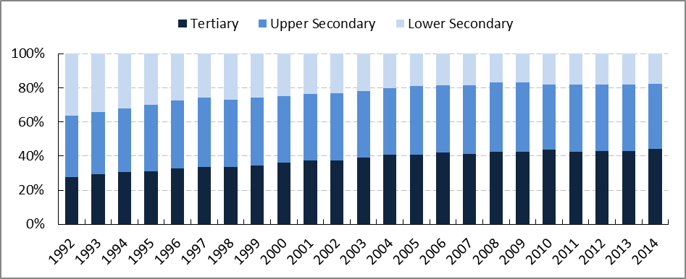Notes: European Labour Force Survey, own illustration based on Eurostat data, edat_lfse_05, edat_lfse_06, edat_lfse_07, accessed 21.05.2015

Figure A3 Highest levels of educational attainment, 25-34 year olds, Denmark, 1992-2014 (%)
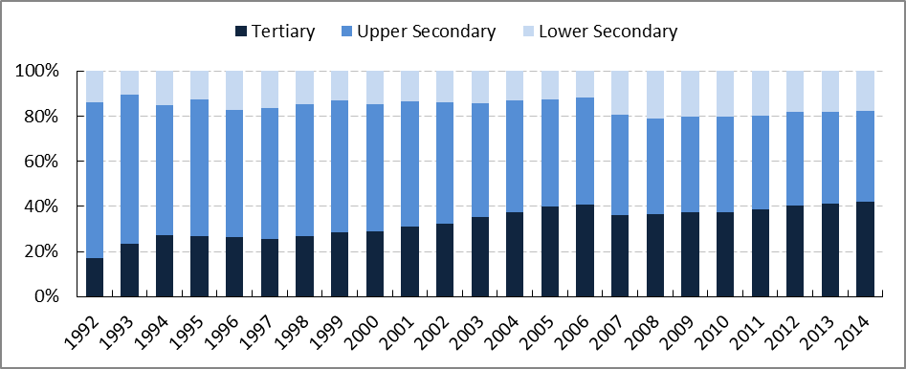
Notes: European Labour Force Survey, own illustration based on Eurostat data, edat_lfse_05, edat_lfse_06, edat_lfse_07, accessed 21.05.2015
Figure A4 Highest levels of educational attainment, 25-34 year olds, France, 1993-2014 (%)
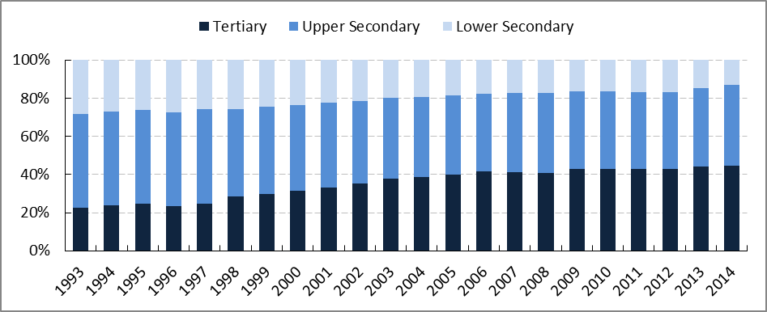
Notes: European Labour Force Survey, own illustration based on Eurostat data, edat_lfse_05, edat_lfse_06, edat_lfse_07, accessed 21.05.2015

Figure A5 Highest levels of educational attainment, 25-34 year olds, Germany, 1992-2014 (%)
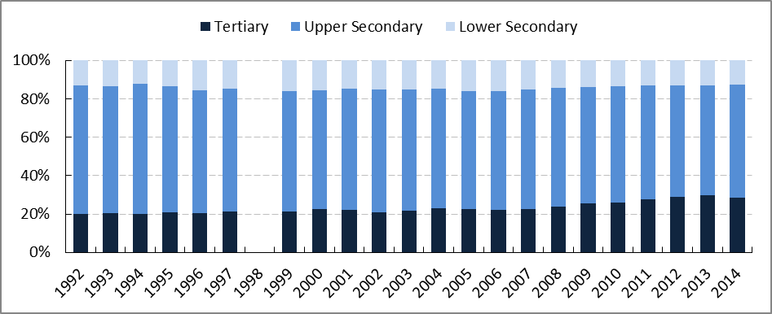
Notes: European Labour Force Survey, own illustration based on Eurostat data, edat_lfse_05, edat_lfse_06, edat_lfse_07, accessed 21.05.2015, data for 1998 missing
Figure A6 Highest levels of educational attainment, 25-34 year olds, Greece, 1992-2014 (%)
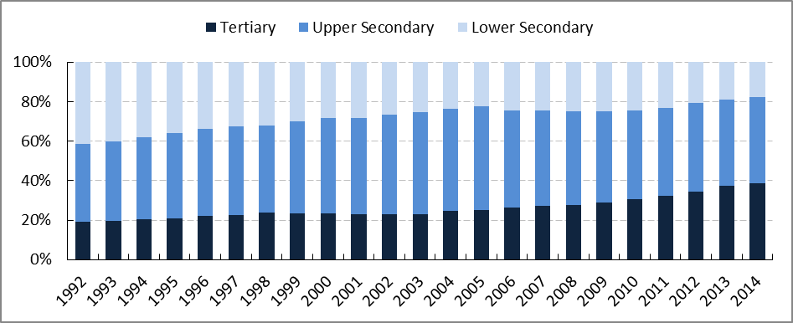
Notes: European Labour Force Survey, own illustration based on Eurostat data, edat_lfse_05, edat_lfse_06, edat_lfse_07, accessed 21.05.2015

Figure A7 Highest levels of educational attainment, 25-34 year olds, Italy, 1992-2014 (%)
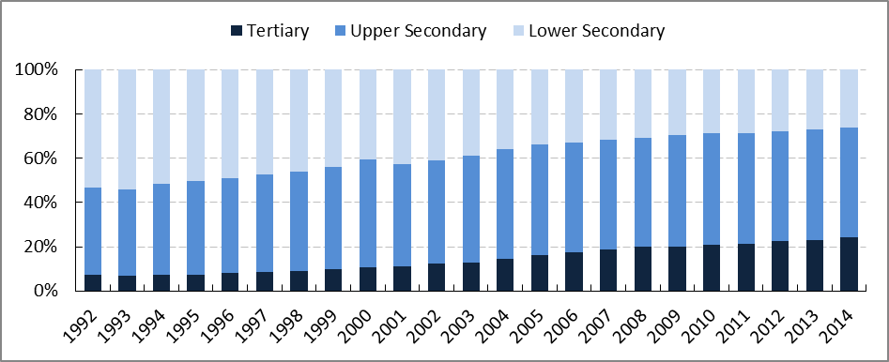
Notes: European Labour Force Survey, own illustration based on Eurostat data, edat_lfse_05, edat_lfse_06, edat_lfse_07, accessed 21.05.2015
Figure A8 Highest levels of educational attainment, 25-34 year olds, Luxembourg, 1992-2014 (%)
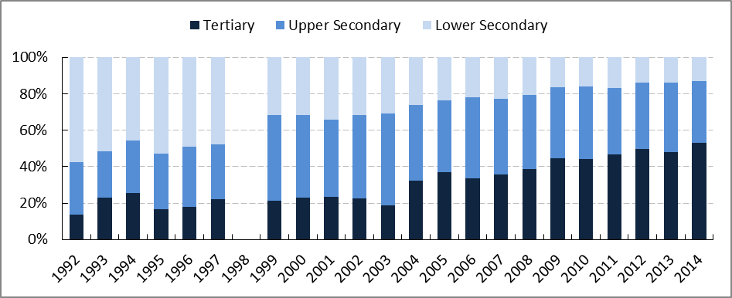
Notes: European Labour Force Survey, own illustration based on Eurostat data, edat_lfse_05, edat_lfse_06, edat_lfse_07, accessed 21.05.2015, data for 1998 missing

Figure A9 Highest levels of educational attainment, 25-34 year olds, Spain, 1992-2014 (%)
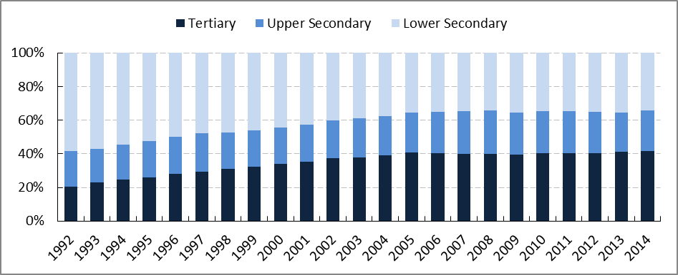
Notes: European Labour Force Survey, own illustration based on Eurostat data, edat_lfse_05, edat_lfse_06, edat_lfse_07, accessed 21.05.2015
Figure A10 Highest levels of educational attainment, 25-34 year olds, Portugal, 1992-2014 (%)
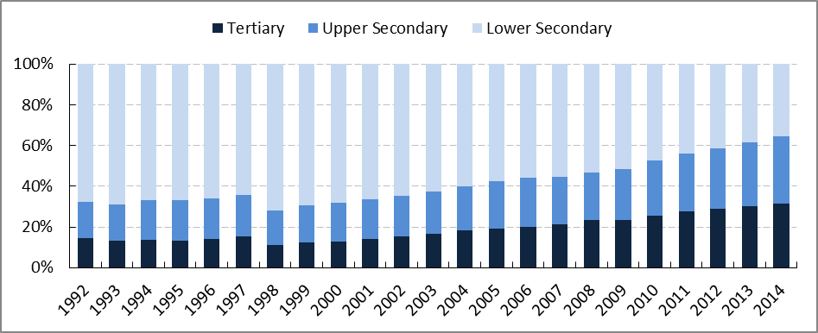
Notes: European Labour Force Survey, own illustration based on Eurostat data, edat_lfse_05, edat_lfse_06, edat_lfse_07, accessed 21.05.2015

Figure A11 Highest levels of educational attainment, 25-34 year olds, United Kingdom, 1992-2014 (%)
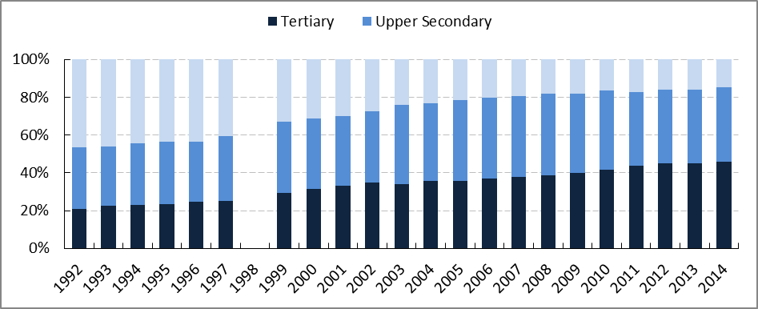
Notes: European Labour Force Survey, own illustration based on Eurostat data, edat_lfse_05, edat_lfse_06, edat_lfse_07, accessed 21.05.2015, data for 1998 missing

Countries for which data is available for 2004-2014

Figure A12 Highest levels of educational attainment, 25-34 year olds, Austria, 2004-2014 (%)
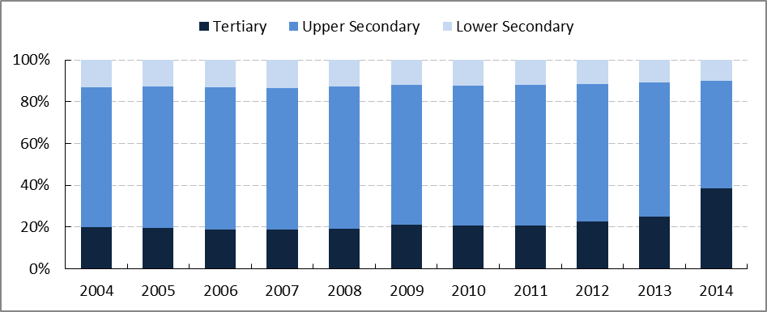
Notes: European Labour Force Survey, own illustration based on Eurostat data, edat_lfse_05, edat_lfse_06, edat_lfse_07, accessed 21.05.2015

Figure A13 Highest levels of educational attainment, 25-34 year olds, Bulgaria, 2004-2014 (%)
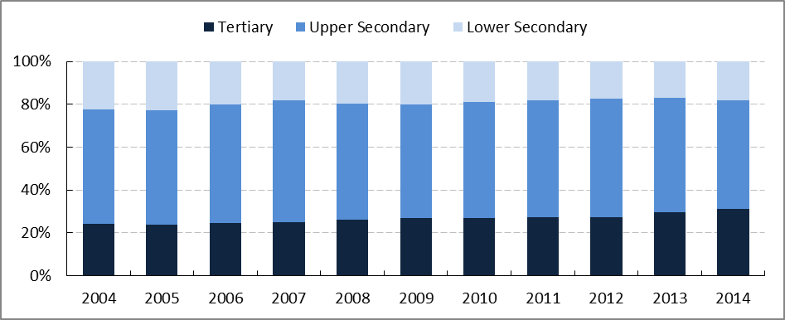
Notes: European Labour Force Survey, own illustration based on Eurostat data, edat_lfse_05, edat_lfse_06, edat_lfse_07, accessed 21.05.2015
Figure A14 Highest levels of educational attainment, 25-34 year olds, Croatia, 2004-2014 (%)
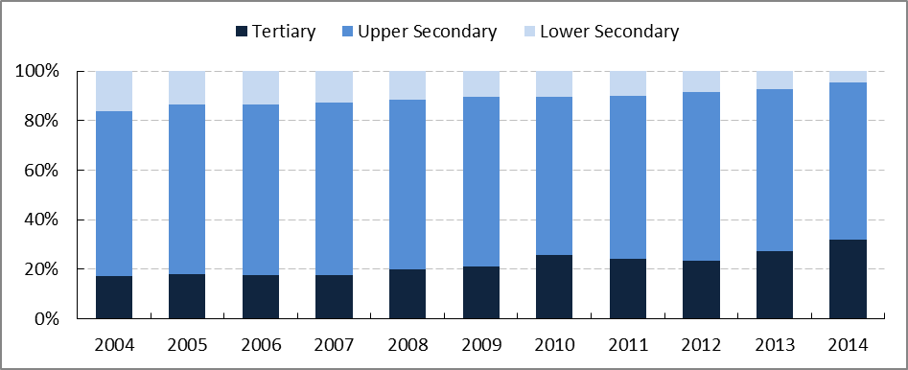
Notes: European Labour Force Survey, own illustration based on Eurostat data, edat_lfse_05, edat_lfse_06, edat_lfse_07, accessed 21.05.2015

Figure A15 Highest levels of educational attainment, 25-34 year olds, Cyprus, 2004-2014 (%)
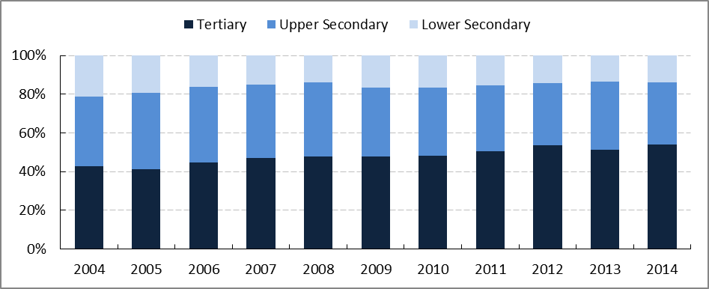
Notes: European Labour Force Survey, own illustration based on Eurostat data, edat_lfse_05, edat_lfse_06, edat_lfse_07, accessed 21.05.2015
Figure A16 Highest levels of educational attainment, 25-34 year olds, Czech Republic, 2004-2014 (%)
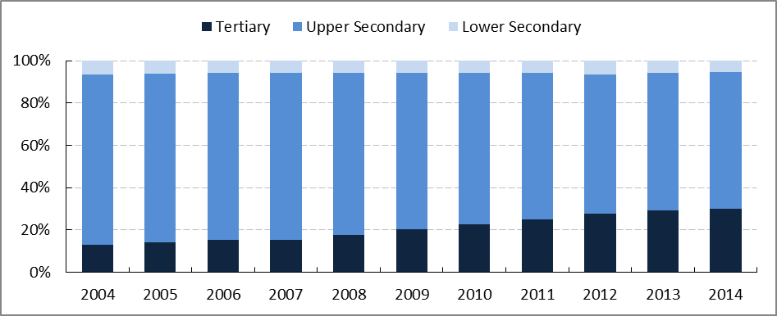
Notes: European Labour Force Survey, own illustration based on Eurostat data, edat_lfse_05, edat_lfse_06, edat_lfse_07, accessed 21.05.2015

Figure A17 Highest levels of educational attainment, 25-34 year olds, Estonia, 2004-2014 (%)
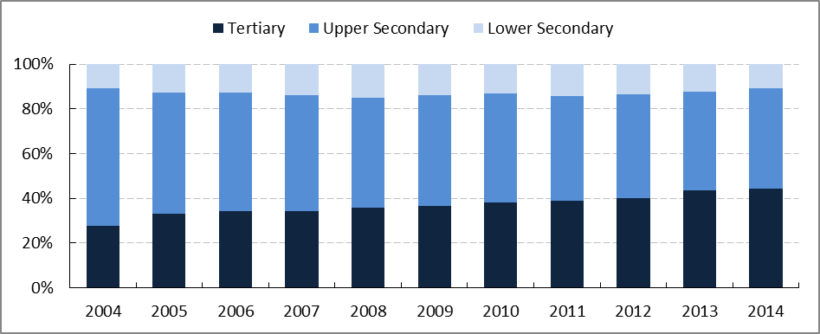Notes: European Labour Force Survey, own illustration based on Eurostat data, edat_lfse_05, edat_lfse_06, edat_lfse_07, accessed 21.05.2015
Figure A18 Highest levels of educational attainment, 25-34 year olds, Finland, 2004-2014 (%)
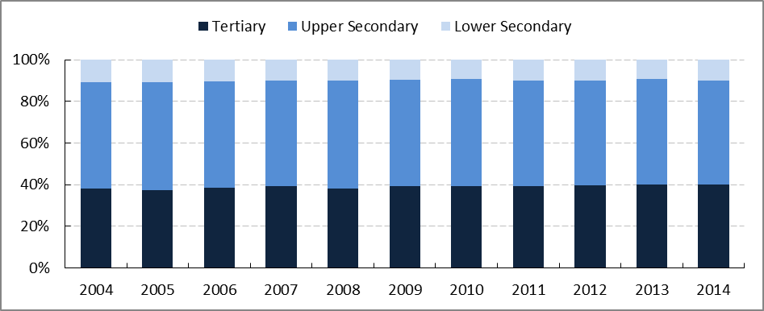
Notes: European Labour Force Survey, own illustration based on Eurostat data, edat_lfse_05, edat_lfse_06, edat_lfse_07, accessed 21.05.2015

Figure A19 Highest levels of educational attainment, 25-34 year olds, Hungary, 2004-2014 (%)
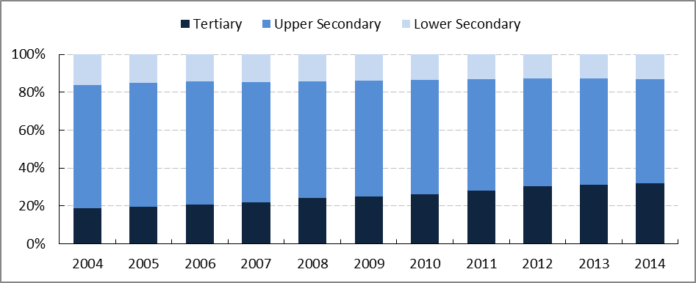
Notes: European Labour Force Survey, own illustration based on Eurostat data, edat_lfse_05, edat_lfse_06, edat_lfse_07, accessed 21.05.2015

Figure A20 Highest levels of educational attainment, 25-34 year olds, Ireland, 2004-2014 (%)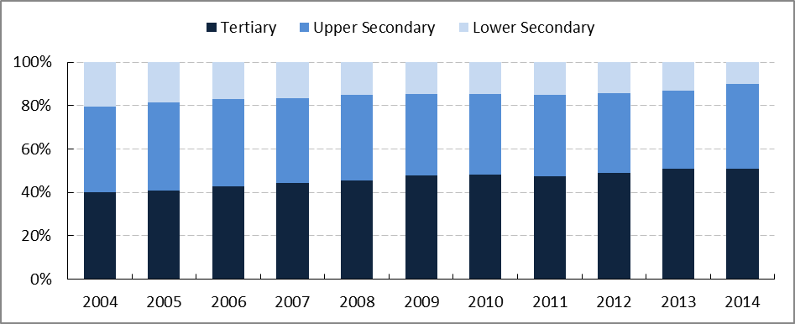Notes: European Labour Force Survey, own illustration based on Eurostat data, edat_lfse_05, edat_lfse_06, edat_lfse_07, accessed 21.05.2015

Figure A21 Highest levels of educational attainment, 25-34 year olds, Latvia, 2004-2014 (%)
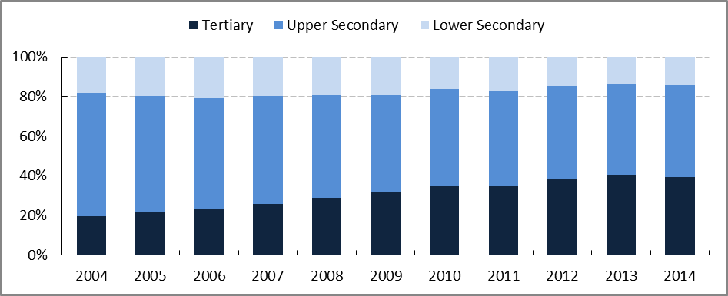
Notes: European Labour Force Survey, own illustration based on Eurostat data, edat_lfse_05, edat_lfse_06, edat_lfse_07, accessed 21.05.2015
Figure A22 Highest levels of educational attainment, 25-34 year olds, Lithuania, 2004-2014 (%)
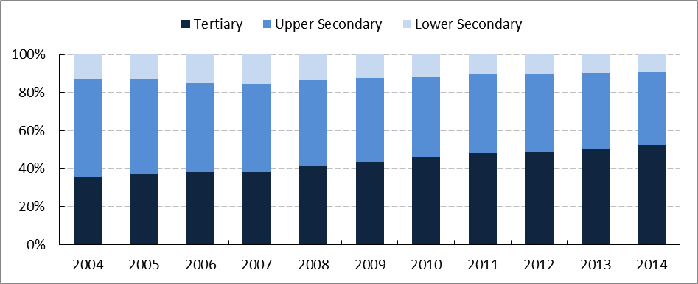
Notes: European Labour Force Survey, own illustration based on Eurostat data, edat_lfse_05, edat_lfse_06, edat_lfse_07, accessed 21.05.2015

Figure A23 Highest levels of educational attainment, 25-34 year olds, Malta, 2004-2014 (%)
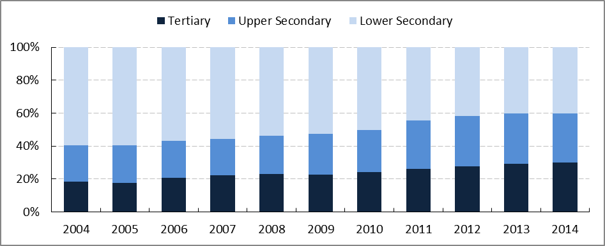
Notes: European Labour Force Survey, own illustration based on Eurostat data, edat_lfse_05, edat_lfse_06, edat_lfse_07, accessed 21.05.2015
Figure A24 Highest levels of educational attainment, 25-34 year olds, Netherlands, 2004-2014 (%)
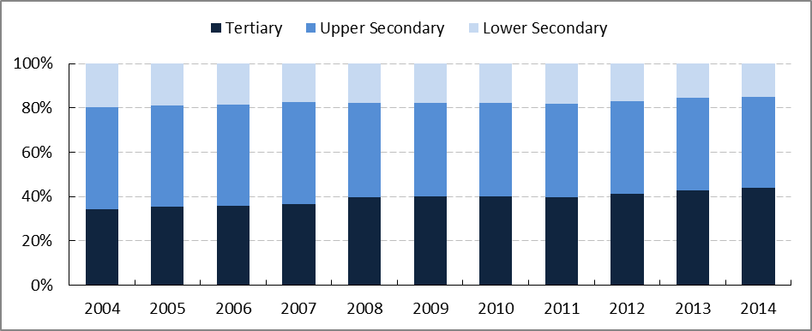
Notes: European Labour Force Survey, own illustration based on Eurostat data, edat_lfse_05, edat_lfse_06, edat_lfse_07, accessed 21.05.2015

Figure A25 Highest levels of educational attainment, 25-34 year olds, Poland, 2004-2014 (%)
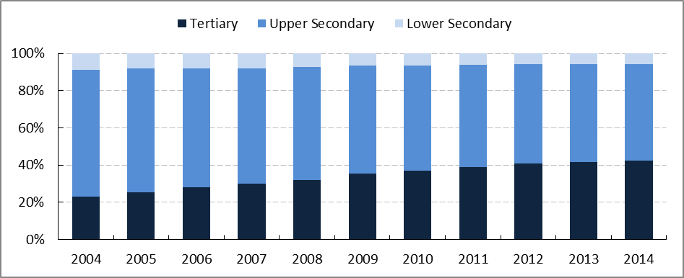
Notes: European Labour Force Survey, own illustration based on Eurostat data, edat_lfse_05, edat_lfse_06, edat_lfse_07, accessed 21.05.2015
Figure A26 Highest levels of educational attainment, 25-34 year olds, Romania, 2004-2014 (%)
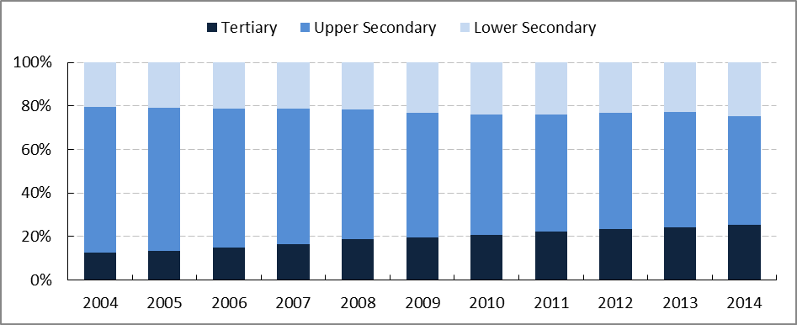
Notes: European Labour Force Survey, own illustration based on Eurostat data, edat_lfse_05, edat_lfse_06, edat_lfse_07, accessed 21.05.2015

Figure A27 Highest levels of educational attainment, 25-34 year olds, Slovenia, 2004-2014 (%)
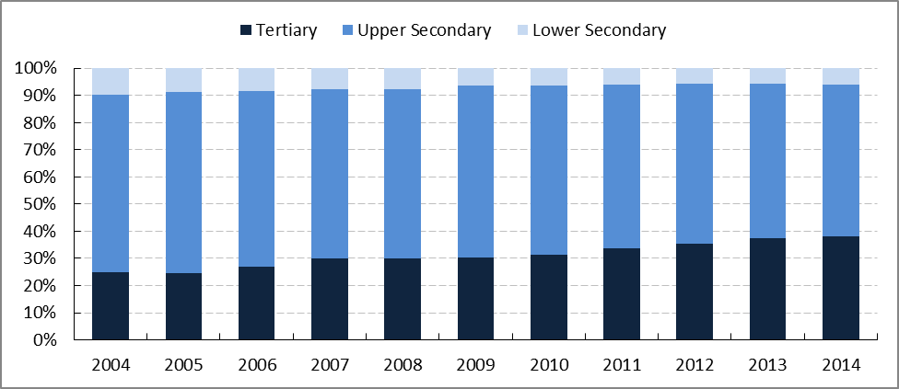
Notes: European Labour Force Survey, own illustration based on Eurostat data, edat_lfse_05, edat_lfse_06, edat_lfse_07, accessed 21.05.2015
Figure A28 Highest levels of educational attainment, 25-34 year olds, Slovakia, 2004-2014 (%)
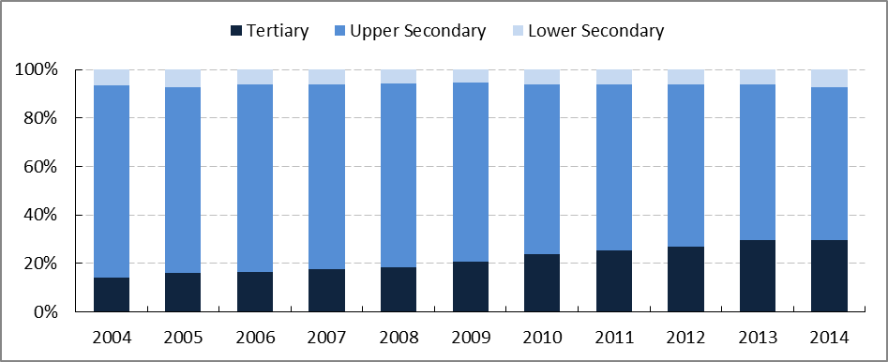
Notes: European Labour Force Survey, own illustration based on Eurostat data, edat_lfse_05, edat_lfse_06, edat_lfse_07, accessed 21.05.2015

Figure A29 Highest levels of educational attainment, 25-34 year olds, Sweden, 2004-2014 (%)
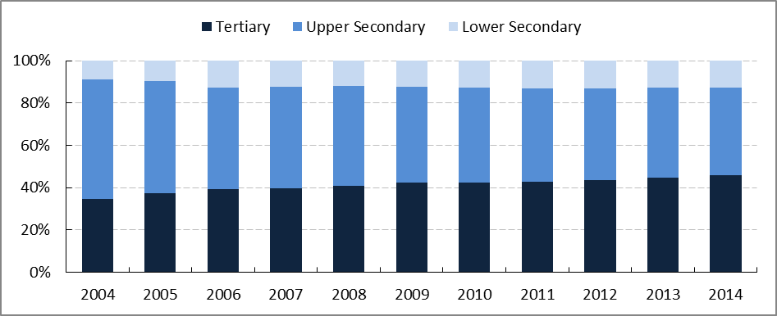
Notes: European Labour Force Survey, own illustration based on Eurostat data, edat_lfse_05, edat_lfse_06, edat_lfse_07, accessed 21.05.2015

Annex V – Variables considered for the empirical model Chapter Five
Table A3 Variables considered for the final empirical model and final variable selection
Dimension | Variable | Included in the final model
School inputs/ Education | Level of higher education achieved by area of study | No
School inputs/ Education | Currently in education | Yes
School inputs/ Education | Current level of education achieved (area of study) | No
School inputs/ Education | Highest level of education obtained by number of years imputed | No
School inputs/ Education | If highest level of education obtained is vocationally oriented or not | No
School inputs/ Education | Highest level of formal education obtained (7 ISCED categories) | Yes
School inputs/ Education | Participation in formal education in the last 12 months | No
School inputs/ Education | Participation in adult education | No
School inputs/ Education | Participation in non formal education in the last 12 months | No
School inputs/ Education | Being a NEET | No
Family/ Socio-Demographic Characteristics | Highest level of education achieved by mother or father | Yes
Family/ Socio-Demographic Characteristics | Test language same as language spoken most often at home | Yes
Family/ Socio-Demographic Characteristics | Parent’s immigration status | No
Family/ Socio-Demographic Characteristics | Respondent is first or second generation immigrant | Yes
Family/ Socio-Demographic Characteristics | Numbers of years in country | No
Family/ Socio-Demographic Characteristics | Self-reported health status | Yes
Family/ Socio-Demographic Characteristics | Age | Yes
Family/ Socio-Demographic Characteristics | Gender | Yes
Work Experience | Current work status – last year in paid work | No
Work Experience | Current work status - Years of paid work | Yes
Work Experience | Occupational classification of respondent’s occupation | Yes

Annex VI – Additional tables Chapter Five
Table A4 Null model, null model with fixed-effects, individual background factor model and country fixed effects model, dependent variable: Log literacy skill score
 | M1 | M2 | M3 | M4
School/Education effects
Tertiary educational attainment (D) | 0.091*** | 0.094*** | 0.056*** | 0.058***
(compared to upper secondary attainment) | (0.009) | (0.009) | (0.005) | (0.005)
Lower secondary educational attainment (D) | -0.146*** | -0.135*** | -0.093*** | -0.088***
(compared to upper secondary attainment) | (0.008) | (0.008) | (0.004) | (0.004)
Still in education (D) |  |  | 0.053*** | 0.052***
 |  |  | (0.006) | (0.006)
Family/Socio-demographic characteristics
Gender (male) |  |  | 0.013*** | 0.014***
 |  |  | (0.003) | (0.003)
Age 30-34 (D) |  |  | -0.008 | 0.004
(compared to 20-24 year olds) |  |  | (0.008) | (0.007)
Age 25-29 (D) |  |  | -0.003 | 0.005
(compared to 20-24 year olds) |  |  | (0.006) | (0.005)
At least one parent has attained tertiary education (D) |  |  | 0.072*** | 0.056***
(compared to neither parent having attained upper secondary) |  |  | (0.007) | (0.007)
At least one parent has attained upper secondary and post-secondary (non tertiary) (D) |  |  | 0.03*** | 0.021***
(compared to neither parent having attained upper secondary) |  |  | (0.007) | (0.006)
Test language same as home (D) |  |  | 0.063*** | 0.064***
 |  |  | (0.016) | (0.016)
No migrant background (D) |  |  | 0.09*** | 0.095***
(compared to first generation migrants) |  |  | (0.007) | (0.005)
2nd generation immigrants (D) |  |  | 0.06*** | 0.050***
(compared to first generation migrants) |  |  | (0.0115) | (0.00891)
Health status (Low -1 to High-5) |  |  | 0.004 | 0.005**
 |  |  | (0.003) | (0.002)

 | M1 | M2 | M3 | M4
Work experience
Number of years of paid work |  |  | 0.001 | 0
 |  |  | (0.001) | (0.001)
Skilled occupations (D) |  |  | 0.064*** | 0.063***
(compared to elementary occupations) |  |  | (0.007) | (0.005)
Semi-skilled white collar occupation (D) |  |  | 0.031*** | 0.033***
(compared to elementary occupations) |  |  | (0.006) | (0.005)
Semi-skilled blue collar occupation (D) |  |  | -0.014 | -0.011
(compared to elementary occupations) |  |  | (0.01) | (0.01)
Country FE | No | Yes | No | Yes
Constant | 5.607*** | 5.625*** | 5.376*** | 5.399***
 | (0.01) | (0.002) | (0.016) | (0.016)
N | 26,927 | 26,927 | 23,343 | 23,343
Number of countries | 16 | 16
R2 overall | 0.192 | 0.217 | 0.323 | 0.341
Adj-R2 | 0.192 | 0.216 | 0.322 | 0.34
Robust standard errors in parentheses, *** p<0.01, ** p<0.05, * p<0.1

Annex VII – Additional tables and information Chapter Six
Table A5 Relative position of countries with regards to average scores in PISA and PIAAC, quintiles
 | Reading age 15 (quint) | Literacy age 27 (quint) | Change over pseudo-cohorts | Math age 15 (quint) | Numeracy age 27 (quint) | Change over pseudo-cohorts
AT | 3 | 3 | 0 | 3 | 4 | 1
BE  (Flanders) | 5 | 4 | -1 | 5 | 5 | 0
CA | 5 | 4 | -1 | 4 | 3 | -1
CZ | 2 | 3 | 1 | 2 | 3 | 1
DE | 1 | 3 | 2 | 1 | 3 | 2
DK | 2 | 3 | 1 | 3 | 4 | 1
EN | 4 | 2 | -2 | 4 | 2 | -2
ES | 1 | 1 | 0 | 1 | 1 | 0
FI | 5 | 5 | 0 | 4 | 5 | 1
FR | 3 | 2 | -1 | 3 | 2 | -1
IR | 4 | 1 | -3 | 2 | 1 | -1
IT | 1 | 1 | 0 | 1 | 2 | 1
JP | 4 | 5 | 1 | 5 | 5 | 0
KR | 4 | 4 | 0 | 5 | 3 | -2
N IR | 3 | 1 | -2 | 4 | 1 | -3
NL | 5 | 5 | 0 | 5 | 4 | -1
NO | 2 | 4 | 2 | 2 | 4 | 2
PL | 1 | 1 | 0 | 1 | 2 | 1
SE | 3 | 5 | 2 | 3 | 5 | 2
US | 2 | 2 | 0 | 2 | 1 | -1
Notes: own analysis based on PISA and PIAAC data

Table A6 Tested country level variables in the multi-level analysis, detailed sources, significance
A41

A42
A43

Further notes on the multi-level analysis
As highlighted in Chapter Five of the report, the theoretical model suggests country-specific effects of qualification levels on educational outcomes. PIAAC contains data on individuals nested within country contexts, i.e. clusters. The standard regression model assumes that individuals are independent from each other and that the regression residuals are independent from each other. This assumption is not fulfilled when individuals are clustered in country contexts. The key challenge to model relationships in this setting appropriately revolves around how to model outcome differences between and within clusters (Bryan and Jenkins 2013:2).
There is a vivid debate on how best to model relationships of interest in this context, both amongst econometricians (who discuss this issue in the context of panel data methods) and social scientists (who discuss this issue in the context of multilevel methods). The feasibility of different specifications crucially depends on the structure of the data, e.g. if sampling weights have to be applied as in this case, the number of ‘missing values’ in different categories and the number of variables to be included in the model.
In the context of this report, we ran a set of different fixed-effect and random-effects models. Under fixed-effects models, we understand models in which only the intercept of the regression varies across countries, but not the slope of the regression. Under random-effects, we understand models in which both the intercept of the regression and the slope varies between countries. It is important that we do not mean random effects, as frequently defined in panel data methodology, as effects, which assumed that the residuals are not correlated with the predictor variables, as this is theoretically and empirically unlikely to be the case here.
Both models are applied in settings in which individuals are nested in countries, with the difference that the random-effects approach aims to explain country level variation, while the fixed-effects approach controls for this variation. Random-effects models are in principle the preferred model for nested data, as they allow investigating if the level of the effect and the strength of an effect varies across countries. However, RE models have limited explanatory power when there is only a small number of macro level units, i.e. countries, (<25), as is the case in the PIAAC survey. This implies that these models have few degrees of freedom, i.e. one can only control for a limited set of macro-level indicators, e.g. school system characteristics at one time, which may cause biases. FEA can be used even with a small number of cases and is able to control for country level characteristics by including dummy variables and interaction effects.
Our final specification for both the FE and RE models of which results are presented in this report was an OLS regression, with robust standard errors by country clusters. This option was selected as it can include the sample weights, worked well computationally and seemed to generate reasonable results. Additionally, we tested the following models, which we found to be less fruitful for our analysis:

Mixed multilevel models (STATA: xtmixed), which make use of maximum likelihood estimation, are powerful and robust. This worked well, however led to large standard errors and it was not possible to include the design weights of PIAAC in the specification.

Fixed-effects panel data models (STATA: xtreg, fe), which again could not be modelled with the necessary design weights.

Generalized Linear Latent and Mixed Models (GLLAMMS) (STATA: gllamm), which is a class of multilevel latent variable models. These have the advantage that weights could be used, but this option was computationally too intensive when more than 3 to 4 variables (as the case in our model) were included.
Results obtained through different specifications were not substantially different from those presented in this report.

HOW TO OBTAIN EU PUBLICATIONS
Free publications:
• one copy:
via EU Bookshop (http://bookshop.europa.eu);
• more than one copy or posters/maps:
from the European Union’s representations (http://ec.europa.eu/represent_en.htm);
from the delegations in non-EU countries (http://eeas.europa.eu/delegations/index_en.htm);
by contacting the Europe Direct service (http://europa.eu/europedirect/index_en.htm) or
calling 00 800 6 7 8 9 10 11 (freephone number from anywhere in the EU) (*).
(*) The information given is free, as are most calls (though some operators, phone boxes or hotels may charge you).
Priced publications:
• via EU Bookshop (http://bookshop.europa.eu).



ISBN: 978-92-79-50996-4

In this report any reference to the education level of ‘upper secondary education’ includes post-secondary non-tertiary education unless specified otherwise.
The partial effect is the effect of an independent/control variable, here educational attainment, on a dependent/outcome variable, here competences as assessed through PIAAC, while controlling for other factors.
³ Australia, Austria, Belgium (only Flanders), Canada, Cyprus, the Czech Republic, Denmark, Estonia, Finland, France, Germany, Ireland, Italy, Japan, Korea, the Netherlands, Norway, Poland, Russia, The Slovak Republic, Spain, Sweden, the United Kingdom (only England and Northern Ireland) and the United States.
Eurostat website, http://ec.europa.eu/eurostat/cache/metadata/en/edat_esms.htm, indicators edat_lfse_05, edat_lfse_06, edat_lfse_07, (accessed 29.06.2015)
ibid
Data prior to 2014 also includes ISCED 3C short, which refer to ISCED level 3 educational programmes of under two years duration.
Data prior to 2014 is coded following the ISCED 1997 classification, including ISCED levels 3A, 3B, 3C long and 4.
Data prior to 2014 is coded following the ISCED 1997 classification, including levels 5 and 6.
Early school leavers are defined as those young people aged 18-24 who have left school prior to completing upper secondary education (whether general or vocational)
Who went through upper secondary education approximately between 1980 and 1995.
Who went through upper secondary education approximately between 1995 and 2010.
Includes only England and Northern Ireland for PIAAC
Includes only England and Northern Ireland in PIAAC
Primary education is here not analysed separately due to small sample sizes in this category.
EU-16 average is a non-weighted average; all Member States are given the same weight.
The gap to lower secondary is selected here instead of the gap to primary due to the generally low precision of the estimates for those with only primary education.
EU-16 average is a non-weighted average; all Member States are given the same weight.
Derived variable included in the PIAAC dataset based on ISCO classification.
Please note that this ‘gain’ should not be interpreted as the causal effect of educational attainment oncompetences, as highlighted in Section 5.3.2 above.
This is an approximation. The correct conversion into percentage would be equivalent to exp(coefficient)-1.
It should be noted that the applied methodology implies a comparison of average competence levels of young people at different levels of educational attainment. While this implies that results have an easily understandable and intuitive interpretation, it is vulnerable to outliers. Future research could explore the application of quintile regression to circumvent this potential bias.
This is an approximation. The correct conversion into percentage would be equivalent to exp(coefficient)-1.
Hanushek and Woessman also find a correlation at 0.86 in both math and science across the 21 countries participating both in the TIMSS 1999 tests and the PISA 2000/02 tests (Hanushek and Woessman 2010).
Theoretical limitations and data availability make it very likely that some relevant factors are omitted in our analysis. Given these limitations, an OLS estimator or a simple mean comparison of proficiency at age 27 are likely to be biased as they do not take into account systematic differences between countries at the beginning of upper secondary phase. The advantage of the DID estimator is that it controls for omitted systematic (time-constant) factors that are likely to affect the outcome over and above the impact of the independent variable.
Denmark could be considered a borderline case because up to 30% of young people take a form of apprenticeship, but many of the apprentices are not on traditional apprentice contracts as in Dual System apprenticeships.
See Eurostat data at: http://epp.eurostat.ec.europa.eu/statistics_explained/index.php/School_enrolment_and_early_leavers_from_education_and_training
The Trends in International Maths and Science Study (TIMSS), targeting 4th and 8th grade students in 2003, 2007 and 2011, was preceded by the Third International Maths and Science Study (also known as TIMSS) which focussed on 9, 13 and 18 year olds in 1995 and was repeated with 13 year olds in 1999. Preceding these were the first and second international maths studies in 1964 (FIMS) and 1980 (SIMS) and the first and second international science studies in 1970 (FISS) and in 1983 (SISS). Both of these targeted 10 and 14 year old students.
Chart C1.4 in OECD, Education at a Glance, 2001, p. 131
In the case of England, we exclude those whose highest qualification has classified as ISCED 3C (≥2), since this category includes many qualifications, like GCSEs, GNVQ Intermediate, BTEC First, NVQ 2 and City and Guilds Level 2, which can either be taken during lower secondary education, or require less than two years of full upper secondary education. For other countries in the survey, qualifications classified to ISCED 3 C (≥2) include only those for which the earliest age of completion is 17 or 18 years, whereas for England the minimum age at which the above qualification can be gained is noted (correctly) as 16 years.
From: OECD (2000), Education and a Glance, dataset athttps://stats.oecd.org/Index.aspx?DataSetCode=RENRL
Skills inequality in the non-migrant 16-65 population is negatively and quite strongly correlated with average levels of skills in the OECD Survey of Adult Skills data. The Pearson correlation coefficients are -0.64 in case of literacy and -0.78 in case of numeracy and are both significant at the 0.001 level.
Above 65 only available for ISCED 0-2
‘Pseudo-cohort’ as it mimics actual cohort analysis, for example the one conducted by the Danish National Centre for Social Research, which tested young people who took part in PISA in 2000 as 15-year olds, 11 years later using PIAAC to determine competence development beyond age 15.
After the inclusion of N – 1 country dummies, the country dummies explain all the variance at the country level, and there is no variance left to be explained by additional country-level variables. Instead of modelling the direct effect of country variables, the FEA includes the interaction between those variables and individual variables. Therefore, FEA is suitable to assess the extent to which an individual phenomenon, such the association between competences and formal qualifications, varies by country-level system characteristics, taking into account the country-level heterogeneity. The moderator effect of macro-level characteristics can be estimated using cross-level interaction effects.

