Article
Miocene Seep-Carbonates of the Northern Apennines (Emilia to Umbria, Italy): An Overview
Stefano Conti ¹, Claudio Argentino ², Chiara Fioroni ¹, Aura Cecilia Salocchi ¹ and Daniela Fontana ^{1,}*
¹ Department of Chemical and Geological Sciences, University of Modena and Reggio Emilia, 41125, Modena, Italy; stefano.conti@unimore.it (S.C.); chiara.fioroni@unimore.it (C.F.); aura.salocchi@gmail.com (A.C.S.)
² CAGE—Centre for Arctic Gas Hydrate, Environment and Climate, Department of Geosciences, UiT the Arctic University of Norway, 9037 Tromsø, Norway; claudio.argentino@uit.no
* Correspondence: daniela.fontana@unimore.it
Citation: Conti, S.; Argentino, C.; Fioroni, C.; Salocchi, A.C.; Fontana, D. Miocene Seep-Carbonates of the Northern Apennines (Emilia to Umbria, Italy): An Overview. Geosciences 2021, 11, x. https://doi.org/10.3390/xxxxx
Received: 23 December 2020
Accepted: 25 January 2021
Published: date
Publisher’s Note: MDPI stays neutral with regard to jurisdictional claims in published maps and institutional affiliations.

Copyright: © 2021 by the authors. Licensee MDPI, Basel, Switzerland. This article is an open access article distributed under the terms and conditions of the Creative Commons Attribution (CC BY) license (http://creativecommons.org/licenses/by/4.0/).
Abstract: The natural emission of methane-rich fluids from the seafloor, known as cold seepage, is a widespread process at modern continental margins. The studies on present-day cold seepages provide high-resolution datasets regarding the fluid plumbing system, biogeochemical processes in the sediment, seafloor seepage distribution and ecosystems. However, the long-term (hundreds of thousands to millions of years) evolution of cold seepage remains elusive. The identification and study of outcrop analogous now exposed on land represent a valuable method for better understanding the effects of geological processes and climate forcing on the development of cold seepage systems. Here, we provide an overview on Miocene seep-carbonate deposits of the northern Apennines (from Emilia to the Umbria-Marchean sector, Italy), based on decades of field research integrated with detailed sedimentological and geochemical investigations. We report a total of 13 seep-carbonate outcrops, which formed in three different structural settings of the paleo-accretionary wedge corresponding to wedge-top basins, outer slope and intrabasinal highs at the deformational front. We discuss the recurring lithostratigraphic occurrence of seep deposits and the main compositional features (carbonate facies, carbon and oxygen stable isotopes) in order to interpret the seepage dynamics, duration and infer the contribution of methane-rich fluids released by paleo-gas hydrates. The datasets presented in this study represent a valuable complete record of cold seepage spanning ~12 Myr, that can be used to better understand factors controlling the regional-scale spatial and temporal evolution of cold seepage systems at modern active continental margins.
Keywords: seep-carbonates; cold seepage; Miocene; northern Apennines; accretionary wedge

1. Introduction
The seepage of methane-rich fluids at the seafloor, also known as cold seeps, has been frequently observed in accretionary wedges, where active tectonics generate pore-fluid overpressures and induce fluid migration through the sediments [1–5]. Cold seepage along the slope of continental margins is often associated with a large variety of sedimentary processes (e.g., landslides, mud volcanism, diapirism) and fluid escape structures (e.g., pockmarks, carbonate mounds) [6–10].
Due to the fluxes of reduced carbon and sulfur compounds reaching the seafloor, these environments are inhabited by peculiar microbial consortia and chemosymbiotic macrofaunal assemblages [11–16] and marked by specific geochemical imprinting [17,18]. Fossil analogous to modern systems have been recognized in exposed sedimentary successions on all continents (except Antarctica) and have allowed the investigation of the long-term evolution of hydrocarbon seepage in relation to tectonic processes and climate change [12]. Spectacular seep-carbonate examples have been reported from Miocene outer shelf and upper slope deposits at Hikurangi Margin, New Zealand [10,19,20] and in Cretaceous deposits linked to cold seepage in forebulge setting (Tepee Buttes carbonate mounds) cropping out in Colorado, USA. [21]. It is worth mentioning the well-exposed and widely-studied Mesozoic seep deposits in the shelf and fore-arc successions of Japan

[22], and seep carbonates in Oligocene flysch related to foreland basins of the Outer Carpathians, Poland [23]. The global sedimentary record of cold seepage provided statistical evidence for the fact that sea-level forcing and rates of organic carbon burial in ocean basins have been the main factors controlling overall seepage activity since the early Cretaceous [24], resulting in cycles with periodicity in the order of tens of Myr.
Fossil seeps have been widely reported from the Italian Apennine chain, in the form of seep-carbonate outcrops, and mostly hosted in Miocene successions [25]. These deposits are historically known under the informal lithostratigraphic name of Calcari a Lucina, as they include densely-packed large lucinid bivalves [26]. These authigenic carbonates are characterized by very negative δ¹³C values (<−30‰ VPDB), peculiar chemosynthetic fauna (vesicomyid and lucinid clams, bathymodiolid mussels) and distinctive carbonate facies related to fluid expulsion processes [27,28], and testify a long history of cold seepage during the Neogene building phase of the Apennine chain. Seep-carbonate precipitation and fluid expulsion processes occurred in different tectonic settings of the Apennine foreland, from wedge-top basins through the outer slope of the accretionary prism, and at the leading edge of the deformational front in the inner foredeep, in correspondence of fault-related anticlines. Outcrop distribution highlights a causal relationship between tectonics and seepage occurrence. Recent studies also showed that some seep deposits could have originated during sea-level low-stands [29–31] and from gas hydrate destabilization events [32,33].
In this paper we provide an overview of the main geochemical, sedimentological and stratigraphical features of the northern Apennine seep-carbonates located in the Emilia to Umbria-Marchean area (Figure 1), included in Burdigalian to Messinian successions. The extraordinary dataset reported here, covers ~10,000 km² area and the examined carbonate outcrops are representative of different structural settings along the paleo-Apennine wedge, thus serving as a record of the regional-scale spatial and temporal evolution of cold seepage systems which can be used to better understand analogous systems in other modern convergent geo-settings.
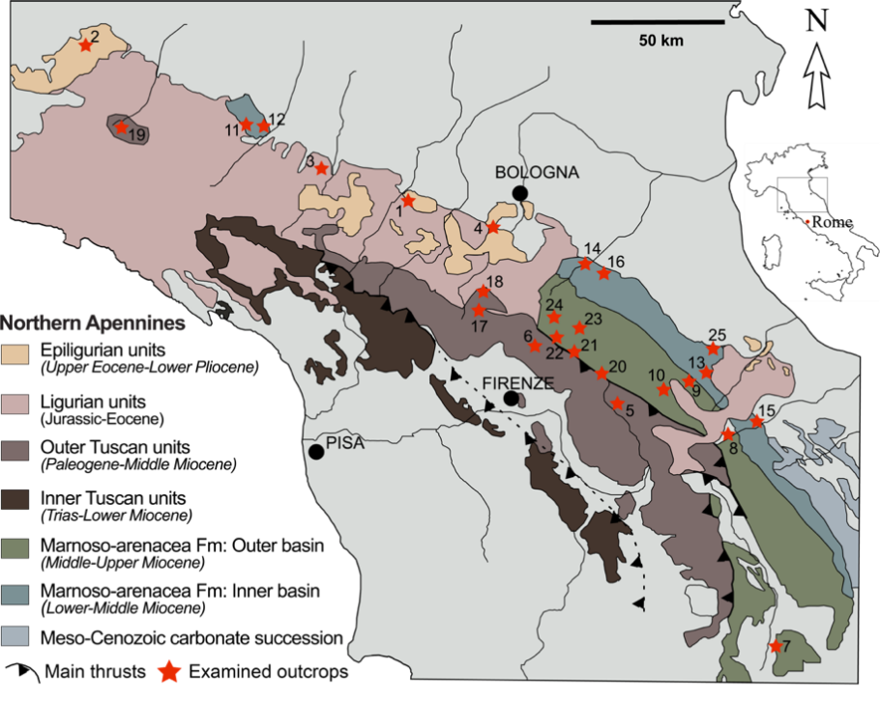
Figure 1. Simplified geological map of the studied area in the northern Apennines. Numbers refer to the examined and correlatable outcrops. 1. Montebaranzone; 2. Cappella Moma; 3. Traversetolo; 4. Lavino Valley; 5. Moggiona; 6. Fosso Riconi; 7. Deruta; 8. Poggio Campane; 9. S. Sofia-S. Vernicio; 10. S. Sofia-Case Buscarelle; 11. Salsomaggiore-Case Gallo; 12. Salsomaggiore-Case Cagnotti-Zappini; 13. Montepetra; 14. Le Lame-Pietralunga; 15. Caresto; 16. Brisighella; 17. Brasimone–Suviana; 18. Poggio Michelino; 19. Telecchio; 20. Castagno d’Andrea-Corella; 21. Acquadalto (Podere Filetta-Monte Citerna); 22. Bibbiana-Le Fogare; 23. Colline-Mondera; 24. Prati Piani; 25. Case Bandirola.

2. Geological Setting
The northern Apennine chain results from the convergence and collision between the European and African plates, with the interposition of the Adria and Corsica-Sardinia microplates. During the early stages of the collision (late Oligocene), the internal oceanic units (Ligurides) were placed over the adjacent thinned margin of the continental Adria microplate, represented by Subligurian units [34]. From Miocene to Recent, the thrust system migrated towards the foreland, involving the continental Tuscan and Umbria-Marchean units deposited on the Adria microplate. This collisional stage involved the subduction of the Adria under the Corsica-Sardinia lithosphere coupled with the flexuring of the foreland and the formation of foredeep basins, progressively migrating towards the northeast [35,36].
The progressive migration of the foredeep produced a segmentation of its inner part [37] by the growing of anticlines on top of synsedimentary blind thrust faults, creating intrabasinal highs. Sedimentation on top of thrust-related anticlines consisted of hemipelagites and diluted turbidites (drape mudstones) forming up to a hundred meter thick fine-grained intervals. The structural evolution of these thrust-related anticlines created favorable conditions for gas accumulation and gas hydrate formation at the ridge crest, promoting the development of cold seepage systems and inducing sediment remobilization along the ridge flanks [28]. The progressive closure of the foredeep, with its involvement in the accretionary wedge (closure phase), is marked by the deposition of slope marls characterized by sediment instability due to the strong tectonic activity of the substrate [38]. Slope sedimentation is stopped by the overriding of the Ligurian units. During the overriding of the Ligurian units, from the Burdigalian to the early Tortonian, sedimentation also occurred in wedge-top basins (Epiligurian succession) at the top of the accretionary prism [39], and marked by intense seepage processes. Authigenic seep-carbonates in Upper Miocene sediments of the Tertiary Piedmont Basin are reported in [40,41].
The age of the Apennine successions becomes younger moving toward northeast, following the direction of wedge advancement and foredeep migration. In the Burdigalian, the closure of the Tuscan foredeep (filled by turbidites of the Falterona-Cervarola Fm) is followed by the deposition of fine-grained hemipelagites of the Vicchio Fm. During the Langhian, the newly formed foredeep is filled by the thick turbidite succession of the Marnoso-arenacea Fm (Umbro-Marchean units) partially sealed by the Verghereto Marls (late Serravallian-early Tortonian) and by the Ghioli di letto mudstones (late Tortonian-Messinian).

3. Structural Distribution of Apennine Seep-Carbonates
Miocene seep-carbonates occur in specific positions of the Apennine wedge-foredeep system, reported below from the inner to the outer sectors (Figure 2; Table 1):
(1) wedge-top basins: seep-carbonates mainly occurring in the Epiligurian units (Termina Fm), associated with diapiric processes;
(2) slope of the accretionary wedge, during two different tectonic phases of the foredeep closure: early phase. Seep-carbonates are hosted in fine-grained sediments draping buried ridges constituted by the older accreted turbiditic units [28]: final phase. Seep-carbonates are hosted in slope hemipelagites preceding the overriding of Ligurian units.
(3) inner foredeep, at the leading edge of the deformational front, in thrust-related anticlines (intrabasinal highs) standing above the seafloor. Seep-carbonates are hosted in fine-grained intervals deposited above these structures.
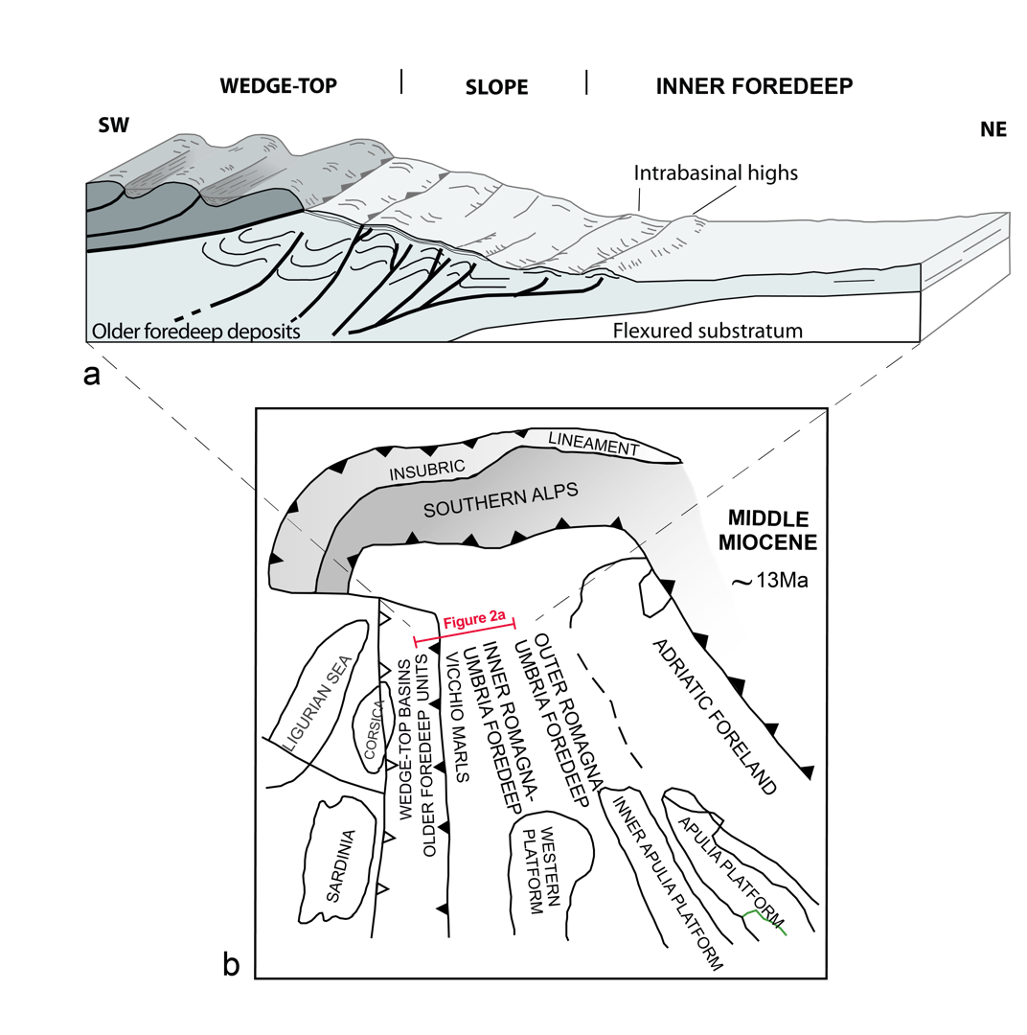
Figure 2. (a) Block diagram showing the northern Apennine wedge-foredeep system during the Miocene. Seep carbonates occurred in wedge-top basins, on the slope and in the inner foredeep basin. (b) Simplified paleogeographic sketch of the Apennine domains during the middle Miocene (modified from [26]).

GEO-SETTING | APENNINIC DOMAIN |  | OUTCROPS
WEDGE-TOP |  |  | Montebaranzone
 | Tuscan | early phase | Moggiona
 |  | final phase | Fosso Riconi
SLOPE | Umbria-Marchean | early phase | Deruta, Poggio Campane
 | inner basin | final phase | Santa Sofia
 | Umbria Marchean | early phase | Montepetra
 | outer basin | final phase | Brisighella,
 |  |  | Minor basins
INNER FOREDEEP | Tuscan |  | Brasimone-Suviana
INNER FOREDEEP | Umbria Marchean |  | Castagno, Corella, Acquadalto

Table 1. Structural distribution and paleogeographic domain of the examined outcrops (described in the text).
It is worth noting that the temporal/structural relationship between the slope and the foredeep is complicated by the migration of the accretionary wedge. This leads to the progressive incorporation of the foredeep units in the slope, and the creation of a new foredeep in a more external position.
In this work we report the location (Figure 1), morphology (Figure 3), facies (Figures 4 and 5), geochemistry (δ¹³C, δ¹⁸O; Figure 6) and stratigraphic distribution (Figure 7) of 13 seep-carbonate outcrops representative of the different geological settings (Table 1).

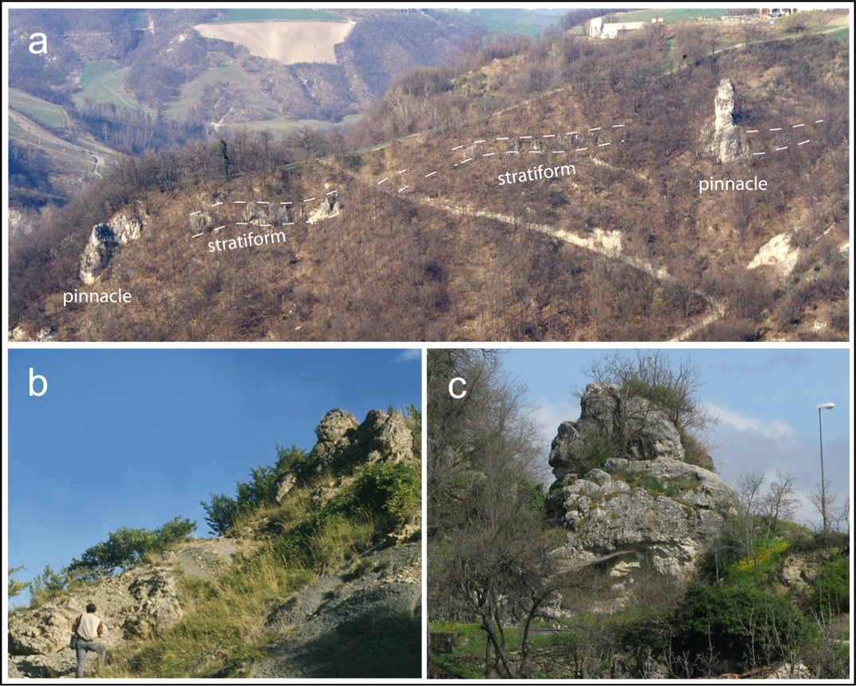
Figure 3. Seep-carbonate outcrops from the three examined geological settings. (a) Seep-carbonates hosted in the wedge-top basin (Termina Fm) in the Montebaranzone area (outcrop 1 in Figure 1), dotted line marks the geometry of the seep-carbonate bodies. (b) Castagno d’Andrea seep-carbonates enclosed in pelitic interval of the inner foredeep (Marnoso-arenacea Fm), (outcrop 20 in Figure 1). (c) Montepetra seep-carbonates hosted in slope fine-grained sediments (Ghioli di letto Fm), (outcrop 13 in Figure 1).

3.1. Wedge-Top Epiligurian Basins

Montebaranzone
Location. Emilia Apennines. Hundreds of seep-carbonate bodies crop out extensively between Parma and Bologna Apennines (Figure 1), enclosed within marly sediments of the Termina Fm (late Serravallian−early Messinian), made up of slope deposits up to 500 m thick. In the upper portion, the Termina Fm is represented by the Montardone mélange, a chaotic body made up of polygenic and heterometric blocks dispersed in a fine-grained matrix. Seep-carbonate deposits reach the maximum concentration in the Montebaranzone syncline (Modena area), associated with the Montardone mélange (for geological details see [42]).
Carbonate size and distribution. Seep-carbonates consist of stratiform bodies and large pinnacles with lateral extent from a few meters to 100 m and a maximum thickness of 25–30 m, mainly concentrated within a 50 m thick stratigraphic interval of slope marlstones. The lithologies are micritic limestones and calcareous marls, with wide portions of carbonate breccias. The contacts with the host sediment vary from sharp to transitional. Conversely, seep-carbonates occurring on the western side of the mélange consist of small and laterally isolated marly and marly-calcareous bodies, which exhibit a lenticular, domed, columnar to irregular shape. Their dimensions vary from a few tens of centimeters to 4–5 m; the lateral contact to enclosing sediment is gradual.
Seep-related facies. Polygenic breccias occur at the base of seep-carbonate bodies close to the contact with the Montardone mélange and form units of variable thickness from some centimeters to a few meters, often interdigitated with fine-grained carbonate cemented sediments. Polygenic breccias contain clasts of different dimensions and provenance, carbonate, arenitic and pelitic, chaotically floating in the micritic matrix. Extraformational clasts largely derive from the basal complex of the Ligurian units. Clasts are heterometric (from some millimeters to ~50 cm), generally angular (Figure 5a). Intraformational clasts are sourced from previously precipitated seep-carbonates and from the Termina marls. Disarticulated and isolated lucinid shells have been observed, as well as fragments of shells forming packstones or grainstones. Pseudo-fluidal textures and soft sediment deformations are observed. Dense localized semi-infaunal chemosynthetic fauna often in living position (mainly lucinid and vesicomyid bivalves) are present in the middle upper portions of the outcrops (Figure 4a). In thin section, authigenic minerals consist of micro- to cryptocrystalline micrite and sparry calcite with minor dolomite. Micrite is the dominant authigenic phase and includes abundant shell fragments, associated with planktonic foraminifera and terrigenous particles in variable amounts.
Carbon and oxygen isotopic composition. Carbon isotopic composition differs for various carbonate bodies and inside a single mass (δ¹³C from −39.1 to −18.2‰ VPDB), with the most negative δ¹³C values obtained in sparry calcite cement in the brecciated portions. Samples are significantly enriched in δ¹⁸O (δ¹⁸O between +0.3 and +5.5‰ VPDB); the δ¹⁸O composition reaches the maximum values in the brecciated portions, close to the contact with the Montardone mélange.
Biostratigraphy of host sediments. The interval hosting seep-carbonates has been ascribed to the Serravallian to early Tortonian based on planktonic foraminiferal assemblages (MMi7-MMi9 Biozone). The oldest ages (Serravallian) are recorded in eastern bodies closest to the vertical contact with the mélange.
Correlatable outcrops. Cappella Moma (δ¹³C from −19.0 to −16.0‰ VPDB; δ¹⁸O from +2.1 to +2.9‰) Traversetolo, Lavino Valley (Figure 1).
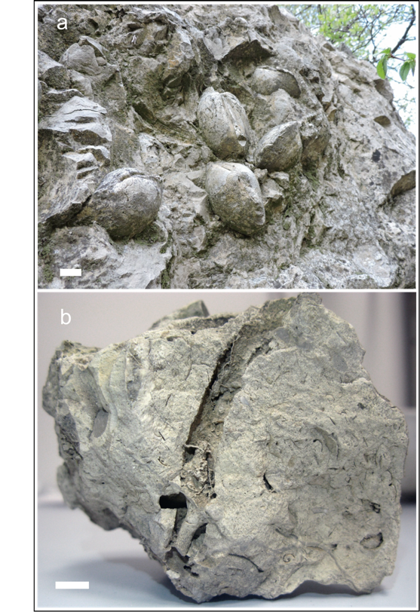
Figure 4. Representative seep-carbonate facies. (a) Densely packed articulated bivalves from the Sasso delle Streghe carbonate pinnacle (Montebaranzone area, outcrop 1 in Figure 1). (b) Large conduit and a complex network of vuggy fabric and doughnut structures from Poggio Campane outcrop (8 in Figure 1). Bar length = 2 cm.

3.2. Outer Slope of the Accretionary Prism
In slope mudstones of the Tuscan and Umbria-Marchean domains (Tuscan-Romagna-Marchean-Umbria Apennines), two different phases of seepage are recognized: the first during the initial part of the foredeep closure stage; the second marks the final part of the closure stage when slope mudstones were topped by Ligurian overthrust (Table 1).

3.2.1. Tuscan Domain

Moggiona
Location. Seep-carbonates are present in the basal member of Vicchio Fm made up of marls and silty marls with centimeter thick layers of fine-grained arenites (early phase of Table 1). Seep-carbonates are located in the footwall syncline at the base of the thrust within a stratigraphic interval 20–30 m thick, with a lateral extent of ~200 m. Carbonate bodies have a vertical attitude and are concordant to host sediments (geological detail in [25,28]).
Carbonate size and distribution. Seep-carbonate bodies are 5–100 m wide and up to 8 m thick; two smaller meter-sized blocks are also present. Morphologies are mostly stratiform with an irregular profile and strong lateral thickness variations. The contacts between carbonates and host sediments vary from sharp to gradual. Pinch-out lateral terminations, bifurcations, multiple interdigitation of carbonates with enclosing marls, lateral repetitions of rounded concretions and nodules are observed.
Seep-related facies. The basal portion of large carbonate bodies is characterized by a dense arrays of conduits, vertical to subhorizontal, with crosscutting relationships. Conduits are generally a few centimeters in diameter, with circular sections, and a few tens of centimeters long; conduit infilling consists of silty particles typically associated with shell debris. The top of the carbonate bodies is commonly characterized by assemblages of chemosynthetic fauna, either articulated and in life position or dismembered shells oriented parallel to bedding.
Carbon and oxygen isotopic composition. δ¹³C ranges from −40.2 to −13.6‰; δ¹⁸O from−9.9 to + 0.7‰.
Biostratigraphy of host sediments. Based on nannofossil assemblages of the enclosing marls, the age of the seep carbonates is ascribed to the Burdigalian MNN3b biozone.
Correlatable outcrops. Poggio Corniolo.

Fosso Riconi
Location. The outcrop (final phase of the closure) is situated in the Tuscan Units (Vicchio Fm) cropping out in the Mugello area. The outcrop includes one of the most extensive exposures of a fossil seep system in the Apennines. About 80 lenses of authigenic carbonates are hosted in the topmost 30 m of marls with a lateral extent of about 500 m; the attitude is conformable to bedding of the enclosing marls (geological detail in [32,43]).
Carbonate size and distribution. Seep-carbonates have various geometries from elongated bed-like to lenticular bodies and pinnacles. The thickness of each body ranges from 1.5 m to 6 m and the lateral extent is from 1.5 to 10 m. The transition to host sediments vary from sharp to gradual. Nodular structures (2–3 cm in diameter), cylindrical to encircling concretions (4–5 cm in diameter) are present in the marginal portion of the seep-carbonates and arranged along stratification. Fossils are irregularly concentrated and consist of densely packed articulated and disarticulated bivalves up to 25 cm long. The most common lithotype is marly limestone.
Seep-related facies. Common facies are mottled carbonates, with irregular patches of micrite, pervaded of sinuous pipes, conduits and tubules, (Figure 4b), varying in diameter from 2–3 mm to 1–2 cm. Conduit sections are circular to elliptical, with the central hole filled by authigenic micrite, sparry calcite, coarser sandy sediment and shell fragments. In thin section, calcite is the dominant authigenic phase, associated with minor ankerite and dolomite. A very subordinate detrital fraction is made of illite-muscovite, chlorite, quartz and albite.
Carbon and oxygen isotopic composition. δ¹³C values range from −39 to −4.7‰ VPDB and δ¹⁸O values from −2 to +4‰ VPDB.
Biostratigraphy of host sediments. Based on planktonic foraminifera and nannofossil, the seep-carbonate precipitation approximates the Langhian/Serravallian boundary (MNN6a Biozone).

3.2.2. Umbria-Marchean Domain (Serravallian to Early Tortonian)
Seep outcrops are included in the Verghereto Marls and other coeval slope deposits. As previously described for the Tuscan slope, two different seepage phases mark respectively the early phase of the closure stage, and the final part of the closure stage when slope mudstones were topped by Ligurian overthrust.

Deruta
Location. Seep-carbonates in Deruta (early phase of the closure) are included in the Marnoso-arenacea Fm at different stratigraphic levels associated with coarse-grained pebbly sandstones and conglomerates (delta-slope and large-scale mass-wasting deposits) in the wedge-top area, prograding into the inner Marnoso-arenacea foredeep. The release of abundant methane-rich fluids through thrust faults pervaded coarse-grained sediments, causing the precipitation of authigenic seep-carbonates both along the delta-slope and the adjacent foredeep (geological details in [44]).
Carbonate size and distribution. Authigenic seep-carbonates occur as large (50 m wide, 10 m thick) fossiliferous lenses, as concretions and cements in previously reworked coarse-grained deposits, and as reworked blocks (cobble and boulder) in slide/slump horizons.
Seep-related facies. Common facies in large lenses are mottled micrite and biomicrite with densely packed seep-bivalves (lucinids, vesicomyids) mainly articulated. Disarticulated shells are scattered in brecciated portions. Vuggy structures are present, with void infilling made up of carbonate cements and/or coarser-grained sediments (Figure 5c). Monogenic breccias consist of angular clasts (a few millimeters to 5–10 cm) made up of previously precipitated micrite. In fine- to coarse-grained calcarenitic limestones, concentric and radial patterns of carbonate veins and micritic patches are frequent; fossils are absent. In delta-front conglomerates and sandstones authigenic micrite precipitated as intergranular cement, dense irregular networks of carbonate-filled veins and extensional fractures are frequent. Veins contain abundant black iron sulfides. The fossil content is scarce, with scattered disarticulated clams or articulated lucinids. Stratified marlstones cemented by authigenic micrite barren of fossils represent a transitional facies to normal marine conditions.
Carbon and oxygen isotopic composition. δ¹³C largely differs in the different lithofacies, ranging from −46.0 to −11.0‰ PDB, and δ¹⁸O ranges from −4.7 to +2.4‰.
Biostratigraphy of host sediments. Nannofossil analyses of the enclosing marls indicate the MNN6b subzone, Serravallian in age.
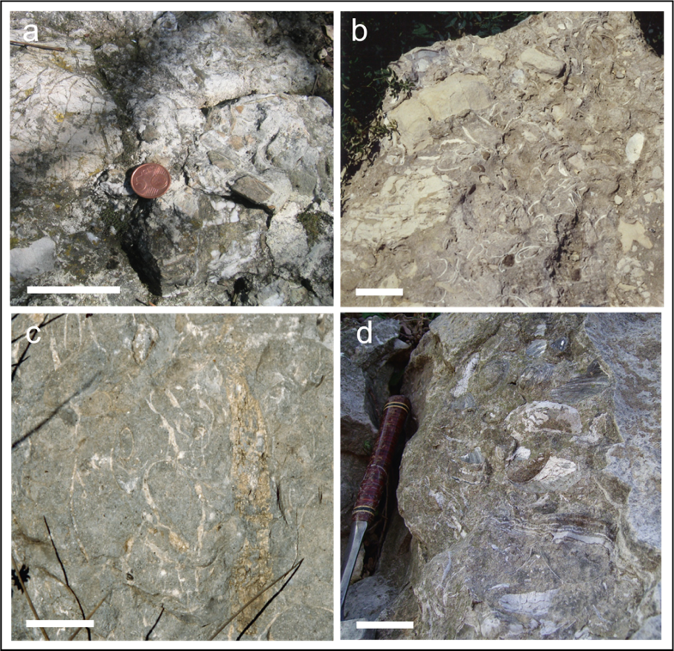
Figure 5. Recurrent seep-carbonate facies. (a) Polygenic breccias with clasts sourced from Ligurian units (Montebaranzone area, outcrop 1 in Figure 1). (b) Polygenic breccias with disarticulated bivalves; clasts sourced from previously formed seep-carbonates and from the underlying Marnoso-arenacea Fm (Colline, outcrop 23 in Figure 1). (c) Complex network of veins and conduits (Deruta, outcrop 7 in Figure 1). (d) Layered structures associated with disarticulated bivalves and mottled micrite (Montepetra, outcrop 13 in Figure 1). Bar length = 5 cm.

Poggio Campane
Location. Seep carbonates are included in Verghereto marls capping the inner Marnoso-arenacea unit coinciding with a main phase of the Apennine overriding (Figure 1).
Carbonate size and distribution. Seep-carbonates consist of three large stratiform bodies and several large pinnacles ranging in extent from a few meters to 20 m and with a maximum thickness of 8–10 m. Several minor irregular blocks and lenses (30 cm to 1 m in extent) are scattered around the main bodies. The lithologies are calcarenites and calcareous marls, with wide portions of carbonate breccias.
Seep-related facies. Marly limestones, calcareous marls, fine to very fine calcarenitic limestones, grey to pale brown in color, with abundant fossil content. Fossils are densely-packed articulated and disarticulated lucinid clams, with maximum diameter up to 25 cm. Other facies include mottled micrites with veins and shell debris, vuggy marly limestones with fractures and cavities, complex vein networks and doughnut structures (Figure 4b). Monogenic breccias are common.
Carbon and oxygen isotopic composition. δ¹³C = −32.2‰; δ¹⁸O = +2.2.
Biostratigraphy of host sediments. Based on nannofossil assemblages, the host sediment indicates the MNN7 biozone.

Santa Sofia
Location. Seep-carbonate blocks are hosted in slope sediments of the Verghereto Marls consisting of laminated, fine grained sandstones and marly-muddy beds, deposited by low density turbulent flows. Seep-carbonates have a wide extent and mark the closure stage of the foredeep before the overriding of the Ligurian units.
Carbonate size and distribution. Several tens of bodies of various dimensions and shapes from large stratiform (up to 50 m in lateral extent and 10 m thick) to irregular metric blocks and lenses. Carbonates consist of lightly colored, micritic limestones rich in mussels and clams [45]. The passage to enclosing marls is gradual.
Seep-related facies. Common facies are: polygenic and monogenic breccias with isolated articulated or disarticulated clams, centimetric conduits and doughnut fabric, network of conduits filled by calcite cements, laminated micritic limestones with alternance of whitish and brownish laminae.
Carbon and oxygen isotopic composition. δ¹³C from −36.4 to −27.2‰; δ¹⁸O from −0.3 to +3.6‰.
Biostratigraphy of host sediments. The nannofossil biostratigraphy indicates the MNN8 biozone (San Vernicio outcrop) and MNN8–9 (Case Buscarelle outcrop).
Correlatable outcrops. Salsomaggiore: Case Gallo, Case Cagnotti and Zappini (δ¹³C from −41.4 to −8.7‰; δ¹⁸O from −2.4 to +2.8‰) (Figure 1) [46].
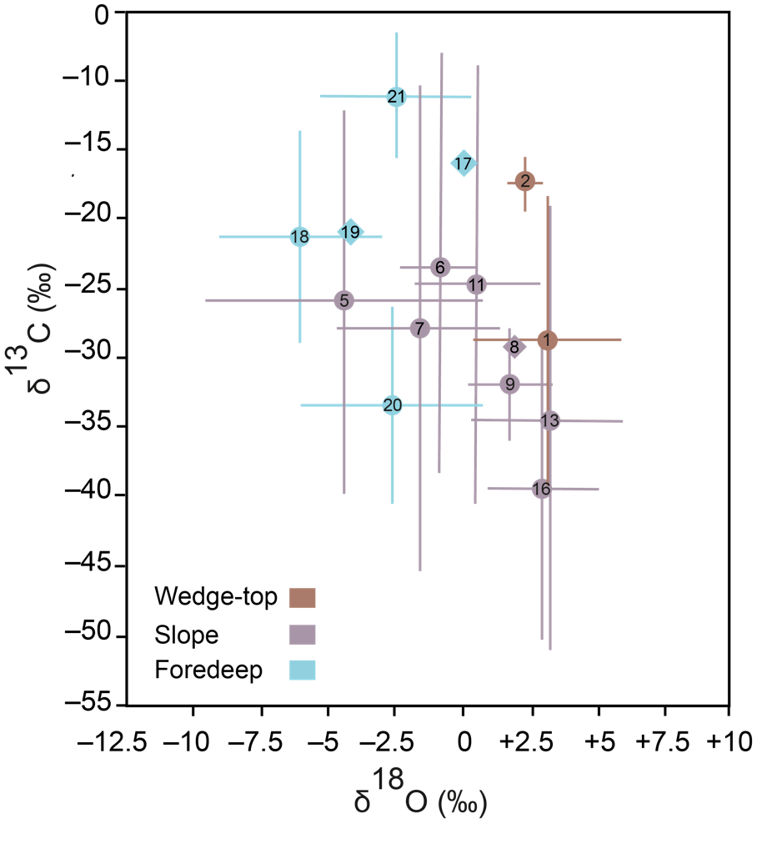
Figure 6. Carbon and oxygen isotopic values measured in seep-carbonates from the examined outcrops. The bar length represents the range of variability of the isotopic values; circles indicate the average of the endmember values and numbers specify the outcrop as listed in the caption of Figure 1. Rhombic features represent single measurement values.

3.2.3. Umbria-Romagna Domain (Tortonian to Messinian)
Seep carbonates are hosted in the Ghioli di letto mudstones and coeval slope deposits: during the early phase of the closure stage (Montepetra outcrops) and at the end of the closure stage below the contact with the Gessoso-solfifera Fm. Seep carbonates are also hosted in minor basin formed during the final stages of the Umbria-Marchean foredeep.

Montepetra
Location. The Montepetra outcrop formed along the outer slope of the accretionary prism, close to the front of the orogenic wedge. Seep-carbonates are hosted in fine-grained sediments (Ghioli di letto Fm, late Tortonian-early Messinian) draping thrust-bounded folds and buried ridges, constituted by the older accreted turbiditic units. The Montepetra outcrop is located in the south-eastern edge of a regional anticline, extending for more than twenty kilometers in a NW−SE direction. Seep-carbonates crop out in the hinge zone of the anticline and at the top of the mass transport deposits (geological details in [47]).
Carbonate size and distribution. Seep-carbonates consist of irregular metric lenses (up to 25 m) and blocks with different morphologies: lenticular-amygdaloid, mound-like irregular bodies, pinnacles, concretions of variable thickness (Figure 3c).
Seep-related facies. Monogenic and polygenic breccias, with intraformational and extraformational clasts (from Ligurian units), networks of conduits and veins, with scarce disarticulated and reworked fossils prevail in the basal portion of seep-carbonate bodies, indicating repeated phases of carbonated precipitation followed by fracturing. Moderate to strong fluid seepages are suggested by laminated and mottled marly limestones with vuggy fabrics chaotically mixed with polygenic microbreccias rich in articulated and/or disarticulated lucinid clams (Figure 5d). Stratified micritic limestones and fine-grained calcarenites with plane-parallel laminations and articulated lucinid-like bivalves occur in the upper portion of the seep bodies during phases of low and diffuse fluid circulation.
Carbon and oxygen isotopic composition. Seep-carbonates yielded depleted δ¹³C values with a large dispersion from −52.7 to −19.1‰, and positive or slightly negative oxygen (δ¹⁸O from −0.7 to +6.0‰). Brecciated levels show the most depleted carbon isotope values (δ¹³C from −52.7 to −36.0‰), associated with heavy δ¹⁸O values (from +2 to +6.0‰).
Biostratigraphy of host sediments. Based on planktonic foraminifera, the age spans from the late Tortonian to the early Messinian MMi12-13 Zones (Figure 7).
Correlatable outcrops. Le Lame, Pietralunga [28,48], Caresto (geological description in [49].
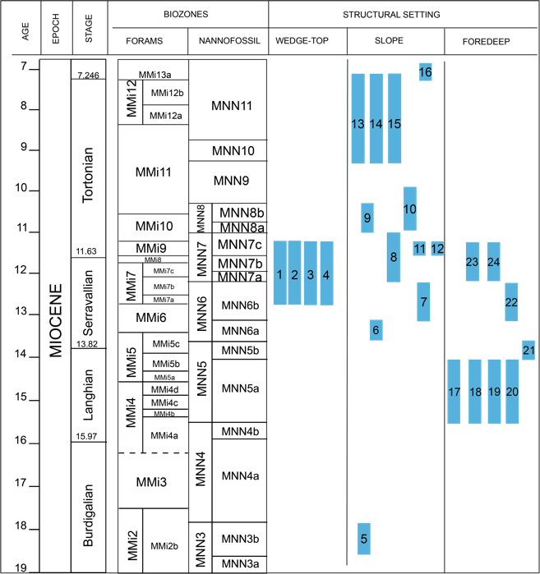
Figure 7. Nannofossil and foraminifera biostratigraphic framework indicating the distribution of the examined outcrops (numbers refer to Figure 1).

Brisighella
Location. Numerous seep-carbonate bodies are located at the top of the euxinic marls of the Ghioli di letto Fm, and mark the contact with the overlying Gessoso-solfifera Fm. Seep-carbonates and evaporitic levels are involved in several back-thrusts striking parallel to the main NW−SE Apennine structures; the detachment level is located at the base of the euxinic marls bearing carbonate bodies. The attitude of seep-carbonate bodies is concordant with the Gessoso-solfifera Fm.
Carbonate size and distribution. Seep-carbonates vary from stratiform to pinnacular (from 1 to 30 m in extent and up 10 m thick), to minor irregular lenses and blocks.
Seep-related facies. Monogenic and polygenic breccias are a common facies, with isolated articulated or disarticulated clams and conduits (diameter of a few cm). Other facies are marly limestones rich in densely packed bivalves (giant lucinids and rarely mussels), massive to laminated micritic limestones resembling Beggiatoa beds, stratified marly limestones with small lucinids and gastropods. Spongy fabric with a complex network of cavities and veins and doughnut fabric, are common.
Carbon and oxygen isotopic composition. δ¹³C from −51.7 to −27.4‰; δ¹⁸O from −1.6 to +5.0‰ [50].
Biostratigraphy of host sediments. Early Messinian.
Correlatable outcrops. See outcrops reported in [50,51].

Minor Basins
Location. Several small seep-carbonates in the Borello and Savio valley of the Romagna Apennines (Case Bandirola outcrop of Figure 1) are hosted in late Tortonian proximal turbidites belonging to minor basins of the Romagna-Marchean foredeep, known in literature under various names (Molasse grossolane, Fontanelice Sandstones, Urbania Sandstones),
Carbonate size and distribution. Carbonates are present as small blocks (thickness ranging from tens of centimeters to meters) in arenaceous coarse-grained turbidites, as crusts or as arenite cement.
Seep-related facies. Common facies are mottled micrite with small articulated bivalves, monogenic breccias with disarticulated bivalves and spongy fabric.
Carbon and oxygen isotopic composition. δ¹³C values are reported in [50].
Biostratigraphy of host sediments. Late Tortonian.

3.3. Intrabasinal Highs of the Inner Foredeep

3.3.1. Tuscan Foredeep (Cervarola Fm)

Brasimone-Suviana
Location. The pelitic interval enclosing seep-carbonates in the M. Cervarola Fm crops out in the northern limb of the Granaglione-Montepiano overturned anticline [52]. The pelitic interval consists of fine-grained marly turbidites up to 40–50 m thick and with a lateral extent of 20 km. Carbonate bodies are located in proximity of the tectonic contact separating the M. Cervarola Fm from the Sestola-Vidiciatico Unit. Geological details in [52].
Carbonate size and distribution. Numerous carbonate lenses (a few decimeters to several meters wide, 20 cm to 4–5 m thick) are made up of micritic and calcarenitic lenses, strongly brecciated and rich in densely packed lucinid bivalves. The micritic groundmass is commonly associated with pyrite, abundant bioclastic debris (planktonic foraminifera and fragments of shells) and locally fine-grained sand grains, made of quartz, feldspars and low-grade metamorphic rock fragments (phyllite, serpentinite, chlorite-schist) similar to those of the M. Cervarola arenites.
Seep-related facies. Common facies are mottled micrite, strongly bioturbated, monogenic and polygenic breccias frequently barren of fossils, usually disarticulated, micrite with dense networks of calcite veins and extensive vuggy fabrics. Micritic doughnuts, nodular and cylindrical concretions and pipe-like structures are interpreted as fluid-flow conduits. Chaotic structures and soft sediment deformation are common and consist of small slumps involving marly and carbonate deposits.
Carbon and oxygen isotopic composition. δ¹³C = −15.9‰; δ¹⁸O = +1.4; Poggio Michelino: δ¹³C from −29.5 to −14.7‰; δ¹⁸O from −8.7 to −2.6‰; Telecchio: δ¹³C = −21.0, δ¹⁸O = −4.0.
Biostratigraphy of host sediments. The nannofossil biostratigraphy indicates the MNN5a Biozone.
Correlatable outcrops. Telecchio, Poggio Michelino (Figure 1).

3.3.2. Umbria-Marchean Foredeep (Marnoso-Arenacea Fm)
Thousands of seep-carbonates crop out in pelitic intervals draping intrabasinal highs in the Marnoso-arenacea foredeep. We recognized several pelitic intervals, each containing numerous seep-carbonate outcrops (Figure 1): Castagno-Corella (geological details in [25,28]; Acquadalto (Podere Filetta, Monte Citerna, Capanne di Favaglie and correlate outcrop of Poggio Cavalmagra); Susinello-Romiceto-Casaglia-M.Colonna-Nasseto described in [53]; Bedetta-Archetta (Colline, Mondera), Visignano (Prati Piani, case Termine). Here we describe the most representative outcrops. The more ancient pelitic interval (Castagno d’Andrea-Corella) contains numerous (up to 40) seep carbonate bodies scattered at various stratigraphic intervals; here we describe the two main outcrops, at the base (Castagno d’Andrea) and at the top (Corella) of the Castagno-Corella pelitic interval.

Castagno d’Andrea
Location. Four large seep-carbonate bodies are vertically stacked and distributed on three stratigraphic horizons concordant to the enclosing sediments and to the main structural trends. Small-scale slumps occur locally in host sediments above the carbonate bodies (geological details in [25,28]).
Carbonate size and distribution. Seep-carbonates vary from pinnacle-like to stratiform, 12 to 30 m wide and 5 to 10 m thick. Stratiform bodies are connected by pinnacular structures (Figure 3b). The basal contact is highly irregular marked by <0.5 m sized micritic concretions. Lateral transitions to enclosing sediments are sharp to gradual, with lateral repetitions of small concretions.
Seep-related facies. Stratiform bodies are characterized by an irregular framework of fractures and drusy-like cavities, associated with branched veins; in the upper portions, dense arrangements of lucinid-like clams are observed. In pinnacle-like bodies polygenic breccias prevail, with mixing of clasts from older underlying successions and from previously precipitated carbonate crusts and disarticulated clams. Monogenic breccias generated by autoclastic processes are common.
Biostratigraphy of host sediments. Calcareous nannofossils of the enclosing marls indicate the Langhian MNN5a subzone [54].

Corella
Location. The outcrop is located within the same pelitic interval as Castagno d’Andrea, approximately 10 km northwest, in a higher stratigraphic position. Six large carbonate bodies and several minor meter-sized blocks are concentrated in two horizons (geological details in [25,28]).
Carbonate size and distribution. Carbonate bodies are stratiform to lenticular, with a lateral extent from 50 m to 230 m and thickness up to 30 m. Basal and upper surfaces are flat. Lateral contacts with the host sediment are usually sharp, with pinch-out terminations. Larger carbonate bodies are vertically connected by irregular minor meter-sized bodies, or by highly cemented sediment.
Seep-related facies. The basal portion of the bodies is characterized by an irregular framework of fractures, conduits, drusy-like cavities and polygenic breccias (mm to cm sized) associated with disarticulated bivalves (Figure 5b). Monogenic breccias occur at various levels. A dense concentration of articulated bivalves is observed at the top of the bodies.
Carbon and oxygen isotopic composition. δ¹³C ranges from −42.3 to −26.6‰ VPDB. δ¹⁸O ranges from −5.7 to +1.2‰ VPDB.
Biostratigraphy of host sediments. Calcareous nannofossils of the enclosing marls indicate the Langhian MNN5a subzone.

Acquadalto
Location. The outcrops (Podere Filetta-Monte Citerna) are located within the pelitic interval of Acquadalto (geological detail in [54]). The interval has a thickness from 40 to 75 m and is cut by normal faults with Apenninic direction. Seep-carbonates are numerous at different levels commonly aligned along bedding. Some bodies show evidence of moderate reworking within the slopes of the intrabasinal high.
Carbonate size and distribution. Seep-carbonates consist of numerous marly-calcareous lenses, or irregular column-like and stratiform bodies, ranging in size from some decimeters to 3–4 m, and with a thickness from 20–30 cm to 3 m. The lateral contact with host sediments is gradual and interfingering; the transition is marked by carbonate-rich marly nodules.
Seep-related facies. The basal portion of bodies is characterized by an irregular framework of fractures, large conduits, drusy-like cavities and polygenic breccias (mm to cm sized) associated with disarticulated bivalves (Figure 5b). Monogenic breccias occur at various levels. Densely packed articulated lucinid-like bivalves occur at the top of the bodies. Mottled micrites pervaded by doughnut-like structures are common. Many marly nodules are connected to seep-carbonates by irregular and intertwined conduits.
Carbon and oxygen isotopic composition. δ¹³C ranges from −15.8 to −3.6‰ VPDB. δ¹⁸O ranges from −4.5 to −0.4‰ VPDB.
Biostratigraphy of host sediments. Calcareous nannofossils of the enclosing marls indicate the Langhian MNN5b subzone.
Similar features characterize the outcrops of Colline Mondera (Bedetta pelitic interval) (more details in [28]), and Prati Piani (Visignano pelitic interval) [55], all referable to the nannofossil MNN7 biozone.
The Prati Piani interval has a lateral extent of about 15 km and a thickness from 60 to 120 m, mainly constituted by hemipelagic marls and thin bedded fine-grained turbidites rich in ichnofossils. Extraformational bodies are present mainly in the basal portion, whereas the top is marked by glauconitic arenites. Seep-carbonates occur both at the base and in the upper portion of the interval.
Correlatable outcrops. Le Caselle-Pontevecchio [56].

4. Discussion
We report the spatial and stratigraphic distribution of seep-carbonate outcrops over an area of ~10,000 km² in the Emilia and Umbria-Marchean sector of the Apennine chain, northern Italy. The examined 13 outcrops are representative of three different structural positions along the Miocene Apenninic accretionary system, and document a clear causal relationship between active tectonics and their origin and distribution. The outcrops formed within wedge-top basin, along the outer continental slope close to the orogenic front, and in a more external position in the inner foredeep, in correspondence with fault-related anticlines. The widely diverse outcrop-scale spatial patterns, facies and morphologies of seep-carbonates reported in our study indicate that several factors influenced seepage activity. From the examination of this dataset it follows that:
- there is a clear link between the onset and evolution of seepage and specific structural positions with respect to main structural elements of the migrating Apenninic thrust-wedge. Anticlinal structures represent the most recurring setting for methane-rich fluid emissions and seep-carbonate formation. Folded structures along the outer slope were constituted by thrust-bounded folds composed of the older imbricated units. In the inner foredeep, at the leading edge of the deformation front, gentle anticlines were generated by blind faults connected to the basal detachment. Upward migrating fluids were conveyed toward the incipient anticline promoting seepage at the forelimb, likely in correspondence of the propagation of the thrust fault to the seafloor as observed in modern systems worldwide [28]. With the proceeding of the deformation, the fault-related folding caused the progressive growth of the ridge. The seepage shifted toward the hinge zone of the anticline, as the extensional stresses created an effective system that provided pathways for migrating fluids at the crest. In some cases, the predominance of diffusive methane seepage led to the precipitation of tens of meter-sized and spatially-scattered carbonate bodies.
- Seep-carbonates provide important constraints to the duration of seepage activity. The majority of studied outcrops are constituted by several meters thick carbonate deposits spanning hundreds of thousands of years of precipitation [28,47]. Often, the seep deposits are represented by numerous vertically-stacked carbonate bodies testifying an intermittent activity of seepage and/or complex fluid flow patterns in the sedimentary column (e.g., Fosso Riconi outcrop, [43]).
- The presence of gas hydrates was an additional controlling factor for seepage distribution on the paleo-wedge of the Apennine and other mountain chains [23,57]. The modelling of the paleo-gas hydrate stability recently reported by [33] for the examined outcrops, indicated that pure methane hydrates were stable at a water depth of 1000 m, within the uppermost few tens of meters to 400 m of sediment (assuming Miocene bottom water temperatures from 4 °C to 10 °C). The growth and the uplift of the thrust-related anticlines created favorable conditions for gas hydrate destabilization reducing the hydrostatic pressure and bringing gas hydrates out of their stability zone (e.g., [58]). The focusing of fluids underneath the crest of the anticline was also favored by the upward shift of the base of gas hydrate stability zone in proximity of the main fault, due to the advection of warm fluids [5,59].
- In the examined wedge-top basin, seep-carbonate precipitation appears strictly related with diapiric processes of the Montardone mélange. Diapirism involved old Epiligurian olistostromes and favored the ascending methane-rich fluids along the faulted flank of the diapir, with the subsequent precipitation of seep-carbonates characterized by chemosynthetic fauna. Diapirism was promoted by thrust loading of underconsolidated mud-breccias. Polygenic breccias sourced from the ascending mélange formed during fast, explosive seepage phases. In the last stage, the mélange reached the sea-bottom and slope failure processes (debris flows, olistostromes) occurred along the flanks of the mud-volcano, involving also blocks of authigenic carbonates.
- Finally, we identify a potential relationship between the lithostratigraphic distribution of seep-carbonates and eustatic/climatic implication as a whole [29,30,60]. Examined seep-carbonates are roughly concentrated in three main intervals of the Miocene: in the Langhian (MNN5a), in the late Serravallian−early Tortonian (MNN6b-MNN7) and the late Tortonian−early Messinian (MNN10-MNN11) (Figure 7). We are aware that the biostratigraphic resolution is conditioned by the duration of the biozone that could be longer than the seepage activity. It is also evident that the tectonic processes played a primary role in favoring the development of seepage systems, by creating the structural pathways for fluid advection (thrust faults) as well as trapping mechanisms for the accumulation of fluids (fold structures). Nevertheless when comparing seep distributions with third-order eustatic curves [61], they seem matching phases of sea-level low-stands. In particular the detailed study of one of the best exposed Apennine outcrops (Fosso Riconi [43]) indicates that the onset of the seepage approximates to the Mi3b cooling event (13.82 Ma). These results also match with results of previous authors that proposed the correspondence of seep-carbonates with cold climate and sea-level lowering. In this proposed scenario, the reduction in hydrostatic pressure acting on the plumbing system, and related to sea-level falls, would shift the bottom of the gas hydrate stability zone to shallower depths, inducing gas hydrate destabilization.

5. Summary
The Miocene seep-carbonate outcrops of the northern Apennines (Italy) reflect a long history of methane-rich fluid emissions along the paleo-accretionary wedge. In the last decades, studies on the lithostratigraphic distribution of seep-carbonate deposits in the Emilia to Umbria-Marchean sector of the Apennine chain highlighted the fact that cold seeps developed in three main tectonic settings, corresponding to wedge-top basins, outer slope and intrabasinal highs located at the deformational front. Structural and biostratigraphic analyses conducted over the years provided solid evidence for the causal relationship between tectonic phases related to the building of the Apennine wedge and the evolution of fluid plumbing systems, and critical estimates of the duration of methane emissions on the paleo-seafloor, that in the case of the largest deposits can reach several hundreds of thousands of years of carbonate precipitation. In some cases, a climate forcing has been proposed as a contributing factor to the inception of seepage. Detailed sedimentological (facies, microstructures) and geochemical (δ¹³C, δ¹⁸O) investigations of seep-carbonates revealed the involvement of paleo-gas hydrates, but further studies are required in order to support the hypothesis of a regional-scale hydrate destabilization.
This study provided an overview on seep-carbonate deposits of the northern Apennines (Emilia to Umbria-Marchean sector) and factors controlling the regional-scale spatial and temporal evolution of Miocene cold seepage systems, representing a remarkably complete record that can be used to better understand fluid plumbing systems at modern convergent margins.
Author Contributions: authors contributed equally to the work
Funding: This research was founded by University of Modena and Reggio Emilia (FAR 2018-2020)
Institutional Review Board Statement:
Informed Consent Statement:
Data Availability Statement:
Acknowledgments: Our thanks to Luca Martire and anonymous reviewer for constructive criticism that led us to improve the paper.
Conflicts of Interest: the authors declare no conflicts of interest

References
- Bohrmann, G.; Heeschen, K.; Jung, C.; Weinrebe, W.; Baranov, B.; Cailleau, B.; Heath, R.; Huhnerbach, V.; Hort, M.; Masson, D.; et al. Widespread fluid expulsion along the seafloor of the Costa Rica convergent margin. Terra Nova 2002, 14, 69–79.
- Ding, F.; Spiess, V.; Fekete, N.; Murton, B.; Brüning, M.; Bohrmann, G. Interaction between accretionary thrust faulting and slope sedimentation at the frontal Makran accretionary prism and its implications for hydrocarbon fluid seepage. J. Geophys. Res. Solid Earth 2010, 115, doi:10.1029/2008JB006246.
- Han, X.; Suess, E.; Liebetrau, V.; Eisenhauer, A.; Huang, Y. Past methane release events and environmental conditions at the upper continental slope of the South China Sea: Constraints by seep carbonates. Int. J. Earth Sci. 2014, 103, 1873–1887.
- Suess, E. Marine cold seeps and their manifestations: Geological control, biogeochemical criteria and environmental conditions. Int. J. Earth Sci. 2014, 103, 1889–1916.
- Klaucke, I.; Berndt, C.; Crutchley, G.; Chi, W.C.; Lin, S.; Muff, S. Fluid venting and seepage at accretionary ridges: The four way closure ridge offshore SW Taiwan. Geo-Mar. Lett. 2015, 36, 165–174.
- Judd, A.; Hovland, M. Seabed Fluid Flow: The Impact on Geology, Biology and the Marine Environment; Cambridge University Press: Cambridge, UK, 2009.
- Leifer, I.; Kamerling, M.J.; Luyendyk, B.P.; Wilson, D.S. Geologic control of natural marine hydrocarbon seep emissions, Coal Oil Point seep field, California. Geo-Mar. Lett. 2010, 30, 331–338.
- Talukder, A.R. Review of submarine cold seep plumbing systems: Leakage to seepage and venting. Terra Nova 2012, 24, 255–272.
- Morley, C.K.; Warren, J.; Tingay, M.; Boonyasaknanon, P.; Julapour, A. Reprint of: Comparison of modern fluid distribution, pressure and flow in sediments associated with anticlines growing in deepwater (Brunei) and continental environments (Iran). Mar. Petrol. Geol. 2014, 55, 230–249.
- Nelson, C.S.; Nyman, S.L.; Campbell, K.A.; Rowland, J.R. Influence of faulting on the distribution and development of cold seep-related dolomitic conduit concretions at East Cape, New Zealand. N. Z. J. Geol. Geophys. 2017, 60, 487–496.
- Levin LA. Ecology of Cold Seep Sediments: Interactions of Fauna with Flow, Chemistry and Microbes. Oceanogr. Mar. Biol. Annu. Rev. 2005, 43, 1–46.
- Campbell, K.A. Hydrocarbon seep and hydrothermal vent paleoenvironments and paleontology: Past developments and future research directions. Palaeogeogr. Palaeoclimatol. Palaeoecol. 2006, 232, 362–407.
- Kiel, S.; Tyler, P.A. Chemosynthetically-Driven Ecosystems in the Deep Sea. In The Vent and Seep Biota; Kiel, S., Ed.; Springer: Dordrecht, The Netherlands, 2010; pp. 1–14.
- Pierre, C.; Blanc-Valleron, M.; Demange, J.; Boudouma, O.; Foucher, J.P.; Pape, T.; Himnler, T.; Fekete, N.; Spiess, P. Authigenic carbonates from active methane seeps offshore southwest Africa. Geo-Mar. Lett. 2012, 32, 501–513.
- Levin, L.A.; Baco, A.R.; Bowden, D.A.; Colaco, A.; Cordes, E.E.; Cunha, M.R.; Demopoulos, A.W.; Gobin, J.; Grupe, B.M.; Le, J.; et al. Hydrothermal vents and methane seeps: Rethinking the sphere of influence. Front. Mar. Sci. 2016, 3, 1–23.
- Kiel, S.; Taviani, M. Chemosymbiotic bivalves from Miocene methane-seep carbonates in Italy. J. Paleontol. 2017, 91, 444–466.
- Hu, Y.; Chen, L.; Feng, D.; Liang, Q.; Xia, Z.; Chen, D. Geochemical record of methane seepage in authigenic carbonates and surrounding host sediments: A case study from the South China Sea. J. Asian Earth Sci. 2017, 138, 51–61.
- Bojanowski, M.J.; Bagiński, B.; Guillermier, C.; Franchi, I.A. Carbon and oxygen isotope analysis of hydrate-associated Oligocene authigenic carbonates using NanoSIMS and IRMS. Chem. Geol. 2015, 416, 51–64.
- Nyman, S.L.; Nelson, C.S.; Campbell, K.A. Miocene tubular concretions in East Coast Basin, New Zealand: Analogue for the subsurface plumbing of cold seeps. Mar. Geol. 2010, 272, 319–336.
- Campbell, K.A.; Francis, D.A.; Collins, M.; Gregory, M.R.; Nelson, C.S.; Greinert, J.; Aharon, P. Hydrocarbon seep-carbonates of a Miocene forearc (East Coast Basin), North Island, New Zealand. Sediment. Geol. 2008, 204, 83–105.
- Metz, C.L. Tectonic Controls on the Genesis and Distribution of Late Cretaceous, Western Interior Basin Hydrocarbon-SeepMounds (Tepee Buttes) of North America. J. Geol. 2010, 118, 201–213.
- Majima, R.; Nobuhara, T.; Kitazaki, T. Review of fossil chemosynthetic assemblages in Japan. Palaeogeogr. Palaeoclimatol. Palaeoecol. 2005, 227, 86–123.
- Bojanowski, M.U. Oligocene cold-seep carbonates from the Carpathyans and their inferred relation to gas hydrates. Facies 2007, 53, 347–360.
- Oppo, D.; De Siena, L.; Kemp, D.B. A record of seafloor methane seepage across the last 150 million years. Sci. Rep. 2020, 10, 2562.
- Conti, S.; Fioroni, C.; Fontana, D. Correlating shelf carbonate evolutive phases with fluid expulsion episodes in the foredeep (Miocene, northern Apennines, Italy). Mar. Pet. Geol. 2017, 79, 351–359.
- Ricci Lucchi, F.; Vai, G.B. A stratigraphic and tectonofacies framework of the “calcari a Lucina” in the Apennine Chain, Italy. Geo-Mar. Lett. 1994, 14, 210–218.
- Taviani, M. Fluid venting and associated processes. In Anatomy of an Orogen: The Apennines and Adjacent Mediterrenean Basins; Vai, G.B., Martini, I.P. Eds.; Springer Sciences & Business Media: Berlin, Germany, 2001; pp. 351–366.
- Argentino, C.; Conti, S.; Crutchley, G.J.; Fioroni, C.; Fontana, D.; Johnson, J.E. Methane-derived authigenic carbonates on accretionary ridges: Miocene case studies in the northern Apennines (Italy) compared with modern submarine counterparts. Mar. Pet. Geol. 2019, 102, 860–872.
- Kiel, S. Global hydrocarbon seep-carbonate precipitation correlates with deep-water temperatures and eustatic sea-level fluctuations since the Late Jurassic. Terra Nova 2009, 21, 279–284.
- Teichert, B.M.A.; Eisenhauer, A.; Bohrmann, G.; Haase-Schramm, A.; Bock, B.; Linke, P. U/Th Systematics and ages of authigenic carbonates from Hydrate Ridge, Cascadia Margin: Recorders of fluid flow variations. Geochim. Cosmochim. Acta 2003, 67, 3845–3857.
- Watanabe, Y.; Nakai, S.; Hiruta, A.; Matsumoto, R.; Yoshida, K. U-Th dating of carbonate nodules from methane seeps off Joetsu. Eastern Margin of Japan Sea. Earth Planet. Sci. Lett. 2008, 272, 89–96.
- Fontana, D.; Conti, S.; Grillenzoni, C.; Mecozzi, S.; Petrucci, F.; Turco, E. Evidence of climatic control on hydrocarbon seepage in the Miocene of the northern Apennines: The case study of the Vicchio Marls. Mar. Pet. Geol. 2013, 48, 90–99.
- Argentino, C.; Conti, S.; Fioroni, C.; Fontana, D. Evidences for Paleo-Gas Hydrate Occurrence: What We Can Infer for the Miocene of the Northern Apennines (Italy). Geosciences 2019, 9, 134.
- Malusà, M.G.; Danišík, M.; Kuhlemann, J. Tracking the Adriatic-slab travel beneath the Tethyan margin of Corsica–Sardinia by low-temperature thermochronometry. Gondwana Res. 2016, 31, 135–149.
- Faccenna, C.; Becker, T.W.; Lucente, F.P.; Jolivet, L.; Rossetti, F. History of subduction and back arc extension in the central Mediterranean. Geophys. J. Int. 2001, 145, 809–820.
- Barchi, M.; Landuzzi, A.; Minelli, G.; Pialli, G. Outer Northern Apennines. In Anatomy of an Orogen: The Apennines and Adjacent Mediterranean Basins; Vai, G.B., Martini, I.P., Eds.; Springer Sciences & Business Media: Berlin, Germany, 2001; pp. 215–254.
- Tinterri, R.; Magalhaes, P.M. Synsedimentary structural control on foredeep turbidites: An example from Miocene Marnoso-arenacea Formation, Northern Apennines, Italy. Mar. Pet. Geol. 2011, 28, 629–657.
- Ricci Lucchi, F. The Oligocene to Recent Foreland Basins of the Northern Apennines. In Foreland Basins; Allen, P.A., Homewood, P., Eds.; International Association of Sedimentologists: Oxford, UK, 1986; pp. 105–139.
- Conti, S.; Fioroni, C.; Fontana, D.; Grillenzoni, C. Depositional history of the Epiligurian wedge-top basin in the Val Marecchia area (northern Apennines, Italy): A revision of the Burdigalian-Tortonian succession. Ital. J. Geosci. 2016, 135, 324–335.
- De La Pierre, F.; Martire, L.; Natalicchio, M.; Clari, P.; Petrea, C. Authigenic carbonates in Upper Miocene sediments of the Tertiary Piedmont Basin (NW Italy): Vestiges of an ancient gas hydrate stability zone? GSA Bull. 2010, 122, 994–1010.
- Martire, L.; Natalicchio, M.; Petrea, C.C.; Cavagna, S.; Clari, P.; Pierre, F.D. Petrographic evidence of the past occurrence of gas hydrates in the Tertiary Piedmont Basin (NW Italy). Geo-Mar. Lett. 2010, 30, 461–476.
- Conti, S.; Fontana, D.; Lucente, C.C.; Pini, G.A. Relationships between seep-carbonates, mud volcanism and basin geometry in the Late Miocene of the northern Apennines of Italy: The Montardone mélange. Int. J. Earth Sci. 2014, 103, 281–295.
- Grillenzoni, C.; Monegatti, P.; Turco, E.; Conti, S.; Fioroni, C.; Fontana, D.; Salocchi, A.C. Paleoenvironmental evolution in a high-stressed cold-seep system (Vicchio Marls, Miocene, northern Apennines, Italy). Palaeogeography. Palaeoclimatology. Palaeoecology. 2017, 487, 37–50.
- Conti, S.; Fontana, D.; Lucente, C.C. Sedimentary filling of a wedge-top basin and relationship with the foredeep (Middle Miocene Marnoso-arenacea Formation, northern Apennines). Facies 2008, 54, 479–498.
- Taviani, M. The calcari a Lucina macrofauna reconsidered: Deep- sea faunal oases from Miocene-age cold vents in the Romagna Apennine, Italy. Geo-Mar. Lett. 1994, 14, 185–191.
- Artoni, A.; Conti, S.; Turco, E.; Iaccarino, S. Tectonic and climatic control on deposition of seep-carbonates: The case of middle-late Miocene Salsomaggiore Ridge (Northern Apennines, Italy). Riv. Ital. Paleontol. Stratigr. 2014, 120, 317–335.
- Conti, S.; Fontana, D.; Mecozzi, S.; Panieri, G.; Pini, G.A. Late Miocene seep-carbonates and fluid migration on top of the Montepetra intrabasinal high (Northern Apennines, Italy): Relations with synsedimentary folding. Sediment. Geol. 2010, 231, 41–54.
- Peckmann, J.; Thiel ,V.; Reitner, J.; Taviani, M.; Aharon, P.; Michaelis, W. A microbial mat of a large sulfur bacterium preserved in a Miocene methane-seep limestone. Geomicrobiol. J. 2004, 21, 247–255.
- De Feyter, A.J. Gravity tectonics and sedimentation of the Montefeltro, Italy. Geol. Ultraiectina 1991, 35, 1–168.
- Terzi, C.; Lucchi, F.R.; Vai, G.B.; Aharon, P. Petrography and stable isotope aspects of cold-vent activity imprinted on Miocene-age “calcari a Lucina” from Tuscan and Romagna Apennines, Italy. Geo-Mar. Lett. 1994, 14, 177–184.
- Iadanza, A.; Sanpalmieri, G.; Cipollari, P.; Mola, M.; Cosentino, D. The “Brecciated Limestones” of Maiella, Italy: Rheological implications of hydrocarbon-charged fluid migration in the Messinian Mediterranean Basin. Palaeogeogr. Palaeoclimatol. Palaeoecol. 2013, 390, 130–147.
- Conti, S.; Fontana, D. A Pelitic Interval Enclosing Primary Chemoherms in the M. Cervarola Formation (Northern Apennines): Evidence for Synsedimentary Tectonics during the Miocene. In Bollettino Della Società Geologica Italiana; 2002; Volume 1, pp. 499–508.
- Lucente, CC.; Taviani, M. Chemosynthetic communities as fingerprints of submarine sliding-linked hydrocarbon seepage, Miocene deep-sea strata of the Tuscan–Romagna Apennines, Italy. Palaeogeogr. Palaeoclimatol. Palaeoecol. 2005, 227, 176–190.
- Conti, S.; Fontana, D.; Gubertini, A.; Sighinolfi, G.; Tateo, F.; Fioroni, C.; Fregni, P. A multidisciplinary study of middle Miocene seep-carbonates from the northern Apennine foredeep (Italy). Sediment. Geol. 2004, 169, 1–19.
- Argentino, C.; Johnson, J.E.; Conti, S.; Fioroni, C.; Fontana, D. Preservation of 34 S-enriched sulfides in fossil sulfate-methane transition zones: New evidence from Miocene outcrops of the northern Apennines (Italy). Geo-Mar. Lett. 2020, 40, 379–390.
- Berti, M.; Cuzzani, M.G.; Landuzzi, A.; Taviani, M.; Aharon, P.; Vai, G.B. Hydrocarbon-derived imprints in olistostromes of the Early Serravallian Marnoso-arenacea Formation, Romagna Apennines (Northern Italy). Geo-Mar. Lett. 1994, 14, 192–200.
- Greinert, J.; Bohrmann, G.; Suess, E. Gas hydrate associated carbonates and methane venting at Hydrate Ridge: Classification, distribution, and origin of authigenic lithologies. In Natural Gas Hydrates: Occurrence, Distribution, and Detection; Paull, C.K., Dillon, W.P., Eds.; American Geophysical Union Geophysical Monograph Series: Washington, DC, USA, 2001, 124, 99–113.
- Paull, C.K.; Buelow, W.J.; Ussler, W., III; Borowski, W.S. Increased continental-margin slumping frequency during sea-level lowstands above gas hydrate-bearing sediments. Geology 1996, 24, 143–146.
- Laird, A.P.; Morley, C.K. Development of gas hydrates in a deep-water anticline based on attribute analysis from three-dimensional seismic data. Geosphere 2011, 7, 240–259.
- Peckmann, J.; Thiel, V. Carbon cycling at ancient methane-seeps. Chem. Geol. 2004, 205, 443–467.
- Haq, B.U.; Hardenbol, J.A.N.; Vail, P.R. Chronology of fluctuating sea levels since the Triassic. Science 1987, 235, 1156–1167.

