Supplementary Information
High H₂O Content in Pyroxenes of Residual Mantle Peridotites at a Mid Atlantic Ridge Segment
Pei Li^{1*}, Qun-Ke-Xia¹, Luigi Dallai², Enrico Bonatti^{3,4}, Daniele Brunelli^{4,5}, Anna Cipriani^{3,5} and Marco Ligi⁴

¹ School of Earth Sciences, Zhejiang University, Hangzhou 310027, China
² Istituto di Geoscienze e Georisorse - CNR, Via G. Moruzzi 1, 56124, Pisa, Italy
³ Lamont-Doherty Earth Observatory of Columbia University, Palisades, New York 10964, USA
⁴ Istituto di Scienze Marine – CNR, via Gobetti 101, 40129, Bologna, Italy
⁵ Dipartimento di Scienze Chimiche e Geologiche, Università di Modena e Reggio Emilia, Modena 41100, Italy

This PDF file includes:
Supplementary Figures 1 to 7
Supplementary Table 1 to 2
References

* To whom correspondence should be addressed. E-mail: peili@zju.edu.cn
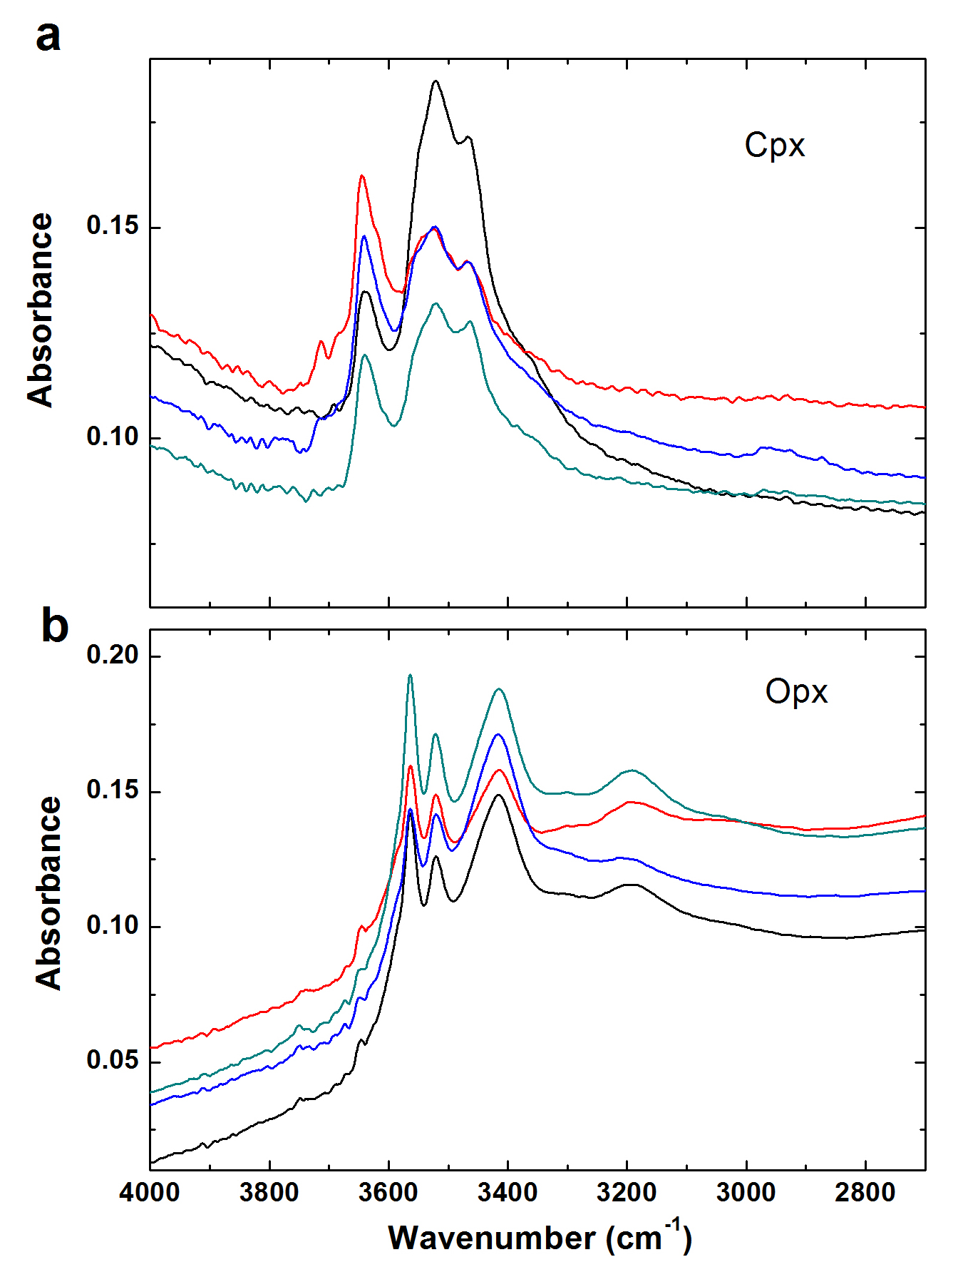
Supplementary Figure 1. Representative non-polarized IR absorption spectra for mineral phases of VLS abyssal peridotites. a, cpx. b, opx. The absorbance spectrum in a and b is normalized to 1 cm thickness. Both spectra were offset vertically for clarity.
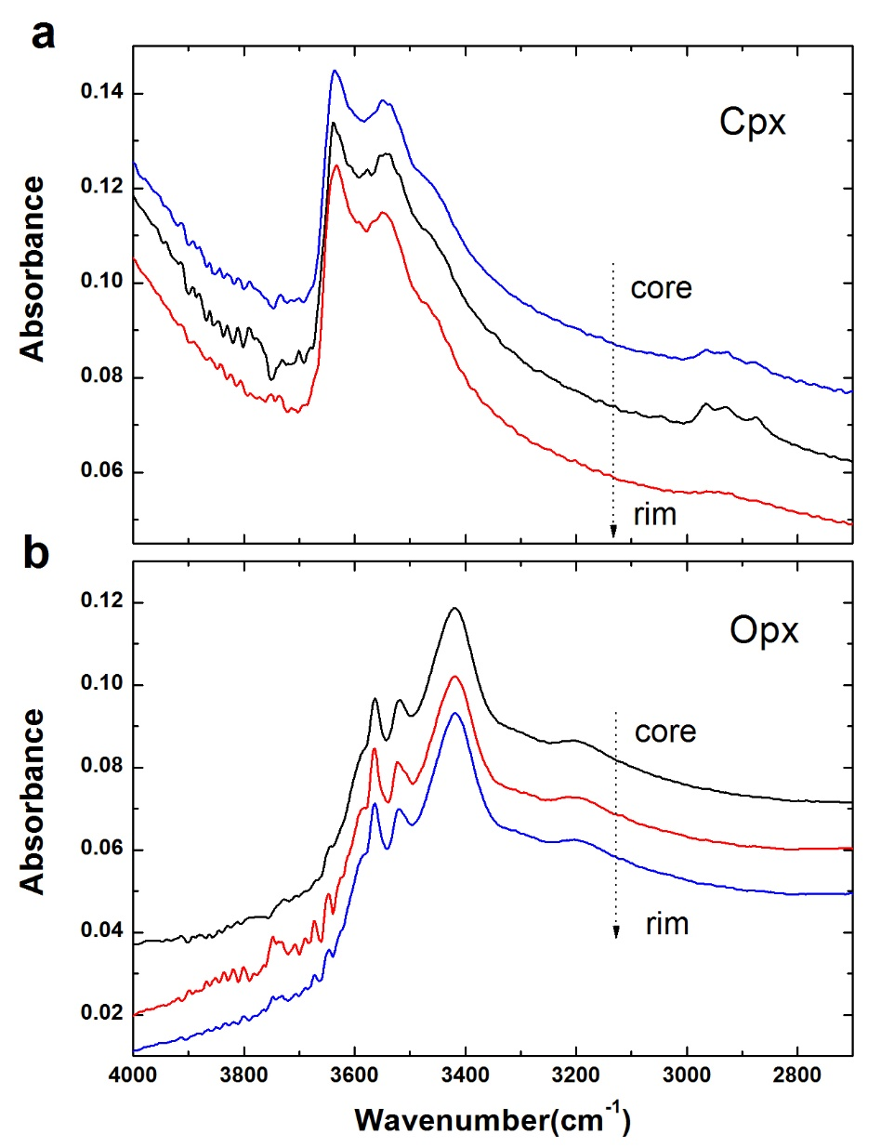
Supplementary Figure 2. Representative IR profile measurement with absorbance spectra offset vertically for clarity. a, cpx. b, opx. The thickness of the measured grains is ~ 0.1 mm.
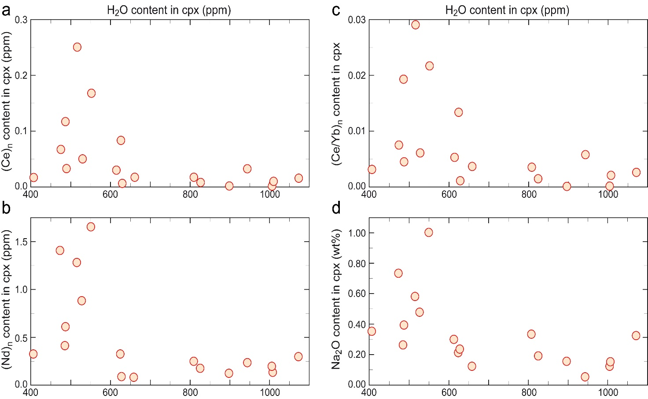
Supplementary Figure 3 | Variations of H₂O content in cpx versus chemical indices reflecting the extent of melting and of metasomatic/melt-rock reactions. Chondrite-normalized (Ce)_{n}, (Nd)_{n} and (Ce/Yb)_{n} contents were obtained using chondritic values from ref. 69. a, (Ce)_{n} in cpx. b, (Nd)_{n} in cpx. c, (Ce/Yb)_{n} ratio in cpx. d, Na₂O (wt%) in cpx. H₂O contents do not correlate with other incompatible elements such as Ce, Nd, Yb and Na, that should behave like H₂O during melting and/or during refertilization by metasomatic/melt-rock reactions. This suggests a non-metasomatic post-melting H₂O enrichment of VLS abyssal peridotites.

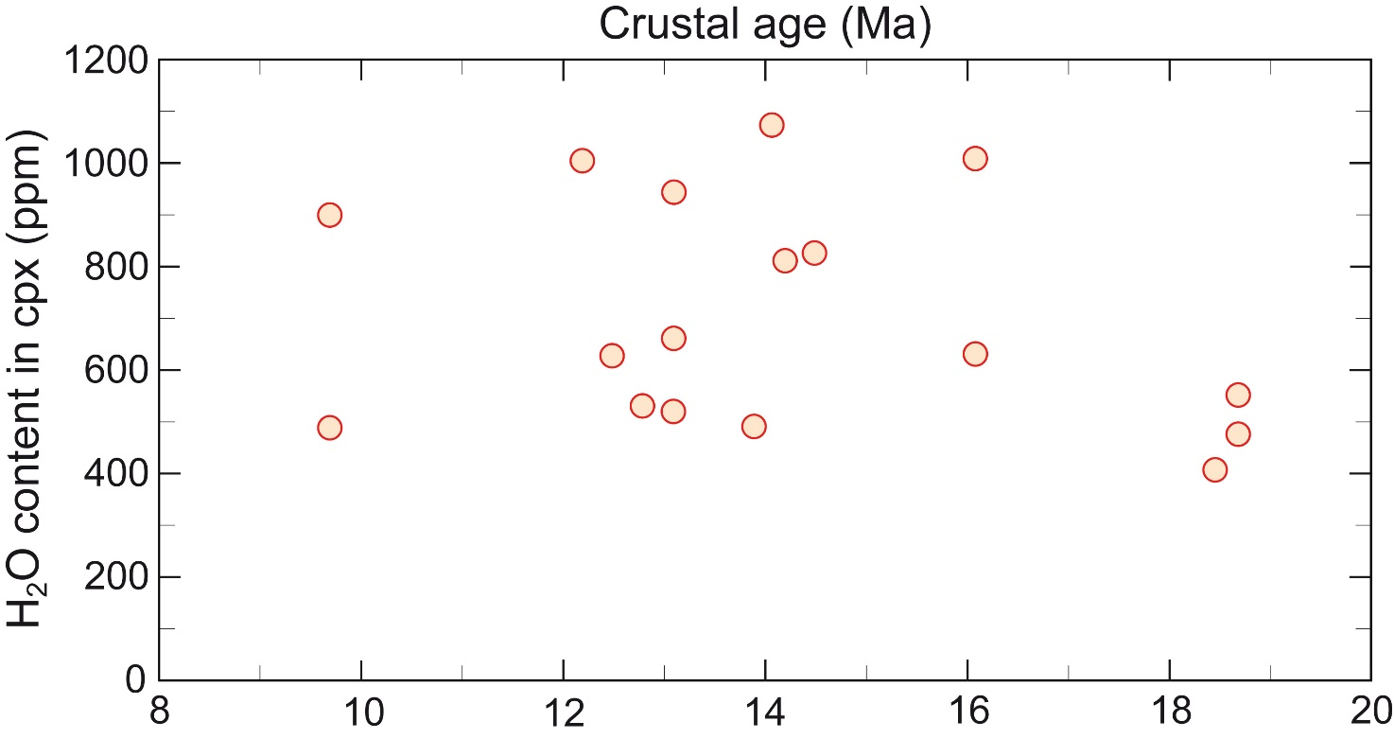
Supplementary Figure 4. Variations of H₂O in cpx of VLS residual peridotites versus age of the associated magmatic crust. Residual abyssal peridotites from the VLS have experienced a similar degree of serpentinization with closure temperatures < 250 °C, estimated from stable isotopes that decrease with distance from the ridge axis¹⁴. δ¹⁸O data suggest oxygen isotope equilibrium at mantle conditions, excluding serpentinization as a cause of the high H₂O content of the VLS pyroxenes.

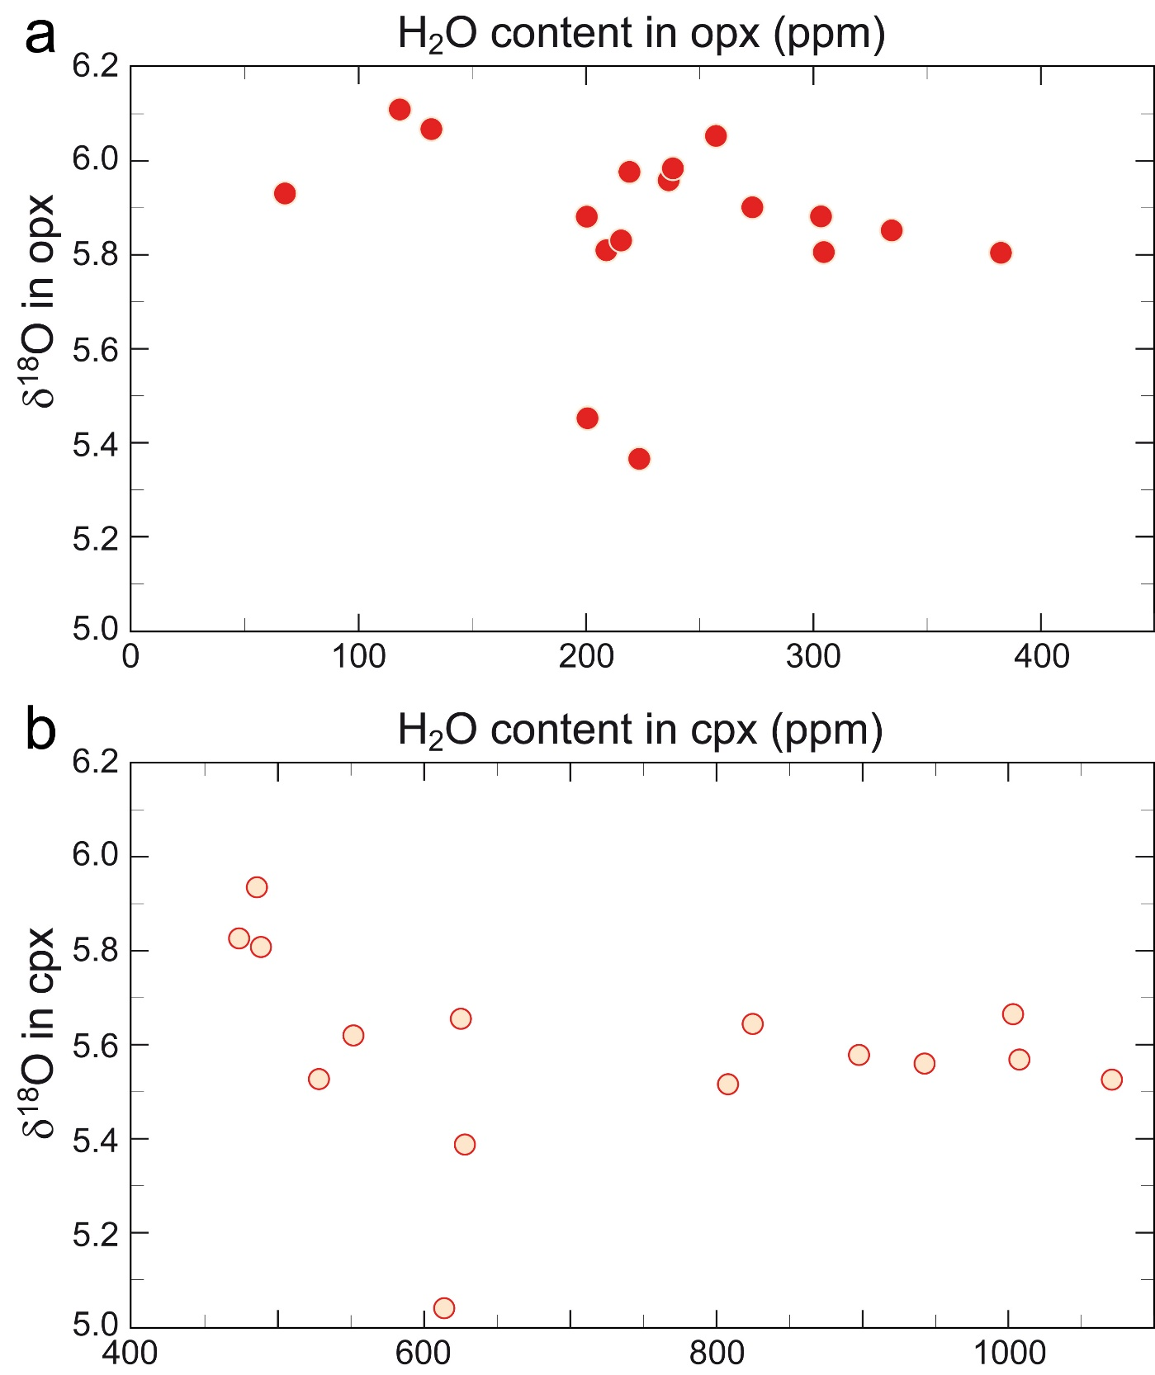
Supplementary Figure 5. Oxygen isotopic ratio (δ¹⁸O) variations versus H₂O contents in VLS residual abyssal peridotites. a, δ¹⁸O vs H₂O content in opx. b, δ¹⁸O vs H₂O content in cpx. Oxygen isotopic data are shown in Supplementary Table 1
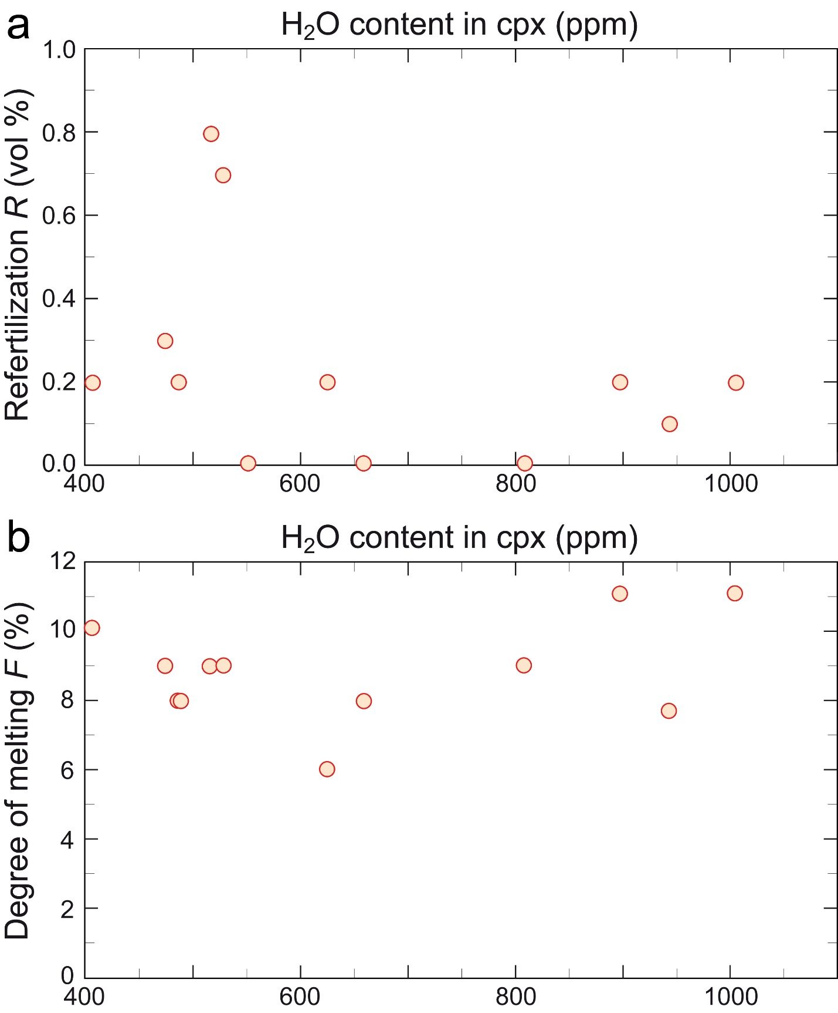Supplementary Figure 6. Influence of extent of melting and/or metasomatism on the H₂O content of VLS residual peridotites. a, R is the amount of refertilization (vol. %). b, F represents the estimated mean degree of melting experienced by the VLS abyssal peridotites. Data from ref. 9.

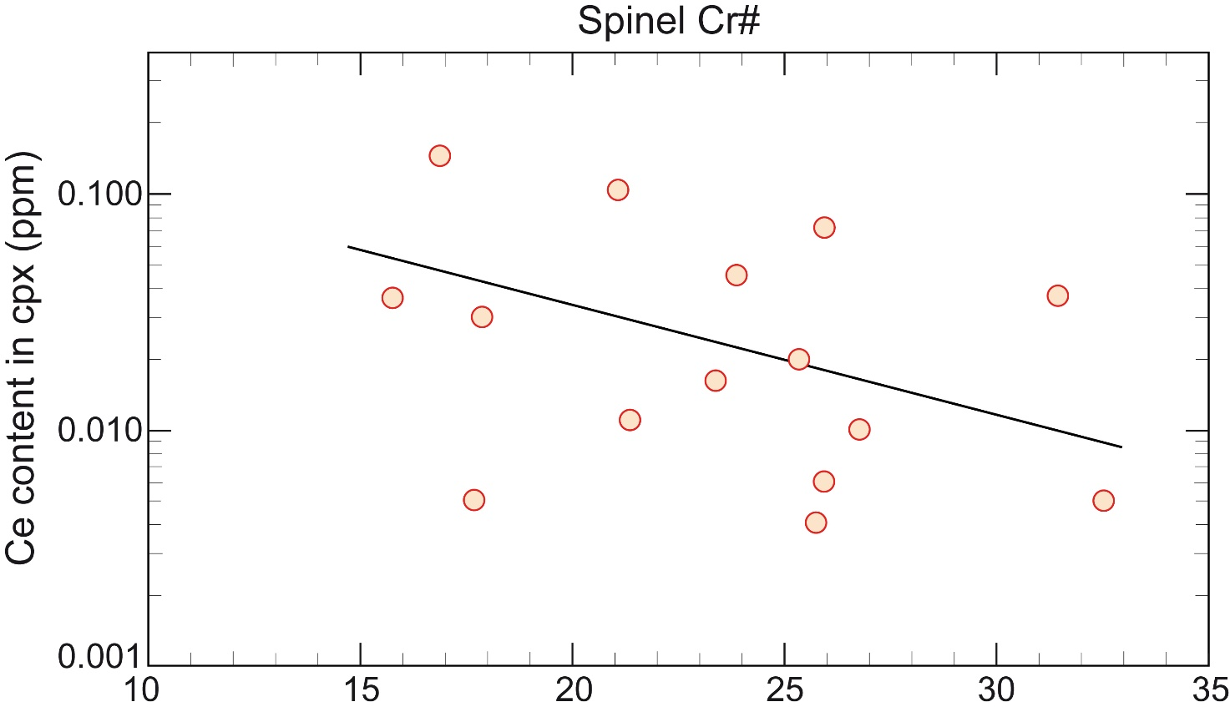
Supplementary Figure 7. Co-variations between Ce concentrations in cpx and Spinel Cr# (a proxy of mantle extent of melting). Note the expected inverse correlation between Ce and the degree of melting parameter. Regression line: black solid line. Data from ref. 9.

Supplementary Table 1. Vema abyssal peridotite δ¹⁸O contents. Laser fluorination oxygen isotope compositions of cpx and opx from the VLS peridotites.
Sample | δ¹⁸O cpx | δ¹⁸° opx | Δ¹⁸ opx-cpx
S1928-23 | 4,86 | 5,58 | 0,72
S2221-02 | 5,64 | 5,98 | 0,34
S2221-04 | 5,93 | 6,05 | 0,12
S2221-05 | 5,57 | 5,90 | 0,33
S1927-02 | 5,66 | 5,80 | 0,14
S1925-71 | 5,65 | 5,96 | 0,31
S1925-75 | 5,11 | 6,17 | 1,06
S1924-19 | 5,52 | 5,88 | 0,35
S1923-46 | 5,56 | 5,85 | 0,29
VE1-1 | 5,81 | 5,98 | 0,17
EW9305-15-23 | 5,52 | 5,80 | 0,28
EW9305-16-1 | 5,51 | 5,81 | 0,29
EW9305-17-5 | 5,64 | 5,83 | 0,19
S1904-76 | 5,57 | 5,88 | 0,31
S1904-77 | 5,38 | 5,98 | 0,59
S1913-03 | 5,82 | 6,11 | 0,28
S1913-36 | 5,62 | 5,96 | 0,34
S1904-33 | 5,24 | 5,52 | 0,28
S1904-42 | 5,21 | 5,37 | 0,16
S1905-111 | 5,36
S1912-08 | 5,82 | 5,93 | 0,11
S1915-71 | 4,88
Note: δ¹⁸O values result from averages of 2 measurements in samples with weight of 1-2 mg.

Supplementary Table 2. H₂O contents in cpx and opx of abyssal peridotites and extent of melting parameters from published data^{21,22,27,65}. Predicted H₂O contents for melt in equilibrium with residual peridotites are estimated from opx and cpx water contents adopting partition coefficients $D_{H_{2}O}^{opx-melt}=0.019$ (value in bold) and $D_{H_{2}O}^{cpx-melt}=0.023$ (value in brackets) from refs.^{38,39}.
Sample | H₂O (ppm) |  |  |  |  | Spinel |  | $F% | Melt H₂O
 | Opx |  |  |  | Cpx | Cr# |  |  | (wt%)
Hess Deep, East Pacific Rise (ref. 27)
147-895D-2R1-34-37 |  |  |  | 124 |  | 53.0 | 18 |  | 0.7
147-895D-2R2-72-82 |  |  |  | 233 |  | 52.0 | 17 |  | 1.2
147-895D-2R2-75-78 |  |  |  | 230 |  | 51.0 | 17 |  | 1.2
147-895D-3R1-83-93 |  |  |  | 229 |  | 52.0 | 17 |  | 1.2
147-895D-4R2-18-31 |  |  |  | 86 |  | 54.0 | 18 |  | 0.5
147-895D-4R3-132-134 |  |  |  | 102 |  | 52.0 | 17 |  | 0.5
147-895D-4R4-85-90 |  |  |  | 88 |  | 53.0 | 18 |  | 0.5
147-895D-8R1-35-44 |  |  |  | 164 |  | 54.0 | 18 |  | 0.9
147-895F-1R1-6-16 |  |  |  | 108 |  | 53.0 | 18 |  | 0.6
Southwest Indian Ridge, from 53°E to 63.5°E (ref. 65)
21V-S9-D5-2 |  |  |  | 59 |  |  |  |  | 0.3
21V-D1-1 |  |  | 24 |  |  |  |  |  | 0.1
21V-D1-2 |  |  | 246 |  |  | 26.2 | 11 |  | 1.3
21V-D1-3 |  |  | 93 |  |  |  |  |  | 0.5
21V-S16-TVG4 |  |  | 171 |  |  | 32.2 | 13 |  | 0.9
Wb-18-b |  |  | 207 |  |  | 16.5 | 6 |  | 1.1
20VII-S24-TVG20 |  |  | 257 |  |  | 14.1 | 4 |  | 1.4
19III-S3-TVG2-4 |  |  | 262 |  |  | 15.2 | 5 |  | 1.4
Southwest Indian Ridge (ref. 22)
PS86-6-38 |  |  | 171 |  | 459 | 11.3 | 2 |  | 0.9 (2.0)
Van7-85-30 |  |  | 289 |  | 793 |  |  |  | 1.5 (3.4)
Van7-85-42 |  |  | 145 |  | 429 | 15.9 | 6 |  | 0.8 (1.9)
Van7-85-47 |  |  | 157 |  | 415 | 17.4 | 7 |  | 0.8 (1.8)
Van7-85-49 |  |  | 198 |  | 398 | 15.0 |  |  | 1.0 (1.7)
Van7-86-27 |  |  |  |  | 748 |  |  |  | (3.3)
Van7-96-25 |  |  | 21 |  | 458 | 13.8 | 4 |  | 0.1 (2.0)
Van7-96-28 |  |  | 122 |  | 613 | 32.3 | 13 |  | 0.6 (2.7)
Van7-96-35 |  |  | 87 |  | 413 | 24.0 | 10 |  | 0.5 (1.8)
Van7-96-38 |  |  | 116 |  | 665 | 11.5 | 2 |  | 0.6 (2.9)
Gakkel Ridge, Arctic Ocean (ref. 22)
PS59-235-17 |  | 145 |  |  | 362 | 13.9 | 4 |  | 0.8 (1.6)
Mid Atlantic Ridge, ODP Leg 153 (ref. 21)
920D-15R1-8-15 |  |  |  | 160 |  | 29.0 | 12 |  | 0.8
920D-22R4-104-109 |  |  |  | 270 |  | 29.0 | 12 |  | 1.4
Note: Opx, orthopyroxenes; Cpx, clinopyroxenes and Sp, spinels.
$Extent of melting F estimated using sp Cr# according to ref. 19.
───────────────────────────────────────────────────────────────
References
- Anders, E. & Grevesse, N. Abundances of the elements: Meteoritic and solar, Geochim. Cosmochim. Acta 53, 197-214 (1989).

