ICAST2019: 30th International Conference on Adaptive Structures and Technologies
October 7-11, 2019, Montreal, QC, Canada

Experimental Characterization of Pull-In Parameters for an
Electrostatically Actuated Cantilever

Andrea Sorrentino¹*, Giovanni Bianchi¹, Davide Castagnetti¹, Enrico Radi¹
¹Department of Science and Methods for Engineering, University of Modena and Reggio Emilia, Via Amendola 2, 42122, Reggio Emilia, Italy
*andrea.sorrentino@unimore.it

Abstract
Micro-electromechanical systems (MEMS) are a promising research frontier thanks to their multiple physical fields properties. In the field of microcantilever actuators, Radi et al., 2017, proposed an accurate analytical approach for estimating the pull-in characteristics of microcantilever actuators subject to electrostatic actuation. The present work assesses this previous analytical model via experimental tests with the use of a simple millimeter scale device. The aim of the work is to measure the critical pull-in voltage and the deflection of an actuated cantilever beam for different configurations in order to easily investigate the trend of pull-in parameters with respect to the variation of the geometrical dimensions of the device. Preliminary tests show that the experimental pull-in voltage and deflection are in good agreement with the results provided by the analytical model. Specifically, the relative difference between experimental and analytical values of pull-in voltage is in the range between 0.7% and 10%.

Introduction
This work experimentally investigates the response of an electrostatically actuated cantilever beam, which reproduces the typical behavior of the micromechanical switching blocks in MEMS applications. The interesting properties of the MEMS devices typically arise from the behavior of the active parts, which, in most cases, are in the forms of cantilevers (Ke and Espinosa, 2005). In particular, the importance of pull-in induced failures in these applications has received great attention in literature on the last recent years. At a critical voltage, named pull-in voltage, the cantilever beam suspended tip pull-in onto the above conductive substrate (Zhang et al., 2014). This work aims to experimentally assess the applicability of an analytical model from the literature (Radi et al., 2017), for the prediction of the pull-in voltage and the deflection of an electrostatically actuated cantilever beam. Specifically, we designed and built a millimeter scale cantilever, which was actuated through an ad-hoc electric circuit. The experimental results closely match the predictions from the analytical model: for instance, the analytical deflection differs from the experimental measurement in the order of tens of microns.
Methods
First the work focused on the design and prototype development of a millimeter scale model of the MEMS device, where the intermolecular surface forces are negligible. The system is composed by two plates, the suspended electrode and the ground, both made of steel C100S. Both plates have a thickness, t=0.2 mm, a width, w=12.7 mm, and the total free length, l, of the suspended electrode was equal to 50 mm. The gap between the two electrodes was set equal to 0.6 mm, and obtained through a simple bi-adhesive tape (Fig. 1-a). The macro scale dimensions of the device require a high actuating voltage to reach pull-in. Thus, we used a high voltage DC-DC power supply (EMCO CB101) managed through a manual potentiometer to actuate the device up to the pull-in threshold. In order to measure the tip deflection of the suspended electrode, we used a single point laser-doppler vibrometer (Polytec OFV-505 sensor head) linked to a National Instrument data acquisition board (NI 9211). An algorithm implemented in the LabVIEW environment registered and processed both the actuating voltage and the deflection measurements. Fig. 1-b shows the set-up of the test bench. Finally, we tested some different configurations of the cantilever to focus the influence of some parameters on the pull-in: specifically, we investigated a variable free length, l, from 50 to 70 mm, in combination with a gap from the ground, g, from 0.6 to 0.8 mm (see Fig. 1-b). For each configuration, we performed 10 replications of the tests.
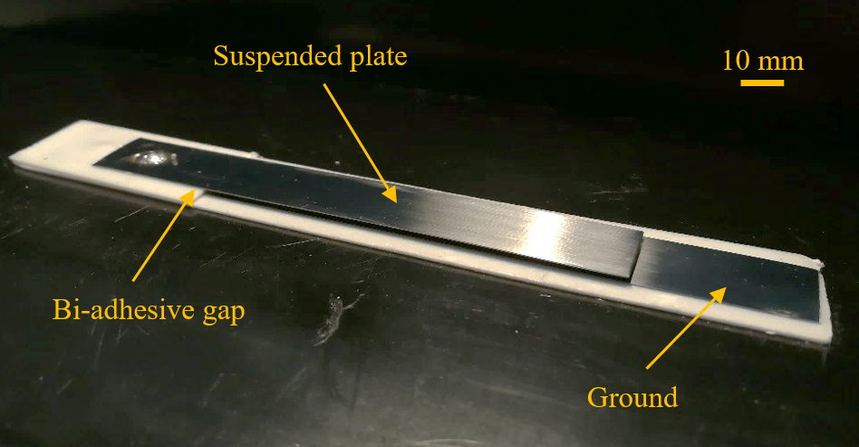 | 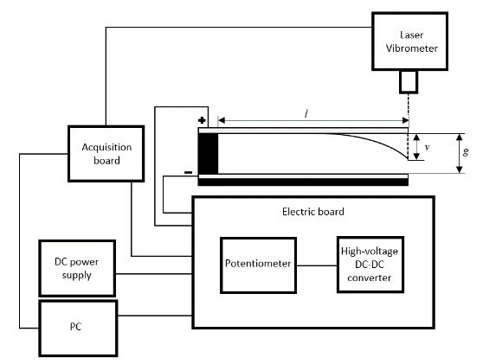
(a) | (b)
Figure 1. Millimeter scale device implemented (a), schematic of the testing benchmark (b)

Results and Discussions
Table 1 compares the critical pull-in parameters for the different configuration of the specimens investigated where, $V_{PI}^{E}$ and $V_{PI}^{A}$, represents the experimental and the analytical pull-in voltage, respectively, and $v_{PI}^{E}$ and $v_{PI}^{A}$ the corresponding pull-in deflections.

Table 1. Comparison between the experimental and analytical pull-in voltage and tip deflection
 | l = 50 mm |  |  |  | l = 70 mm
g  [mm] | $V_{PI}^{E}$  [V] | $V_{PI}^{A}$  [V] | $v_{PI}^{E}$  [mm] | $v_{PI}^{A}$ [mm] | $V_{PI}^{E}$  [V] | $V_{PI}^{A}$ [V] | $v_{PI}^{E}$  [mm] | $v_{PI}^{A}$ [mm]
0.6 | 1250 ± 14.98 | 1342 | 0.252 ± 0.015 | 0.267 | 690 ± 2.45 | 685 | 0.280 ± 0.013 | 0.267
0.8 | 2040 ± 42.45 | 2066 | 0.290 ± 0.055 | 0.356 | 950 ± 8.35 | 1052 | 0.420 ± 0.023 | 0.356
The experimental results are exhibits a very good agreement with the analytical predictions. In particular, we obtained a relative difference between experimental and analytical values of the pull-in voltage in the range between 0.7% - 10%, whereas the relative difference of the pull-in deflection falls in the range from 1.1% up to 18. We can observe that the air gap and the free length have a great influence on pull-in instability. In particular, by increasing the gap, g, of 0.01 mm the pull-in voltage increases of about 18-36 V, depending on the free length.

References
Ke C and Espinosa HD (2005) Nanoelectromechanical Systems and Modeling. Handbook of Theoretical and Computational Nanotechnology.
Radi E, Bianchi G and di Ruvo L (2017) Upper and lower bounds for the pull-in parameters of a micro- or nanocantilever on a flexible support. International Journal of Non-Linear Mechanics 92(July 2016). Elsevier Ltd: 176–186. DOI: 10.1016/j.ijnonlinmec.2017.03.011.
Zhang WM, Yan H, Peng ZK, et al. (2014) Electrostatic pull-in instability in MEMS/NEMS: A review. Sensors and Actuators, A: Physical 214. Elsevier B.V.: 187–218. DOI: 10.1016/j.sna.2014.04.025.

