Supplementary Material for

Improved Empirical Force-Field for Multicomponent Oxide Glasses and Crystals.
Marco Bertani,ª Maria Cristina Menzianiª and Alfonso Pedone^{a,}*
^{a)}Department of Chemical and Geological Sciences, University of Modena and Reggio Emilia, via G. Campi 103, 41125, Modena, Italia

*Corresponding author email: alfonso.pedone@unimore.it

- Description of the SHIK and CS Force-Fields and parameters.

SHIK potentials.
In this potential, the long-range electrostatic interactions are evaluated by means of the Wolf truncation method [1], whereas the Buckingham functional form is used for the short-range interactions:
$$U_{ij}\left(r_{ij}\right)=U_{ij}^{W}\left(r_{ij}\right)+A_{ij}e^{-\frac{r_{ij}}{ρ_{ij}}}-\frac{C_{ij}}{{r_{ij}}^{6}}+\frac{D_{ij}}{{r_{ij}}^{24}} (S1)$$
where
$U_{ij}^{W}\left(r_{ij}\right)=z_{i}z_{j}\left[\frac{1}{r_{ij}}-\frac{1}{r_{cut}^{W}}+\frac{\left(r_{ij}-r_{cut}^{W}\right)}{{\left(r_{cut}^{W}\right)}^{2}}\right]$ (S2)
The Coulombic interactions are truncated at $r_{cut}^{W}=$10 Å, whereas the van der Waals interactions are truncated at a distance of 8 Å. The Si, Al, K, and Na charges are fixed, whereas the oxygen charge depends on the glass composition as follows: [2]
$z_{O}=\frac{\left(1-y_{X}-y_{Al}\right)z_{Si}+2y_{X}z_{X}+2y_{Al}z_{Al}}{y_{X}-y_{Al}-2} X=Li,Na,K$ (S3)
$y_{α}$and $z_{α}$ are the mole fractions of the oxides and charges of the species α, respectively. The parameters, A_{ij}, r_{ij}, C_{ij,} and D_{ij}, have been determined to reproduce the pair distribution functions evaluated by ab initio MD simulations of melts of silicate and aluminosilicate systems at high temperatures. [3] The parameters are reported in Table SI.

Table SI. SHIK interatomic potential parameters (q_{Si}=1.7755, q_{Al}=1.6334, q_{Na}=0.6018, q_{K}=0.6294)
Atom Pairs | A_{ij} (eV) | ρ_{ij} (Å) | C_{ij} (eV Å⁶) | D_{ij} (eV Å²)
O-O | 1120.5 | 2.8927 | 26.132 | 16800
O-Si | 23108 | 5.0979 | 139.70 | 66
Si-Si | 2798.0 | 4.4073 | 0.0 | 3423204
O-Na | 1127566 | 6.8986 | 40.562 | 16800
Si-Na | 495653 | 5.4151 | 0.0 | 16800
Na-Na | 1476.9 | 3.4075 | 0.0 | 16800
O-K | 219750 | 5.2494 | 111.97 | 16800
Si-K | 550659 | 4.8283 | 0.0 | 16800
K-K | 1177.8 | 2.7363 | 0.0 | 16800
O-Li | 6745.2 | 4.9120 | 41.221 | 70
Si-Li | 17284 | 4.3848 | 0.0 | 16800
Li-Li | 2323.8 | 3.9129 | 0.0 | 3240
O-Al | 21740 | 5.3054 | 65.815 | 66
Al-Al | 1799.1 | 3.6778 | 100.0 | 16800

Core-Shell (CS) model potentials
In this model, the total charge Z of the oxygen ions is split into a core with charge Z+Y and a massless shell with charge –Y, and they are coupled by a harmonic spring with force constant $k_{s}$. [4] Besides the damped harmonic interaction with the corresponding core, the oxygen shells interact with each other and with the different cations through a short-range Buckingham term, whereas electrostatic forces act among all species, which bear full formal charges. Besides, the three-body screened harmonic potentials are used to control the intra-tetrahedral O-T-O (T=Si, Al, P) angles. The full expression of the potential is given by:
$U_{ij}\left(r_{ij},r_{c-s},θ_{ijk}\right)=\frac{z_{i}z_{j}e^{2}}{r_{ij}^{2}}+A_{ij}e^{-\left(\frac{r_{ij}}{ρ_{ij}}\right)}-\frac{C_{ij}}{r_{ij}^{6}}+\frac{1}{2}k_{s}{\left(r_{c-s}\right)}^{2}+\frac{1}{2}k_{b}{\left(θ_{ijk}-θ_{ijk}^{0}\right)}^{2}e^{-\left(\frac{r_{ij}}{ρ}+\frac{r_{jk}}{ρ}\right)}$ (S4)
The employed parameters [5,6] are reported in Table SII. It is worth to highlight that the Li-O interatomic potential parameters have been fitted in this work using the relaxed method [7] implemented in the GULP code [8] on the structure of Li₂SiO₃ and Li₂Si₂O₅ crystals taken from the MINCRYST database. [9]

Table SII. Shell model interatomic potential parameters.
 | Buckingham
Pairs | A (eV) | ρ (Å) | C (eV Å⁶)
O_{s}-O_{s} | 22764.30 | 0.1490 | 27.88
Si-O_{s} | 1283.91 | 0.32052 | 10.66158
K-O_{s} | 7338.603 | 0.263891 | 0.000000
Na-O_{s} | 56465.345 | 0.193931 | 0.000000
Al-O_{s} | 1460.3000 | 0.29912 | 0.000000
P-O_{s} | 1120.09 | 0.33477 | 0.0
 | Three-body potential
 | k_{b} (eV rad⁻²) | θ₀ (deg) | ρ (Å)
O-Si-O | 100.0 | 109.47 | 1.0
O-Al-O | 100.0 | 109.47 | 1.0
O-P-O | 50.0 | 109.47 | 1.0
 | Core-shell potential
 | k_{s} (eV Å⁻²) | Y(e)
O_{c}-O_{s} | 74.92 | -2.8482

- Computational details.
2.1 Generation of glass structural models.
The leap-frog algorithm encoded in the DL_POLY2.14 package [10] was used to integrate the equations of motion with a time step of 0.2 fs and 2 fs for the core-shell and the RI potentials, respectively. The initial configurations were generated by randomly placing the atoms in a cubic box, whose size corresponds to the experimental density. Table SIII lists the number of the atomic species and the experimental density used to determine the unit cell size.
The quenching was carried out using both NVT and NPT ensembles. The employment of the latter is necessary to determine the density. As for the NVT simulations, the systems were suddenly heated and hold at 3500 K (in cases of PMMCS, BMPs, and SHIK potentials) or 3200K (in the case of CS) for 100 ps, a time required to ensure a sufficient melting of the samples. The liquids were then monotonically cooled to 300 K with a cooling rate of ~5 K/ps. The resulting glass structures were subjected to a final equilibration run of 200 ps. Instead, for the NPT simulations, we heated the system in NPT ensemble with a heating rate of ~5 K/ps to a temperature depending on the composition and reported in Table SIII of the ESI, which ensures the melting of the initial structure. Then, the systems were equilibrated at high temperature for 400 ps in the NVT (the first 200 ps) and NPT (the last 200 ps) ensembles to eliminate memory effects. Subsequently, the melts have been cooled down to 300K with the same cooling rate as in NVT simulations. In all cases, the temperature and pressure (0.1 MPa) were controlled using the Berendsen thermostat and barostats [11] with frictional constants set to 0.2 ps. The Coulomb interactions were calculated by the Ewald summation method [11] except for the SHIK potential for which the Wolf method was used. [1] The cutoff distance is 12 Å for the PMMCS, BMPs, and CS potentials, and 10 Å for the SHIK potential. The short-range interactions were evaluated using cutoff values of 5.5 Å for PMMCS, 7.0 Å for BMPs potentials, and 7.5 Å for the CS potential.
It is worth to note that it is well-known that the glass properties and structure depends on their history. Several authors have previously investigated the effect of the quenching rate [12–16] and observed that rates of 5 K/ps usually produce converged results and that to observe significant differences rates of order of magnitude lowers should be used. However, these are computationally unreachable at the moment.

Table SIII. Number of atomic species in the simulation boxes of the different glasses investigated, experimental density used to fix the box dimension in NVT simulations, and maximum temperature used to melt the systems.
 | N_{Si} | N_{Al} | N_{P} | N_{Na} | N_{K} | N_{Li} | N_{Ca} | O | N_{tot} | ρ (g/cm³) | T_{max} (K)
SiO₂  LS10 | 500  461 |  |  |  |  | 102 |  | 1000  973 | 1500  1536 | 2.200  2,235 | 3500  3500
LS15 | 435 |  |  |  |  | 154 |  | 947 | 1536 | 2,254 | 3500
LS20 | 410 |  |  |  |  | 204 |  | 922 | 1536 | 2,283 | 3500
LS25 | 384 |  |  |  |  | 256 |  | 896 | 1536 | 2,301 | 3500
LS30 | 358 |  |  |  |  | 308 |  | 870 | 1536 | 2,33 | 3500
LS33 | 340 |  |  |  |  | 340 |  | 850 | 1530 | 2,349 | 3400
LS40 | 300 |  |  |  |  | 400 |  | 800 | 1500 | 2,346 | 3200
NS10 | 461 |  |  | 102 |  |  |  | 973 | 1536 | 2,289 | 3500
NS15 | 435 |  |  | 154 |  |  |  | 947 | 1536 | 2,328 | 3500
NS20 | 410 |  |  | 204 |  |  |  | 922 | 1536 | 2,383 | 3200
NS25 | 384 |  |  | 256 |  |  |  | 896 | 1536 | 2,418 | 3200
NS30 | 358 |  |  | 308 |  |  |  | 870 | 1536 | 2,466 | 2800
NS33 | 340 |  |  | 340 |  |  |  | 850 | 1530 | 2,496 | 2800
NS40 | 300 |  |  | 400 |  |  |  | 800 | 1500 | 2,532 | 2500
NS50 | 250 |  |  | 500 |  |  |  | 750 | 1500 | 2,56 | 2400
KS10 | 461 |  |  |  | 102 |  |  | 973 | 1536 | 2,305 | 3000
KS15 | 435 |  |  |  | 154 |  |  | 947 | 1536 | 2,341 | 3000
KS20 | 410 |  |  |  | 204 |  |  | 922 | 1536 | 2,389 | 2500
KS25 | 384 |  |  |  | 256 |  |  | 896 | 1536 | 2,417 | 2500
KS30 | 358 |  |  |  | 308 |  |  | 870 | 1536 | 2,453 | 2400
KS33 | 340 |  |  |  | 340 |  |  | 850 | 1530 | 2,472 | 2300
KS40 | 300 |  |  |  | 400 |  |  | 800 | 1500 | 2,489 | 2000
NASR-07 | 175 | 250 |  | 250 |  |  |  | 850 | 1525 | 2,502 | 3500
NASR-1 | 220 | 220 |  | 220 |  |  |  | 880 | 1540 | 2,498 | 3500
NASR-3 | 360 | 120 |  | 120 |  |  |  | 960 | 1560 | 2,38 | 3500
NAST-1.5 | 306 | 230 |  | 158 |  |  |  | 1036 | 1730 | 2,4711 | 3500
NAST-1 | 319 | 181 |  | 181 |  |  |  | 1000 | 1681 | 2,4702 | 3500
NAST-0.6 | 311 | 148 |  | 230 |  |  |  | 959 | 1648 | 2,4478 | 3500
SAN | 1040 | 320 |  | 800 |  |  |  | 2960 | 5120 | 2,455 | 3500
SANK | 1040 | 320 |  | 400 | 400 |  |  | 2960 | 5120 | 2,465 | 3500
SAK | 1040 | 320 |  |  | 800 |  |  | 2960 | 5120 | 2,477 | 3000
NP |  |  | 315 | 315 |  |  |  | 945 | 1575 | 2,47 | 2800
NCP |  |  | 340 | 68 |  |  | 136 | 1020 | 1564 | 2,61 | 2800
CP |  |  | 350 |  |  |  | 175 | 1050 | 1575 | 2,59 | 3500
NCPS_2.11 | 231 |  | 26 | 246 |  |  | 133 | 783 | 1419 | 2,704 | 3500
NCPS_2.30 | 227 |  | 40 | 242 |  |  | 132 | 807 | 1448 | 2,704 | 3500
NCPS_2.54 | 243 |  | 40 | 242 |  |  | 116 | 823 | 1464 | 2,65 | 3500
NCPS_2.74 | 275 |  | 26 | 202 |  |  | 111 | 827 | 1441 | 2,64 | 3500
NCPS_2.93 | 274 |  | 40 | 180 |  |  | 116 | 854 | 1464 | 2,639 | 3500

2.1 Neutron Total Distribution functions.
The Total correlation function (TCF, T(r)) is defined as follow:
$$T\left(r\right)=\sum_{i,j}{{c_{i}t}_{ij}(r)}=4πr\sum_{i,j}{{c_{i}c_{j}ρ_{0}ρ}_{ij}(r)}$$  $$t_{ij}\left(r\right)=4πrρ_{j}^{0}ρ_{ij}(r)$$ | (S5)
where $c_{j}$ is the fraction of atoms j in the system whereas $ρ_{0}=N/V$ is the average number density of the material (in atoms Å⁻³) and $ρ_{ij}(r)$) is the pair distribution function (PDF) describing on average the number density of the atomic species j at a distance r from the central atomic species i relative to the total number density of the system.
The PDF can be expressed in the following form:
$$ρ_{ij}\left(r\right)=\frac{〈N_{j}(r,∆r)〉}{\frac{1}{2}N_{i}ρ_{j}^{0}V(r,∆r)}=\frac{\sum_{k=1}^{M}{N_{j}^{k}(r,∆r)}}{M1/2N_{i}ρ_{j}^{0}V(r,∆r)}$$ | (S6)
In the second formulation, $N_{j}^{k}(r,∆r)$ is the number of atoms of the j-th species found at the instant t_{k} in a spherical shell of radius r and thickness Δr, with the shell centered on an atom of the i-th species; V(r,Δr) is the volume of the shell; N_{i} is the number of atoms of the i-th species; $ρ_{j}^{0}=\frac{N_{J}}{V}=c_{j}ρ_{0}$ is the density of atoms of the j-th species.
To compare correctly the computed TDF with the experimental one the former has to be broadened to account for the limit of the momentum transfer (Q_{max}) used in diffraction experiments. To do so, the partial correlation function $t_{ij}(r)$ is first broadened by convoluting with a component peak function $P_{ij}(r)$ defining the experimental resolution:
$$t_{ij}^{'}\left(r\right)=\int_{0}^{∞}{t_{ij}\left(r'\right)\left[P_{ij}\left(r-r^{'}\right)-P_{ij}\left(r+r^{'}\right)\right]dr'}$$ | (S7)
For neutron experiments, the peak component function $P_{ij}^{N}(r)$ si defined as:
$$P_{ij}^{N}\left(r\right)=\frac{\overline{b_{i}}\overline{b_{j}}}{π}\int_{0}^{Q_{max}}{M\left(Q\right)\cos{(rQ)dQ}}$$ | (S8)
Where $\overline{b_{i}}$ is the average neutron scattering length of atom i, Q_{max} is the maximum value of the experimental scattering vector and M(Q) is a modification function.
A Lorch function is usually employed as a modification function since it provides a gradual cutoff:
$$M\left(Q\right)=\left\{\begin{aligned}\frac{\sin{∆r}}{∆rQ} Q≤Q_{max} \\ 0 Q> Q_{max}\end{aligned}\right.$$ | (S9)

2.2 Elastic Properties calculations.
The elastic properties have been computed using two methods: i) the second derivative (static) method implemented in the GULP code [8] and ii) MD simulations. [17]
2.2.1 Static method
In this method, the structures of the glasses are optimized via energy minimization and the elastic properties are calculated from the curvature of the energy surface at the minimum, thus performing a second derivative calculation to obtain the stiffness matrix elements as
$$C_{ij}=\frac{1}{V}\left(\frac{∂E}{∂ε_{i}∂ε_{j}}\right)$$ | (S10)
with V and E representing the total volume and the energy of the system, respectively, and $ε_{i}$ being the i-
component of the strain vector $ε=\left(ε_{xx},ε_{yy},ε_{zz},ε_{xy},ε_{xz},ε_{yz}\right)=\left(ε_{1},ε_{2},ε_{3},ε_{4},ε_{5},ε_{6}\right)$.
From this 6×6 stiffness matrix, the compliance matrix is computed with simple matrix inversion
$$S=C^{-1}$$ | (S11)
while, in turn, Young’s modulus components which describe the response of a rigid system to a strain are calculated from the compliance matrix as
$$E_{i}^{-1}=\sum_{j=1}^{3}{S_{ij}δ_{ji}}$$ | (S12)
with i and j being two of the three principal components and $δ_{ij}$ being the Kronecker’s delta, such that $δ_{ij}=1$ if i=j, and 0 otherwise. In this work, the three components are averaged to obtain an isotropic Young’s modulus.
The bulk modulus B has been computed using the Reuss notation from the upper-left quadrant of the compliance matrix S as
$$B^{-1}=\sum_{i,j=1}^{3}{S_{ij}}$$ | (S13)

2.2.2 Dynamic method
Molecular Dynamics simulations have been performed, using the same procedure described in section 2.1 of the ESI, on boxes containing almost 10000 atoms with the desired composition. Number of atoms in the boxes are reported in Table SIV. The stress/strain (σ/ε) diagram has been obtained subjecting the samples to uniaxial tensile loading through gradual elongation using the procedure described by Pedone et al., [17] with a strain rate $\dot{ε}={10}^{9} s^{-1}$. The procedure has been applied on the three principal axis, so stretching the three cell sides, and the data have been averaged. The obtained curves have been fitted with a third-grade polynomial which has been demonstrated to reproduce the non-linear stress/strain behavior [18] (R² > 0.99 always):
$E\left(ε\right)=E_{0}ε+{(E}_{1}/2)ε^{2}+(E_{2}/6)ε^{3}+E_{3}$ (S14)
Where E₀ is the conventional, zero strain, Young modulus.

Table SIV. Number of atoms in the simulation boxes for the calculation of Young modulus with the dynamical method
 | Si | Al | Na | K | Li | O | tot
LS10  LS15  LS20  LS25  LS30 | 3060  2890  2720  2550  2380 |  |  |  | 680  1020  1360  1700  2040 | 6460  6290  6120  5950  5780 | 10200  10200  10200  10200  10200
NS10  NS15  NS20  NS25  NS30 | 3060  2890  2720  2550  2380 |  | 680  1020  1360  1700  2040 |  |  | 6460  6290  6120  5950  5780 | 10200  10200  10200  10200  10200
KS15  KS20  KS25 | 2890  2720  2550 |  |  | 1020  1360  1700 |  | 6290  6120  5950 | 10200  10200  10200
NAST-0.6 | 1848 | 936 | 1368 |  |  | 5784 | 9936
NAST-1 | 1914 | 1086 | 1086 |  |  | 6000 | 10086
NAST-1.5 | 1836 | 1380 | 948 |  |  | 6216 | 10380

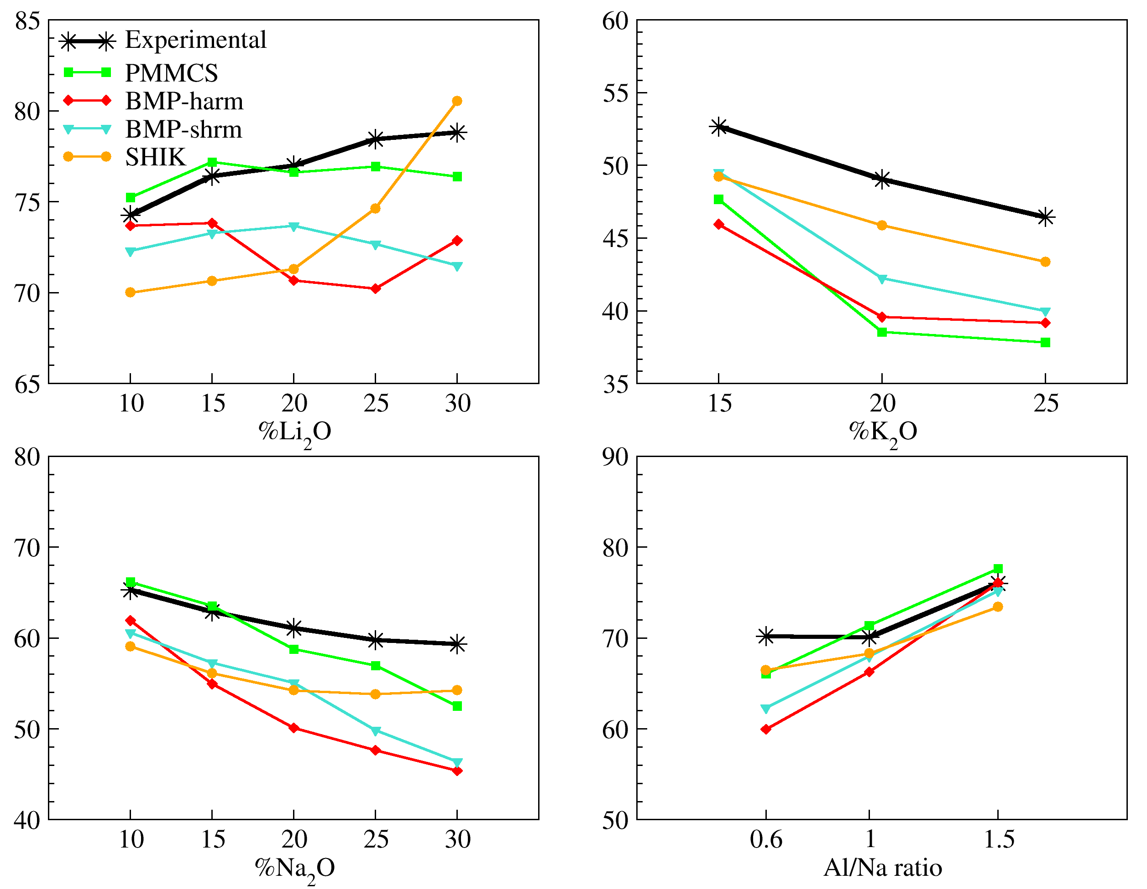
Figure S1. Young modulus of the binary silicate and NAST aluminosilicate glasses calculated with the dynamic method.

Data obtained with this method confirm what observed with the static one reported in the main text. PMMCS still results to be the best potential for the computation of elastic properties, while BMP ones perform slightly worse. SHIK potential demonstrates to be a very good force field for the prediction of Young modulus using the dynamic method, but a part for KS series, PMMCS always performs better. The two BMP potentials seem to reproduce well all the trend, except for the monotonically increasing one of lithium silicates.
2.3 Ionic conductivity calculations.
The total ionic conductivity ($σ$) has been calculated as the sum of contributions ($σ_{i}$) provided by each ionic mobile species (i) in the system:
$σ=\sum_{i}{σ_{i}}=\sum_{i}{c_{i}e\left|z_{i}\right|μ_{i}}$ (S15)
where $c_{i}$ is the concentration of the charge carrier i, $z_{i}$ is the charge and $μ_{i}$ is the ionic mobility, which is defined as the average drift velocity per electric field and is computed in this work through the Nernst-Einstein relation [19]
$μ_{i}=\frac{e\left|z_{i}\right|D_{i}}{k_{B}T}$ (S16)
where $k_{B}$ is the Boltzmann constant and $D_{i}$ is the diffusion coefficient that can be computed through the Einstein relation: [11]
$D=\frac{r^{2}}{2n_{d}Δt}$ (S17)
where n_{d} is the dimensionality of the simulation system, Δt is the change in time over which diffusion is calculated and r² is the Mean Square Displacement (MSD) expressed as
$r^{2}=〈Δ\vec{x}{\left(t\right)}^{2}〉=\frac{1}{N}\sum_{i=1}^{N}{{\left({\vec{x}}_{i}\left(t\right)-{\vec{x}}_{i}\left(0\right)\right)}^{2}}$ (S18)
where N is the number of averaged particles, ${\vec{x}}_{i}\left(0\right)$is an initial reference position, ${\vec{x}}_{i}\left(t\right)$ is the position at time t. To compute the ionic conductivity, NPT-MD simulations of 10 ns were performed for the quenched systems exposed to an electric field of 5 x 10⁵ V/m at a temperature below the glass transition temperature of each system. It is important to note that an effective concentration of charge carriers was used. That means that only the alkali ions that make at least a jump during the simulation timeframe were considered in eq. (S18).
2.4 NMR calculations.
NMR calculations were performed using glass models containing about 400 atoms (see Table SV). Before computing the NMR parameters, the structural models were relaxed at the molecular mechanics level using the four interatomic potentials used to generate them. This procedure differs from the usual MD-GIPAW approach used in our previous works [20–22] where the structural models are relaxed at the DFT level but it allows to better compare the performance of the interatomic potentials models. Chemical shielding and EFG tensors were computed with the NMR-CASTEP [23] density functional theory (DFT) code using the GIPAW [24] and PAW [25] algorithms, respectively. The generalized gradient approximation (GGA) PBE [26] functional was employed, and the core-valence interactions were described by ultrasoft pseudopotentials generated on the fly with parameters stated in Table SVI.
All the DFT calculations have been performed at the Γ point using plane waves with the kinetic energy cutoff of 610 eV, this has been demonstrated to be long enough to reach energy, and NMR chemical shift converged values. Further, to fix the ²⁹Si, ¹⁷O, ³¹P, and ²⁷Al, δ scale, the same structural relaxation with the studied interatomic potential used for glasses has been applied to α-quartz (SiO₂), Li₃PO₄, and γ-LiAlO₂ to obtain different values of σ_{ref}, using the formula σ_{ref} = σ_{iso} + δ_{iso}. Values are reported in Table SVII. The experimentally determined quadrupolar moment, eQ, of 140.4 and 25.58 mB were used for the ²⁷Al and ¹⁷O atoms.
The simulation of the solid-state MAS and isotropic spectra from the CASTEP outputs has been carried out using the software SoSNMR. [27]
Table SV. Number of atomic species in the simulation boxes used for the NMR calculations.
 | Si | Al | P | Na | K | Li | Ca | O | tot
LS33 | 80 |  |  |  |  | 80 |  | 200 | 360
NS33 | 80 |  |  | 80 |  |  |  | 200 | 360
KS33 | 80 |  |  |  | 80 |  |  | 200 | 360
NASR-1 | 57 | 57 |  | 57 |  |  |  | 228 | 399
NCP |  |  | 85 | 17 |  |  | 34 | 255 | 391
NCPS_2.11 | 71 |  | 8 | 76 |  |  | 41 | 241 | 437

Table SVI. Pseudopotential details
Atom | Valence configuration used for  ultra-soft pseudopotential generation | Core radii [a.u.] | Angular momentum  local channel projectors
²⁹Si | 3s² 3p² | 1.8 | s, p and d
²⁷Al | 3s² 3p¹ | 1.8 | s, p and d
¹⁷O | 2s² 2p⁴ | 1.3 | s and p
⁴³Ca ^{(a)} | 3s² 3p⁶ 4s² | 2.0 | s, p and d
²³Na | 2s² 2p⁶ 3s¹ | 1.3 | S
³¹P | 3s² 3p³ | 1.8 | s, p and d
- 3d level shifted as suggested by Profeta et Al. [28]

Table SVII. σ_{ref} values for the different nuclei and potentials
 | PMMCS | SHIK | Coreshell | BMP-harm | BMP-shrm
²⁹Si | 328.14 | 331.48 | 320.51 | 327.60 | 323.42
²⁷Al | 550.07 | 556.65 | 554.95 | 552.26 | 552.26
¹⁷O | 260.50 | 260.50 | 260.50 | 260.50 | 260.50
³¹P | 286.00 |  | 278.97 | 288.90 | 288.89

- Results
  - Density
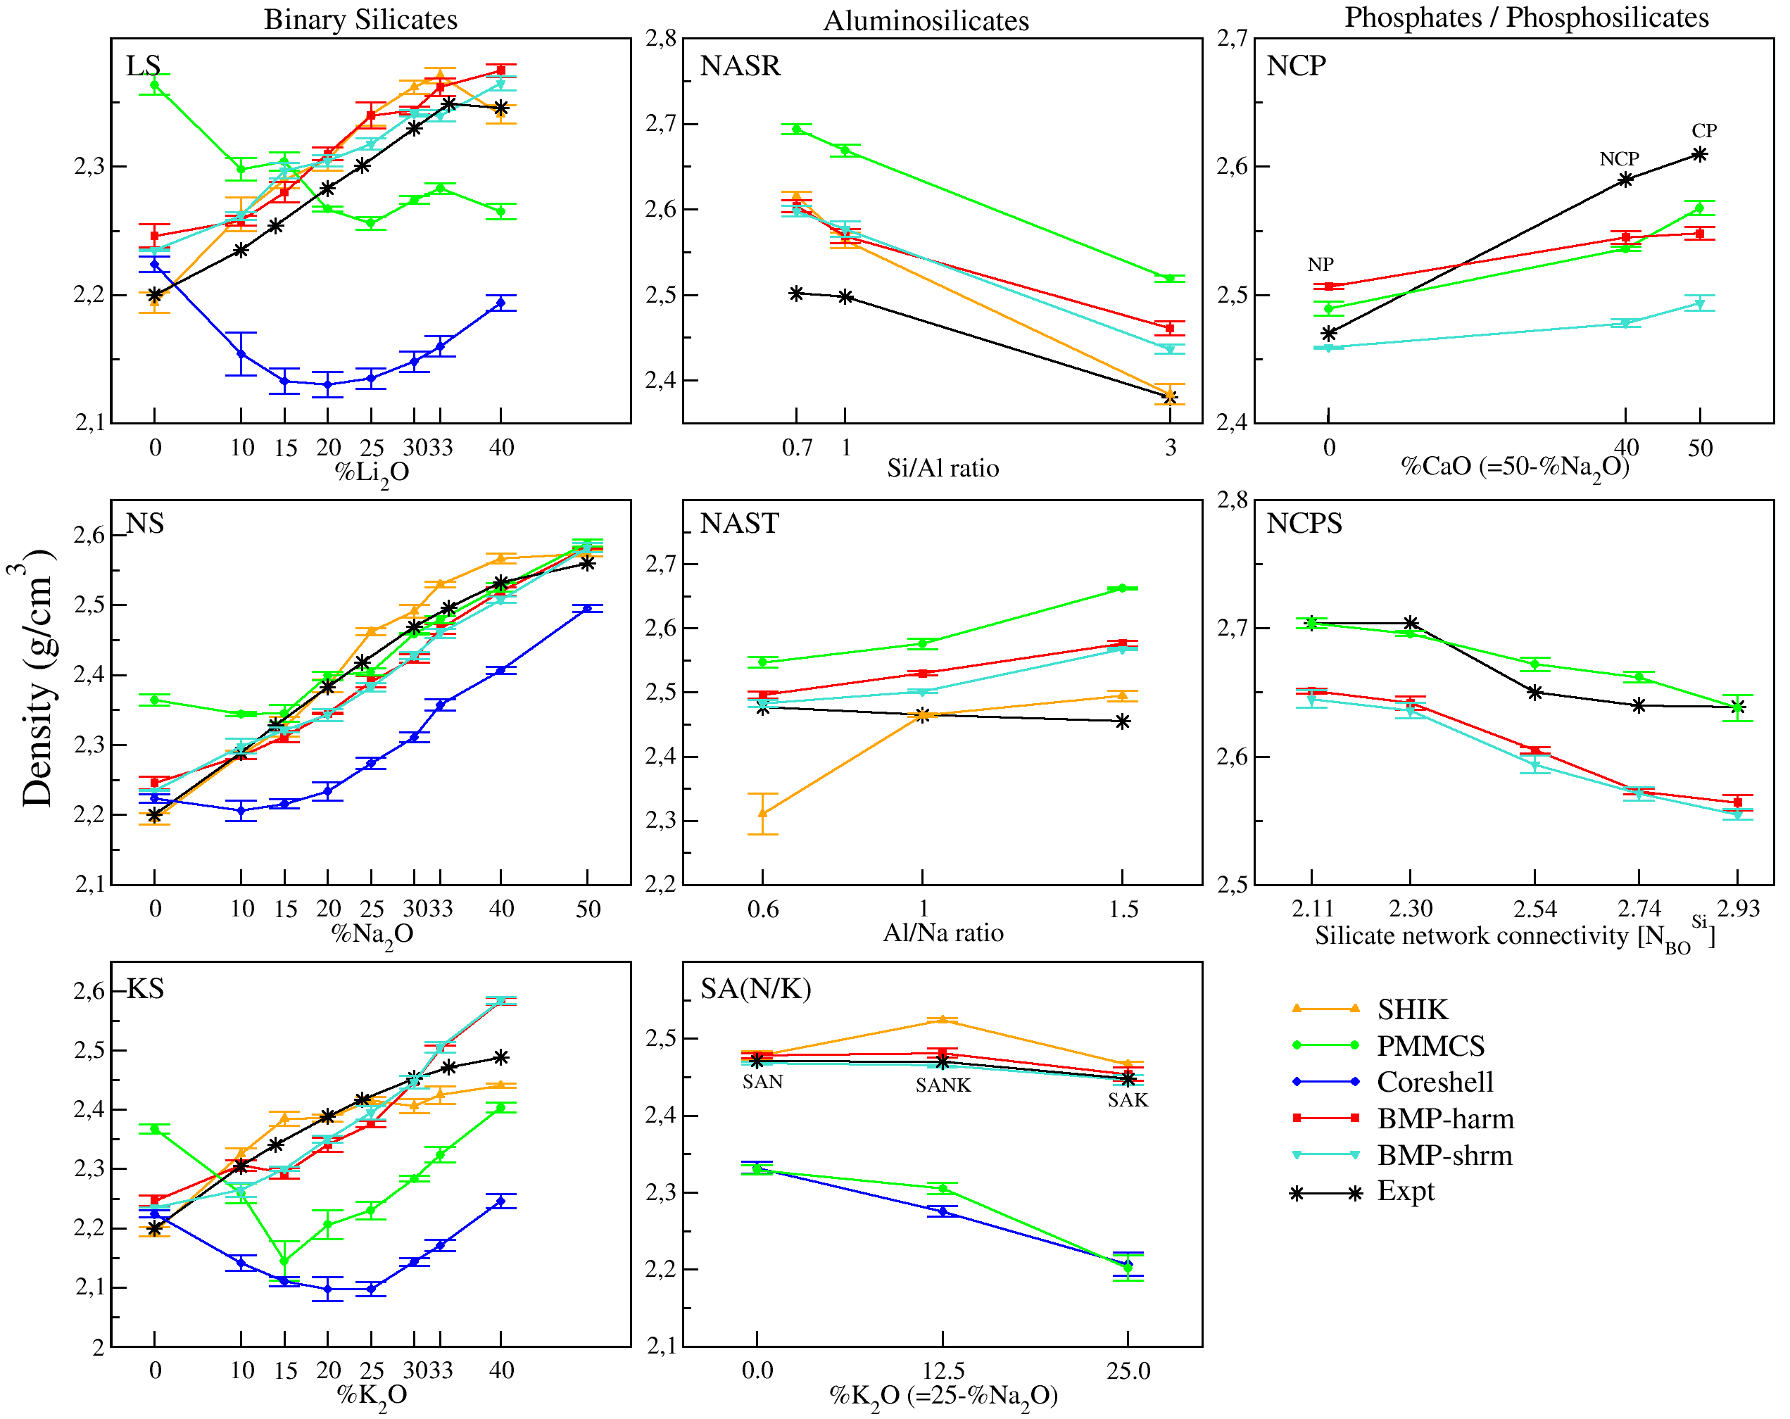
Figure S2. Density trends along the glass series investigated.
  - Total Neutron Distribution Functions
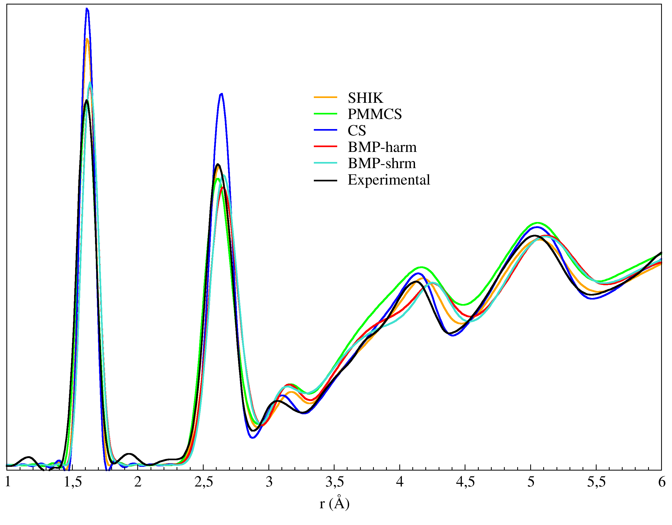
Figure S3. Simulated and experimental total neutron distribution functions of v-silica.
  - Aluminum and phosphorus coordination
An important structural detail is the amount of 5-fold coordinated P and Al ions in the glasses. Table SVIII reports the amount of 5-coordinated P and Al ions in all the phosphate and aluminosilicate glasses studied with the different FFs. Regarding the coordination of Al, previous investigations showed that the PMMCS provides a not negligible amount of 5-coordinated Al ions in glass compositions, in contrast with the 4-coordination always found in the experimental studies. [29,30] The core-shell force field is the only one that always shows the complete absence of 5-folded Al; this is expected since CS forces this coordination by the application of the O-T-O three-body potentials (T=Si, Al, P). Both the BMP potentials provide lower AlO₅ amounts for all the studied aluminosilicates with respect to the other Rigid-Ion models studied here, showing values under 0.1% for all investigated glasses except NAST-1 and NAST-0.6 (for the latter only BMP-shrm shows %AlO₅ > 0.1, in particular, 0.3%), while SHIK and PMMCS potentials provide higher values: up to 1.1 and 3.3%, respectively. For sake of simplicity, here we do not report the data of the SAN/K series, but they totally agree with all the considerations made for the other aluminosilicate glass series. Data obtained with CS, SHIK, and PMMCS for the SAN/K have been reported in a previous work. [31] As for the coordination of P, CS and BMP-shrm are the only studied potentials that always predicts 0% of 5-folded P, in agreement with experiments. [32] BMP-harm provides good values, in fact %P⁽⁵⁾ < 0.5% for all the studied phosphate glasses, while PMMCS always gives %P⁽⁵⁾ > 1.4%, with 2.2% for NCP glass.
Table SVIII. Percentage of 5-fold coordinated Al and P atoms in the aluminosilicate and phosphate glasses investigated. In bracket the standard deviation
%AlO₅ | Data (standard deviation)
%AlO₅ | PMMCS | SHIK | Coreshell | BMP-shrm | BMP-harm
NASR-0.7 | 3.307 (1.339) | 0.619 (0.410) | 0.000 (0.000) | 0.065 (0.061) | 0.040 (0.050)
NASR-1 | 1.655 (0.112) | 0.636 (0.562) | 0.000 (0.000) | 0.045 (0.036) | 0.069 (0.088)
NASR-3 | 0.889 (0.618) | 0.369 (0.167) | 0.000 (0.000) | 0.005(0.009) | 0.016 (0.022)
NAST-1.5 | 1.540 (0.602) | 1.075 (0.527) | 0.000 (0.000) | 0.023 (0.039) | 0.083 (0.062)
NAST-1 | 1.010 (0.314) | 0.466 (0.269) | 0.000 (0.000) | 0.165 (0.122) | 0.140 (0.112)
NAST-0.6 | 0.433 (0.152) | 0.777 (0.746) | 0.000 (0.000) | 0.300 (0.143) | 0.012 (0.015)
%PO₅ | Data (standard deviation)
%PO₅ | PMMCS | SHIK | Coreshell | BMP-shrm | BMP-harm
NP | 1.483 (0.740) | - | 0.000 (0.000) | 0.000 (0.000) | 0.370 (0.094)
NCP | 2.208 (0.605) | - | 0.010 (0.010) | 0.000 (0.000) | 0.415 (0.174)
CP | 2.108 (0.482) | - | 0.000 (0.000) | 0.000 (0.000) | 0.475 (0.201)
3.4 Bond Angle Distributions
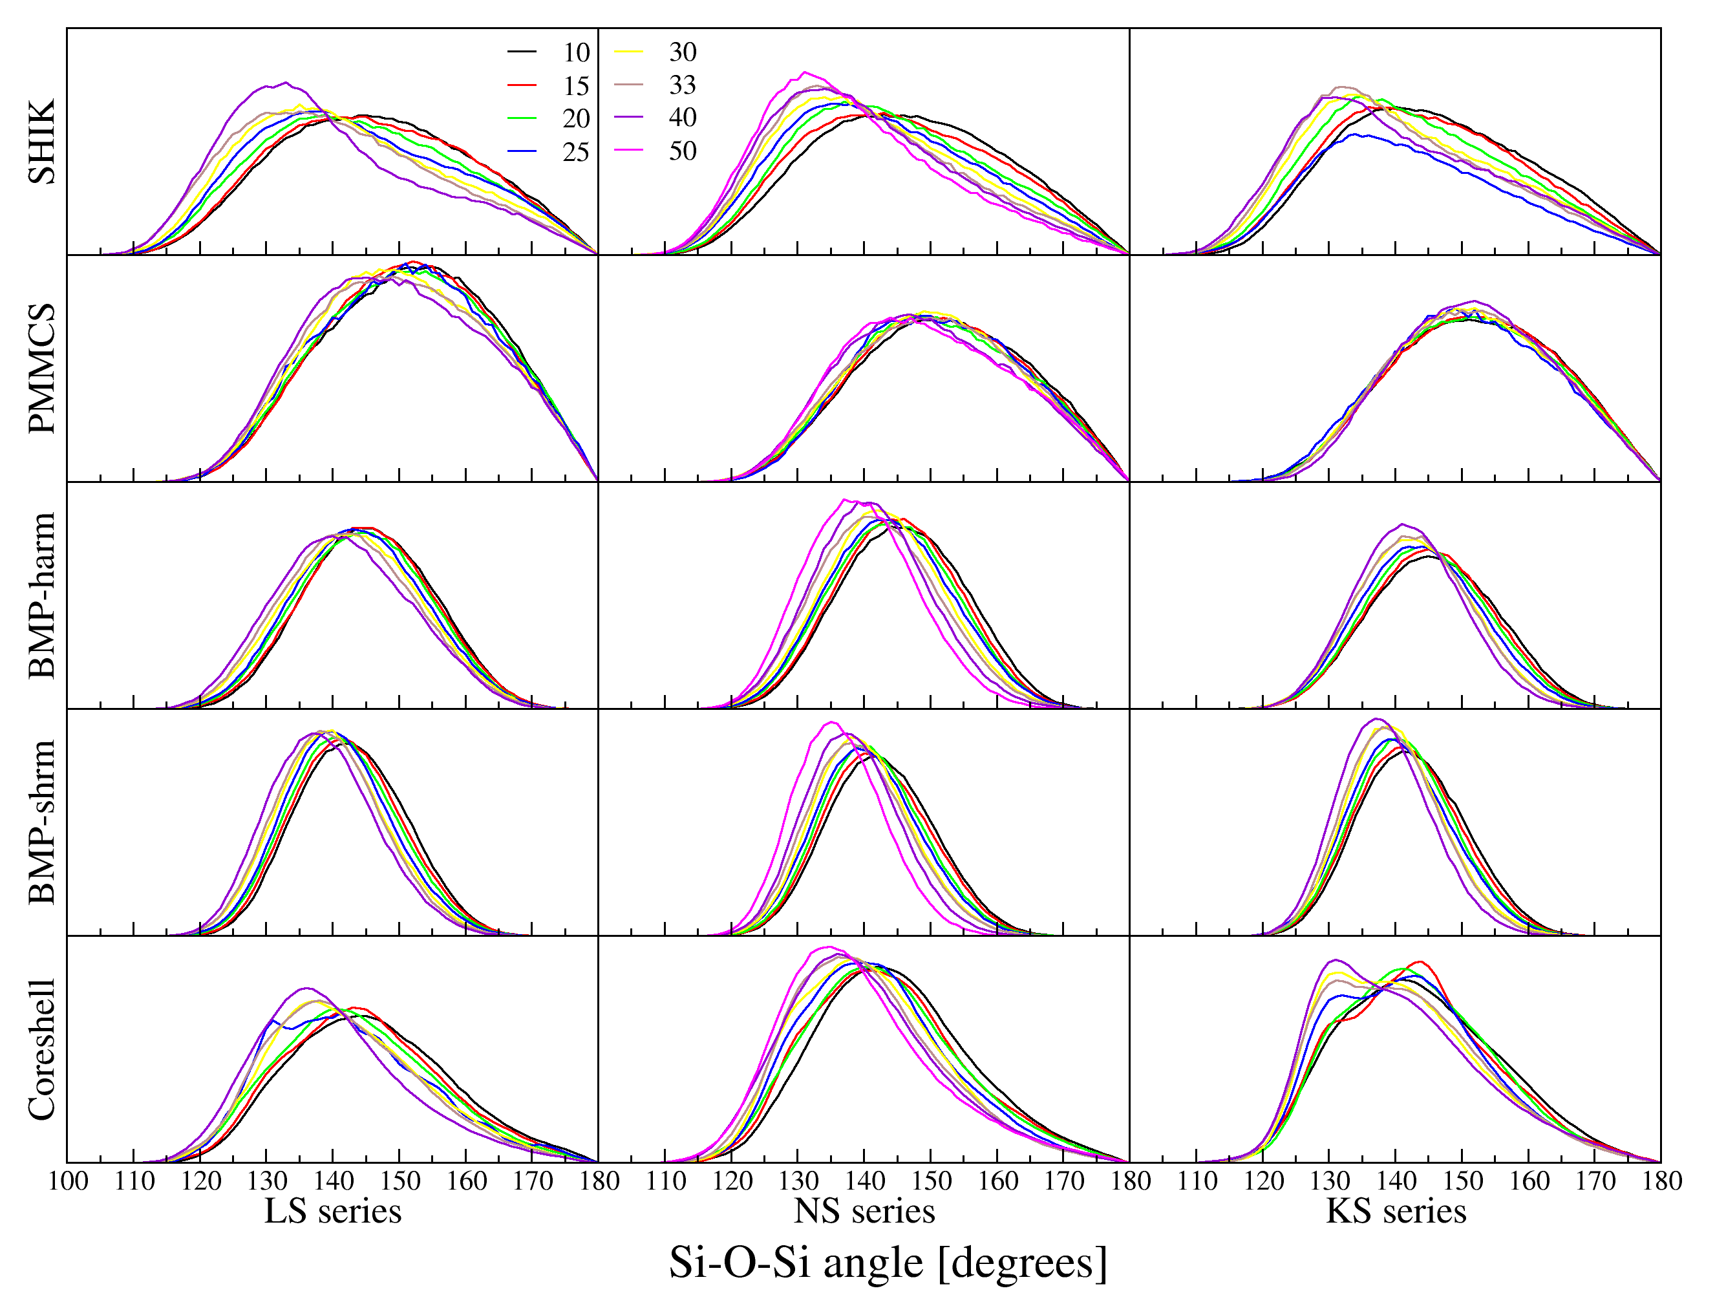
Figure S4. Si-O-Si BADs for the binary alkali silicate glasses investigated.
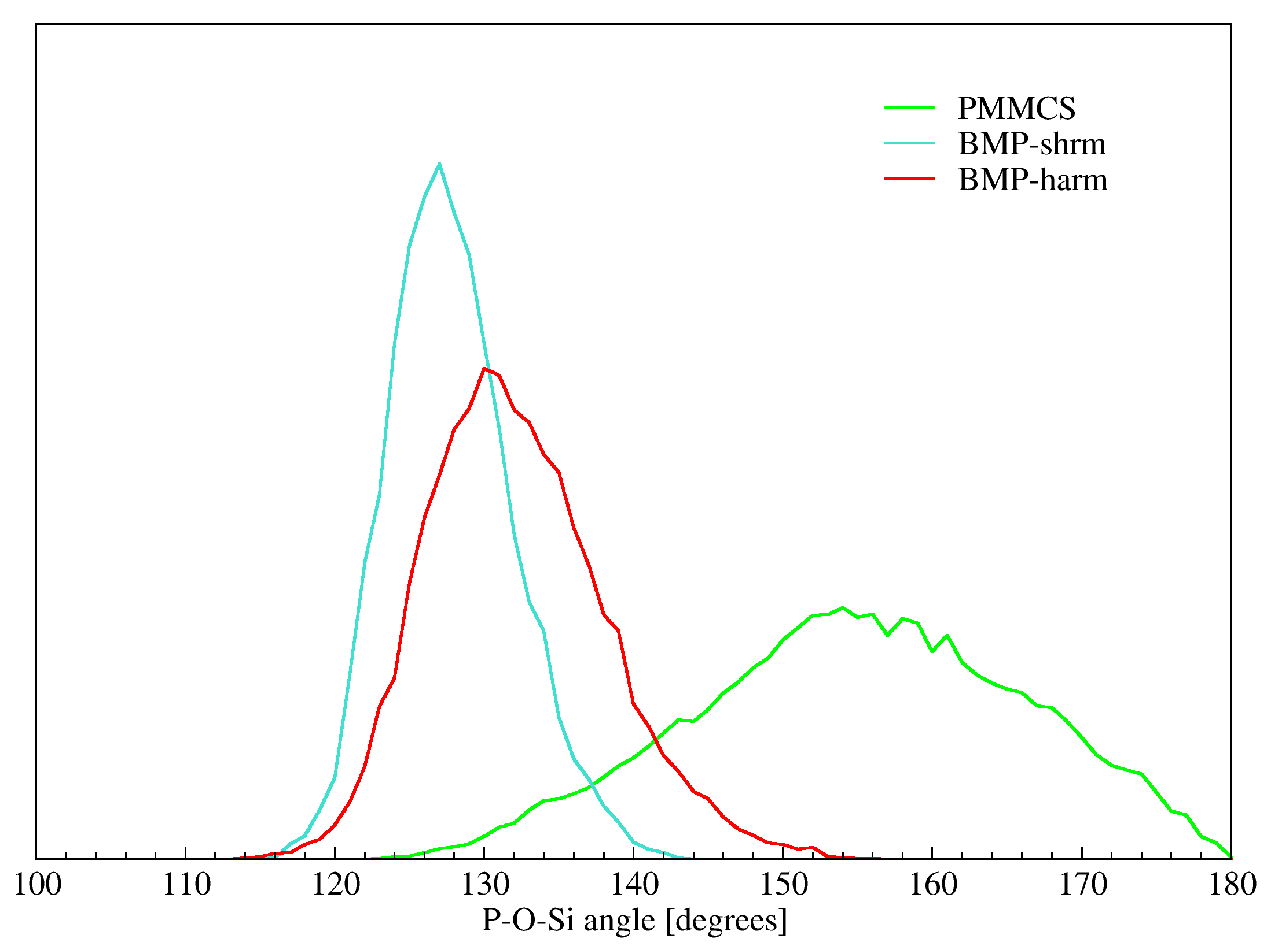
Figure S5. P-O-Si bond angle distributions in the NCPS_2.93 phosphosilicate glass calculated with PMMCS, BMP-harm, and BMP-shrm potentials.

3.5 Q^{n} distributions.
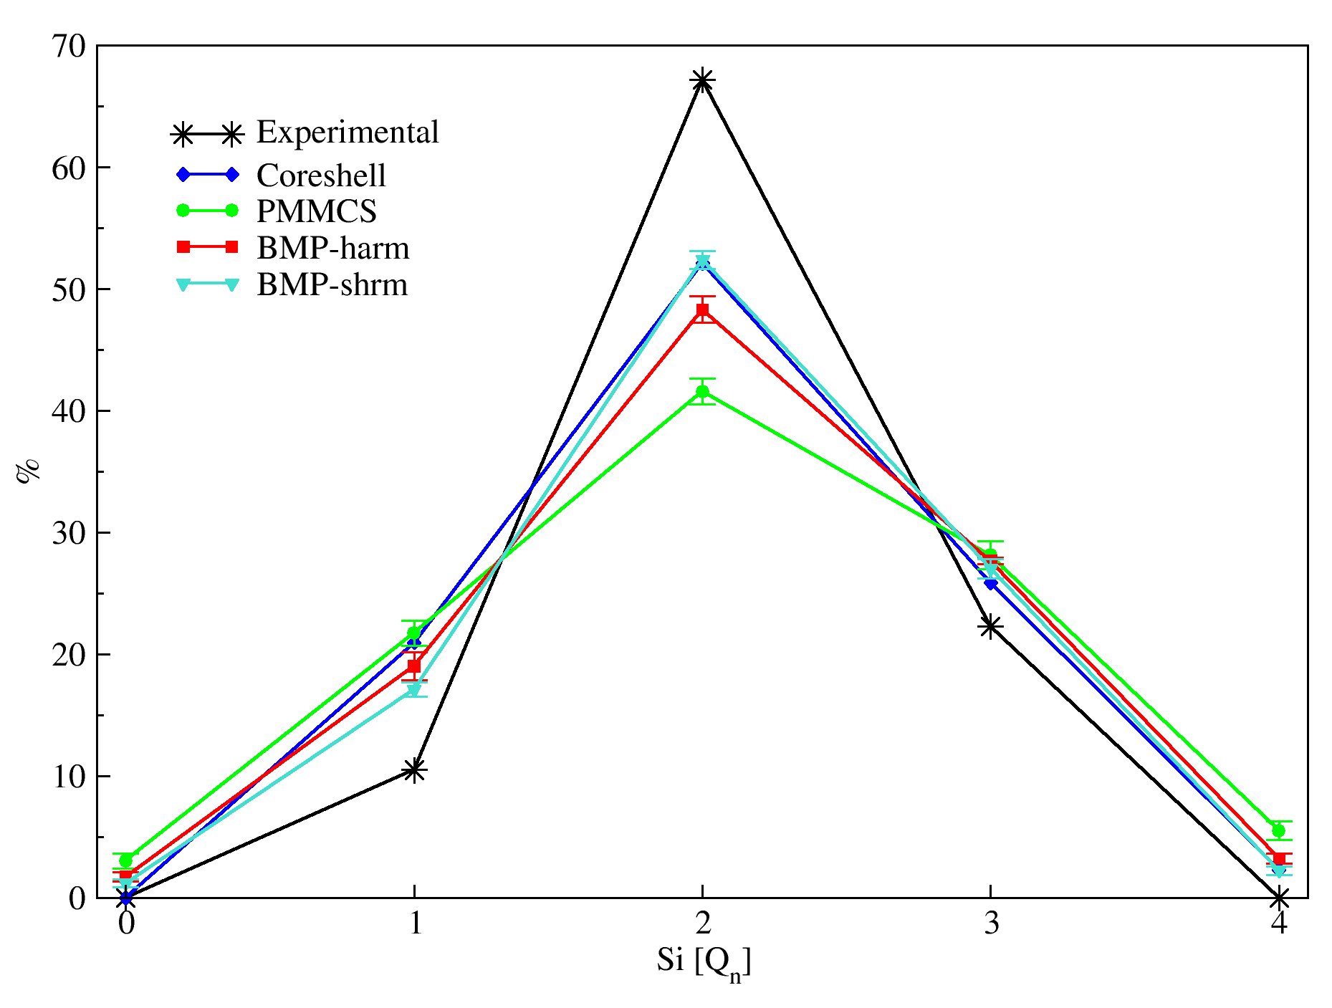
Figure S6. Q^{n} distribution of Silicon in the NCPS_2.11 glass (45S5 Bioglass®) computed with the BMP-harm, BMP-shrm, PMMCS, and CS potentials.

3.6 VDOS
The vibrational density of states of v-SiO₂ has been calculated with BMP potentials and compared to the one obtained with the original PMMCS and with experiment from inelastic neutron scattering measurement [33] (Figure S7). The structures, obtained by the melt-quench procedure on boxes containing 1500 atoms with the different potentials, have been optimized at constant pressure (0 GPa) at molecular mechanic level. The VDOS has been calculated at the Γ point with the different FFs by direct diagonalization of the weighted Hessian matrix using the GULP code. [8]
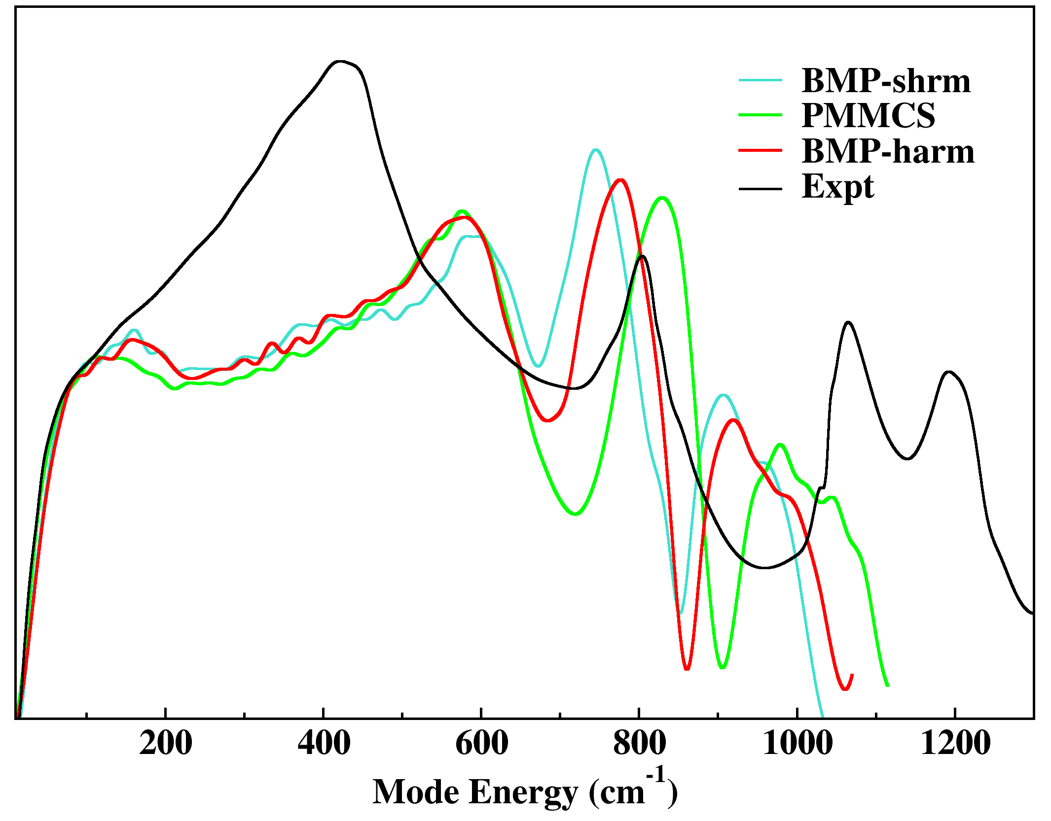
Figure S7. Vibrational Density of State (VDOS) of vitreous silica obtained with PMMCS, BPM-harm, and BMP-shrm potentials compared with the experimental one.

The two peaks at lower frequencies are strongly overlapped because of the broadening of the band due to structural disorder of glasses, and assume the shape of a high peak at ~400 cm⁻¹ with a shoulder around 100cm⁻¹, called low-energy boson peak. [34] In the region at higher energy, two main bands can be recognized: one at ~800 cm⁻¹, related to the Si-O-Si bending mode, and a double peak at ~1100-1200 cm⁻¹ related to the longitudinal and transverse stretching vibrations of the SiO₄ units. [35]
The first peak is well reproduced by all the potentials. This is important because a good description of the low-energy vibrational modes is required for accurate thermodynamic parameters calculations. [36] None of the reported potentials show a good agreement with the second peak at ~400 cm⁻¹ providing a lower one at higher energy. The third peak of the experimental VDOS is overestimated by all the potential, especially by BMP-shrm, which provide also the worst position. BMP-harm and PMMCS perform better for what concerns the position of this peak, slightly underestimating and overestimating it, respectively. The double peak at high energy is not well reproduces neither in the shape nor in the position by all the reported potentials. The separation in this peak is not evident in the simulated spectra, where only a shoulder is present, becoming more evident from PMMCS to BMP-harm and BMP-shrm.

References.
[1] D. Wolf, P. Keblinski, S. R. Phillpot, and J. Eggebrecht, Exact Method for the Simulation of Coulombic Systems by Spherically Truncated, Pairwise R−1 Summation, J. Chem. Phys. 110, 8254 (1999).
[2] S. Sundararaman, L. Huang, S. Ispas, and W. Kob, New Interaction Potentials for Alkali and Alkaline-Earth Aluminosilicate Glasses, J Chem Phys 150, 154505 (2019).
[3] S. Sundararaman, L. Huang, S. Ispas, and W. Kob, New Optimization Scheme to Obtain Interaction Potentials for Oxide Glasses, J. Chem. Phys. 148, 194504 (2018).
[4] B. G. Dick and A. W. Overhauser, Theory of the Dielectric Constants of Alkali Halide Crystals, Phys. Rev. 112, 90 (1958).
[5] A. Tilocca, N. H. de Leeuw, and A. N. Cormack, Shell-Model Molecular Dynamics Calculations of Modified Silicate Glasses, Phys. Rev. B 73, 104209 (2006).
[6] A. Pedone, E. Gambuzzi, G. Malavasi, and M. C. Menziani, First-Principles Simulations of the Al-27 and O-17 Solid-State NMR Spectra of the CaAl₂Si₃O₁₀ Glass, Theor. Chem. Acc. 131, 1147 (2012).
[7] J. D. Gale, Empirical Potential Derivation for Ionic Materials, Philos. Mag. B 73, 3 (1996).
[8] J. D. Gale and A. L. Rohl, The General Utility Lattice Program (GULP), Mol. Simul. 29, 291 (2003).
[9] WWW-MINCRYST - CRYSTALLOGRAPHIC DATABASE FOR MINERALS, http://database.iem.ac.ru/mincryst/index.php.
[10] W. Smith and T. R. Forester, DL_POLY_2.0: A General-Purpose Parallel Molecular Dynamics Simulation Package, J. Mol. Graph. 14, 136 (1996).
[11] M. P. Allen, M. P. Allen, D. J. Tildesley, and D. J. Tildesley, Computer Simulation of Liquids (Clarendon Press, 1989).
[12] L. Deng and J. Du, Effects of System Size and Cooling Rate on the Structure and Properties of Sodium Borosilicate Glasses from Molecular Dynamics Simulations, J. Chem. Phys. 148, 024504 (2018).
[13] X. Li, W. Song, K. Yang, N. M. A. Krishnan, B. Wang, M. M. Smedskjaer, J. C. Mauro, G. Sant, M. Balonis, and M. Bauchy, Cooling Rate Effects in Sodium Silicate Glasses: Bridging the Gap between Molecular Dynamics Simulations and Experiments, J. Chem. Phys. 147, 074501 (2017).
[14] M. Pota, A. Pedone, G. Malavasi, C. Durante, M. Cocchi, and M. C. Menziani, Molecular Dynamics Simulations of Sodium Silicate Glasses: Optimization and Limits of the Computational Procedure, Comput. Mater. Sci. 47, 739 (2010).
[15] A. Tilocca, Cooling Rate and Size Effects on the Medium-Range Structure of Multicomponent Oxide Glasses Simulated by Molecular Dynamics, J. Chem. Phys. 139, 114501 (2013).
[16] K. Vollmayr, W. Kob, and K. Binder, Cooling-Rate Effects in Amorphous Silica: A Computer-Simulation Study, Phys. Rev. B 54, 15808 (1996).
[17] A. Pedone, G. Malavasi, M. C. Menziani, U. Segre, and A. N. Cormack, Molecular Dynamics Studies of Stress-Strain Behavior of Silica Glass under a Tensile Load, Chem. Mater. 20, 4356 (2008).
[18] P. K. Gupta and C. R. Kurkjian, Intrinsic Failure and Non-Linear Elastic Behavior of Glasses, J. Non-Cryst. Solids 351, 2324 (2005).
[19] C. Müller, E. Zienicke, S. Adams, J. Habasaki, and P. Maass, Comparison of Ion Sites and Diffusion Paths in Glasses Obtained by Molecular Dynamics Simulations and Bond Valence Analysis, Phys. Rev. B 75, 014203 (2007).
[20] M. Fortino, A. Berselli, N. Stone‐Weiss, L. Deng, A. Goel, J. Du, and A. Pedone, Assessment of Interatomic Parameters for the Reproduction of Borosilicate Glass Structures via DFT-GIPAW Calculations, J. Am. Ceram. Soc. 102, 7225 (2019).
[21] A. Pedone, Recent Advances in Solid-State NMR Computational Spectroscopy: The Case of Alumino-Silicate Glasses, Int. J. Quantum Chem. 116, 1520 (2016).
[22] T. Charpentier, M. C. Menziani, and A. Pedone, Computational Simulations of Solid State NMR Spectra: A New Era in Structure Determination of Oxide Glasses, Rsc Adv. 3, 10550 (2013).
[23] M. D. Segall, P. J. D. Lindan, M. J. Probert, C. J. Pickard, P. J. Hasnip, S. J. Clark, and M. C. Payne, First-Principles Simulation: Ideas, Illustrations and the CASTEP Code, J. Phys.-Condens. Matter 14, 2717 (2002).
[24] C. J. Pickard and F. Mauri, All-Electron Magnetic Response with Pseudopotentials: NMR Chemical Shifts, Phys. Rev. B 63, 245101 (2001).
[25] P. E. Blöchl, Projector Augmented-Wave Method, Phys. Rev. B 50, 17953 (1994).
[26] J. P. Perdew, K. Burke, and M. Ernzerhof, Generalized Gradient Approximation Made Simple, Phys. Rev. Lett. 77, 3865 (1996).
[27] D. Presti, A. Pedone, D. Licari, and V. Barone, A Modular Implementation for the Simulation of 1D and 2D Solid-State NMR Spectra of Quadrupolar Nuclei in the Virtual Multifrequency Spectrometer-Draw Graphical Interface, J. Chem. Theory Comput. 13, 2215 (2017).
[28] M. Profeta, M. Benoit, F. Mauri, and C. J. Pickard, First-Principles Calculation of the 17O NMR Parameters in Ca Oxide and Ca Aluminosilicates: The Partially Covalent Nature of the Ca−O Bond, a Challenge for Density Functional Theory, J. Am. Chem. Soc. 126, 12628 (2004).
[29] Y. Xiang, J. Du, M. M. Smedskjaer, and J. C. Mauro, Structure and Properties of Sodium Aluminosilicate Glasses from Molecular Dynamics Simulations, J. Chem. Phys. 139, 044507 (2013).
[30] T. Charpentier, K. Okhotnikov, A. N. Novikov, L. Hennet, H. E. Fischer, D. R. Neuville, and P. Florian, Structure of Strontium Aluminosilicate Glasses from Molecular Dynamics Simulation, Neutron Diffraction, and Nuclear Magnetic Resonance Studies, J. Phys. Chem. B 122, 9567 (2018).
[31] F. Lodesani, M. C. Menziani, H. Hijiya, Y. Takato, S. Urata, and A. Pedone, Structural Origins of the Mixed Alkali Effect in Alkali Aluminosilicate Glasses: Molecular Dynamics Study and Its Assessment, Sci. Rep. 10, 1 (2020).
[32] R. K. Brow, Review: The Structure of Simple Phosphate Glasses, J. Non-Cryst. Solids 263–264, 1 (2000).
[33] A. Hiramatsu, M. Arai, H. Shibazaki, M. Tsunekawa, T. Otomo, A. C. Hannon, S. M. Bennington, N. Kitamura, and A. Onodera, Investigation on Permanently Densified Vitreous Silica by Means of Neutron Scattering, Phys. B Condens. Matter 219–220, 287 (1996).
[34] U. Buchenau, M. Prager, N. Nücker, A. J. Dianoux, N. Ahmad, and W. A. Phillips, Low-Frequency Modes in Vitreous Silica, Phys. Rev. B 34, 5665 (1986).
[35] M. Handke and W. Mozgawa, Model Quasi-Molecule Si2O as an Approach in the IR Spectra Description Glassy and Crystalline Framework Silicates, J. Mol. Struct. 348, 341 (1995).
[36] P. C. M. Fossati, T. A. Mellan, N. Kuganathan, and W. E. Lee, Atomistic Modeling Approach to the Thermodynamics of Sodium Silicate Glasses, J. Am. Ceram. Soc. 104, 1331 (2021).

