Cellular uptake and metabolic degradation of a conjugate of folic acid with an anticancer peptide targeting the human Thymidylate synthase.

Lorenzo Tagliazucchi *, Gaetano Marverti **, Domenico D’Arca **, Glauco Ponterini *, Maria Paola Costi*

* Dept. Life Sciences, Via Campi 103, University of Modena and Reggio Emilia, 41125, Modena
** Dept. Biomedical, Metabolic and Neural Sciences, Via Campi 287, University of Modena and Reggio Emilia

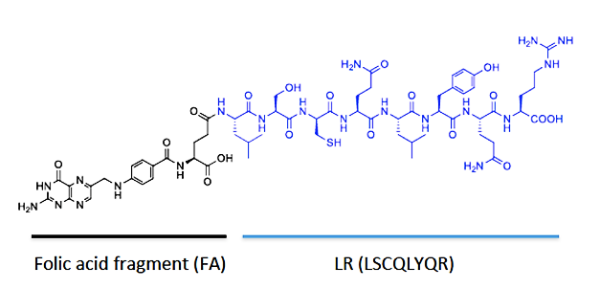
Human Thymidylate synthase (hTS) is an enzyme that catalyses the conversion of deoxyuridine monophosphate (dUMP) to deoxythymidine monophosphate (dTMP), and the key enzyme of folate cycle for the DNA biosynthesis. We have designed a novel hTS monomer-monomer peptide inhibitor conjugated with folic acid (Figure 1) to improve cellular targeting towards folate receptor α (FRα), overexpressed in cancer cells. In in-vitro studies on different cancer cell lines, FA-LR conjugate showed nanomolar affinity towards FRα, and 250nM affinity for the interface of hTS, with a non-competitive/mixed inhibition mechanism. Furthermore, FA-LR does not induce folate cycle enzyme overexpression, unlike 5-fluorouracil.
Figure 1. FA-LR conjugated peptide
We performed LC-MS studies to assess in vitro cellular uptake and metabolism to characterize FA-LR subcellular stability and its degradation steps. FA-LR was delivered to C13* cells overexpressing FRα, at 5µM at different time lapses. Isolated cellular cytosols were collected, diluted, and analysed with an Ultimate™ UPLC coupled to an Orbitrap Q-Exactive™ high-resolution mass spectrometer.

The data were normalized to cell count per sample and average C13* cytosolic volume to obtain the analytes real concentration for a singular cytoplasm. FA-LR showed an initial extended FRα uptake, 4-fold higher than the extracellular drug concentration (18.6µM). Measurements over time suggest a 1st order kinetic degradation of the conjugated peptide, with an intracellular half-life of about 4 hours (Figure 2).
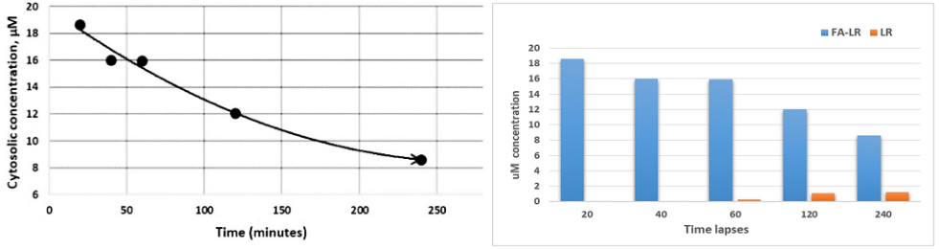
The free-LR peptide shows an undetectable concentration 20mins after the administration and rises to 14% of the total FA-LR conjugate dose 4 hours after the treatment, indicating that peptide release is progressively increasing as a metabolic product of the conjugate (Figure 3). A wide set of other possible metabolites and conjugate adducts have been quantified, including LR-Cys-disulphide, the oxidation product of two LR monomers (LRs-sLR), LYQR and QLYQR hydrolysis catabolites. Relatively small concentration of LR disulphide dimer were also measured constant over time, and an interesting LR-glutathione adduct is reported to form just after FA-LR administration- which would be undetectable after 4 hours- when negligible amount of inactive QLYQR degradation peptide is formed. The spectrometric study confirmed that FA-LR undergoes 1st order degradation kinetics with a cytosolic t _{½} of about 4 hours, and it releases an amount of free-LR peptide which is also able to inhibit hTS dimer interface. This ensures quite a long-lasting action of the novel inhibitor at a moderate administration dose without the onset of enzyme resistance mechanisms, thus avoiding hTS overexpression.
The results obtained support the concept that FA-LR is a promising candidate for the development of selective agents for ovarian cancer overexpressing (FRα).
Figures 2 and 3. FA-LR time measurement and FA-LR / LR ratio

Wilson PM, Danenberg PV, Johnston PG, Lenz HJ, Ladner RD. 2014. Standing the test of time: targeting thymidylate biosynthesis in cancer therapy. Nature Reviews Clinical Oncology, 11:282-298.
Cardinale D, Guaitoli G, Tondi D, Luciani R, Henrich S, Salo-Ahen O, Ferrari S, Marverti G, Guerrieri D, Ligabue A, Frassineti C, Pozzi C, Mangani S, Fessas D, Guerrini R, Ponterini G, Wade R, Costi MP. 2011. Protein-protein interface-binding peptides inhibit the cancer therapy target human thymidylate synthase. PNAS. 108. E542-9.

