Physical insights into trapping effects on vertical GaN-on-Si Trench MOSFETs from TCAD
Nicolò Zagni^{1, †}, Manuel Fregolent^{2, †}, Andrea Del Fiol², Davide Favero², Francesco Bergamin², Giovanni Verzellesi^{3,4}, Carlo De Santi², Gaudenzio Meneghesso², Enrico Zanoni², Christian Huber⁵, Matteo Meneghini², and Paolo Pavan¹
¹Department of Engineering “Enzo Ferrari”, University of Modena and Reggio Emilia, 41125, Modena, Italy ²Department of Information Engineering, University of Padova, 35131 Padova, Italy
³Department of Sciences and Methods for Engineering (DISMI), University of Modena and Reggio Emilia, 42122, Reggio Emilia, Italy
⁴EN&TECH Center, University of Modena and Reggio Emilia, 42122, Reggio Emilia, Italy
⁵Advanced Technologies and Micro Systems Department, Robert Bosch GmbH, 71272, Renningen, Germany

Abstract: Vertical GaN power MOSFET is a novel technology that offers great potential for power switching applications. Being still in an early development phase, vertical GaN devices are yet to be fully optimized and require careful studies to foster their development. In this work, we report on the physical insights into device performance improvements obtained during the development of vertical GaN-on-Si Trench MOSFETs (TMOS’s) provided by TCAD simulations, enhancing the dependability of the adopted process optimization approaches. Specifically, two different TMOS devices are compared in terms of transfer-curve hysteresis (H) and subthreshold slope (SS), showing a ≈75% H reduction along with a ≈30% SS decrease. Simulations allow attributing the achieved improvements to a decrease in the border and interface traps, respectively. A sensitivity analysis is also carried out, allowing to quantify the additional trap density reduction required to minimize both figures of merit.

Key words: Vertical GaN Trench MOSFET; SiO₂; Interface Traps; Border Traps; Hysteresis; BTI

1. Introduction
Lateral Gallium-nitride (GaN) field-effect transistors are currently being employed as switches for efficient power conversion. While lateral GaN High Electron Mobility (HEMTs) are already commercially available, vertical counterparts are still in a relatively early development phase, and intensive research is undergoing to harness their advantages over the lateral devices in high power applications [1], [2]. These advantages stem from the fact that in vertical transistors the drift region develops through the device depth (instead of length); this design allows increasing the maximum blocking voltage without extending laterally the device and allows for the peak electric field to be far from the device surface, enhancing both stability and reliability [2], [3]. Consequently, vertical devices operating safely in the kV range can be designed with relatively small area and that are naturally immune from common drawbacks that vex lateral devices operation (e.g., current-collapse, dynamic R_{ON}, etc.) [3]–[7]. Furthermore, reliable and unclamped inductive switching in converter circuits employing vertical GaN devices can be achieved thanks to their avalanche capability [8]–[10]. However, vertical GaN devices are yet to be fully optimized and suffer from stability and reliability issues of their own [11], particularly regarding the gate oxide and its interface with GaN [2], [11]–[13].
In this work, we investigated the influence of gate oxide optimization on the transfer characteristics hysteresis (H) and subthreshold-slope (SS) of two different pseudo-vertical GaN-on-Si Trench MOSFETs (TMOS’s). Experimental characterization was carried out to quantify the hysteresis and its dependence on the maximum gate-source voltage applied, whereas TCAD simulations were adopted to gain insight into the observed H and SS reduction obtained with device B with respect to device A. Our analysis allows to entirely attribute the presence of the hysteresis to electron trapping into border traps, i.e., to trap states located in the gate oxide at a tunneling range from the oxide/semiconductor interface, and the observed H improvement from device A to device B to a 4× reduction in the border-trap density. SS is instead mainly governed by interface traps and its improvement can be ascribed to a 2× decrease in their density. Moreover, the mobility improvement between the two devices can be attributed to increased SiO₂/GaN interface quality that reduces the amount of interface traps.

2. Devices and Experimental Results
Devices Under Test (DUT’s) in this work are pseudo-vertical GaN Trench MOSFETs (TMOS’s) on 150 mm GaN-on-Si wafers. The MOS gate stack was based on an LPCVD SiO₂ gate dielectric with polysilicon gate electrode which has previously been shown to be suitable for GaN planar MOSFETs [14], [15]. The schematic 2-D device structure is shown in Fig. 1. The epitaxial GaN stack from bottom to top consists of a strain-relief buffer layer and a n⁺ drain layer (1 µm) to achieve ohmic contact with the drain metal. The drain contact is deposited on the surface laterally with respect to the device active mesa region which consists of a n⁻ drift region (1 µm), a p body channel region (0.5 µm) and a n⁺ source layer (0.3 µm). The nominal magnesium concentration in the p body layer is 10¹⁹ cm⁻³. It should be noted that the thickness of n⁻ drift region is too low to block considerable voltages. Indeed, its thickness was on purpose chosen such that its resistance contribution is minor compared to the channel resistance. The gate trench was formed by chlorine plasma etching followed by wet treatment in TMAH in order to reduce crystal damage induced by the dry etch process and selectively prepare the m-plane of the GaN crystal.
The deposition of the 70-nm silicon dioxide (SiO₂) single-layer gate dielectric differed in the two devices (A and B) considered in this work. For device A, gate oxide was deposited by low-pressure chemical vapor deposition at 785 °C with a post-deposition anneal at 800 °C, whereas for device B, SiO₂ deposition was carried out at 880 °C with a post-deposition anneal at 900 °C. It was previously found that such an annealing treatment improves the field effect mobility in the channel of lateral channel MOSFETs [15].
Fig. 1 (b) shows a TEM image of the gate trench for device B. It can be seen that fabrication resulted in straight trenched sidewalls with a smooth interface between semiconductor and dielectric perpendicular to the c-planes, as also shown by the HRTEM image at 820Kx magnification in Fig. 2.
Both device A and B were characterized with Keysight 5260 Source Measurement Units (SMUs) by performing a back-and-forth gate-to-source voltage (V_{GS}) sweep in DC regime while keeping the drain-to-source voltage (V_{DS}) fixed at 1 V and recording the drain current (I_{D}). A set of I_{D}-V_{GS} transfer characteristics were acquired by increasing the maximum applied voltage (V_{GS,max}) from 5 to 40 V; the minimum applied V_{GS} was always –5 V. The sweep rate was 1 V/s, and the bias step was 100 mV. Note that 40 V is the maximum allowed bias to avoid excessive gate leakage, while typically maximum bias during device operation is ≤ 20 V.
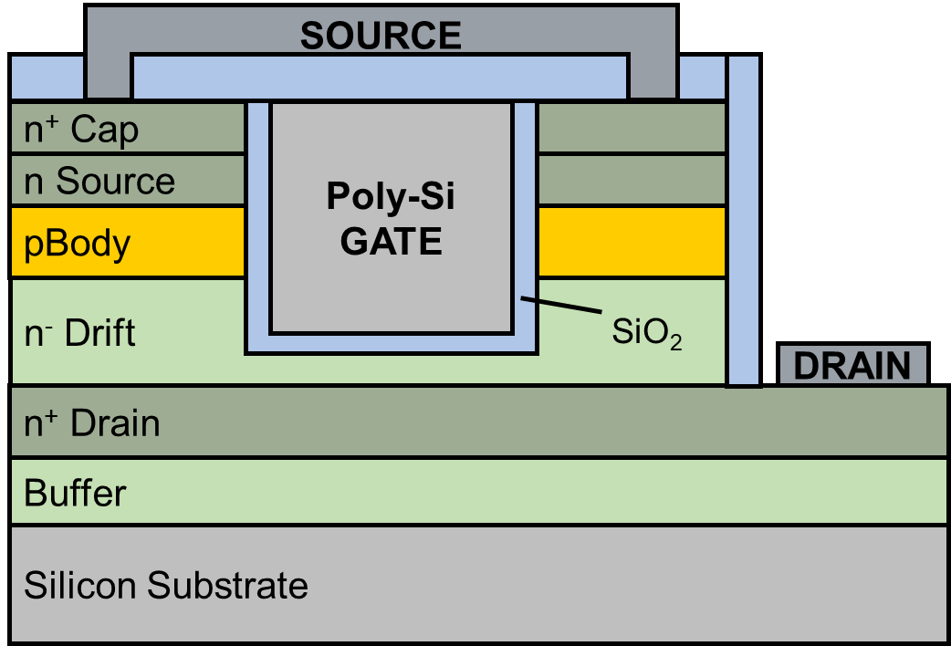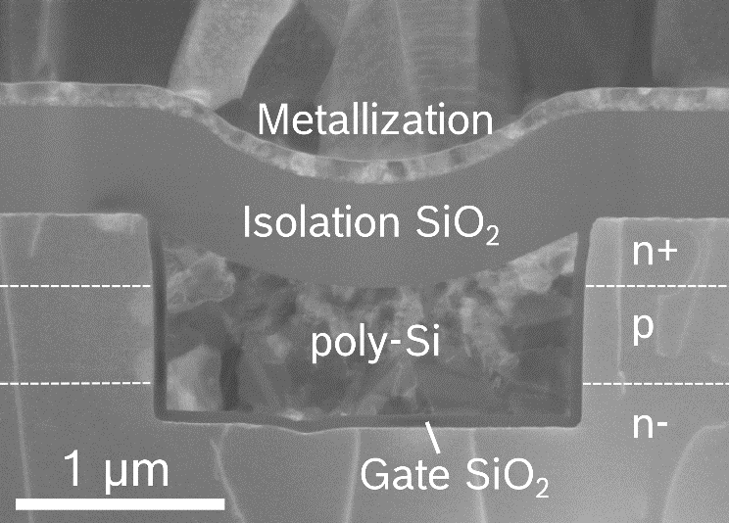
(a) | (b)
Fig. 1. (Color online) (a) Schematic 2-D view of the pseudo-vertical GaN-on-Si TMOS under study in this work. (b) TEM image of a FIB lamella taken from the gate trench.

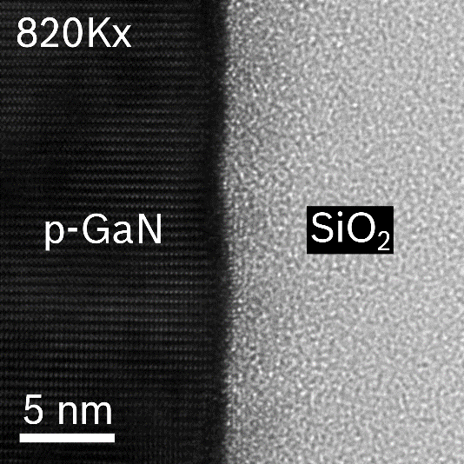
Fig. 2. HRTEM image at 820Kx magnification of the gate interface in the channel region on the etched sidewall for device B.

To restore the state of the device and avoid trapped charge accumulation, after each sweep the DUT’s were exposed to 365 nm (3.4 eV) ultraviolet (UV) illumination for a few minutes. Experimental data are collected in Fig. 3, showing the set of I_{D}-V_{GS} curves for device A (a) and B (b) for different V_{GS,max}. Saturation current (I_{D,SS}) at V_{DS} = 5 V and V_{GS} = 20 V is 0.12 mA/mm and 0.2 A/mm for device A and B, respectively. The main factors limiting I_{D,SS} are the mobility degradation due to electron conduction near the semiconductor/oxide interface and the Fermi level pinning due to charged acceptor interface and border traps.
The almost overlapping threshold voltage (V_{T}) of the forward I_{D}-V_{GS} curves for both devices indicates that the 3.4 eV UV light is effective in restoring the state of the device. On the other hand, at room temperature it was found that 100-s recovery phase at V_{GS} = 0 V after 100-s stress at V_{GS} = 40 V led to a residual ≈2 V positive V_{T} shift, i.e., full recovery was not achieved, see Fig. 4.
For both devices, we observed a V_{T} shift between the forward and backward sweep, indicating that slow traps get filled with electrons during the forward sweep and are not thermally emitted during the backward sweep. The V_{T} difference between the backward and forward sweep is commonly referred to as hysteresis. Note that V_{T} is taken at V_{GS} for which I_{D} = 1 μA/mm. Because the amount of trapped charge increases with increasing V_{GS,max}, hysteresis is also proportional to V_{GS,max} [16]. As can be noted by comparing Fig. 3(a) and (b), device B hysteresis is remarkedly lower than that of device A. This behavior is further investigated by means of numerical simulations in Sec. 3.

Fig. 3. (Color online) Experimentally measured I_{D}-V_{GS} of device A (a) and B (b). Continuous lines with squares (dashed lines with circles) are the forward and backward sweeps, respectively.
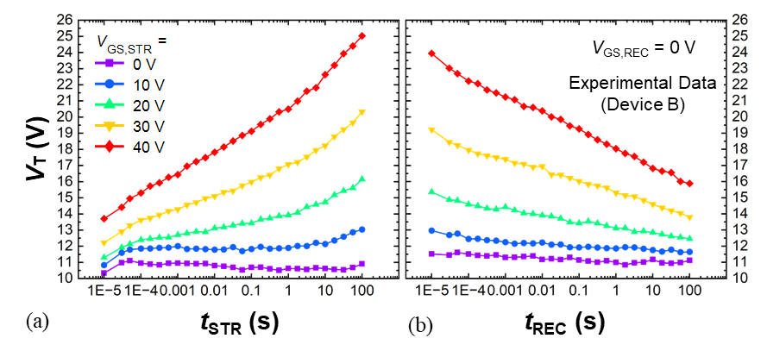
Fig. 4. (Color online) V_{T} time evolution during (a) stress and (b) recovery experiments on device B. Different stress voltages (V_{GS,STR}) were applied (see legend), whereas the recovery voltage (V_{GS,REC}) was always 0 V.

In general, both electron trapping and detrapping are dynamic processes that determine a positive/negative V_{T} drift, respectively, and as such these V_{T} drifts are proportional to the duration of bias application. Non-zero hysteresis can thus be interpreted as the net result of electron trapping followed by an electron release that is not fully completed in the time window of the applied V_{GS} range.
Fig. 4 better clarifies this point, showing the V_{T} drift during stress/recovery experiments carried out for several time decades (from 10 μs to 100 s) at different stress voltages (V_{GS,STR}) and at a fixed 0 V recovery bias (V_{GS,REC}) on device B. During stress and recovery cycles, stress (recovery) bias was periodically turned off to allow the measurement of the I_{D}-V_{GS} curve to probe V_{T}, by sweeping V_{GS} from 0 to 30 V in 10 μs with V_{DS} = 1 V. In this case, due to insufficient resolution of the experimental setup at low currents, V_{T} was taken at I_{D} = 1 mA/mm. The non-saturating behavior of V_{T} shift with both stress and recovery time in Fig. 4 is in agreement with previous studies of PBTI on GaN-based planar devices [17]–[19].
Looking, for instance, at the case V_{GS,STR} = 40 V in Fig. 4, the net V_{T} drift (taken as the difference between the value at the beginning of the stress cycle and that at the end of the recovery one) is about 2 V, which correlates nicely with hysteresis at V_{GS,max} = 40 V as shown in Fig. 3 (and Fig. 7). This result suggests that non-zero hysteresis can be interpreted as the net result of the dynamic processes of electron trapping and incomplete recovery (from trapping) in the time window of the applied V_{GS} sweep.
Further, V_{T} drift during stress at V_{GS,STR} = 30 V was characterized at different temperatures to better understand the physical mechanism at the origin of hysteresis. Fig. 5 shows the results of this characterization on device A, and it can be observed that V_{T} drift during stress is not influenced by temperature, supporting the hypothesis of tunneling as the underlying mechanism. A more detailed discussion of the V_{T} shift during stress and recovery experiments is provided in [20].

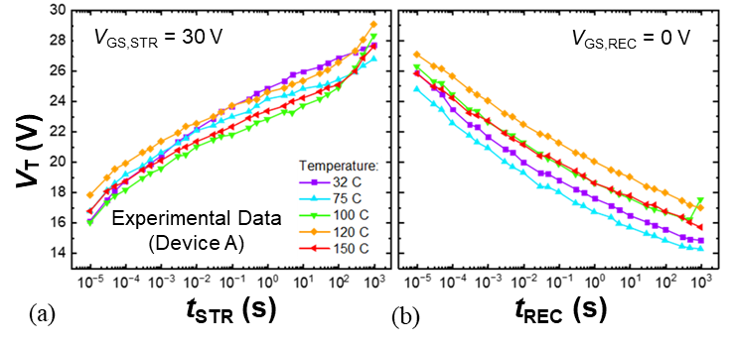
Fig. 5. (Color online) V_{T} time evolution during (a) stress (V_{GS,STR} = 30 V) and (b) recovery (V_{GS,REC} = 0 V) experiments on device A and different temperatures (see legend). No clear dependence of V_{T} shift on temperature was found.

3. Simulation Results and Discussion
Two-dimensional numerical device simulations were performed with the Synopsys TCAD tool SDevice [21] aimed at obtaining insights on the improvement in the stability of I_{D}-V_{GS} curves of the two devices discussed in Sec. 2. Particularly, we investigated the impact of border and interface traps on hysteresis and subthreshold slope reduction. Charging and discharging of interface traps is accounted for by means of a fully dynamic SRH model (no quasi-static approximation), that is self-consistently coupled to the drift-diffusion equations. Additionally, border traps are placed into SiO₂ gate oxide region and are allowed to exchange electrons with the GaN surface through the nonlocal “tunneling into traps” model included in the simulator [21]. A constant mobility model, only dependent on temperature, was adopted for simplicity. Hence, technological development in terms of mobility improvement is reproduced in the simulations by setting the channel mobility value (μ_{ch}) in the body (i.e., where the inversion channel forms) layer for the two devices to the respective field-effect mobility extracted from the measurements.

Table 1. Trap-related simulation parameters (Device A/Device B).
Label* | Areal Density (D_{IT}, cm⁻².eV⁻¹) | Volume Density (D_{BT}, cm⁻³.eV⁻¹) | Energy Mean** (E_{M}, eV) | Energy Spread  (E_{S}, eV)
IT,A | 1×10¹³/5×10¹² | // | 0 | 0.2
IT,D | 2×10¹²/1×10¹² | // | 0.9 | 1.6
BT,A | // | 4×10¹⁹/1×10¹⁹ | 0 | 2
*A stands for acceptors, D for donors
**With respect to GaN conduction band edge (E_{C})
The energy distributions and concentration of interface (IT) and border traps (BT), as well as channel mobility, were firstly calibrated to obtain a best fitting with the experimentally measured hysteresis on device A. Box-like distributions for trap distributions were adopted for a more straightforward parametrization. Trap parameters are summarized in Tab. I.
Fig. 6. (Color online) (a) Interface and (b) border trap densities vs trap energy (E_{T}) referred to the conduction band edge of GaN (E_{C}) employed in the simulations of device A (for device B, all parameters were the same except for the concentrations, see Tab. I). E_{CNL} in (a) indicates the assumed charge neutrality level that discriminates between acceptor-like and donor-like interface traps [22]. Border traps are only acceptor states.

The box-like distribution has the following form [21]:

$\left\{\begin{aligned}D_{T}, E_{M}-0.5E_{S}<E<E_{M}+0.5E_{S} \\ 0, elsewhere\end{aligned}\right.$ (1)

where D_{T} is either D_{BT} or D_{IT} (see Tab. I). E_{M}, and E_{S} are defined in Tab. I. We assume donor interface traps to have a large energy distribution across the upper portion of GaN energy gap and acceptor interface traps to be narrowly distributed near the conduction band edge (E_{C}), which corresponds to assume that the charge neutrality level [23] is located 0.1 eV below E_{C}. Interface and border traps distribution employed in the simulations are shown in Fig. 6. The interface trap distribution was modeled starting from the distribution experimentally validated for other material systems (such as Si-SiO₂ interface [24], Al₂O₃-InGaAs [16]) and conventionally assumed for oxide/semiconductor interfaces [22]. Border trap distribution parameters were set in order to reproduce experimentally measured hysteresis.

Fig. 7. (Color online) Simulated I_{D}-V_{GS} of device A (left) and B (right). Continuous (dashed) lines are the forward and backward sweeps, respectively.
Fig. 8. (a) Simulated band diagram (device B) plotted along the lateral dimension perpendicular to the vertical current flow for different V_{GS} (see legend). (b) Corresponding trapped charge in border traps (n_{BT}) in the gate oxide (SiO₂) and free electron density (n) in the channel (GaN).

The channel mobility (μ_{ch}) was set to 3 cm²/V.s, corresponding to the field-effect mobility extracted from the measurements. The results of the simulations of device A in terms of I_{D}-V_{GS} curves for different V_{GS,max} (V_{DS} = 1 V) are shown in Fig. 7(a). Good agreement is obtained between experiments and simulations, compare Figs. 7(a) and 3(a). Hysteresis is physically induced by channel electron tunneling into the border traps during the upward V_{GS} sweep and only partial electron release during the downward one, resulting in a right-shifted threshold voltage.
By properly reducing the IT and BT concentrations, as well as increasing channel mobility, without adjusting any other parameter, we calibrated the simulation results on device B as well, as shown by the I_{D}-V_{GS} curves in Fig. 7(b). Trap parameters are again reported in Tab. I. μ_{ch} in this case was set to 17 cm²/V.s, corresponding to the field-effect mobility extracted from the measurements.
The physical mechanism of hysteresis can be better understood with the aid of Fig. 8(a), showing the simulated band diagram across the channel (i.e., plotted along the lateral dimension perpendicular to the vertical current flow) for different V_{GS} (see legend). Additionally, Fig. 8(b) shows the concentration of trapped charge in the oxide (n_{BT}) and free electron density (n) in the channel corresponding to the same biases. As V_{GS} increases, so does n in the channel as the Fermi level moves above the conduction band edge (i.e., inversion occurs). The raise in Fermi level position (with respect to E_{C}) increases the probability for electron tunneling from the channel to the traps in the gate oxide (border traps). This consequently increases n_{BT} in the same region, as shown in Fig. 8(b).

Fig. 9. (a) Simulated band diagram (device B) plotted along the lateral dimension perpendicular to the vertical current flow for different V_{GS} (see legend). (b) Corresponding trapped charge in border traps (n_{BT}) in the gate oxide (SiO₂) and free electron density (n) in the channel (GaN).

Fig. 9 shows the same quantities as Fig. 8 but taken on the forward and backward curves at the same bias of V_{GS} = 5 V. The larger n_{BT} on the backward curve compared to the forward one causes a smaller n in the channel, see Fig. 9(b), leading to higher V_{T} (and thus, hysteresis). This is consistent with the band diagrams shown in Fig. 9(a), as the band bending corresponding to V_{GS} = 5 V on the backward curve is less than that on the forward one, meaning that inversion is weaker in the former than in the latter case, thus explaining the reduced n.

Fig. 10. (Color online) Hysteresis in the I_{D}-V_{GS} (see text for definition) of device A and B. Both experimental data and simulation results are shown. Dashed lines are linear fitting of data points. The ≈75% hysteresis reduction at V_{GS,max} = 40 V of device B compared to A is reproduced by simulations by reducing oxide trap concentration by the same amount.

The agreement between the simulations and experimental data in terms of hysteresis is further confirmed by Fig. 10, that shows how the calibrated setups are able to capture the linear dependence of hysteresis on V_{GS,max} for both TMOS devices. Remarkably, the hysteresis reduction observed between the two devices of ≈75% at V_{GS,max} = 40 V is captured by the simulations when reducing the BT density from 4×10¹⁹ eV^{–1}cm^{–3} to 1×10¹⁹ eV^{–1}cm^{–3}. As stated earlier, typical gate bias during actual device operation is ≤ 20V so that H in practice is < 1 V for device B.
IT concentration has little role on the hysteresis, due to the short emission time constants and fast charge (during upward V_{GS} sweep) and discharge (backward V_{GS} sweep) [16]; however, the IT density reduction impacts favorably SS, besides correlating with the mobility improvement as a result of the interface quality improvement [25].
By extending the BT and IT density range, it is possible to extrapolate the corresponding H and SS values, particularly to estimate the amount of trap density reduction required to minimize both H and SS. Fig. 11 shows the results of this analysis for the hysteresis vs BT density curve (with all other parameters of the setup calibrated on the experimental data of device B). This analysis reveals a strong dependence of hysteresis on BT density in the 5×10¹⁸-5×10¹⁹ eV⁻¹ cm⁻³ range: the higher the trap density, the higher the concentration of trapped electrons that cause the V_{T} shift between forward and backward sweeps. Further reducing BT density below 10¹⁹ eV⁻¹ cm⁻³ leads to negligible hysteresis.

Fig. 11. (Color online) Sensitivity of H to border trap density (D_{BT}) with the simulation setup calibrated on device B. The experimental data points at V_{GS,max} = 40 V are shown for reference.

Fig. 12. (Color online) Sensitivity of SS (obtained on the upward sweep) to interface trap density (D_{IT}) with the simulation setup calibrated on device B. The experimental data points at V_{GS,max} = 40 V are shown for reference. The asymptotic theoretical limit (i.e., for a trap-free interface determined only by the depletion capacitance, C_{D}, and oxide capacitance, C_{ox}) is also indicated.

Fig. 12 on the other hand, illustrates the dependence of SS on the interface trap density. As can be seen, the ≈30% SS reduction obtained by device B compared to device A is explained by TCAD simulations as a result of D_{IT} reduction.
4. Conclusion
We presented electrical characterization data and simulation results on two different pseudo-vertical GaN-on-Si Trench MOSFETs. The higher temperature gate oxide deposition technique used in device B compared to device A led to a reduced transfer curve hysteresis and subthreshold slope, as well as increased channel mobility. Calibrated simulation decks on both devices allowed us to investigate in detail the cause for hysteresis, which can be attributed to oxide traps near the interface with the semiconductor (border traps). The subthreshold slope is instead mainly governed by the density of interface traps. The improvements in hysteresis and subthreshold slope achieved by device B can therefore be attributed to a consistent decrease in the density of border and interface traps, respectively. The sensitivity analysis carried out by means of TCAD simulations in terms of hysteresis (subthreshold slope) vs border trap (interface trap) density, allows quantifying the additional trap density reduction required to minimize both figures of merit.

Acknowledgments

This work has been carried out in the framework of the European Project “YESvGaN”. The project has received funding from the Electronic Component Systems for European Leadership Joint Undertaking (ECSEL JU), under grant agreement No. 101007229. This Joint Undertaking receives support from the European Union’s Horizon 2020 Research and Innovation Programme, and Germany, France, Belgium, Austria, Sweden, Spain, and Italy.

References
[1] H. Fu, K. Fu, S. Chowdhury, T. Palacios, and Y. Zhao, “Vertical GaN Power Devices: Device Principles and Fabrication Technologies--Part II,” IEEE Transactions on Electron Devices, vol. 68, no. 7, pp. 3212–3222, Jul. 2021, doi: 10.1109/TED.2021.3083209.
[2] M. Meneghini, C. De Santi, I. Abid, M. Buffolo, M. Cioni, R. A. Khadar, L. Nela, N. Zagni, A. Chini, F. Medjdoub, G. Meneghesso, G. Verzellesi, E. Zanoni, and E. Matioli, “GaN-based power devices: Physics, reliability, and perspectives,” Journal of Applied Physics, vol. 130, no. 18, p. 181101, Nov. 2021, doi: 10.1063/5.0061354.
[3] J. A. del Alamo and E. S. Lee, “Stability and Reliability of Lateral GaN Power Field-Effect Transistors,” IEEE Transactions on Electron Devices, vol. 66, no. 11, pp. 4578–4590, Nov. 2019, doi: 10.1109/TED.2019.2931718.
[4] N. Zagni, A. Chini, F. M. Puglisi, M. Meneghini, G. Meneghesso, E. Zanoni, P. Pavan, and G. Verzellesi, “‘Hole Redistribution’ Model Explaining the Thermally Activated R _{ON} Stress/Recovery Transients in Carbon-Doped AlGaN/GaN Power MIS-HEMTs,” IEEE Trans. Electron Devices, vol. 68, no. 2, pp. 697–703, Feb. 2021, doi: 10.1109/TED.2020.3045683.
[5] M. Cioni, N. Zagni, F. Iucolano, M. Moschetti, G. Verzellesi, and A. Chini, “Partial Recovery of Dynamic R _{ON} Versus OFF-State Stress Voltage in p-GaN Gate AlGaN/GaN Power HEMTs,” IEEE Trans. Electron Devices, vol. 68, no. 10, pp. 4862–4868, Oct. 2021, doi: 10.1109/TED.2021.3105075.
[6] A. Chini, G. Meneghesso, M. Meneghini, F. Fantini, G. Verzellesi, A. Patti, and F. Iucolano, “Experimental and Numerical Analysis of Hole Emission Process from Carbon-Related Traps in GaN Buffer Layers,” IEEE Transactions on Electron Devices, vol. 63, no. 9, pp. 3473–3478, Sep. 2016, doi: 10.1109/TED.2016.2593791.
[7] N. Modolo, C. De Santi, A. Minetto, L. Sayadi, S. Sicre, G. Prechtl, G. Meneghesso, E. Zanoni, and M. Meneghini, “A Physics-Based Approach to Model Hot-Electron Trapping Kinetics in p-GaN HEMTs,” IEEE Electron Device Letters, vol. 42, no. 5, pp. 673–676, May 2021, doi: 10.1109/LED.2021.3067796.
[8] K. Ohnishi, S. Kawasaki, N. Fujimoto, S. Nitta, H. Watanabe, Y. Honda, and H. Amano, “Vertical GaN p+-n junction diode with ideal avalanche capability grown by halide vapor phase epitaxy,” Applied Physics Letters, vol. 119, no. 15, p. 152102, Oct. 2021, doi: 10.1063/5.0066139.
[9] Z. Bian, K. Zeng, and S. Chowdhury, “2.8 kV Avalanche in Vertical GaN PN Diode Utilizing Field Plate on Hydrogen Passivated P-Layer,” IEEE Electron Device Letters, vol. 43, no. 4, pp. 596–599, Apr. 2022, doi: 10.1109/LED.2022.3149748.
[10] J. Liu, M. Xiao, Y. Zhang, S. Pidaparthi, H. Cui, A. Edwards, L. Baubutr, W. Meier, C. Coles, and C. Drowley, “1.2 kV Vertical GaN Fin JFETs with Robust Avalanche and Fast Switching Capabilities,” in 2020 IEEE International Electron Devices Meeting (IEDM), Dec. 2020, p. 23.2.1-23.2.4. doi: 10.1109/IEDM13553.2020.9372048.
[11] K. Mukherjee, C. De Santi, M. Borga, K. Geens, S. You, B. Bakeroot, S. Decoutere, P. Diehle, S. Hübner, F. Altmann, M. Buffolo, G. Meneghesso, E. Zanoni, and M. Meneghini, “Challenges and Perspectives for Vertical GaN-on-Si Trench MOS Reliability: From Leakage Current Analysis to Gate Stack Optimization,” Materials, vol. 14, no. 9, Art. no. 9, Jan. 2021, doi: 10.3390/ma14092316.
[12] E. Bahat Treidel, O. Hilt, V. Hoffmann, F. Brunner, N. Bickel, A. Thies, K. Tetzner, H. Gargouri, C. Huber, K. Donimirski, and J. Wurfl, “On the Conduction Properties of Vertical GaN n-Channel Trench MISFETs,” IEEE Journal of the Electron Devices Society, vol. 9, no. February, pp. 215–228, 2021, doi: 10.1109/JEDS.2021.3056697.
[13] K. Mukherjee, C. De Santi, M. Borga, S. You, K. Geens, B. Bakeroot, S. Decoutere, G. Meneghesso, E. Zanoni, and M. Meneghini, “Use of Bilayer Gate Insulator in GaN-on-Si Vertical Trench MOSFETs: Impact on Performance and Reliability,” Materials, vol. 13, no. 21, Art. no. 21, Jan. 2020, doi: 10.3390/ma13214740.
[14] K. Dannecker and J. Baringhaus, “Fully vertical gallium nitride trench MOSFETs fabricated with metal-free gate first process,” Journal of Vacuum Science & Technology B, vol. 39, no. 3, p. 032204, Apr. 2021, doi: 10.1116/6.0000980.
[15] M. Henn and C. Huber, “Impact of Gate Dielectric Deposition Temperature on p-type Inversion Channel MOSFETs fabricated on GaN-on-Si,” in 2022 IEEE Workshop on Wide Bandgap Power Devices and Applications in Europe (WiPDA Europe), Sep. 2022, pp. 1–5. doi: 10.1109/WiPDAEurope55971.2022.9936574.
[16] P. Pavan, N. Zagni, F. M. Puglisi, A. Alian, A. V.-Y. Thean, N. Collaert, and G. Verzellesi, “The impact of interface and border traps on current-voltage, capacitance-voltage, and split-CV mobility measurements in InGaAs MOSFETs: Current-voltage, capacitance-voltage, and mobility measurements in InGaAs MOSFETs,” Phys. Status Solidi A, vol. 214, no. 3, p. 1600592, Mar. 2017, doi: 10.1002/pssa.201600592.
[17] A. Guo and J. A. Del Alamo, “Unified Mechanism for Positive- and Negative-Bias Temperature Instability in GaN MOSFETs,” IEEE Transactions on Electron Devices, vol. 64, no. 5, pp. 2142–2147, May 2017, doi: 10.1109/TED.2017.2686840.
[18] T.-L. Wu, J. Franco, D. Marcon, B. De Jaeger, B. Bakeroot, S. Stoffels, M. Van Hove, G. Groeseneken, and S. Decoutere, “Toward Understanding Positive Bias Temperature Instability in Fully Recessed-Gate GaN MISFETs,” IEEE Transactions on Electron Devices, vol. 63, no. 5, pp. 1853–1860, May 2016, doi: 10.1109/TED.2016.2539341.
[19] P. Lagger, M. Reiner, D. Pogany, and C. Ostermaier, “Comprehensive Study of the Complex Dynamics of Forward Bias-Induced Threshold Voltage Drifts in GaN Based MIS-HEMTs by Stress/Recovery Experiments,” IEEE Trans. Electron Devices, vol. 61, no. 4, pp. 1022–1030, Apr. 2014, doi: 10.1109/TED.2014.2303853.
[20] M. Fregolent, A. Del Fiol, C. De Santi, C. Huber, G. Meneghesso, E. Zanoni, and M. Meneghini, “Threshold voltage instability in SiO2-gate semi-vertical GaN trench MOSFETs grown on silicon substrate,” Microelectronics Reliability, p. 115130, Oct. 2023, doi: 10.1016/j.microrel.2023.115130.
[21] Synopsys, “Sentaurus SDevice Manual (S-2021.06).” 2021.
[22] D. K. Schroder, “OXIDE AND INTERFACE TRAPPED CHARGES, OXIDE THICKNESS,” in Semiconductor Material and Device Characterization, John Wiley & Sons, Inc., 2005, pp. 319–387. doi: 10.1002/0471749095.
[23] S. M. Sze and K. K. Ng, Physics of Semiconductor Devices. Hoboken, NJ, USA: John Wiley & Sons, Inc., 2006. doi: 10.1002/0470068329.
[24] M. Yu, S. McNab, I. Al-Dhahir, C. E. Patrick, P. P. Altermatt, and R. S. Bonilla, “Extracting band-tail interface state densities from measurements and modelling of space charge layer resistance,” Solar Energy Materials and Solar Cells, vol. 231, p. 111307, Oct. 2021, doi: 10.1016/j.solmat.2021.111307.
[25] L. Selmi, E. Caruso, S. Carapezzi, M. Visciarelli, E. Gnani, N. Zagni, P. Pavan, P. Palestri, D. Esseni, A. Gnudi, S. Reggiani, F. M. Puglisi, and G. Verzellesi, “Modelling nanoscale n-MOSFETs with III-V compound semiconductor channels: From advanced models for band structures, electrostatics and transport to TCAD,” in 2017 IEEE International Electron Devices Meeting (IEDM), San Francisco, CA, USA, Dec. 2017, p. 13.4.1-13.4.4. doi: 10.1109/IEDM.2017.8268384.

